REVIEWED DISASTER MANAGEMENT SECTOR PLAN 2019/ 2020

AUTHOR: M.W. DLAMINI (MANAGER COMMUNITY SAFETY)

Document Information
Document Type | DR. NKOSAZANA DLAMINI ZUMA MUNICIPALITY’S DISASTER MANAGEMENT SECTOR PLAN
Applicability | To be included in the municipality’s Integrated Development Plan and copy submitted to COGTA
Status | FINAL
Author | M.W. Dlamini (Manager Community Safety)
Recommend for endorsement | M.P. Mtungwa (Act. Senior Manager Community Services)
Endorsement | N.C. Vezi (Municipal Manager)
Date of this Compilation | March 2019
Other Documents which have direct bearing on this document | - The Constitution of South Africa (Chapter 7, section  152 (d)  - Disaster Management Act 57 of 2002  - Fire Brigades Act  - Disaster Management Plan for Dr. Nkosazana Dlamini Zuma Municipality  - Veld Fire and Forest Act

TABLE OF CONTENTS
CONTENTS PAGE
Status quo for Disaster Management at NDZ Municipality…………………………………………………………………4
KPA 1
Integrated Institutional Capacity for Disaster Management……………………………………………………………….5
Disaster Management Framework……………………………………………………………………………………………………..5
Disaster Management Advisory Forum………………………………………………………………………………………………5
Sendai Framework for Disaster Risk Reduction Vision 2030……………………………………………………………….8
Key Performance Indicators……………………………………………………………………………………………………………….8
Establishment of Disaster Management Centre/ Fire Station……………………………………………………………..10
Funding and Available Budget…………………………………………………………………………………………………………….10
Employment of fire services staff……………………………………………………………………………………………………….10
Storage Facilities…………………………………………………………………………………………………………………………………11
Location of Disaster Management………………………………………………………………………………………………………11
Ward Based Disaster Management Volunteers…………………………………………………………………………………..12
Prevention and Mitigation………………………………………………………………………………………………………………….12
Enforcement of Legislation…………………………………………………………………………………………………………………13
Disaster Management Interdepartmental Committee………………………………………………………………………..13
Key Performance Indicators………………………………………………………………………………………………………………..13
Disaster Management Plan…………………………………………………………………………………………………………………13
Key Performance Indicator………………………………………………………………………………………………………………….14
Municipal Safety Plan………………………………………………………………………………………………………………………….14
Road Cameras……………………………………………………………………………………………………………………………………..14
Animal Pound………………………………………………………………………………………………………………………………………17
Crime Prevention and Combat…………………………………………………………………………………………………………….17
Road Blocks…………………………………………………………………………………………………………………………………………17
Clearing of Bushes and Conducting Fire Breaks……………………………………………………………………………………20
Key Performance Indicator………………………………………………………………………………………………………………….21
Key Performance Area 2 Disaster Risk Assessment……………………………………………………………………………..21
Mapping of Disaster Risks……………………………………………………………………………………………………………………28
Disaster places of safety………………………………………………………………………………………………………………………39
Disaster Risk Reduction Projects………………………………………………………………………………………………………….40
Major Hazard Installation……………………………………………………………………………………………………………………41
Dealing with Snow………………………………………………………………………………………………………………………………43
Key Performance Indicator………………………………………………………………………………………………………………….43
Key Performance Area 3 Response and Recovery………………………………………………………………………………..50
Key Performance Indicator………………………………………………………………………………………………………………….53
Stakeholders Representatives……………………………………………………………………………………………………………..54
Enabler 1 Disaster Management Information and Communication System…………………………………………56
Early Warning System………………………………………………………………………………………………………………………….56
Enabler 2 Education, Training, Public Awareness and Research…………………………………………………………..57
Enabler 3 Funding Arrangements for Disaster Risk Management ……………………………………………………….59
Internal Funding………………………………………………………………………………………………………………………………….59
Government Funding………………………………………………………………………………………………………………………….59
Private Sector……………………………………………………………………………………………………………………………………..59
SWOT Analysis…………………………………………………………………………………………………………………………………….60
Climate Change……………………………………………………………………………………………………………………………………60
Climate Change Effects………………………………………………………………………………………………………………………..61
Synopsis of the Agricultural Sector in NDZ…………………………………………………………………………………………..62
Responses on Issues of Climate Change (Ecosystem based Disaster Risk Reduction)…………………………..63
Environmental Measures for Ecosystem based Disaster Risk Reduction………………………………………………63
Forest Plantations…………………………………………………………………………………………………………………………………63
Waste Management …………………………………………………………………………………………………………………………….64
Rehabilitation of the Environment………………………………………………………………………………………………………..64
Tourism Disaster Risk Reduction Initiatives……………………………………………………………………………………………64
Protection of Wetland……………………………………………………………………………………………………………………….....65
Energy Saving…………………………………………………………………………………………………………………………………………67
Plantation of trees, Flowers and Beautification…………………………………………………………………………………….69
Key challenges………………………………………………………………………………………………………………………………………70
DISASTER RISK MANAGEMENT
- STATUS QUO OF DISASTER MANAGEMENT IN DR. NKOSAZANA DLAMINI ZUMA MUNICIPALITY
The Disaster Management Act (Act 57 of 2002), as amended from time to time in chapter 5, clearly define the requirements that, municipalities must undertake to fulfill their disaster management mandate.
The area of jurisdiction of Dr. Nkosazana Dlamini Zuma municipality is prone to diverse types of disaster hazards ranging from natural and human induced. Whilst natural hazards cannot be prevented but is of paramount importance to note that, initiatives and/ or measures are put in place to mitigate the effects of such natural phenomenon.
Human induced disaster hazards are by all possible means preventable and hence the municipality is very vigilant to such phenomenon and has further put in place drastic measures and / or programs in place to effectively prevent such human induced hazards from happening and where, such hazards do occur, effective response systems get activated and deal with such.
One of the most fundamental issues in disaster management is that of ensuring disaster management centers act as repository and conduits to information and building capacity at a community level with the effort of building disaster resilient communities. The area of jurisdiction of the municipality has sixteen (16) traditional councils, which therefore places indigenous knowledge information at the center stage of disaster management in terms of incorporation whenever a risk assessment is done in terms of key performance area 2 of the disaster management framework. The traditional leaders are also represented in the Disaster Management Advisory forum.
Dr. Nkosazana Dlamini Zuma municipality shall endeavor to ensure compliance with all disaster management statutory prescripts including the constitution of the republic, which is an overarching legislative document in the country, with the purpose of ensuring a safe environment and building resilient communities whilst reducing disaster vulnerabilities.
The municipality is currently striving to promote a continuous and integrated multi-sectoral, multi-disciplinary process of planning and implementation of measures aimed at:
- Preventing or reducing the risk of disasters
- Mitigating the severity or consequences of disasters
- Emergency preparedness
- A rapid and effective response to disasters and
- Post –disaster recovery and rehabilitation
As indicative above, the following projects are testimonies that, Dr. Nkosazana Dlamini Zuma municipality is hard at work with special emphasis in prioritizing disaster management issues:
- Establishment of fire station that will also be utilized to dispatch disaster management activities
- Development of the Disaster Management Policy Framework to be developed in the 2018/2019 fiscal year
- Disaster Management plan has been developed
- Disaster Management Advisory Forum established
- Disaster Risk Assessment has been done
- Disaster Risk Reduction projects incorporated in the IDP
- Disaster Response and Recovery
- Information Management and Communication
- Education, Training, Public Awareness and Research
- Funding Arrangements for Disaster Risk Management drastically improved
- KEY PERFORMANCE AREA 1

2.1 INTEGRATED INSTITUTIONAL CAPACITY FOR DISASTER RISK MANAGEMENT

2.1.1 DISASTER MANAGEMENT FRAMEWORK

The Dr. Nkosazana Dlamini Zuma municipality interns developing its Disaster Management Policy Framework in the fiscal year 2018/2019, in terms of section 42 of the Disaster Management Act, (Act 57 of 2002), in line with the National Disaster Management Framework of 2005. The Disaster Management Framework is essential to ensure an integrated and uniform approach to disaster management in the municipality’s area of jurisdiction by-

- The municipality and statutory functionaries of the municipality.
- All municipal entities operating in jurisdiction
- All non-governmental institutions involved in disaster management in the area
- The private sector

The Disaster Management Framework also put more and more emphasis in ensuring that all role players in the disaster management arena (including Government, None Government Organizations, Traditional Authorities and the Private Sector) work together in a coherent and coordinated fashion prevent and or mitigate the occurrence and/ or effects of disasters incidents or disasters.
KEY PERFORMANCE INDICATOR
The Disaster Management Framework approved by council, once developed.
2.2.1 DISASTER MANAGEMENT ADVISORY FORUM
The advisory forum sits four times on annual basis, which translate to one (1) meeting in three (3) months. The effectiveness and sustainability sitting of meetings on quarterly basis has seen the implementation of disaster management issues evolve from being reactive to be more proactive with more emphasis on prevention and mitigation of hazards.
The representation of the disaster management advisory forum for Dr. Nkosazana Dlamini Zuma municipality is as follows:

NO | STAKEHOLDERS
1. | Dr. Nkosazana Dlamini Zuma Municipality
2. | Harry Gwala District Municipality’s Disaster Management Centre
3. | Provincial Disaster Management Centre
4. | Department of Health Communicable Diseases
5. | Department of Health Emergency Management Services
6. | Social Development
7. | South African Social Security Agency
8. | South African Police Services Bulwer
9. | Midlands EMS
10. | Road Traffic Inspectorate (RTI)
11. | UMkomaas Fire Protection Association
12. | Southern Berg Fire Protection Association
13. | Creighton Engen Depot
14. | Rural Metro Fire Services
15. | Magma Security
16. | Berg Security
17. | Working on Fire
18. | South African Police Creighton
19. | South African Police Himeville
20. | South African Police Donnybrook
21. | Ward Committee members

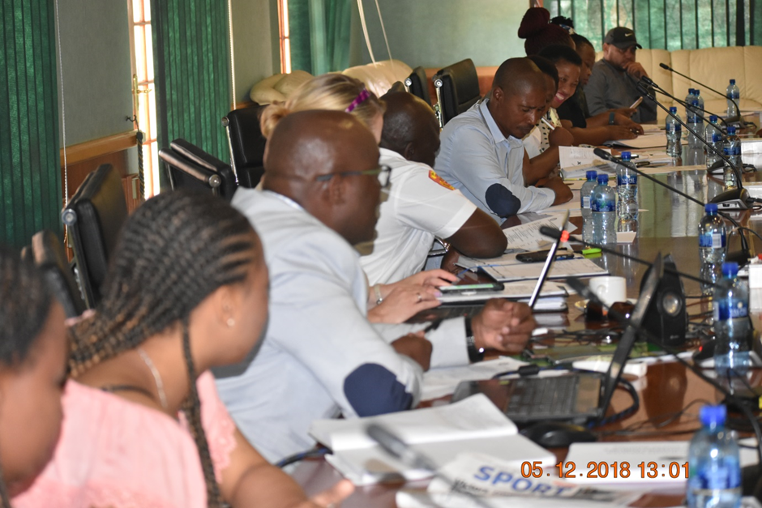Disaster Management Advisory Forum Meeting on the 05 December 2018
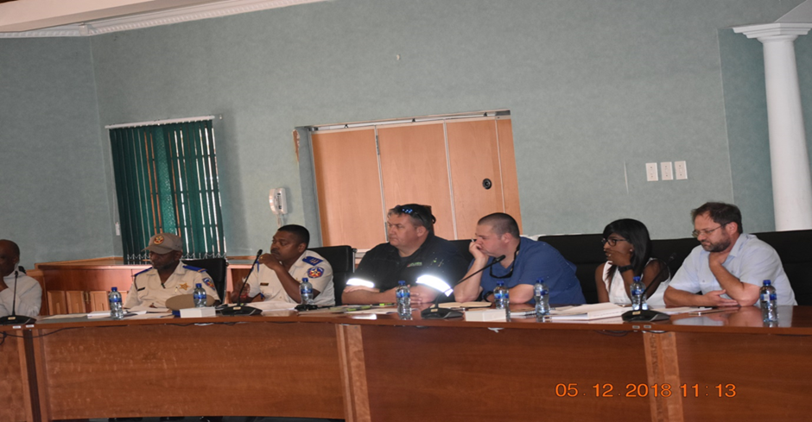Disaster Management Advisory Forum Meeting on the 05 December 2018
SENDAI FRAMEWORK FOR DISASTER RISK REDUCTION VISION 2030
The Sendai Framework for Disaster Risk Reduction promotes a more people centered preventative and mitigation approach to disaster risk reduction. It put emphases on governments to engage with relevant stakeholders, including women, children, youth, people with disabilities, poor people, migrants and older people.
The above people are the most affected whenever disaster incidents and/ or disasters are realized on their basis of their vulnerabilities.
In a view to implement the vision of the Sendai Framework, the municipality has realized the need to incorporate representatives of the above stakeholders in its Disaster Management Advisory Forum, with a view to ensure that, their needs are taking into consideration whenever disaster management policies and plans are put in place.
This will be a very useful platform for such representatives on the basis that, they have their own forums wherein they can thereafter report to such forums on any information coming from the Disaster management Advisory Forum and their input as well.
2.2.2 KEY PERFORMANCE INDICATOR
- Disaster Management Advisory Forum sustainable and taking relevant decisions to promote disaster risk reduction within the area of the municipality.
- Disaster Management Advisory Forum to ensure representation from the following categories of stakeholders:

- Representative from the Women Forum
- Representative from the Youth Forum
- Representative from the people with disabilities
- Representative from migrants’ structures
- Representative from old citizens

- Disaster Management Forum to ensure alignment with the above structures to ensure that, disaster management issues are dealt with in an integrated manner.
No | Stakeholder | RESPONSIBILITIES
1. | Line Function Departments in the municipality | - To provide expertise and technical information pertaining to their line function departments  - To act as leading agencies in dealing with certain hazards that require technical skills
2. | Traditional Leaders | - To ensure that, traditional values and indigenous information is also forms part of disaster management planning in the municipal area
3. | South African Weather Services | - To provide advices on weather patterns and cascade early warning systems as part of ensuring state of preparedness
4. | SASSA | - To make provision of the diverse types of grants to needy communities  - To also provide relief such as food vouchers and/or groceries
5. | Home Affairs | - To ensure that, communities receive their identity documents  - To control illegal emigration of people to and from the South African Borders
6. | South African Liquor Authority | - Responsible of regulating liquor licenses in the area  - Attend to all liquor related complaints and ensure that, they are resolved timeously
7. | Provincial Disaster Management Centre | - To provide oversight on disaster risk management issues implementation at a local level  - Assist with training and capacity building  - Provide enormous disaster related support
8. | None Government Organizations | - To provide support (disaster relief) whenever a need arises
9. | NDZ municipal Disaster Management Centre | - Point of coordination for Disaster Management  - Ensure development of Disaster Management plans and monitoring the implementation thereof  - Conduct risk assessment for the area of jurisdiction of the municipality in consultation with all relevant role players  - Promote prevention, mitigation and response initiatives by municipal organs of state, non-governmental organizations and communities in jurisdiction.  - Measure performance and evaluate progress of initiatives  - Facilitate the activation of Joint Operation Centre whenever a need arises  - Make referrals to other sector departments  - Plan and execute awareness campaigns
10. | Community Based Organizations | - To provide both physical and emotional support during tough times to victims
11. | Eskom | - To provide technical information and skills on electricity  - To conduct awareness campaigns
12. | South African Police | - To ensure safety and security
13. | Fire Services | - To ensure fire safety communities
14. | Department of Health | - To deal with diseases and provide technical information on how to prevent and mitigate the effects of diseases
15. | Department of Transport | - To make provision of measures to prevent motor vehicle accidents
16. | District Disaster Management Centre | - Provide support to the municipality on disaster management issues
17. | Magma Security | - Ensure safety and security
18 | KSA | - Ensure safety and security
19 | Berg Security | - Ensure safety and security

2.3.1 ESTABLISHMENT OF THE DR. NKOSAZANA DLAMINI ZUMA MUNICIPALITY’S EMERGENCY
CENTRE
The Disaster Management amended Act 2015, (Act 16 of 2015), section 16 subsection 4, read in conjunction with the Disaster Management Act of 2002, (Act 57 of 2002) indicate that, a local municipality MAY establish a disaster management center in consultation with the relevant district municipality in accordance with the terms set out in a service level agreement between the two parties, in alignment with the national norms and standards.
Dr. Nkosazana Dlamini Zuma municipality in a process of establishing an integrated emergency Centre that will house all the emergency services within the municipality which are as follows:
- Disaster Management
- Fire Services
- Traffic
The municipality has applied to Cooperative Governance and Traditional Affairs, for funding to construct such a Centre.
FUNDING AND AVAILABLE BUDGET
It is the vision of the municipality to have a fully fletched fire services before or on the fiscal year 2021/2022 and as a result it has started to channel more financial resources towards realizing this goal. The financial muscle for the municipality is very limited and hence will also be going out to source funds to realize this goal, as such an application of R 15, 000 000. 00 (Fifteen Million Rands Only) to boost the municipal financial muscle to realize the facility.
In the financial year 2018/2019, the municipality reserved a budget of R 500 000. 00, for the designs of the emergency Centre, and to this end such was advertised by the municipality and hence supply chain processes are being followed to realize such designs.
For the financial year 2019/2020, the municipality has budgeted an amount of R 3, 000 000. 00 (Three million Rands) for the construction of phase 1 of the Dr. Nkosazana Dlamini Zuma Municipality Emergency Centre.
Furthermore, the municipality budgeted an amount of R 2, 500 000.00 for the procurement of a fire truck and such was advertised accordingly, and a service provider was appointed to supply the Fire Truck.
For the financial year 2019/2020 the municipality has, furthermore, budgeted an amount of R 1, 700, 000.00 (One million seven hundred thousand Rands) for procurement of three (3) vehicles being the emergency response vehicle, a double cab for fire services and once again another double cab for traffic.
EMPLOYMENT OF FIRE SERVICES OFFICIALS
During the financial year 2018/2019, the municipality budgeted salaries towards the employment of a Chief Fire Officer and two (2) fire fighters. Such positions will be filled in this current year 2019.
Over and above this, the municipality has further channeled some budget towards undertaking some disaster risk reduction projects as part of its commitment towards complying with the disaster management act, as amended from time to time.
The municipality has also budgeted for the procurement of disaster relief in case disaster incidents and/ or disasters are realized within the area of jurisdiction of the municipality.
INTER-DEPARTMENTAL DISASTER MANAGEMENT COMMITTEE
Dr. Nkosazana Dlamini Zuma Municipality formed an interdepartmental disaster management committee that deals with disaster management issues within the municipality and comprise of the following members:
NO | NAME OF OFFICIAL | DESIGNATION | DEPARTMENT REPRESENTATION
1. | Mr. M. Mzimela | Chief Financial Officer | Finance
2. | Mr. P. Mtungwa | Head of Department Community Services | Community Services Department
3. | Mr. Z. Dlamini | Assistant Manager PWBS (Public Works and Basic Services) | PWBS Department
4. | Mr. M.W. Dlamini | Manager Community Safety | Community Services Department

STORAGE FACILITIES
Storage facilities are also available wherein all disaster management relief is stored, although it is not conducive as compared to a proper fire station or disaster management center wherein a one stop shop is envisaged.
LOCATION OF DISASTER MANAGEMENT
In terms of location, the disaster management unit is located within the Community Services Department under the Community Safety section with the organogram as follows:
AN IDEAL DISASTER MANAGEMENT ORGANOGRAM

ACTING HEAD OF DEPARTMENT

MANAGER COMMUNITY SAFETY

1 X DISASTER MANAGEMENT OFFICER
1 X CHIEF FIRE OFFICER
(Vacant Funded)

1 X DISASTER MANAGEMENT CLERK

1 X STATION OFFICER
(Not Funded)

2 X SHIFT LEADERS
(Not Funded)

4 X FIRE FIGHTERS
(Two Vacant Funded)

WARD BASED VOLUNTEERS
Dr. Nkosazana Dlamini Zuma municipality is fully aware of the Disaster Management Volunteer regulations and it endeavors to strive to comply with it in terms of ensuring that, a unit of volunteers is readily available whenever needed.
As part of streamlining disaster management at ward level, the municipality has undertaken to recruit all ward committee members to also participate in the unit of volunteers, by doing so, they will be able to benefit from disaster management capacity building, and thus to implement their knowledge in their wards to help their community.
Over and above that, the municipality will also embark on recruiting qualified people who are interested in voluntarily investing their skills to disaster management as part of members of the volunteer unit.
A data base will then be created for monitoring purposes. In the future the municipality will further ensure that, protective clothing is procured for such volunteers to wear whenever they perform disaster management duties.
PREVENTION AND MITIGATION
In line with section 47 of the Disaster Management 2002, (Act 57 of 2002), the municipality has put measures in place to the extent of its capacity to always provide guidance to other organs of state particularly the sector departments, private sector, non-governmental organizations, communities and individuals in municipal area to assess and prevent or reduce the risk of disasters.
- The risk assessment was done and is enshrined in the disaster management plan
- Currently the municipality is increasing the capacity for communities and households to minimise risks and the impact of disaster through awareness campaigns, education and training. Communities will be also provided with fire beaters and knapsack tanks to ensure that, as first responders, they have some mechanism to deal with the fires before the fire services can arrive.
- Contingency plans are also developed on seasonal basis, as part of ensuring that, a state of preparedness to deal with disaster incidents and/ or disasters is in place.
ENFORCEMENT OF LEGISLATION
The disaster management section, working together with the fire services conduct fire safety inspections in all the business premises within the area of jurisdiction of the municipality.
Joint inspections are also conducted where-in several line function departments come together and target specific areas that, have been identified to be not complying with the legislation. In such joint inspections, confiscation of illegal items is done, raids of specific premises. It is one of the ways or measures that, ensures risk reduction within the private sector.
DISASTER MANAGEMENT INTERDEPARTMENTAL COMMITTEE
As part of introducing the disaster management concept and ensuring disaster management compliance and understanding within the municipality, a disaster management interdepartmental committee will be established in the fiscal year 2018-2019.
This will assist in terms of ensuring that, every department within the municipality understands its roles and responsibilities that, they must undertake in disaster management. Such committee will be represented by middle management.

2.3.2 KEY PERFOMANCE INDICATORS
- New proposed fire station constructed.
- Storeroom to store disaster management equipment and relief in place.
- Human resources capacity in place.
- Unit of volunteers in place.
- Prevention and mitigation measures in place.
- Risk reduction initiatives, projects and programmes are being implemented.
- Disaster Management Interdepartmental Committee in place.
2.4.1 DISASTER RISK MANAGEMENT PLAN
The Dr. Nkosazana Dlamini Zuma Municipality’s Disaster Risk Management Plan has been developed and approved by Council on the 29 March 2018. Contained in the disaster risk management plan is the disaster risk assessment which outlines the hazard that are imminent within the area of jurisdiction of the municipality.
There are also disaster risk reduction projects and or programmes identified to prevent and or mitigate the disaster risks eminent in different areas of the municipalities. Attached therein is also the budget to implement such projects and programmes.
2.4.2 KEY PERFORMANCE INDICATOR
A Disaster Management was developed by the municipality and was approved on the 29 May 2018 and contained therein is the disaster risk assessment and disaster risk reduction projects and programmes.
2.5.1 MUNICIPAL SAFETY PLAN
Dr. Nkosazana Dlamini Zuma municipality is working very closely with other government departments, the private sector and other stakeholders to combat crime, ensure safety on the roads and ensuring safety at communities at large.
The following structures are in place to deal with issues of crime and safety:
- Local crime Policing Forums
- Rural Safety Meetings
- Station Crime Combating Forum (SCCF)
- Regional/ Cluster Rural Safety Forum
- Qedubugebengu
- Disaster Management Advisory Forum
ROAD CAMERAS
As part of combating crime, the private sector (Community Watch) has come on board and erected cameras on all the roads that lead to the town of Underberg and Himeville. Such cameras can detect everything that happens on such roads and through communication, it therefore becomes easier to respond to incidents of crimes and any other assistance that may be needed by commuters.
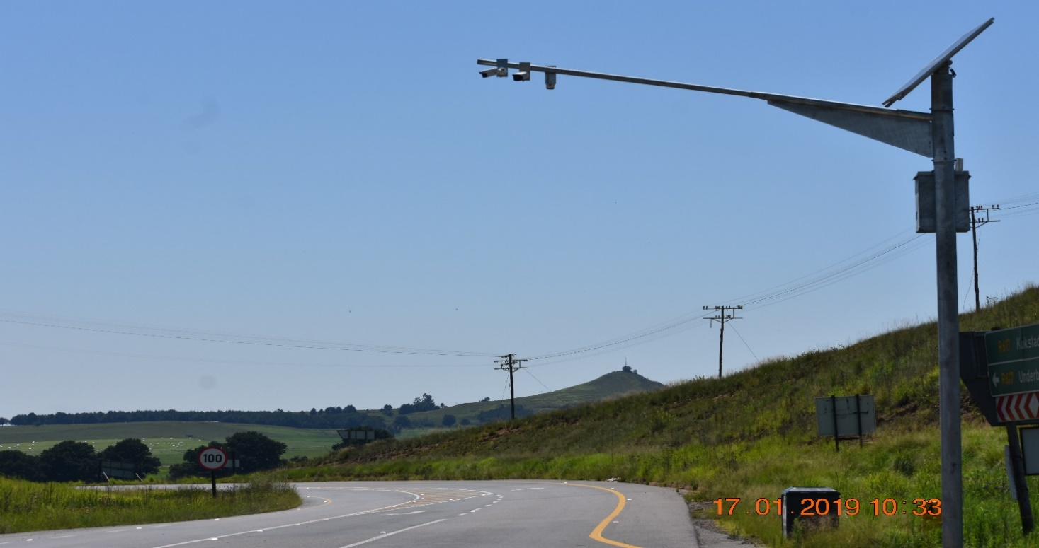Camera on R 617 from Underberg to Bulwer
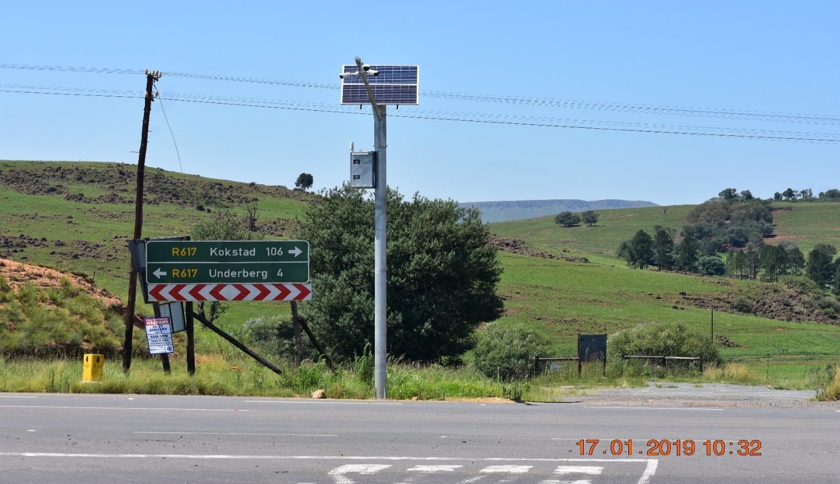Camera on R 617 from Underberg towards Kokstad
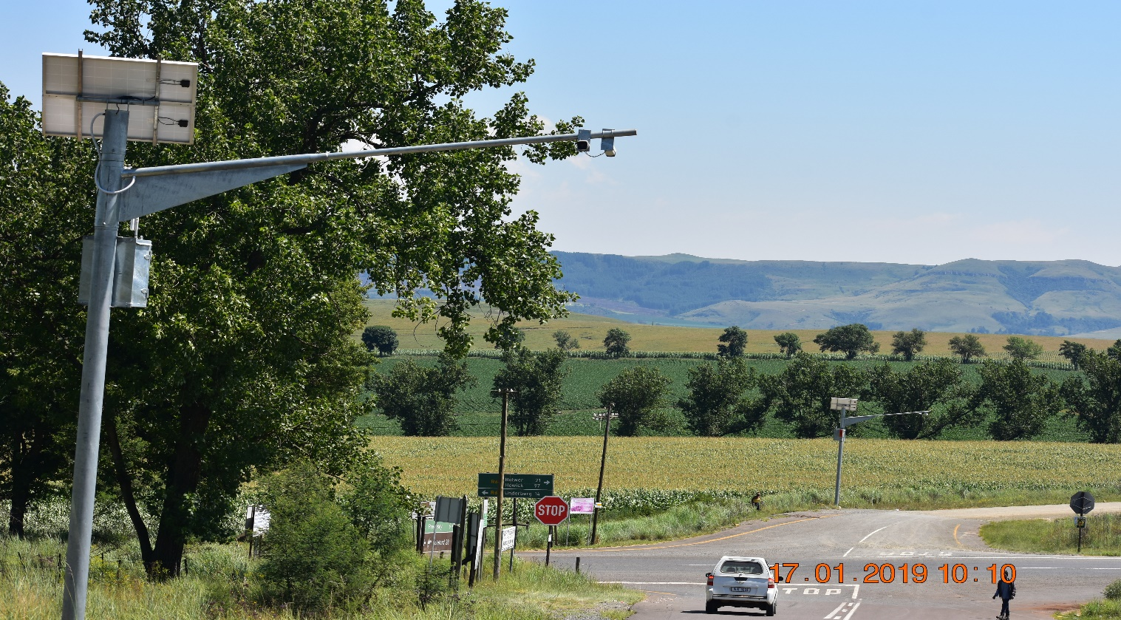Camera Coleford intersection on R 617
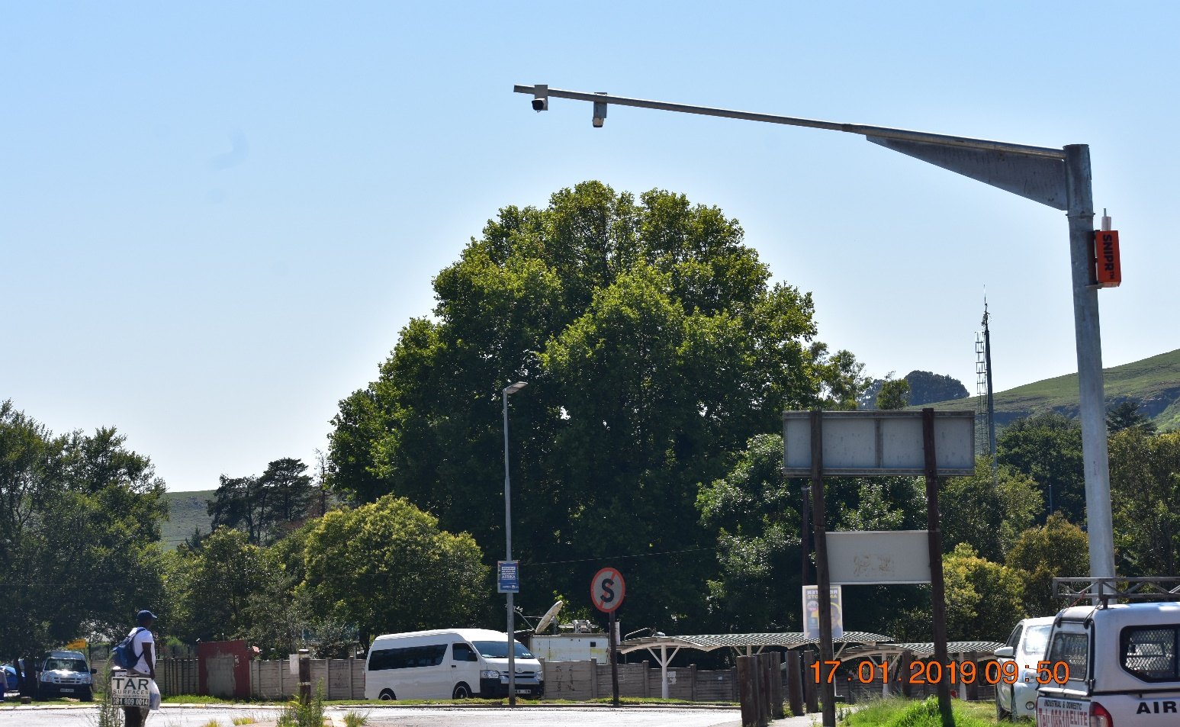Camera in the middle of town in Underberg

ANIMAL POUNDS
The municipality has got two animal pounds situated in its area of jurisdiction, namely
- Himevile Pound
- Creighton Pound
Both pounds are operational and assist a lot to keep stray animals from the road where they can cause motor vehicle accidents and thus causing the mortality rate of MVAs to be high. The municipality is working very hard to keep animals away from the roads within its area of jurisdiction through different programmes that are in place such as:
- Integrated Community Safety Awareness Campaigns (ICSAC)
- Developed impounding policy
- Has procured a truck to be utilized to impound stray animals from the road and delivery is expected in June 2018
CRIME PREVENTION AND COMBAT
South African Police services as a leading agent, plays a very critical role in ensuring that crime prevention does take place and criminals found to be breaking the law are dealt with accordingly, assisted by all the other security companies within the area.
Himeville and Underberg are known as being tourist’s destinations and hence the issue of security to tourist is of high priority to the municipality. The presence of tourists boosts the local spin off, of the business sector.
It is therefore for this reason that, has seen the area installing the road cameras as part of a synergy amongst the stakeholders to deal with crime.
Crime statistics is shared amongst the security clusters to use the information to develop strategies to combat future crime elements.
Joint raids are conducted on regular basis wherein to deal with issues of illegal migrants, none compliance, identifying fugitives, identifying drugs dealings and other things. Such operation is done swiftly and bears wonderful fruits cause all agencies are in one place to deal with any eventualities that may arise.
MULTI STAKEHOLDER ROAD BLOCKS
As part of combating crime, the Municipal Traffic Police, South African Police Services, RTI, Hlokomela and other agencies conduct road blocks wherein road unworthy vehicles are removed on the roads. Road blocks also assist in many ways in terms of identifying criminals that are a danger to society, including people that transport drugs, counterfeit goods e.t.c.
The municipality has even gone an extra mile to put such road blocks in its Service delivery Budgetary Implementation Plan as way to monitor and evaluate its implementation.
There are local road blocks conducted and over above that, there are also multisectoral integrated road blocks that are held on regular basis in different strategic areas.
Such operations are very fruitful on the basis that, the occurrence of big accidents is declining as compared to the past.
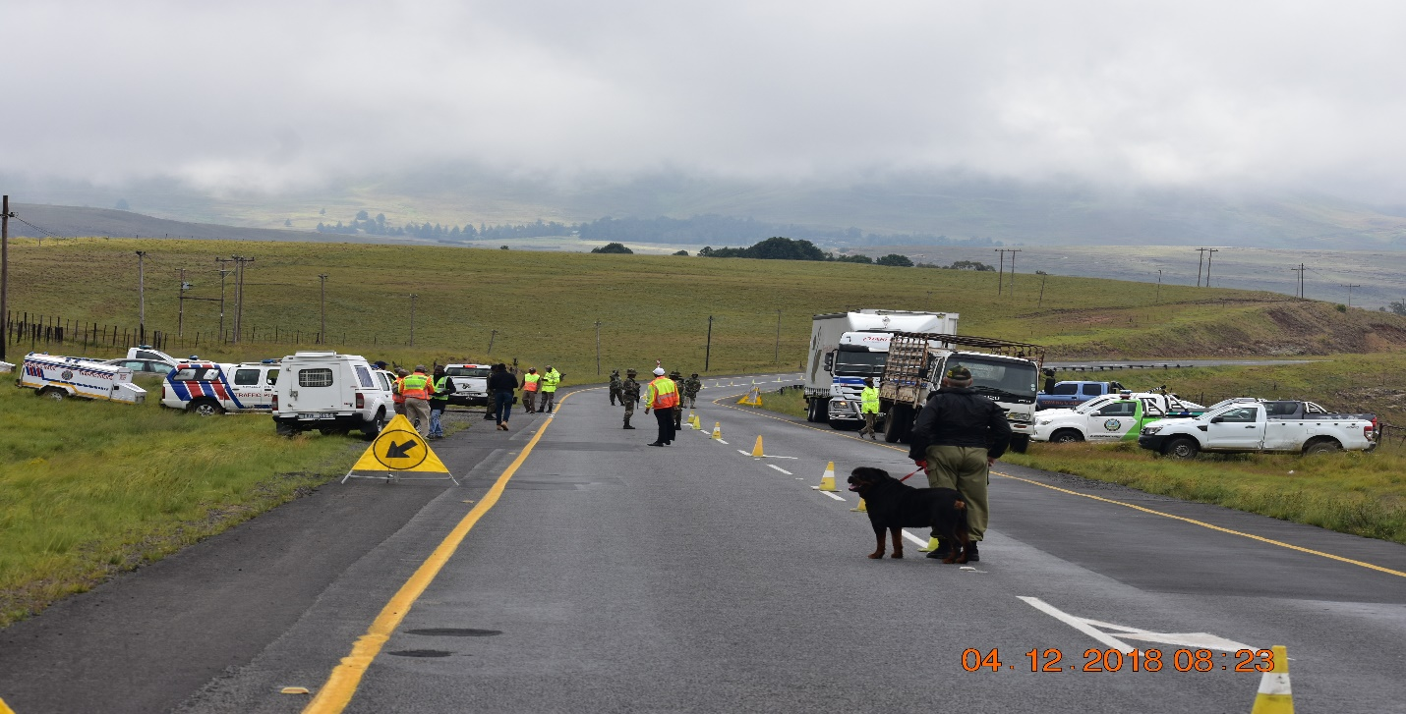
Multi-stakeholder Road Block held at Evatt in R 617 to Kokstad on the 04 December 2018
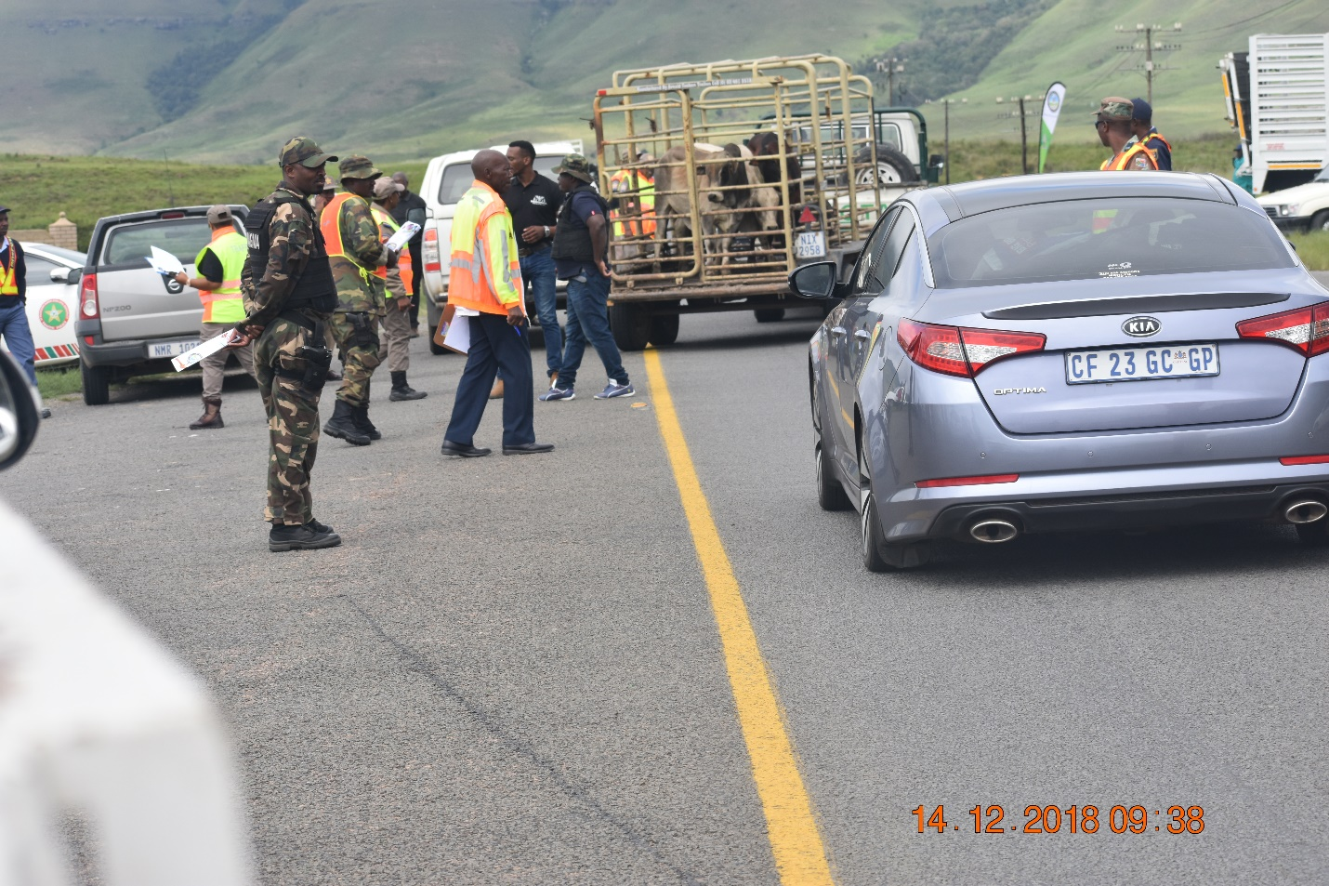
Multi-stakeholder roadblock held on the 14 December 2018 on R617 in Bulwer
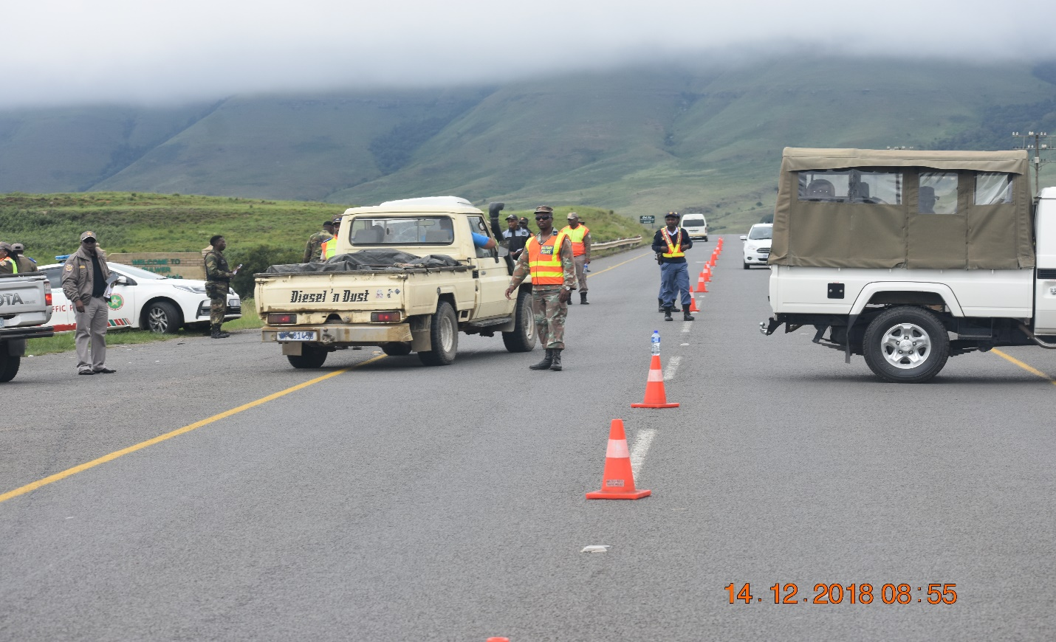
Multi-stakeholder Road Block in Bulwer
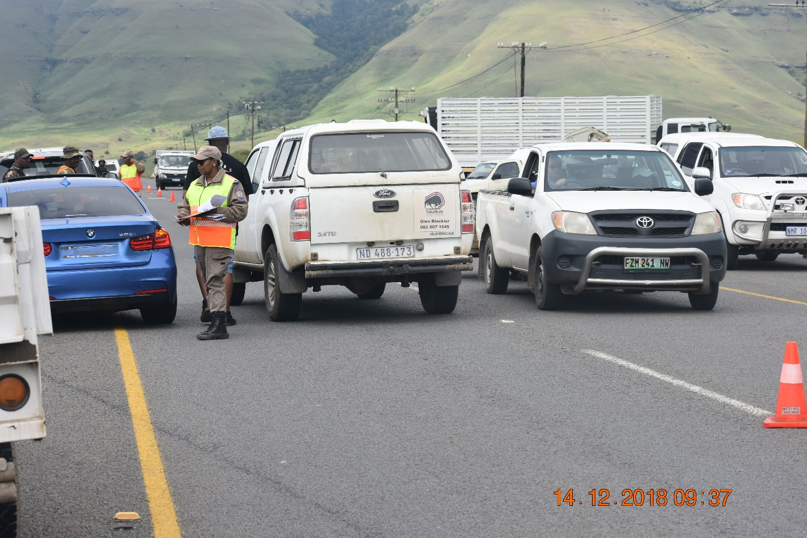Proceedings of the Road Block
CLEARING OF BUSHES AND CONDUCTING FIRE BREAKS
The municipality has got wonderful bylaws that, encourage residents of Dr. Nkosazana Dlamini Zuma that own vacant properties to clear their properties and make sure that are clean all the time, failing which the municipality clears such properties and bill the owners.
Furthermore, the municipality works very closely with Working on Fire and Fire Protection Associations to do fire breaks and remove alien plants.
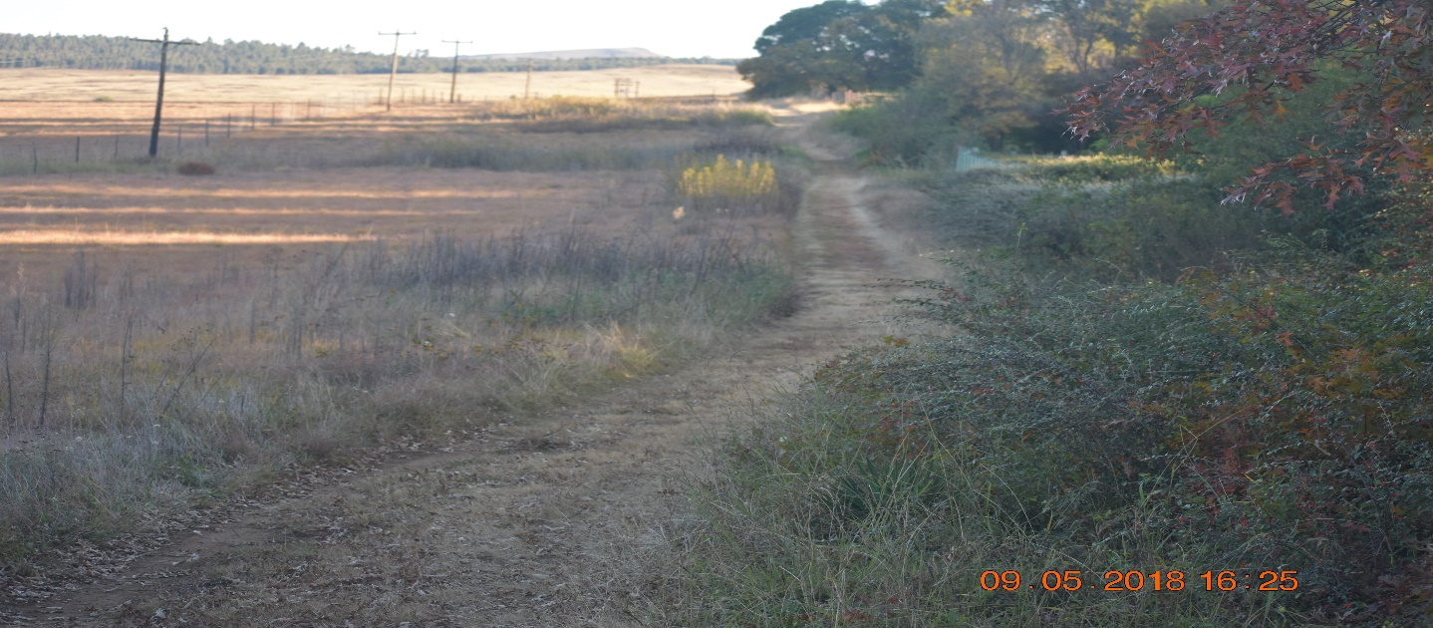
Fire break to prevent fires from accessing residential areas
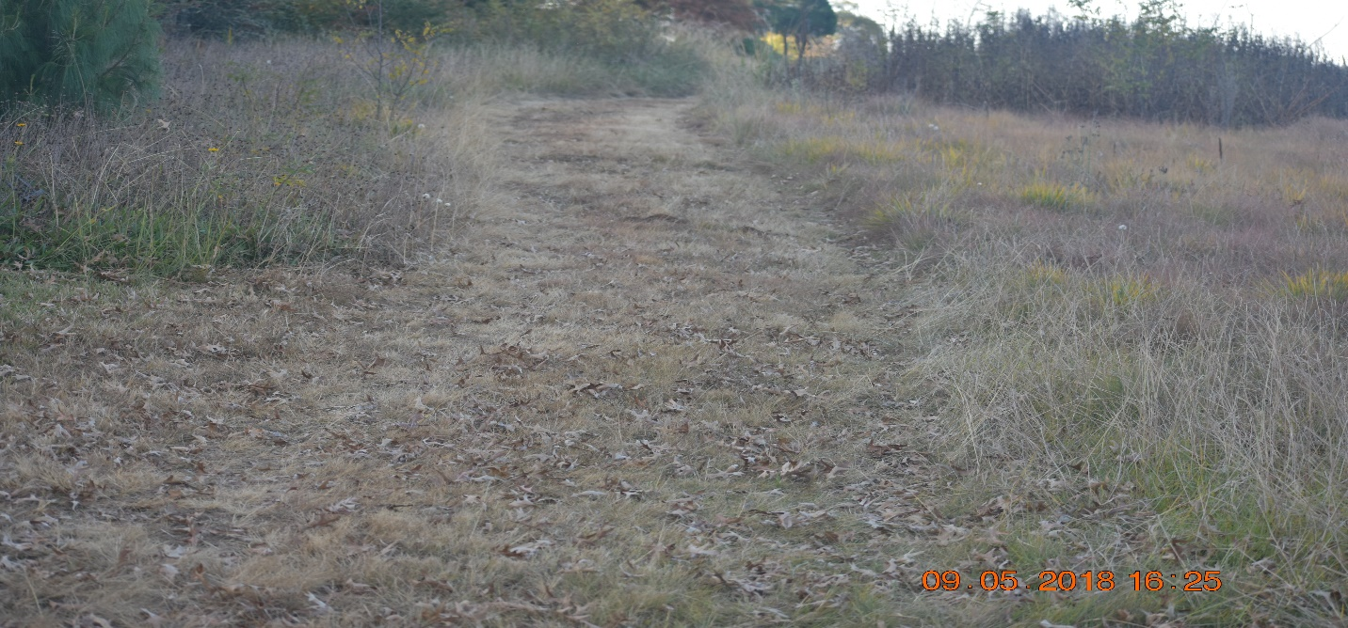
Zoomed picture of a fire break
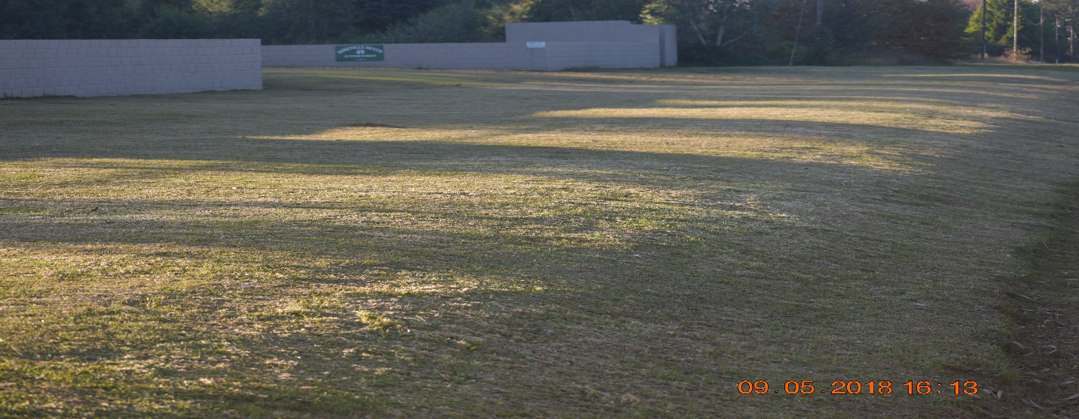
Picture showing how vacant properties are maintained
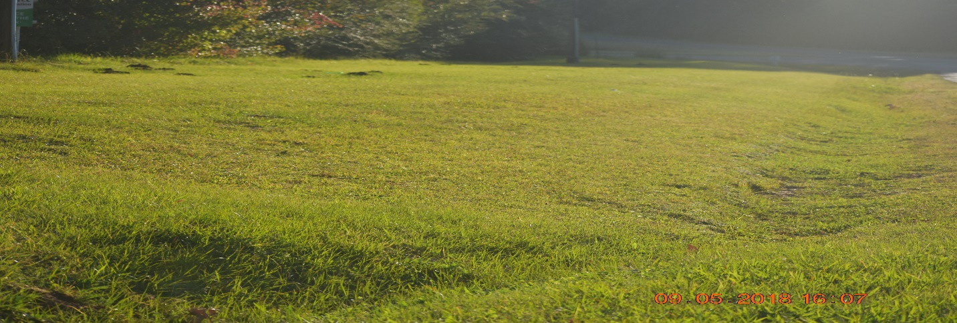
Another picture showing a maintained vacant property
2.5.2 KEY PERFORMANCE INDICATOR
- Safer Communities
- Reduced Crime
- Reduced Motor Vehicle Accidents
- Reduced Structural and veld Fires
- Reduced Road Unworthy Vehicles
- Reduced bushes both in residential places and in town

- KEY PERFORMANCE AREA 2
  - DISASTER RISK ASSESSMENT
The disaster risk assessment for Dr. Nkosazana Dlamini Zuma was conducted from the 20th, 22nd and 23rd of March 2018 wherein all ward committee members and councilors were invited to participate. It was a very fruitful exercise.
The risk profile for the municipality is therefore as follows:
LEGEND
Extremely High Hazard
High Hazard
Moderate Hazard
Low hazard

WARD NO | PRIORITY HAZARDS | LEGEND INDEX | LEGEND DESCRIPTION | NUMBER OF HALLS | NUMBER OF SCHOOLS
1 | Storms |  | Extremely High | 7 | 13
 | Heavy Rain |  | Moderate
 | Lightning |  | High
 | Floods |  | High
 | Fierce Wind |  | High
 | Snow |  | High
 | Crime |  | Moderate
 | Structural Fires |  | High
 | Veld Fires |  | Extremely High
 | Drought |  | Low
 | Hail Storm |  | Moderate
 | Road Accidents |  | Moderate
2 | Storms |  | Extremely High | 4 | 8
 | Heavy Rain |  | Moderate
 | Snow |  | Extremely High
 | Structural Fires |  | Moderate
 | Lightning |  | Moderate
 | Veld Fires |  | Moderate
 | Fierce winds |  | High
 | Crime |  | Moderate
 | Drought |  | Low
 | Road Accidents |  | High
 | Floods |  | High
 | Hail storm |  | Moderate
3 | Storms |  | Extremely High | 0 | 3
 | Fierce Winds |  | High
 | Crime |  | Moderate
 | Road Accidents |  | High
 | Structural Fires |  | High
 | Snow |  | Extremely High
 | Floods |  | High
 | Heavy Rain |  | Moderate
 | Hail Storm |  | Moderate
 | Veld Fires |  | Moderate
 | Lightning |  | Moderate
 | Drought |  | Low

WARD NO | PRIORITY HAZARDS | LEGEND INDEX | LEGEND DESCRIPTION | NUMBER OF HALLS | NUMBER OF SCHOOLS
4 | Storms |  | High | 4 | 8
 | Floods |  | Moderate
 | Heavy Rain |  | Moderate
 | Hail Storm |  | Moderate
 | Road Accidents |  | Low
 | Structural Fires |  | Moderate
 | Snow |  | Extremely High
 | Veld Fires |  | Moderate
 | Lightning |  | High
 | Fierce Winds |  | High
 | Drought |  | Moderate
5 | Storms |  | High | 4 | 5
 | Floods |  | Moderate
 | Fierce Winds |  | High
 | Hail Storm |  | High
 | Road Accidents |  | Low
 | Structural Fires |  | Moderate
 | Snow |  | Moderate
 | Veld Fires |  | High
 | Lightning |  | High
 | Heavy Rain |  | High
 | Drought |  | Moderate
6 | Storms |  | High | 6 | 9
 | Floods |  | Moderate
 | Fierce wind |  | High
 | Hail Storms |  | High
 | Road Accidents |  | Low
 | Structural Fires |  | Moderate
 | Snow |  | Moderate
 | Veld Fires |  | High
 | Lightning |  | High
 | Heavy Rain |  | High
 | Drought |  | Moderate

WARD NO | PRIORITY HAZARD | LEGEND INDEX | LEGEND DESCRIPTION | NUMBER OF HALLS | NUMBER OF SCHOOLS
7 | Storms |  | High | 3 | 7
 | Floods |  | Moderate
 | Fierce Wind |  | High
 | Hail Storms |  | High
 | Road Accidents |  | Low
 | Structural Fires |  | Moderate
 | Snow |  | Moderate
 | Veld Fires |  | High
 | Lightning |  | High
 | Heavy rain |  | High
 | Drought |  | Low
8 | Storms |  | High | 4 | 8
 | Floods |  | Low
 | Fierce Wind |  | High
 | Hail Storm |  | Low
 | Road Accidents |  | Low
 | Structural Fires |  | Moderate
 | Snow |  | Moderate
 | Veld Fires |  | Extremely High
 | Lightning |  | High
 | Heavy Rain |  | Moderate
 | Drought |  | High
9 | Storms |  | High | 2 | 2
 | Floods |  | Moderate
 | Fierce Wind |  | High
 | Hail Storm |  | High
 | Road Accidents |  | High
 | Structural Fires |  | Moderate
 | Snow |  | Moderate
 | Veld Fires |  | Moderate
 | Lightning |  | High
 | Heavy Rain |  | High
 | Drought |  | Moderate

WARD NO | PRIORITY HAZARD | LEGEND INDEX | LEGEND DESCRIPTION | NUMBER OF HALLS | NUMBER OF SCHOOLS
10 | Storms |  | High | 4 | 10
 | Floods |  | High
 | Fierce Wind |  | High
 | Hail Storm |  | Moderate
 | Road Accidents |  | Extremely High
 | Structural Fires |  | High
 | Snow |  | Moderate
 | Veld Fires |  | High
 | Lightning |  | Moderate
 | Heavy Rain |  | High
 | Drought |  | Moderate
11 | Storms |  | Moderate | 6 | 11
 | Floods |  | Moderate
 | Fierce Wind |  | Moderate
 | Hail Storm |  | High
 | Road Accidents |  | High
 | Structural Fires |  | Moderate
 | Snow |  | High
 | Veld Fires |  | Moderate
 | Lightning |  | Moderate
 | Heavy Rain |  | High
 | Drought |  | Low
12 | Storms |  | High | 5 | 10
 | Floods |  | Moderate
 | Fierce Wind |  | Extremely High
 | Hail Storm |  | High
 | Road Accidents |  | Moderate
 | Structural Fires |  | Moderate
 | Snow |  | Low
 | Veld Fires |  | Extremely High
 | Lightning |  | High
 | Heavy Rain |  | Moderate
 | Drought |  | Moderate

WARD NO | PRIORITY HAZARD | LEGEND INDEX | LEGEND DESRIPTION | NUMBER OF HALLS | NUMBER OF SCHOOLS
13 | Storms |  | High | 3 | 6
 | Floods |  | Moderate
 | Fierce Wind |  | Moderate
 | Road Accidents |  | Moderate
 | Structural Fires |  | Moderate
 | Snow |  | Moderate
 | Veld Fires |  | Extremely High
 | Lightning |  | High
 | Heavy Rain |  | High
 | Drought |  | Low
 | Hail Storm |  | Moderate
14 | Storms |  | Moderate | 4 | 8
 | Floods |  | Low
 | Fierce Wind |  | Moderate
 | Road Accidents |  | Low
 | Structural Fires |  | Moderate
 | Snow |  | Moderate
 | Hail Storm |  | Moderate
 | Veld Fires |  | High
 | Lightning |  | Moderate
 | Heavy Rain |  | Moderate
 | Drought |  | High
 | Fuel Explosion |  | High
15 | Storms |  | High | 4 | 10
 | Floods |  | Moderate
 | Fierce Wind |  | Extremely High
 | Road Accidents |  | Low
 | Structural Fires |  | High
 | Snow |  | Low
 | Veld Fires |  | Extremely High
 | Lightning |  | High
 | Heavy Rain |  | High
 | Drought |  | Moderate
 | Hail Storm |  | Moderate

MAPPING OF DISASTER RISKS
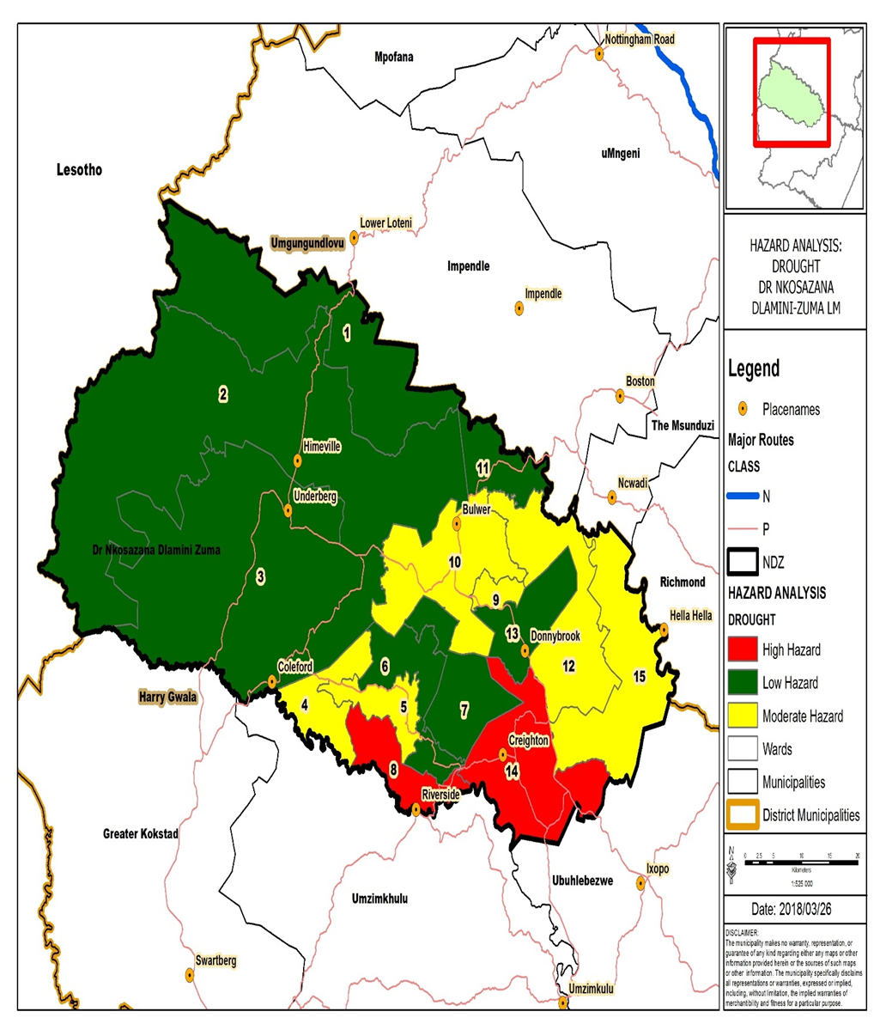

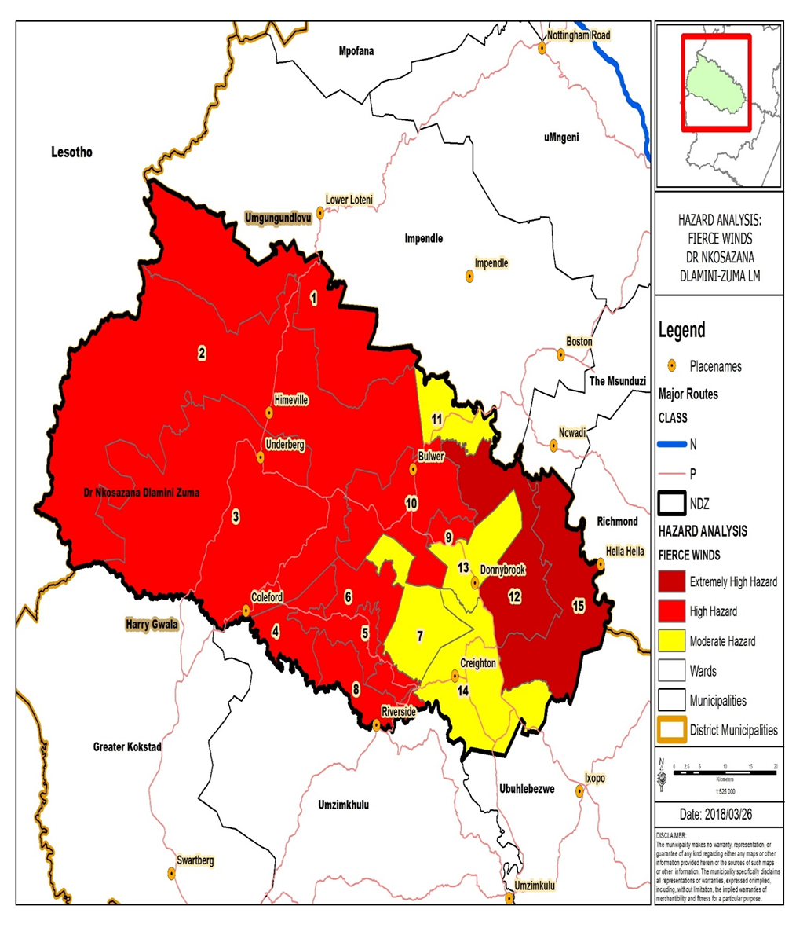

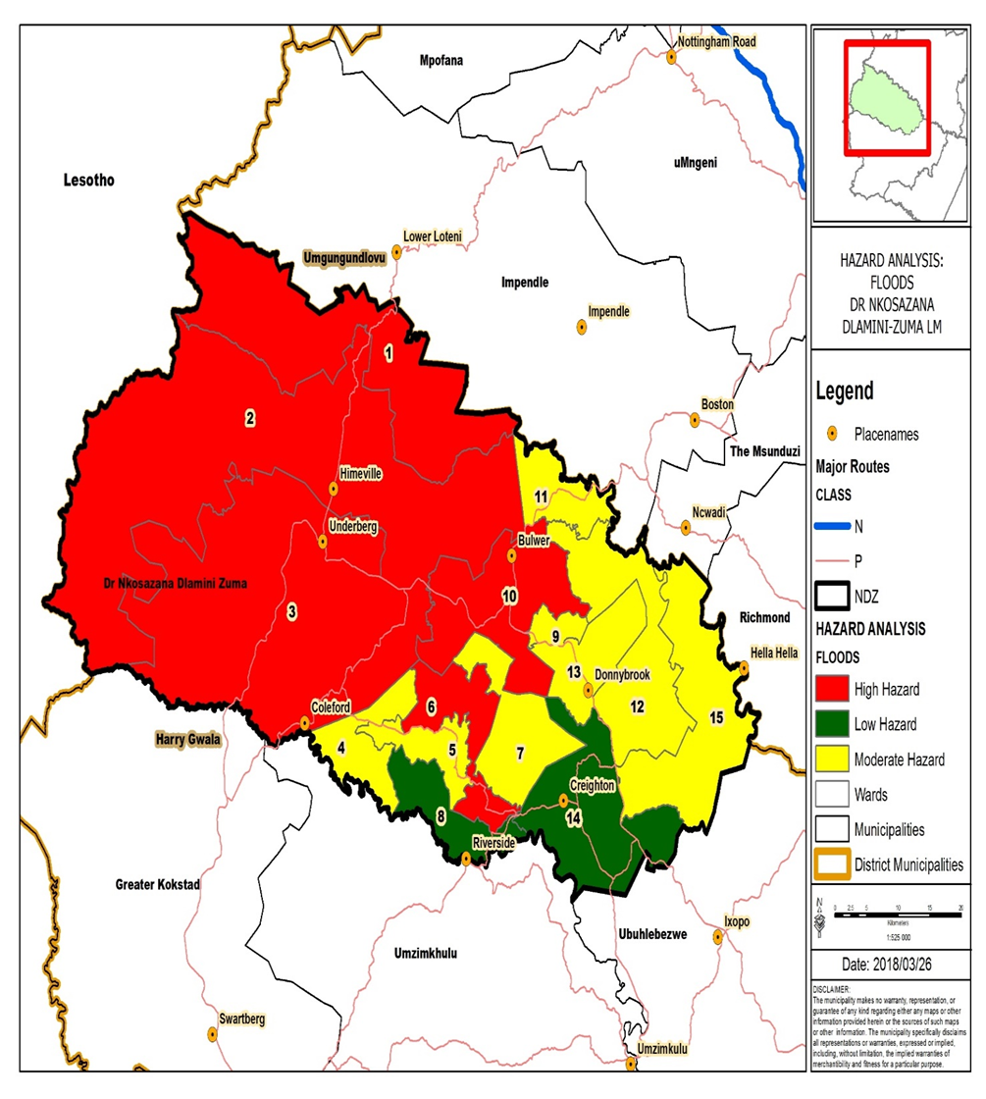

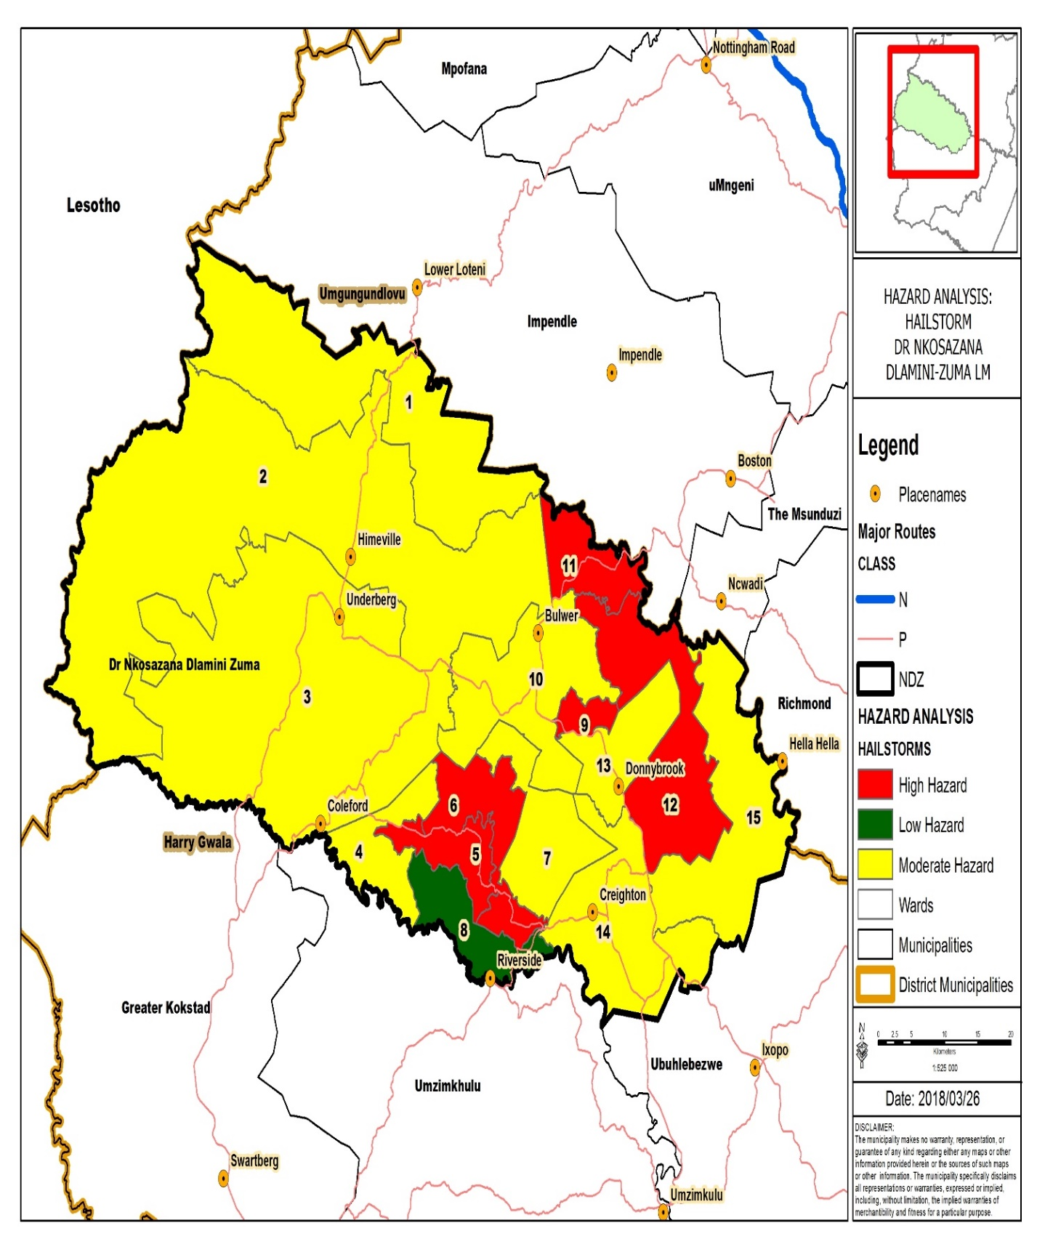

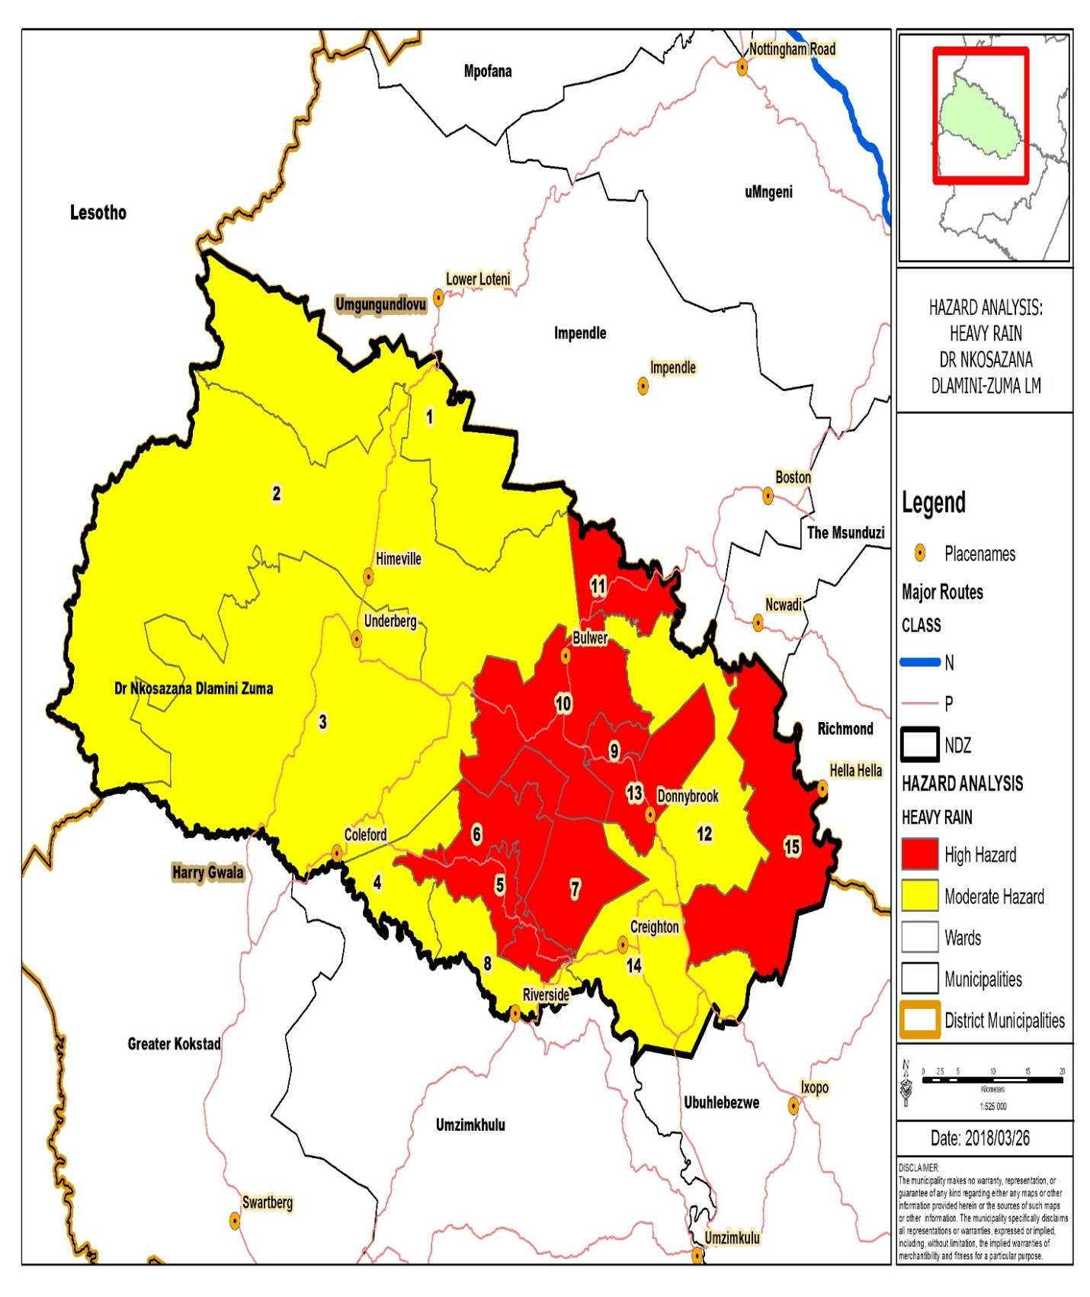

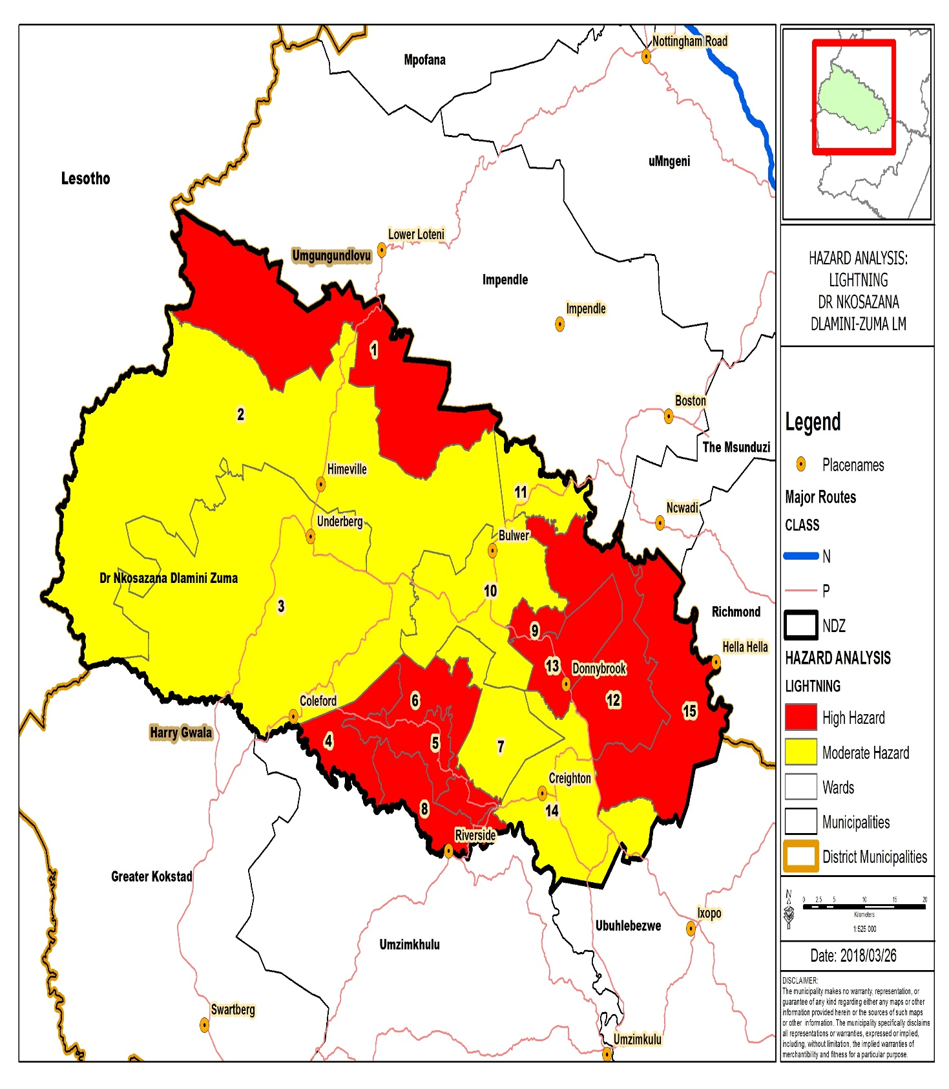

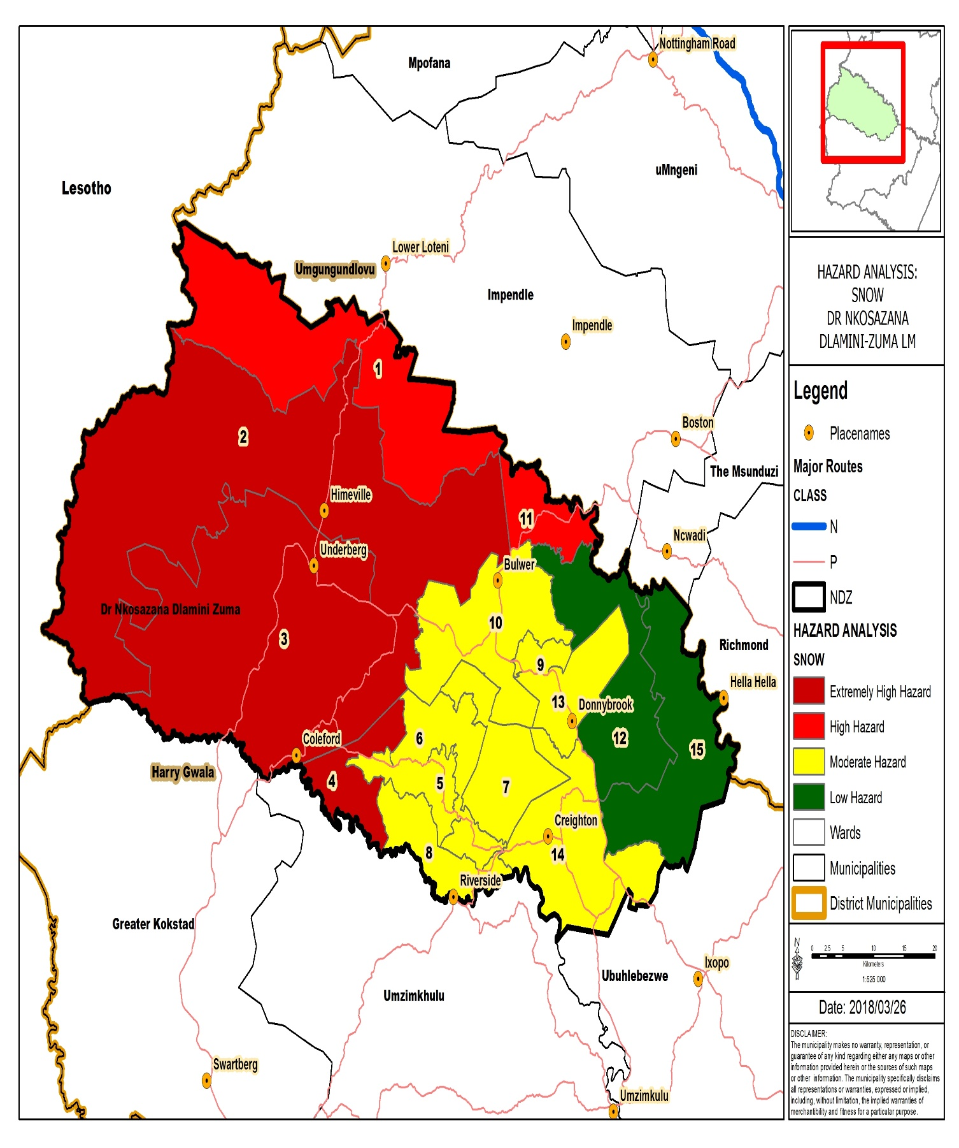

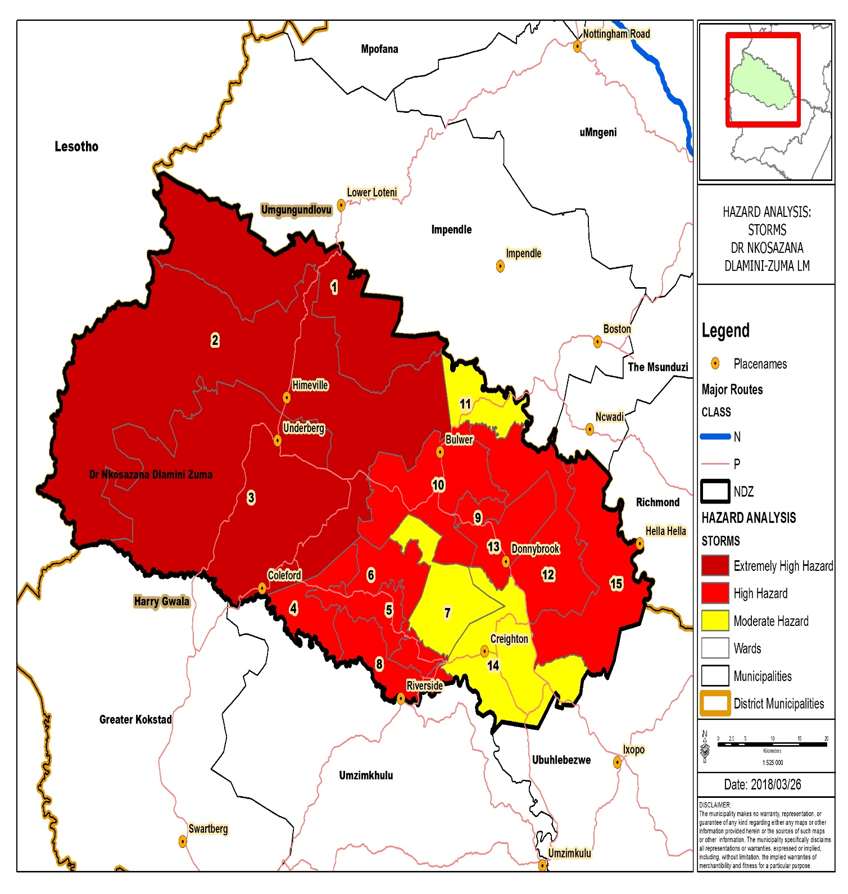

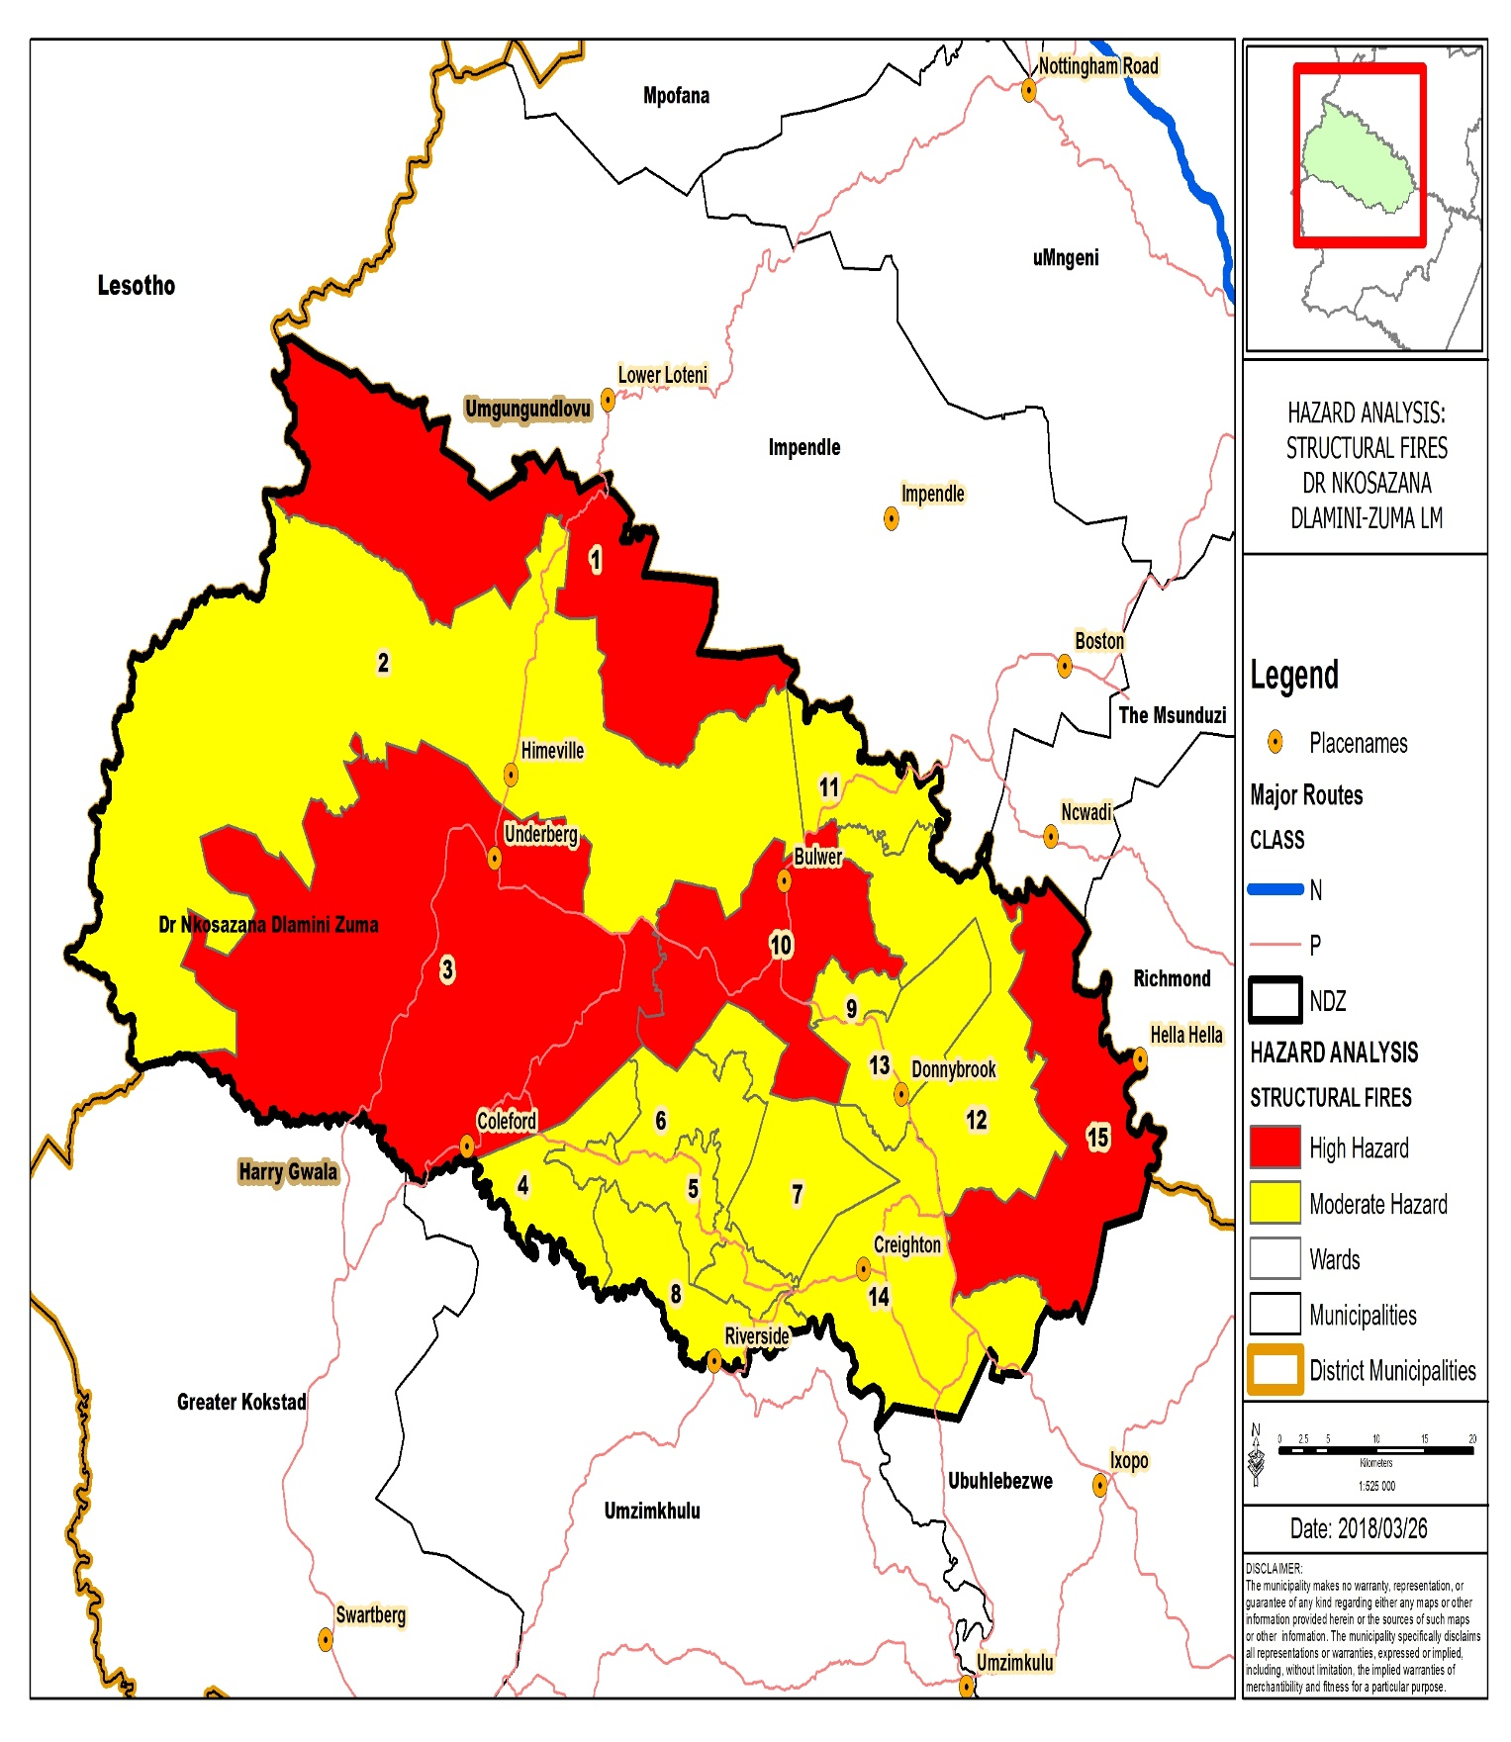

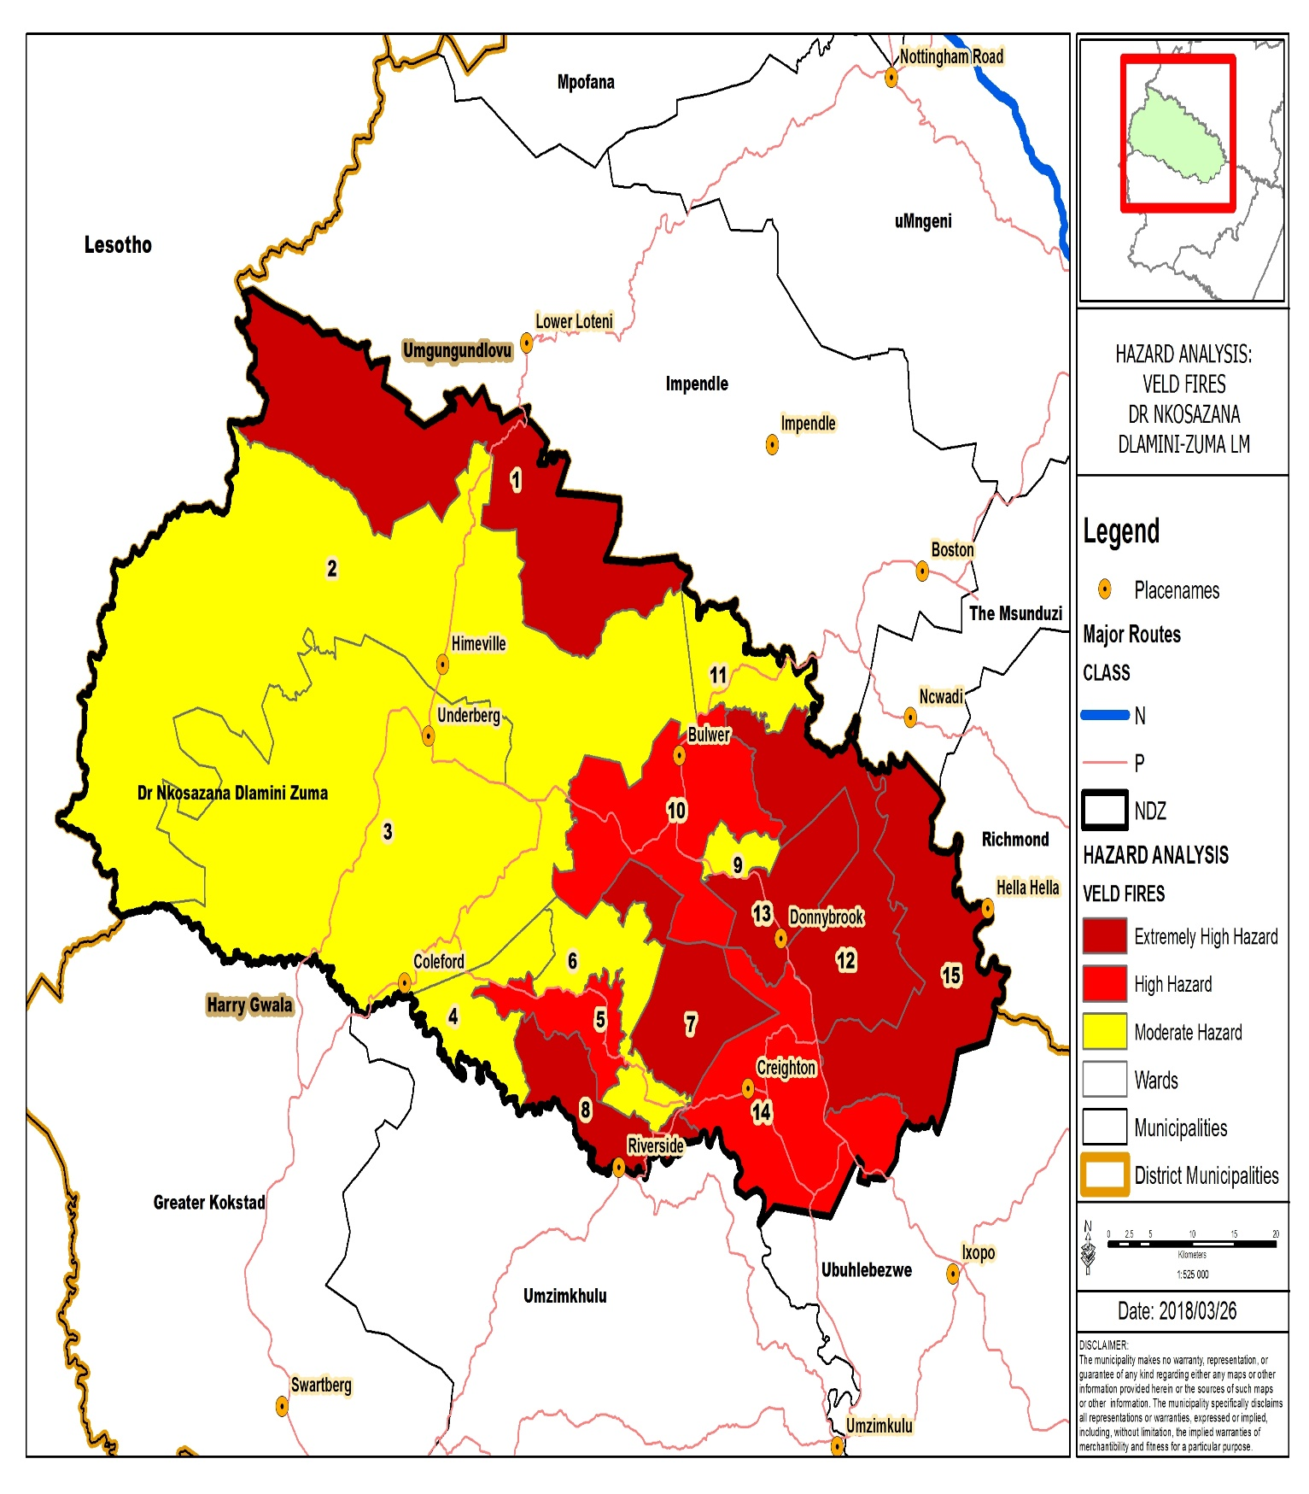

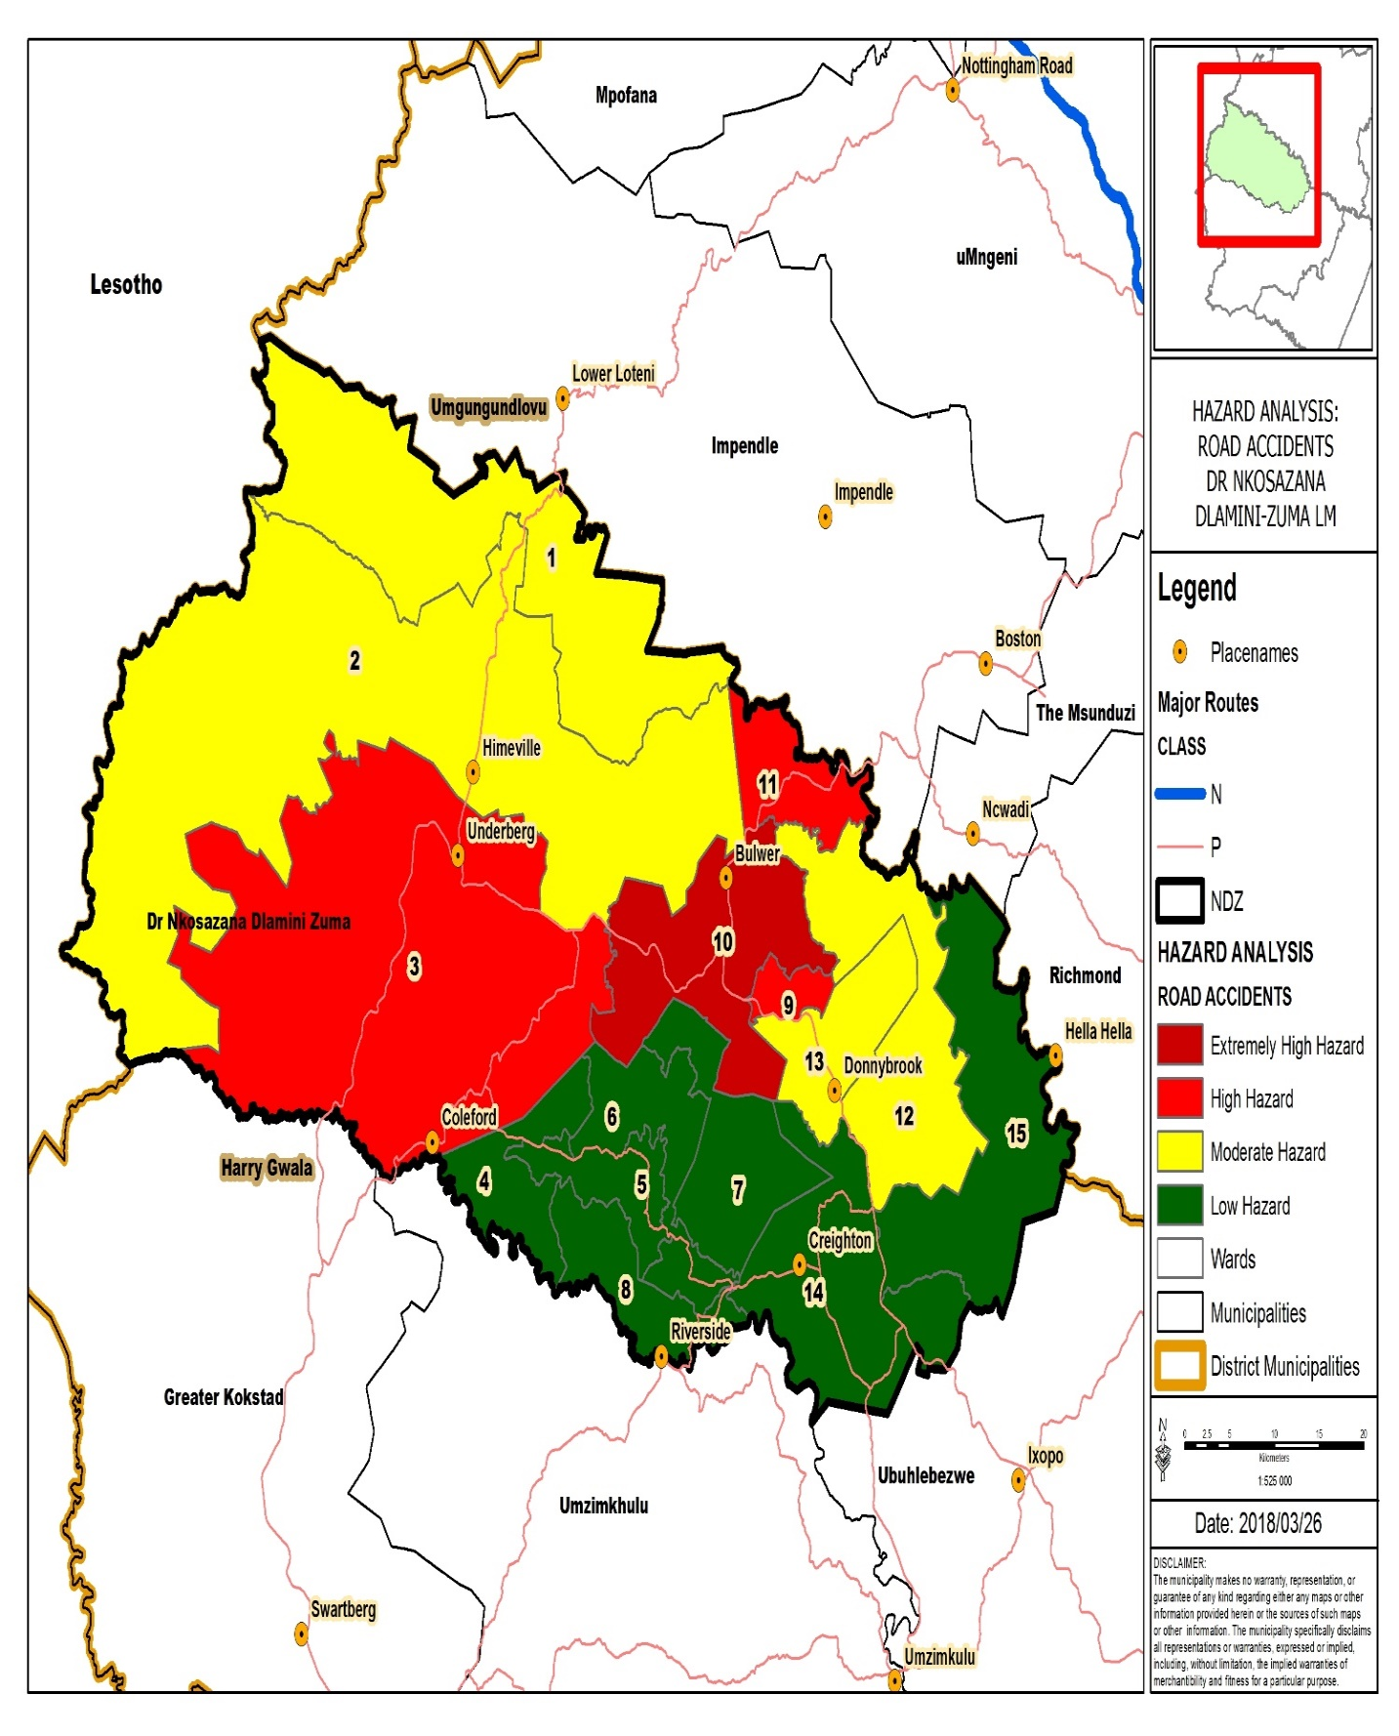

3.2 DISASTER MANAGEMENT PLACES OF SAFETY (SOCIAL FACILITIES, HALLS AND SCHOOLS)
During the risk assessment the municipality also identified the number of halls and schools available in each ward that can be utilized as places of safety should a need arise wherein major disaster incidents and/ or disasters warrant that; residents or victims of such disasters can be evacuated to ensure their safety. Such halls and schools can be utilized to accommodate residents for a duration that will be determined by the disaster management officials, acting in conjunction with the Joint Operations Centre and management.
3.3 DISASTER INCIDENT MAPPING
The municipality will be soon, be starting with the mapping of disaster incidents, as part of ensuring that, every incident that occur GPS coordinates are taken to indicate a historical occurrence of such an event.
Such incident mapping will be very useful in the future on the basis that, risk assessment will be informed by historical recorded and reliable data, which shall pin point exactly where the incidents occurred specifically.
A GPS unit was procured for the sole purpose to map incidents mapping, one should also acknowledge the Geographical Information Systems (GIS) unit, at COGTA for assisting with training on such incident mapping. In the financial year 2019/ 2020, more GPS gadgets will be procured to ensure that each official/ group of officials conducting disaster assessment do have one.
The Disaster Management and Fire Fighters personnel will be trained on how to utilize the GPS unit and all of them are expected to utilize it. This makes it easier whenever an incident has occurred on the basis that such data is collected on site, immediately, and such is thereafter captured into the system in terms of filling the beneficiary list which is later submitted to the district municipality and thereafter to the provincial disaster management center (COGTA).
3.4. KEY PERFORMANCE INDICATORS
- Disaster Risk Profile in place
- Disaster Risk profile spatial Mapping
- Disaster Management Places of Safety Identified
- Disaster Incident Mapping to be done as soon as a Geographical Information System Officer is employed

- KEY PERFORMANCE AREA 3
4.1 DISASTER RISK REDUCTION
Dr. Nkosazana Dlamini Zuma Municipality takes the issue of disaster risk reduction very seriously, and this is evident in terms of the development that takes place in the municipality. In ward 6 the municipality has erected a pedestrian bridge to prevent the community from being washed away by floods in summer in case they are realized.
Such bridge also assists scholars when they go to school to easily cross the river without wetting themselves in the river.
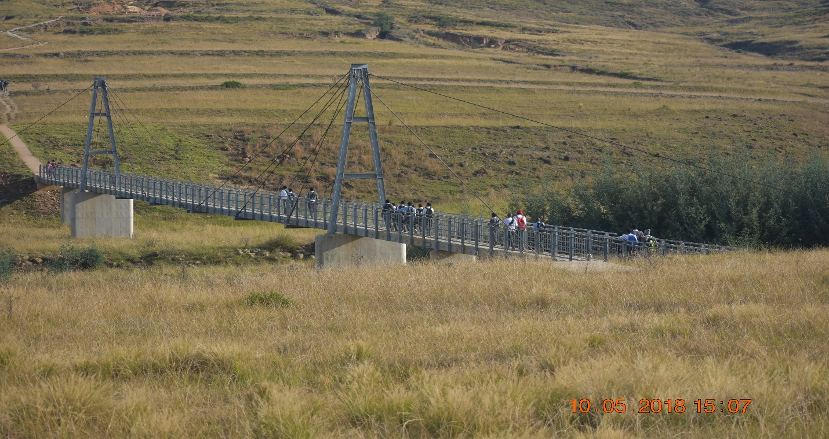
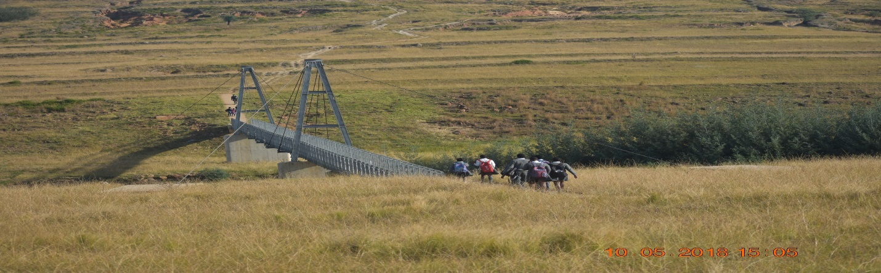Pedestrian Bridge in Dr. Nkosazana Dlamini Zuma Municipality
MAJOR HAZARD INSTALLATION
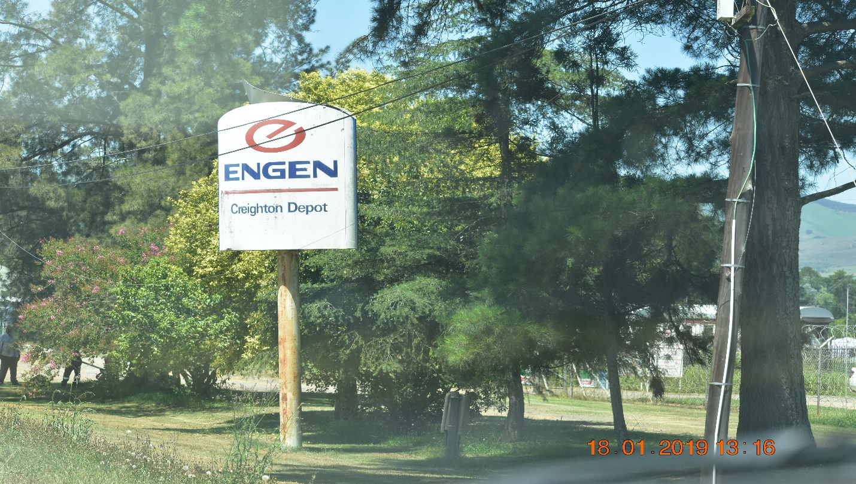
Creighton Engen Depot
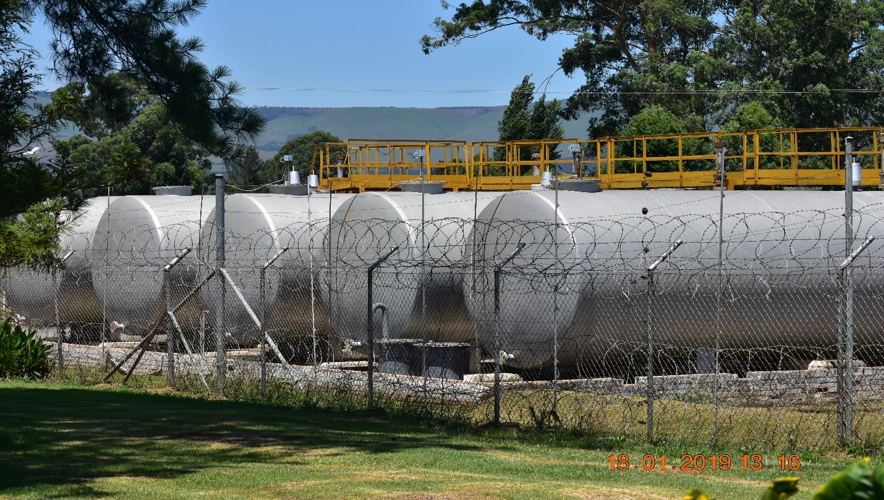
Creighton Engen Depot
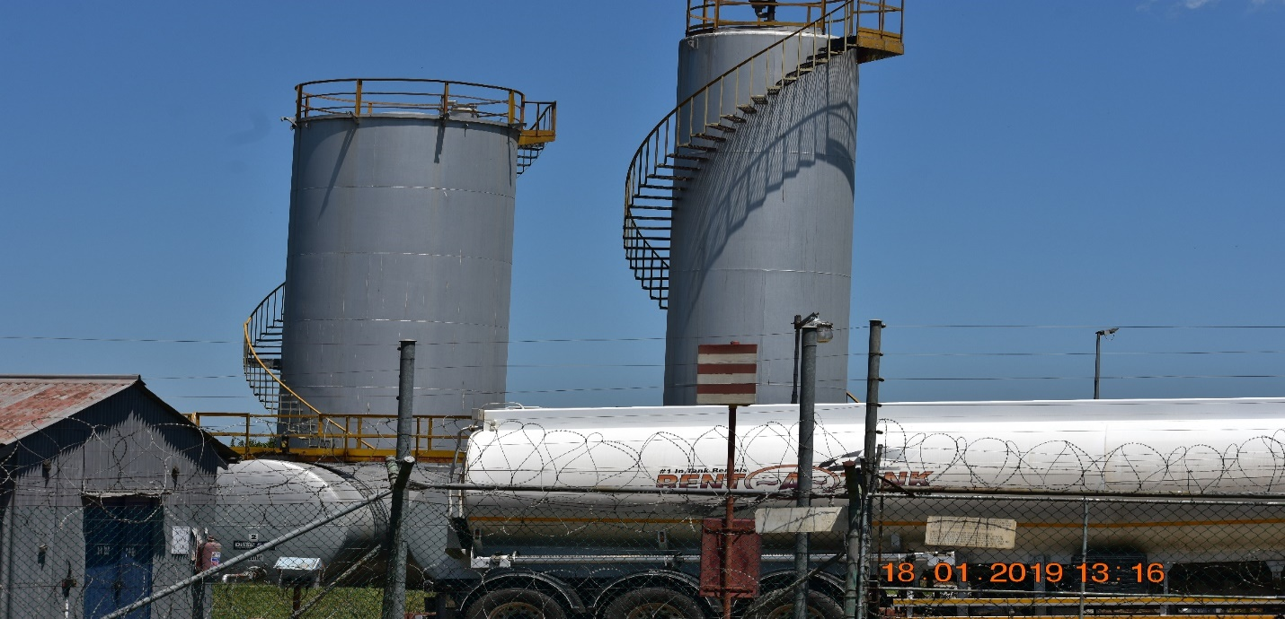
Creighton Engen Depot
In Creighton, there is an Engen depot which is classified as a Major Hazard Installation, in line with the major hazard installations regulations. The risk assessment for the facility was conducted in 2017 and hence it is valid for a period of five (5) years from the 06 October 2017.
The depot consists of the following tanks utilized to store fuel:
Tank Farm A
- Tank 1 – 82 m cube horizontal diesel tank
- Tank 2 – 82 m cube horizontal diesel tank
- Tank 3 – 82 m cube horizontal paraffin tank
- Tank 5 – 203 m cube vertical diesel tank
- Tank 6 – 82 m cube vertical diesel tank
Tank Farm B
- Tank 1116 – 82 m cube horizontal 95 ULP tank
- Tank 899 – 82 m cube horizontal 95 ULP tank
- Tank 869 – 82 m cube horizontal diesel tank
- Tank 868 – 82 m cube horizontal diesel tank
- Tank 867 – 82 m cube horizontal diesel tank
CATAGORIZATION OF MATERIALS ON SITE AS PER SANS 10228:2003 CLASSES OF DANGEROUS SUBSTANCES

CLASS | DESCRIPTION
1 | Explosives (Not included in MHI Regulations)
2 | Gases (Flammable or Toxic Gases only)
3 | Flammable Liquids
4 | Flammable solids
5 | Oxidizing substances and Peroxides
6 | Toxic and Infectious substances
7 | Radioactive material (Not included in MHI Regulations)
8 | Corrosives
9 | Combustible Materials

As part of compliance with the major hazard installation regulations, Creighton Engen Depot submitted to the municipality a risk assessment document outlining the risks involved on the site. Furthermore, the document contains risk prevention and mitigation strategies and outlines the procedure to be followed when during an emergency.

DISASTER RISK REDUCTION PROJECTS
NO | NAME OF HAZARD | DISASTER RISK REDUCTION PROJECTS | STAKEHOLDER
1 | FLOODS | Enforcement of legislation to ensure building of houses in accordance to building standards | NDZ Municipality
 |  | Construction of dams | HGDM Municipality
 |  | Ongoing awareness campaigns conducted | All
 |  | Always improving early warning systems and cascading thereof | Weather Services and municipalities
 |  | Construction of high standard bridges with long life spans | NDZ and Public Works, Dept of Transport
2 | FIRE | Procurement of a fully equipped fire truck | NDZ
 |  | Procurement of Fire beaters and knapsack tanks | NDZ
 |  | Continuous burning of fire breaks | NDZ
 |  | Procure and recruit state of the art fire equipment and personnel respectively to enhance fire fighting | NDZ
 |  | Conduct fire safety inspections | NDZ
 |  | Identify site to construct fire station | NDZ
 |  | Construction of fire station | NDZ
 |  | Promote partnership with forestry companies such as mondi and sappi | NDZ
3 | LIGHTNING | Procurement and Installation of lightning conductors | NDZ
 |  | Continuous awareness campaigns | NDZ, District
 |  | Distribution of early warning systems | Weather services and NDZ, COGTA and District
4 | STORMS | Distribution of early warning systems | Weather services and NDZ, COGTA and District
 |  | Ongoing awareness campaigns | NDZ
5 | SNOW | Early warning | Weather services and NDZ, COGTA and District
 |  | Putting snow protocol contingency plans into place | NDZ
 |  | Grading of snow from the roads and surrounding areas | Department of transport
6 | Motor Vehicle Accidents | Improve road maintenance and upgrading | NDZ and dept of transport
 |  | Improve law enforcement and visibility of traffic police on the roads | NDZ, RTI and SAPS
 |  | Continuous awareness campaigns | NDZ, RTI
7 | Drought | Conduct ongoing awareness campaigns | NDZ
 |  | Promote water harvesting and assist with water tanks where possible | NDZ, district and Human Settlement
8 | Fierce Winds | Promote planting of trees as wind breakers | NDZ
 |  | Awareness Campaigns | NDZ
 |  | Promote building of houses in accordance with building standards | NDZ
9 | Hail Storms | Awareness Campaigns conducted continuously | NDZ

4.2 KEY PERFORMANCE INDICATORS
- Disaster Risk Reduction Projects and Programmes put in place and implemented.
Below is a template showing the budget for Dr. NDZ municipality to implement disaster management in terms of the fiscal year 2019/2020.
DR NDZ MUNICIPALITY BUDGET FOR DISASTER MANAGEMENT 2019/2020
IDP NO | PROJECT NAME | PROJECT DESCRIPTION | FUNDING SOURCE | Financial Year :2019/2020
 | Procurement of Fire Rescue Response Vehicle and Double cabs | 1 x Fire/ MVA Rescue Response Vehicle  1 x Double 4x4 to carry skid unit  1 x Double Cab for Traffic | INTERNAL | R 1, 700, 000.00
 | Integrated Community Safety Awareness Campaigns (ICSAC) | 4 ICSAC | INTERNAL | R 50, 000.00
 | Ensuring sustainability of the Disaster Management Advisory Forum (DMAF) | 4 DMAF | INTERNAL | R 10, 000.00
 | Construction of Fire Station | Construction of Fire Station | INTERNAL | R 3, 000 000.00
 | Procurement of Fire beaters and Knapsack tanks | Procurement of 70 Fire beaters and 10 knapsack Tanks | INTERNAL | R 86, 960.00
 | Disaster Relief Provision (Indigent) | Procurement of 100 blankets and 50 sponges | INTERNAL | R 151, 054.00
 | fire safety inspections | 60 fire safety inspections conducted | INTERNAL | Operational
 | Jaws of Life | 1 x set of Heavy-Duty Jaws of Life | INTERNAL | R 500, 000.00
 | Installation of lightning conductors | 5 lightning conductors procured and installed | INTERNAL | R 79, 200.00
 | Self-Contained Breathing Apparatus | 4 x sets of Self-Contained Breathing Apparatus | INTERNAL | R 65, 000.00

DR. NKOSAZANA DLAMINI ZUMA MUNICIPALITY’S SERVICE DELIVERY BUDGETORY IMPLEMENTATION PLAN 2019/2020
PROJECT NAME | KPA | KPI | BUDGET | TARGET AREAS | RESPONSIBLE STAKEHOLDER | DEADLINE
New Fire/ MVA Rescue Response Vehicle and Double Cabs | Procurement 1 x Fire/MVA Rescue Response Vehicle and 2 x Double cabs Fire & Traffic | Delivery of 3 vehicles | R 1, 700, 000 | All | NDZ- Disaster management | June 2020
New Lightning Conductors | Procurement and Installation of 5 lightning conductors | 15 Lightning Conductors Procured and Installed | R 79, 200.00 | High Risk Areas | NDZ- Disaster Management & Public Works- Basic Services | June 2020
Disaster Management Advisory Forums Meetings | Ensure Sustainability of the Disaster Management Advisory Forum | 4 Conducted Disaster Management Advisory Forum Meetings | R 10, 000.00 | All | All Stakeholders | June 2020
Disaster Relief | Procurement and Distribution of Disaster Relief | Procured and distributed relief to the needy | R 152, 054.00 | All | NDZ- Disaster Management | June 2020
Self-Contained Breathing Apparatus | Procurement of 4 sets of self- contained breathing apparatus | Delivery of 4 self- contained breathing apparatus | R 65, 000.00 | All | NDZ- Disaster Management | June 2020
Heavy Duty Jaws of Life | Procurement of 1 set of Heavy- Duty Jaws of Life | Delivery of 1 set of Heavy- Duty Jaws of Life | R 500, 000.00 | All | NDZ- Disaster Management | June 2020
Fire Beaters and Knapsack Tanks | Procurement and Distribution of 100 Fire Beaters and 20 Knapsack Tanks | 70 Fire beaters and 10 knapsack tanks procured and distributed | R 86, 960.00 | Fire High Risk | NDZ- Disaster management | June 2020
Establishment of a Fire Station | Phase 1 of project | Undertaking of Phase 1 of the project | R 3, 000 000.00 | All | NDZ- Disaster Management & Public Works and Basic Services | June 2020
Integrated Community Safety Awareness Campaigns | Conduct Integrated Community Safety Awareness Campaigns | 4 Integrated Community Safety Awareness Campaigns Conducted | R 50, 000.00 | All | All Stakeholders | June 2020
Fire Safety Inspections | Conduct fire safety inspections | 60 Fire Safety Inspections Conducted | R0 | All | NDZ- Fire department
GPS Unit | Procure GPS unit | 1 x GPS unit procured | R 14, 000. 00 | All | NDZ- Disaster Management | June 2020
DR. NKOSAZANA DLAMINI ZUMA MUNICIPALITY’S MUNICIPAL INFRASTRUCTURE GRANT PROJECTS IMPLEMENTED BY THE PUBLIC WORKS AND BASIC SERVICES DEPARTMENT IN THE MUNICIPALITY
PROJECT NAME |  |  | BUDGET- ENDING JUNE 2020 |  | RISK REDUCTION IMPACT
Solokohlo Community Hall |  |  | 2,000,000 |  | Can be utilized as an evacuation area
Himeville Business Hives |  |  | 2,000,000
Underberg Community Town Hall Phase 1 |  |  | 3,000,000 |  | Can be utilized as an evacuation area
Sdangeni Bridge Road |  |  | 2,199,000 |  | Crossover by both motorists and pedestrians
Mampondweni Access Road |  |  | 1,250,000 |  | Easy access to communities
Lookout Access Road |  |  | 1,200,000 |  | Easy access to communities
Gqumeni Creche |  |  | 1,275,000 |  | Can be utilized as an evacuation area
Magoso Access Road Phase 2 |  |  | 1,800,000 |  | Easy access to communities
Khumalo Access Road |  |  | 1,200,000 |  | Easy access to communities
Dazela Access Road |  |  | 1,350,000 |  | Easy access to communities
Bhidla Creche |  |  | 1,275,000 |  | Can be utilized as an evacuation area
Mqulelwa Sportsfield |  |  | 2,500,000 |  | Utilize as a mass casualty area
Dumabezwe Sportsfield |  |  | 2,500,000 |  | Utilize as a mass casualty area
Mshushwana Access Road |  |  | 1,100,000 |  | Easy access to communities
Msameni Sportsfield |  |  | 2,500,000

HARRY GWALA DISTRICT MUNICIPALITY’S DISASTER RISK REDUCTION PROJECTS
NAME OF THE PROJECT | BUDGET | TARGETED AREAS | YEAR
Procurement of Gym Equipment | R300,000.00 | Disaster Management Centre | 2020/2021
Procurement of Fire & Rescue Equipment | R1000.000.00 | Disaster Management Centre | 2021/2021
District Disaster Management Advisory Forum | R35 000.00 | All Local Municipalities | 30 June 2020
Procurement of Disaster Management Relief Material | R 1000 000 00 | To support all LM’s | 30 June 2020
Installation of Lightning Conductors to areas prone to lightning | R1 000.000.00 | All Local Municipalities | 30 June 2020
Maintenance of DM Information& Communication System | R300 000.00 | Disaster Management Centre | 30 June 2020
Conduct Awareness campaigns & Distribution of educational equipment | R200 000.00 | All Local Municipalities | 30 June 2020
Training of disaster management volunteers in order to Respond effectively to disasters/incidents | R150 000.00 | All affected areas within the district | 30 June 2020

DEALING WITH SNOW
One of the highest risks within the area of jurisdiction of Dr. Nkosazana Dlamini Zuma municipality is the prevalence of snow in winter on our roads and the R 617 that links Greater Kokstad and Pietermaritzburg.
The Sani Pass road the leads to the border post also experience closure in cases where the snow is experienced.
It is therefore of paramount importance that, the municipality and other relevant stakeholders react swiftly to remove the snow on the roads to allow traffic flow to be normal.
Road closures have a negative impact on the economy and to tourists as well given the fact that, Underberg and Himeville are tourists destinations.
While the realization of snow also has got a very good turnover of spinoff in terms of tourists coming to the area, but the roads must be cleared to ensure that tourists reach their destinations.

To deal with the snow the municipality and the department of transport in the area have got the following equipment:
EQUIPMENT | QUANTITY | STAKEHOLDER
Snow Plough | 1 | Department of transport
Graders | 5 | Department of transport
Raw Salt | 5 bgs | Department of transport
Graders | 1 | NDZ Municipality

- KEY PERFORMANCE AREA 4
5.1 RESPONSE AND RECOVERY
Disaster response and recovery includes all necessary measures to provide immediate/ emergency assistance to the affected people of Dr. Nkosazana Dlamini Zuma municipality, by undertaking search, rescue and evacuation. It is very important to fully understand what must be done during a state of a disaster to assist those affected effectively to recover from the effects of a disaster incident and/ or disaster.
Immediately after a disaster has occurred, a joint operations centre is always, activated by the municipality in consultation with the district municipality, which shall ensure an integrated response effort by all relevant stakeholders.
Relevant response teams are very crucial to prevent any unnecessary secondary disaster incidents at the scene of the disaster and/ or disaster incident.
Dr. Nkosazana Dlamini Zuma municipality has a compliment of personnel responsible for disaster management and fire services is in place with expertise, including departmental and/ or sector department’s employees representing different functionaries that are activated whenever there are disaster incidents/ disasters.
The following activities take place during and/ or after the occurrence of a disaster inter alia:
- Monitoring and evaluation of hazardous and potential disastrous incidents
- Possibly declaring a state of disaster
- Activating and implementing contingency or response plans, developed as part of planning and mitigation
- Informing other relevant disaster risk management role players and institutions, such as the Harry Gwala District Disaster Management Centre, Sector Departments, KwaZulu Natal Provincial Disaster Management Centre and the National Disaster Management Centre.
- Deploying response resources to the scene
- Managing and distributing the resources deployed accordingly.
- Monitoring of disaster intervention activities
- Reporting and recording of decisions
I) “Post-mortem" analysis to improve systems, plans and methods
Reporting and recording of decisions
- Outcomes:
- Response actions
- Reports and lessons learn
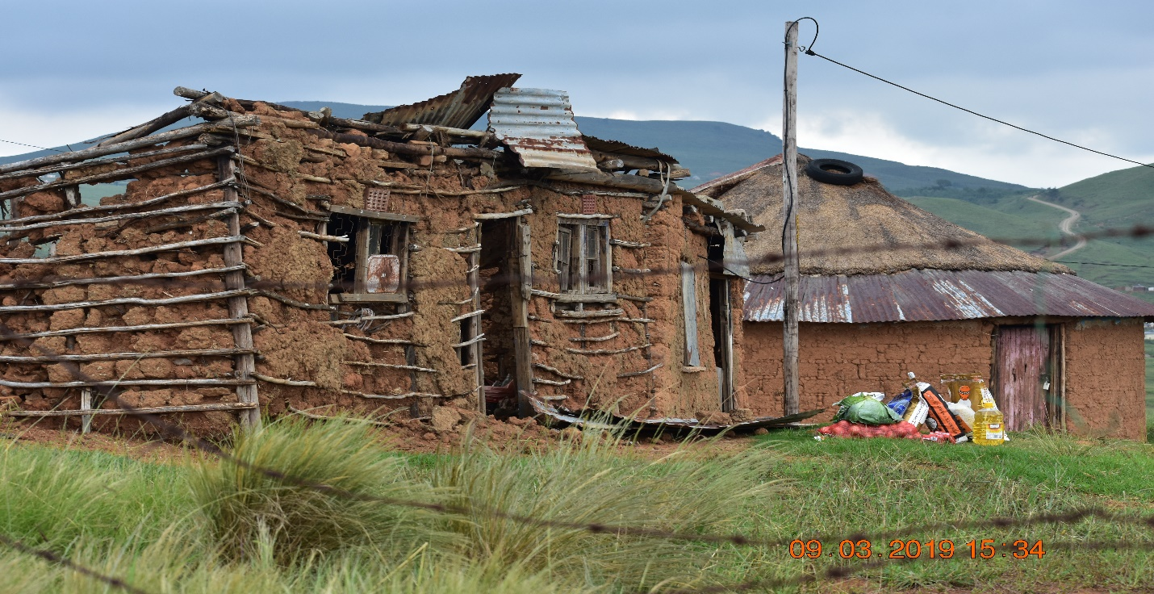
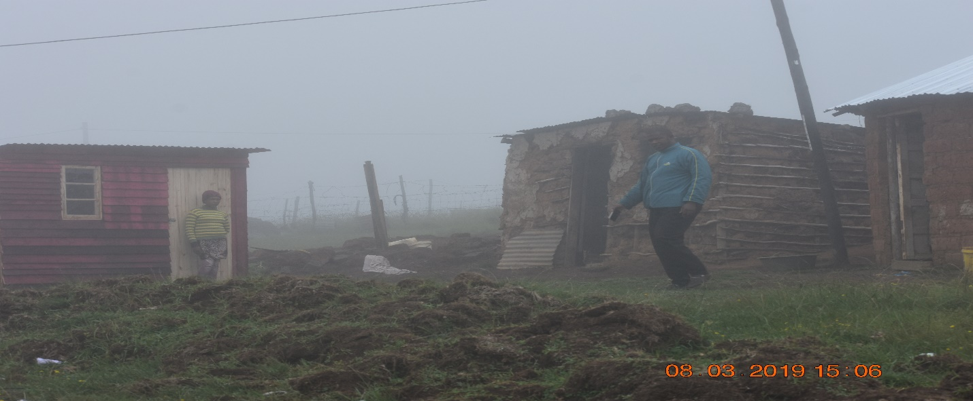
Emergency Response with an emergency house after a heavy storm in Bulwer
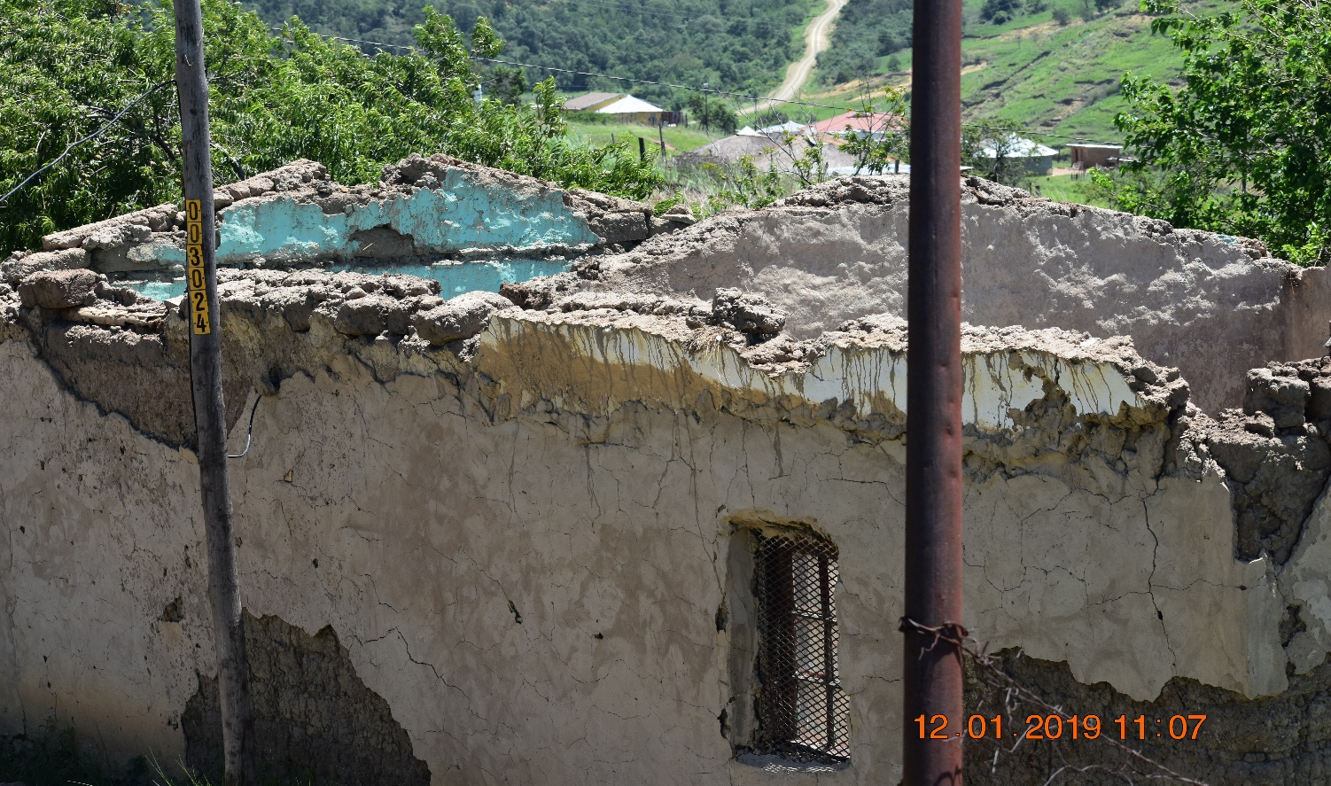
House its roof blown away
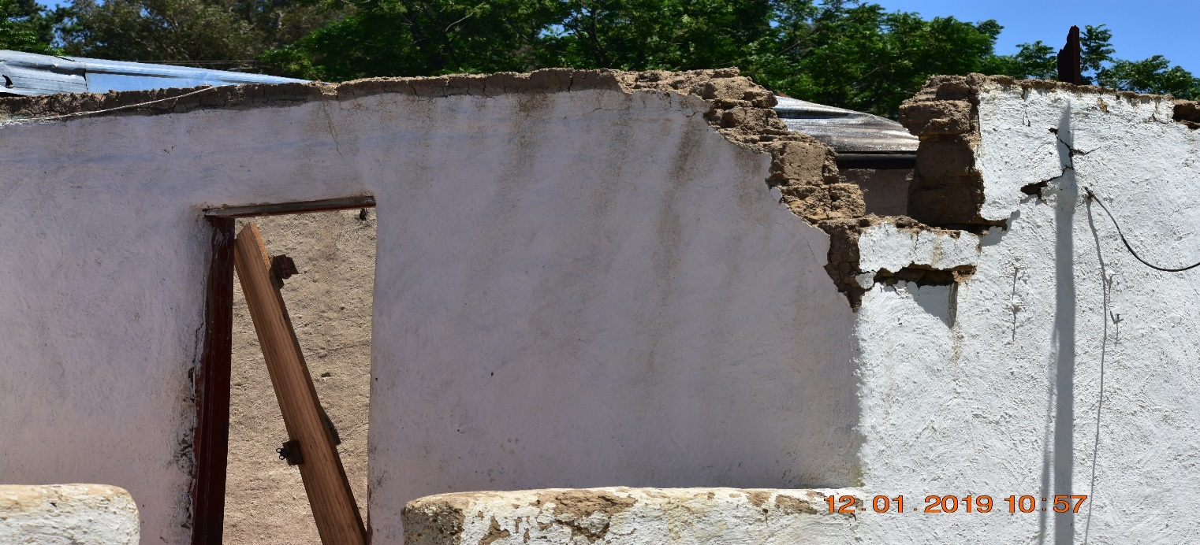
Roof blown away by wind
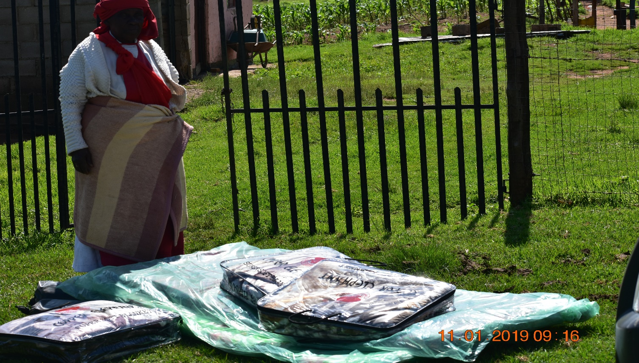
Victims of a disaster incident receiving their relief
5.2 KEY PERFORMANCE INDICATOR
- Mechanisms are in place to ensure proper response and recovery takes place swiftly
- List of all relevant stakeholders responsible for disaster management is in place
5.3 RELEVANT STAKEHOLDERS REPRESENTATIVES FOR RESPONSE AND RECOVERY
Name of Department |  |  | Community Services
Contact Person |  |  | P. Mtungwa
Designation |  |  | Acting Head of Department
Emergency Number |  |  | 0714841593 | Tel: 039 833 1038
Email | senioraccountant@kwasani.gov.za |  |  | Cell: 0714841593
Section |  |  | Community Safety
Contact Person |  |  | Mr. M.W. Dlamini
Designation |  |  | Manager Community Safety
Emergency Number |  |  | 0837082314 | Tel: 033 702 1060
Email |  | protectionmanager@ndz.gov.za |  | Cell: 0829681168

Name of Department |  |  | Disaster Management Harry Gwala District
Contact Person |  |  | Thandi Dzanibe
Designation |  |  | Disaster Manager
Emergency Number |  |  | 0828057892 | Tel: 039 834 0043
Email | dzanibet@harrygwaladm.gov.za |  |  | Cell: 07828057892
Alternative Person |  |  | Nosipho Mazibuko
Designation |  |  | Disaster Officer
Emergency Number |  |  | 0788013512 | Tel: 039 834 0043
Email |  | mazibukon@harrygwaladm.gov.za |  | Cell: 0788013512

Name of department |  |  |  | PDMC
Contact Person |  |  |  | JONTY NDLANZI
Designation |  |  |  | Head Of Provincial Disaster Management Centre
Emergency Number |  |  |  | 0813858362 | Tel: 033-8469000
Email |  |  |  |  | Cell: 0822603081
Alternative Person |  |  |  | Ngubane Themba
Designation
Emergency Number |  |  |  | 0761533685 | Tel: 033-8469000
Email |  |  | Themba.ngubane@kzncogta.gov.za |  | Cell: 0721021495
Alternative Person |  |  |  | Bheki Phungula
Designation |  |  |  | Deputy Director: Disaster Management Implementation
Emergency Number |  |  |  | 0725128601 | Tel: 033-8469000
Email |  | Bheki.phungula@kzncogta.gov.za |  |  | Cell: 0725128601

Name of department |  |  | EMRS
Contact Person |  |  | MR TS Mkhize
Designation |  |  | District Manager
Emergency Number |  |  | 10177 /039 834 8501 | Tel: 039 8347 211
Email | Tobias.mkhize@kznhealth.gov.za |  |  | Cell:083 468 9563
Alternative Person |  |  | V. Dawchurran
Designation |  |  | Communications Officer
Emergency Number |  |  | 10177/0398348501 | Tel: 0398348501
Email |  | Vikash.dawchurran@kznhealth.gov.za |  | Cell: 084 4047817

Name of Department |  |  | RTI IXOPO
Contact Person |  |  | Mr. Kesar
Designation |  |  | Principal Provincial Inspector
Emergency Number |  |  | 082 9042218 | Tel: 039 834 1450
Email |  |  |  | Cell: 0829417212
Alternative Person |  |  | Ms N Mhlophe
Designation |  |  | Senior Provincial Inspector
Emergency Number |  |  | 082 9074 079 | Tel: 039 834 1450
Email |  |  |  | Cell: 082 9074 079

Name of Department |  |  |  | Municipal Health Services
Contact Person |  |  |  | Mr E Mlomo
Designation |  |  |  | Manager
Emergency Number |  |  |  | 078 140 7357 | Tel: 039 8348700
Email |  | mlomoe@harrygwaladm.gov.za |  |  | Cell: 078 140 7357
Alternative Person |  |  |  | Ms T Mahlaba
Designation |  |  |  | Director Social Services
Emergency Number |  |  |  | Cell: 0833805058 | Tel: 039 834 8700
Email |  |  | mahlabat@harrygwaladm.gov.za |  | Cell: 0833805058
Alternative Person |  |  |  | Mrs. MB Mchunu
Designation |  |  |  | Municipal Health Manager
Emergency Number |  |  |  | 0724210687 | Tel: 039 8348700
Email | mchunum@harrygwala.gov.za |  |  |  | Cell: 0724210687

Name of department |  | ESKOM
Contact Person |  | Jaishika Sunker
Designation |  | Manager
Emergency Number |  | 033-3957058 | Tel: 033-3957058
Email | sunkerj@eskom.co.za |  | Cell: 0723333202

Name of department |  | Working on Fire
Contact Person |  | Simphiwe Dlamini
Designation
Emergency Number |  | 0725115119 | 033-3307715
Email | Simphiwe.dlamini@wof.co.za |  | Cell: 0725115119

Name of department |  |  | Department of Community Safety and Liaison
Contact Person |  |  | Miss Amangile Ncapayi
Designation |  |  | Assisatnt Manager: Crime prevention
Emergency Number |  |  | 0605201248 | 039-8340054
Email | Amangile.ncapayi@comsafety.go.za |  |  | Cell: 0605201248
Alternative Person |  |  | Mlata Z.
Designation |  |  | District Manager
Emergency Number |  |  | 0823005397 | 039-8340054
Email |  | mlataz@comsafety.gov.za |  | Cell: 0823005397

Name of department |  |  | Liquor Authority
Contact Person |  |  | Juliet Vanderbyl
Designation |  |  | District Inspector
Emergency Number |  |  | 0810330783 | 0398340060
Email | Juliet.vanderbyl@kznla.co.za |  |  | Cell: 0810330783
Alternative Person |  |  | Khorola Lesuthu
Designation |  |  | DSRT
Emergency Number |  |  | 0810330775 | 039-8340060
Email |  | Khorola.lesuthu@kznlqa.co.za |  | Cell: 0810330775

Name of department |  | Social Development (DSD)
Contact Person |  | Mrs Mlambo
Designation |  | Manager
Emergency Number |  | 0828044973 | Tel:
Email |  |  | Cell: 0828044973

Name of department |  | Creighton Engen Depot
Contact Person |  | Mr. Paul Louise
Designation |  | Manager
Emergency Number |  | 0823773914 | Tel:
Email |  |  | Cell: 0823773914

6.ENABLER 1 INFORMATION MANAGEMENT AND COMMUNICATION SYSTEM
The municipality has put mechanisms or a system in place within the disaster management unit, to ensure that, information is managed, processed and transferred where necessary to other disaster management stakeholders. Such systems are as follows:
INFORMATION COMMUNICATION SYSTEM | QUANTITY
Telephones | 2
Computers (2 x lap tops) | 2
Cell phones | 3
Radios | 4
Photocopying, scanning machine | 1
Emails | 2

EARLY WARNING SYSTEMS
- The municipality considers the issue of early warning systems very seriously and hence it receives such from the South African weather board, provincial disaster management centre and the district municipality.
- Whilst the system works very well but, it is equally important to be very vigilant when such is cascaded to the community as skilled people would need to be identified to receive the early warnings and digest same before taking actions.
- Currently, the early warnings are received, processed by the municipality, and be shared amongst disaster management unit personnel and other stakeholders to be alert for any reported adverse weather conditions to respond as soon as it is necessary in case of any eventualities.

- Enabler 2 Education, Training, Public Awareness and Research
In line with the Disaster Management Act (Act 57 of 2002), section 44 (h), the municipality promotes capacity building, training and education including at schools in the municipal area.
Furthermore, the municipality conducts continuous disaster management awareness campaigns and training in the following areas:
- Community level
- Schools
- Clinics
- Home Affairs Offices
- Hospitals
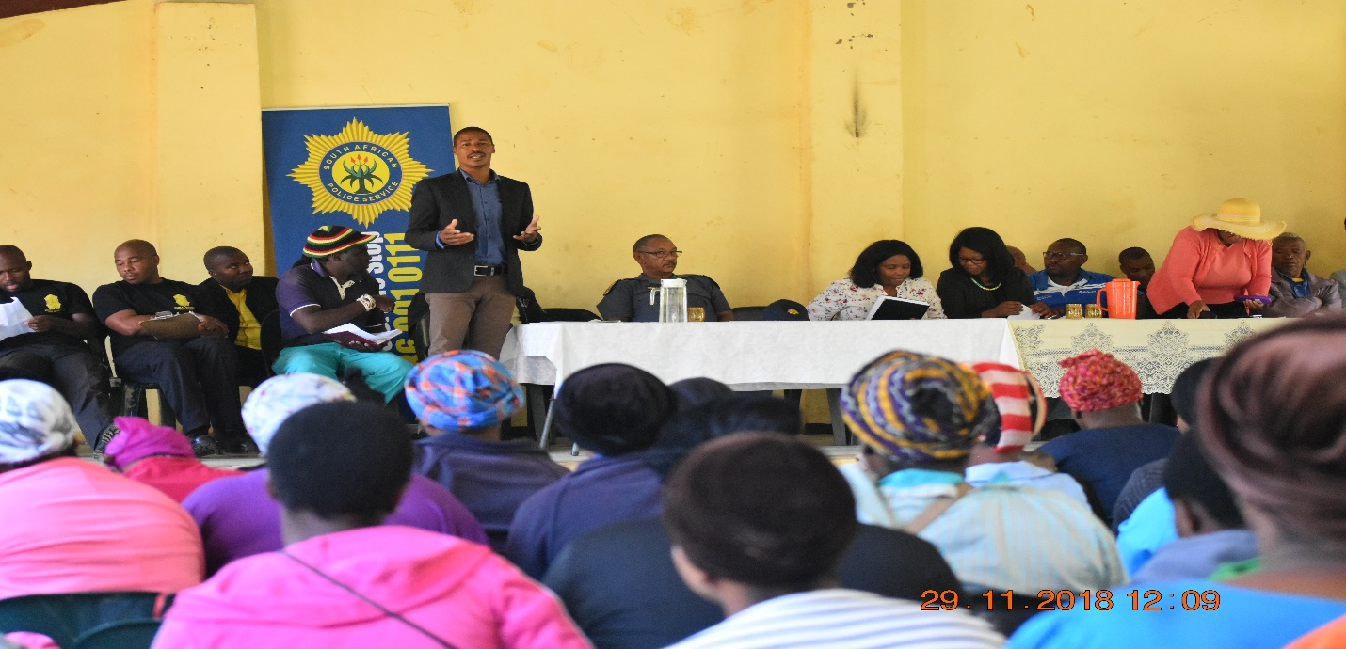Integrated Community Safety Awareness Campaign held at Khukhulela Community Hall in ward 5
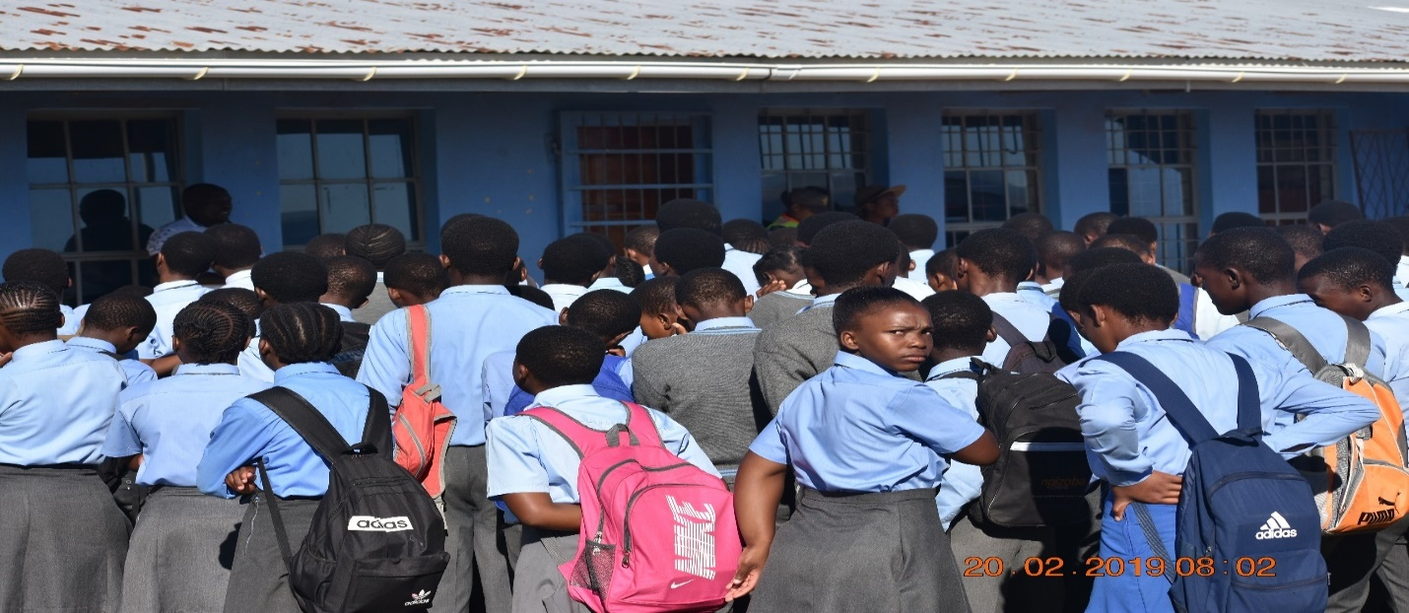SCHOOL AWARENESS CAMPAIGNS
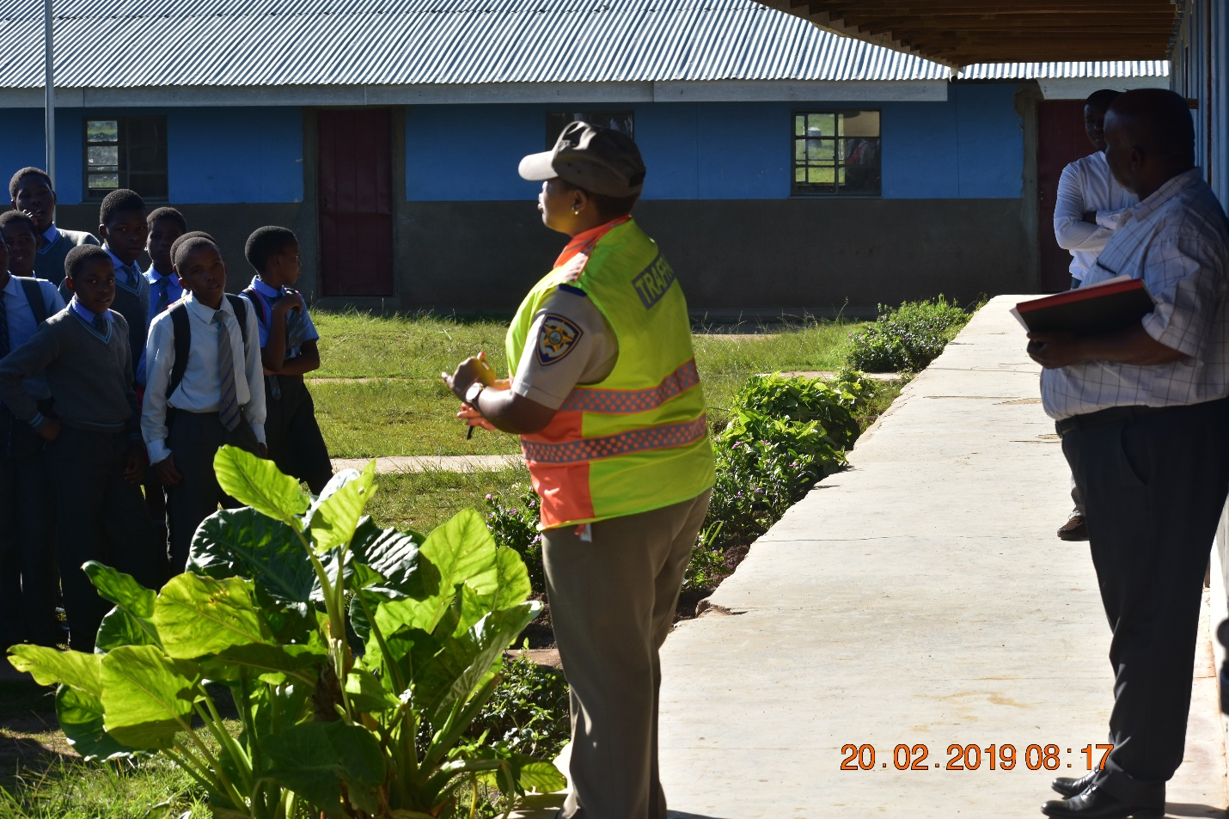AWARENESS CAMPAIGN IN ONE OF THE SCHOOLS
- ENABLER 3 FUNDING ARRANGEMENTS FOR DISASTER RISK MANAGEMENT
The municipality, from the fiscal year 2018/2019 has started prioritizing disaster management budget, for both proactive and reactive disaster management initiatives for the purposes of ensuring that, it complies with the requirements of the Disaster Management Act (Act 57 of 2002) as amended from time to time.
  - INTERNAL FUNDING
Dr Nkosazana Dlamini Zuma municipality, is currently funding disaster risk management programmes and projects from its own internal funding in terms of the current and medium-term expenditure framework. In the financial year 2018/2019, the municipality reserved in the budget an amount of two million and five hundred thousand Rands to procure a fully equipped fire truck.
  - GOVERNMENT FUNDING
The municipality also receives equitable share, from national treasury in terms of the Division of the Revenues Act (DoRA), which funds are then divided in accordance to the needs of the community of Dr. Nkosazana Dlamini Zuma municipality, in line with the approved IDP.
There are also funds such as the Municipal Infrastructure Grants (MIG) that are provided to
municipalities to fund infrastructure related projects.
The municipality is currently lobbying for funding to build a fire station
that will be strategically positioned to discharge suffice provision of disaster risk management
  - PRIVATE SECTOR AND NON-GOVERNMENTAL ORGANIZATIONS
The municipality also partner with the private sector and none governmental organizations to play their roles on disaster management programmes, in terms of sponsoring such programmes whenever are implemented.
- SWOT ANALYSIS
STRENGTHS | WEAKNESSES
- Active participation of ward committee members on disaster management  - Provision of budget by municipality to undertake disaster management projects  - Disaster Management is also utilizing fire fighters to perform some of the functions  - Disaster Management Volunteers availability at ward level  - Disaster Management Forum is very effective  - Disaster Management and Sector plan completed and approved | - Lack of a proper Fire Station/ disaster management centre  - Insufficient funds to build the Fire Station/ disaster management centre  - Rural areas are very sparsely
OPPORTUNITIES | THREATS
- Improved working relationships with other relevant disaster management stakeholders  - Participation of private sector, NGOs and on issues of disaster management  - Participation of the private sector on issues of disaster management | - Unavailability of fire hydrants in most rural areas  - Occurrence of natural disasters  - Houses not built in accordance with national building standards and regulations (rural and informal settlements)

- CLIMATE CHANGE

  - CLIMATE CHANGE
In accordance with the oxford dictionary, the term “CLIMATE CHANGE” means changes in the weather, including changes in temperature, wind patterns, rainfall, especially the increase in temperature of the earth’s atmosphere that is caused by the increase of gases especially carbon dioxide (CO2).
According to Mr. Paul Polman – CEO Uniliver, climate change can be regarded as the change in average global temperature which increases due to increased “greenhouse gases” emissions in the earth’s atmosphere.
There are natural causes that, contribute to climate fluctuation, but industrial practices are behind the recent rapid acceleration in global warming. The demand of ever growing population has led to deforestation, burning of fossil fuels and intensive farming or agricultural activities.
The above activities all produce greenhouse gases into the atmosphere.
In line with the South African Climate Change Response Plan Implementation, by Judy Beaumont, outlines the greenhouse gases (GHG) profile as follows:
GREENHOUSE GASES (GHG) | PERCENTAGE
Industrial Processes and Products | 7%
Agricultural Activities | 8%
Waste | 2%
Energy | 83%
TOTAL | 100%
The greenhouse gases such as carbon dioxide, nitrous oxide, and methane trap heat from the sun instead of radiating it back to space. This then causes the earth’s atmosphere to heat up in what is known as the greenhouse effect.
Climate change can ruin food chains and ecosystems and thus putting all species at risk of extinction. When global warming occurs, sea levels rise as glaciers melt, this causes certain regions to more at risk of heat waves, drought as it is witnessed in South Africa, flooding and other natural disasters.
Once again it is of paramount importance to fully understand the distinction between climate change and global warming although the terms are very much related. Whilst the term global warming is used to describe the current increase in the earth’s average temperature, climate change refers to global changes in temperature but also to changes in weather patterns. Global warming is a worldwide phenomenon whilst climate change can be seen at global, regional and/ or even more at local scales.
10.2 CLIMATE CHANGE EFFECTS
Climate change effects are as follows:
- Increased flooding
- Extended droughts
- Frequent heat and cold waves
- Strong storms, cyclones and hurricanes
- Loss of biodiversity
- Ocean acidification
- Rise in global sea levels
- Widespread melting of snow and ice around the world
- Negative Health Impacts
In the past year or so, the Dr. Nkosazana Dlamini Zuma Municipality experienced drought in some parts of its area, which is a very slow onset kind of a catastrophe. As this is believed to be associated with climate change and global warming which to a certain extent result in adverse weather conditions. A shift has been noticed on patterns of rainfall being delayed in some areas whilst in other areas such rain is seen to be taking place more often.
From December 2016, the municipal area has received some rain, but that does not imply that the municipal area is already out of the red in terms of drought, since it is not known during the winter season whether the rains currently received now will be able to sustain the communities in the area.
The effects of climate change are also witnessed through the following:
- Grazing land becoming eroded
- Livestock dying
- Crops damaged
- Water vanishing from dams because of no rainfall, although has improved a little bit
- Adverse weather conditions realized resulting in catastrophic conditions.
10.3 SYNOPSIS OF THE AGRICULTURAL SECTOR IN NDZ
Dr. Nkosazana Dlamini Zuma Municipality is more agricultural as compared to industrial activities and hence its contribution to GHG could be through agriculture, waste and emissions from the transport industry.
Agricultural landscape in the municipal area is spread according to the following categories:
- Subsistence agriculture
- Emerging agriculture
- Commercial agriculture
Subsistence and emerging farming is mostly done by black farmers whilst on the other hand white farmers specialize on commercial farming. Subsistence farmers are numerically the highest in the municipal area but have the lowest agricultural output.
Commercial farmers are mostly found in Underberg and surroundings, wherein milk farming is dominant. Timber farming is one of the most dominant in the area, with timber farming extending from the Creighton area all the way to Underberg.
The following crops are also produced:
- Maize
- Pastures
- Potatoes
- Tomatoes
- Cabbages
Mostly the above activities, fertilizers are utilized to enhance the growth and stability of crops whilst on the other side insecticides are also utilized to prevent insects from destroying crops.
Most of the farmers employ local people to work in the farms, which therefore contribute to reducing the rate of unemployment in the area.
10.4 RESPONSE ON ISSUES OF CLIMATE CHANGE
WHAT IS ECOSYSTEM BASED DISASTER RISK REDUCTION?
The United Nations Environmental Programme and Centre for Natural Resources and Development defines, ecosystem-based disaster risk reduction (Eco-DRR) as the sustainable management, conservation and restoration of ecosystems to reduce disaster risk, with the aim to achieve sustainable and resilient development (Estrella and Saalismaa,2013). Well-managed ecosystems, such as wetlands, forests and coastal systems, act as natural infrastructure, reducing physical exposure to many hazards and increasing socio-economic resilience of people and communities by sustaining local livelihoods and providing essential natural resources such as food, water and building materials.

Environment and disasters interact with each other in several ways. Disasters cause massive damage to the environment, while degraded environments exacerbate disaster impacts. Responding to disasters often leads to additional environmental impacts, while investments in sound environmental management, especially in disaster prevention and post-disaster recovery stages, can reduce disaster risks and thus contribute to a more resilient and sustainable development. Climate change will likely exacerbate disaster impacts, while environmental management solutions are increasingly being applied for adaptation to climate change.

The close inter-linkages between sound environ-mental management, climate change impacts and disaster responses require a more systematic and comprehensive approach to disaster risk management, which in the past has mainly been reactive rather than preventive, engineering focused rather than based on planning and use of natural landscape features to prevent disaster risks.

10.5 ENVIRONMENTAL MEASURES FOR ECOSYSTEM BASED DISASTER RISK REDUCTION
Dr. Nkosazana Dlamini Zuma municipality is conversant with issues of environmental management, and hence does all in its power to protect the environment and thus reducing the vulnerability of such environment from the impacts of disasters. The following projects are implemented as part of ecosystem-based disaster risk reduction:

10.6 FORESTS PLANTATIONS
As indicated above, in the municipal area, forest plantations are one of the economic development initiatives in the area. There are huge forest plantations that belong to SAPPI and Mondi that employs several people in the area. While such forests plantations play a crucial role in reducing the vulnerability of the environment, they also act as an anchor of the soil.
Such plantations are also amongst rural residential places. Their presence is very important to act as wind breakers during winter seasons when there is a lot of wind and thus reducing the disaster risk of wind to blow roofs of properties.
10.7 WASTE MANAGEMENT
The municipality is currently in the process of developing an integrated waste management plan. Within the area of jurisdiction waste burning is discouraged by all possible means and hence collected waste is disposed of in Creighton and Bulwer licensed dump sites where it is covered.
In Underberg and Himeville, waste collected is temporarily stored at the waste transfer station situated in Himeville wherein on regular basis such waste is removed from the transfer station to be disposed of in Pietermartizburg.
State of the art equipment was procured to ensure effective waste collection, transportation and disposal thereof. The collection of waste prevents it from contaminating the environment, water sources, and wetlands.
The towns are equipped with diverse types waste collection equipment for purposes of keeping waste for a temporal period whilst waiting to be collected. The effective waste management collection system is very crucial to reduce the blockages of storm water drains, and thus mitigating the impact of flooding. Unblocked storm water drains allow the free flow of access water.
10.8 REHABILITATION OF THE ENVIRONMENT
One of the most important aspects of ensuring environmental sustainability is that of having a strategy to promote rehabilitation of the environment whenever engineering projects have disturbed virgin land. Usually this will be the form part of the conditions to protect the environment whenever an Environmental Impact Assessment is conducted.
10.9 TOURISM DISASTER RISK REDUCTION INITIATIVE
As part of tourism promotion in the area a coal locomotive is utilized to ride tourists from one area to the other and hence burning of coal contribute highly to the green gases that affect the environment. When the train is operation on regular basis, black smoke can be seen winding up with the rail to wherever the train is going at the time, hence such smoke has a negative effect to the atmosphere by contributing to the green hose gases.
Whilst this initiative contributes positively to local economic development, it is once again imperative to reduce the emissions to acceptable levels as part of disaster risk reduction.

10.10 PROTECTION OF WETLANDS
As part of promoting biodiversity, the wetlands are very of paramount since there are a variety of plant and animal species that habit is such places. In Himeville within the Himeville nature reserve there are two wetlands that are protected in terms of fencing to ensure that nothing sinister happens there.
There are varied species that grow and habit in such wetlands.
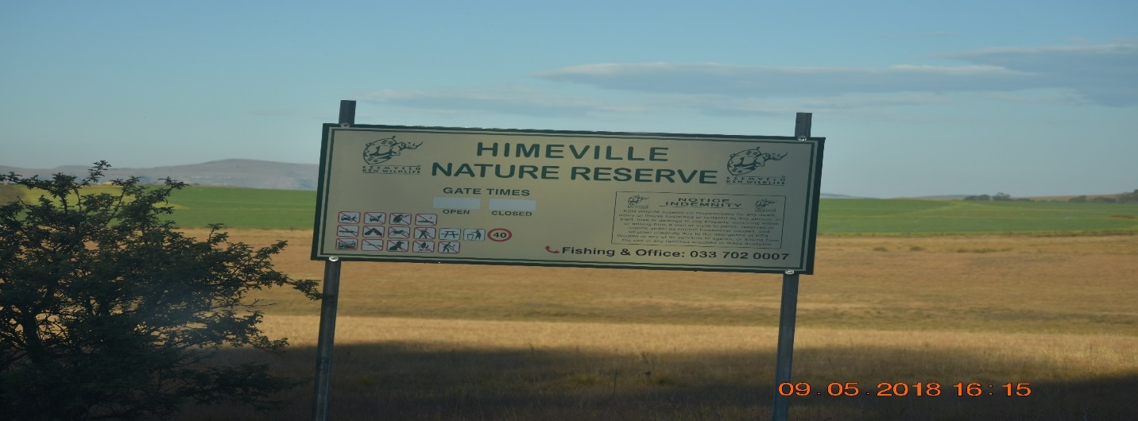
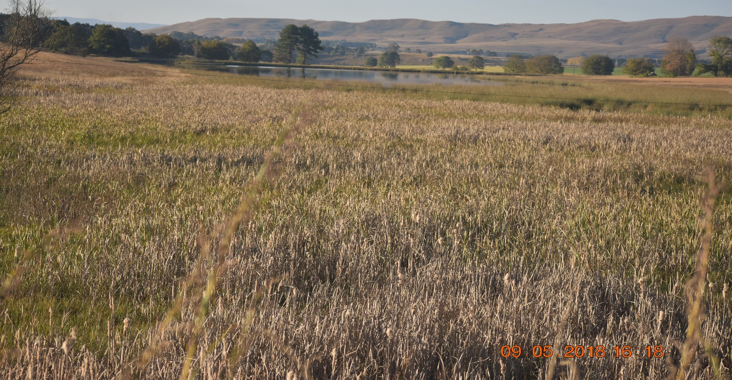
Pictures of the wetland in Himeville
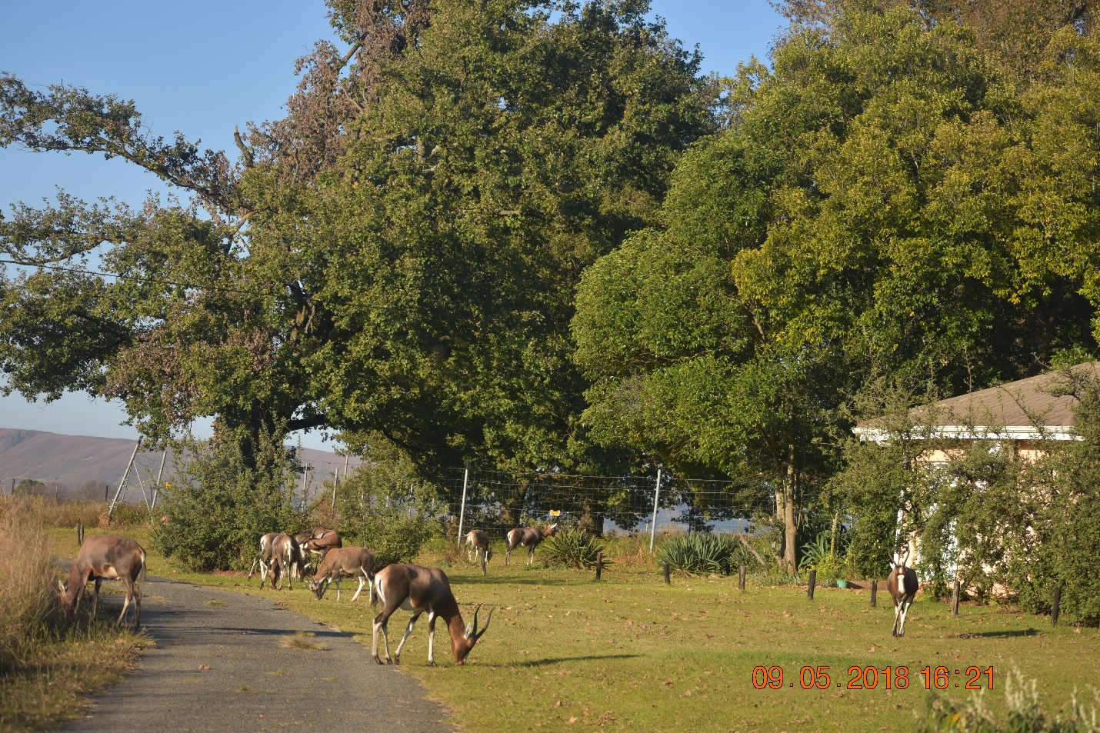
Animals also habiting around the wetland
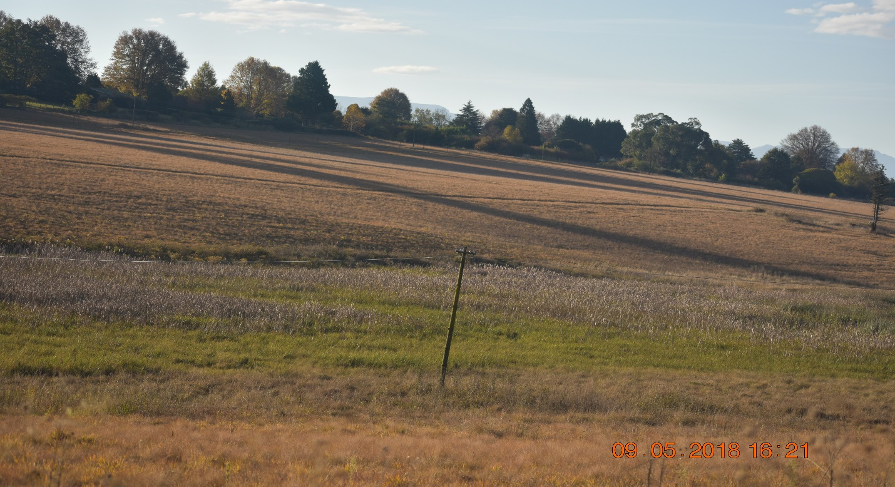
Another part of the wetland

10.11 ENERGY SAVING
Energy is one of the most culprits in terms of contribution to the greenhouses gases wherein it is rated at 83 %. It is therefore of paramount importance for municipalities to engage on initiatives that will ensure energy saving to relieve pressure from the national grid.
Dr. Nkosazana Dlamini Zuma Municipality is looking at different infrastructure development models that will ensure minimum usage of electricity and thus promoting greening of our environment. When building halls, they should be such that, they allow more natural illumination as compared to putting more electricity bulbs.
The municipality has also undertaken the installation of solar guizers in most of its townships in Underberg and Himeville. Of more interest is that, those that can afford installing such solar guizers in the suburbs are also doing so, to alternatively switch from the electricity grid to the solar electricity.
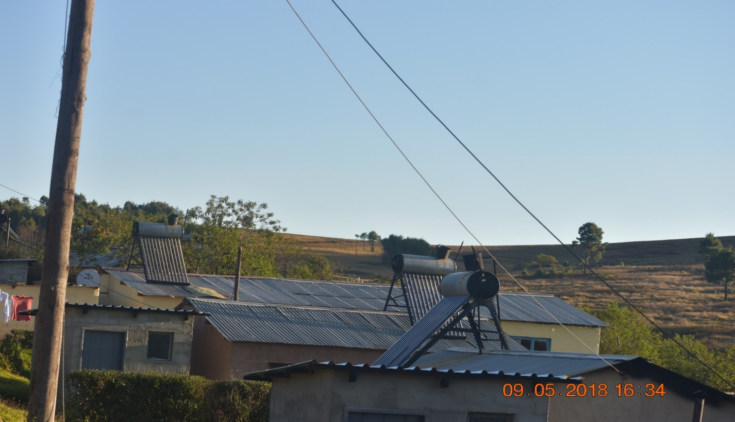
Solar guizers at Himeville Township
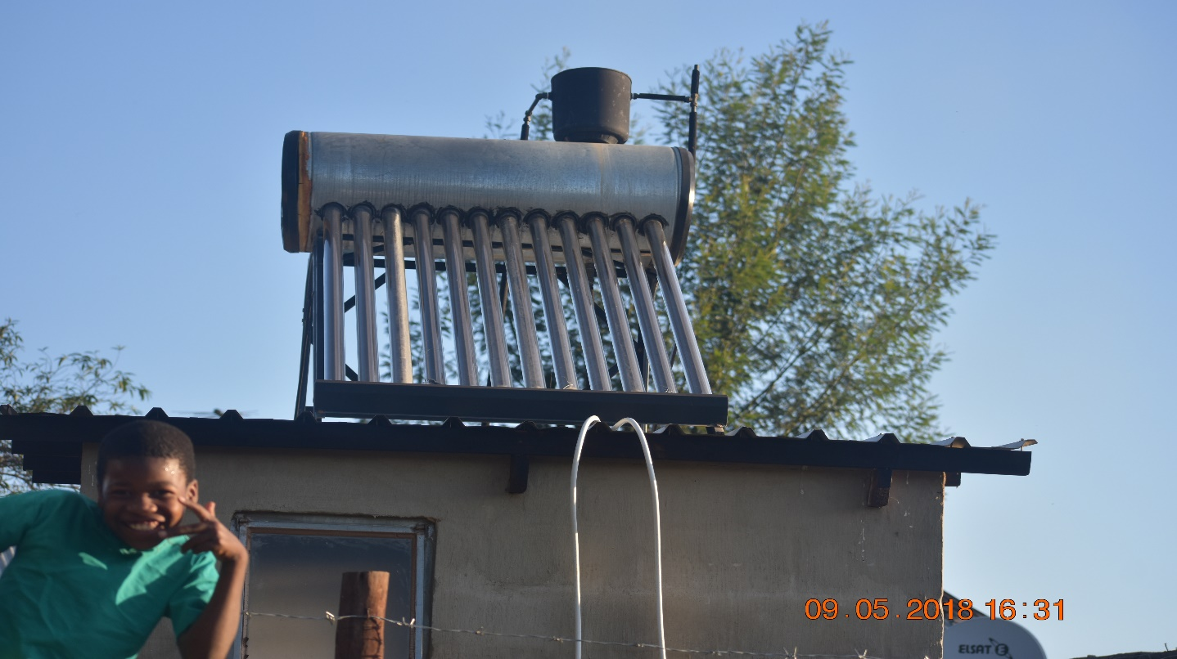

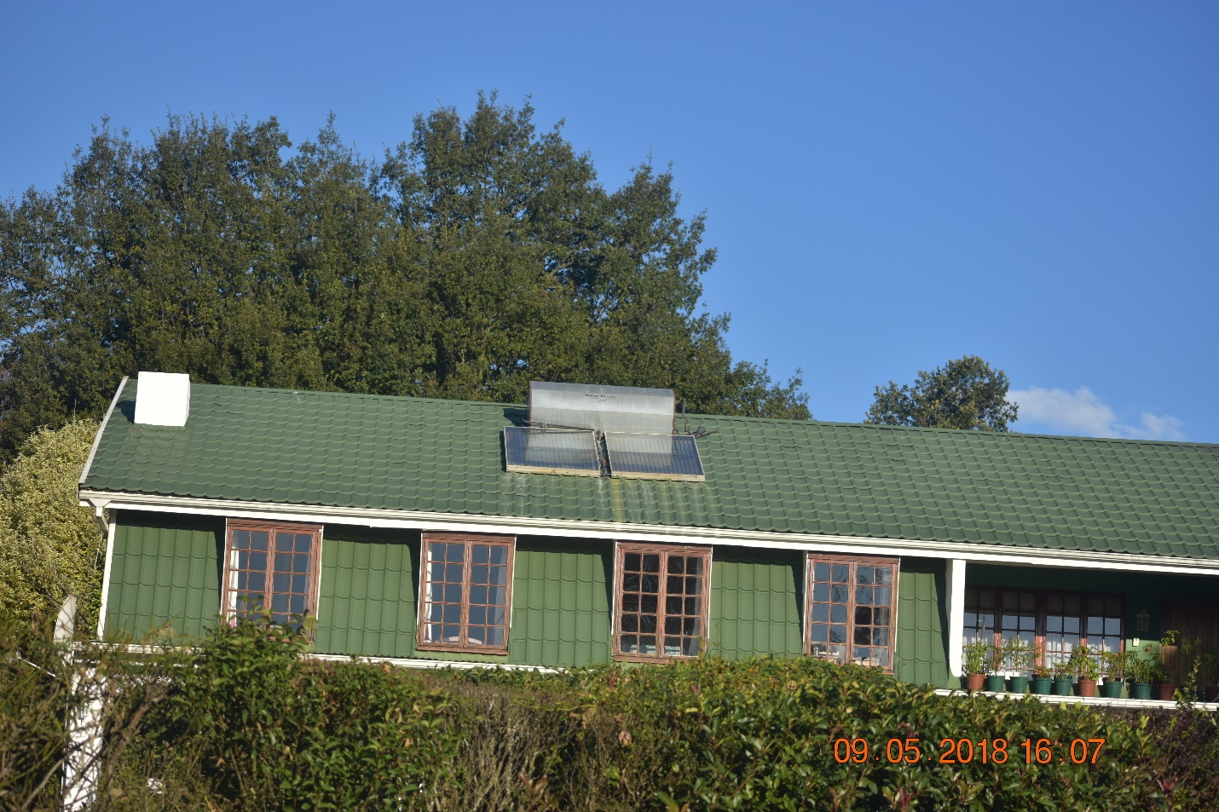
One of the houses in the Himeville Suburbs that utilizes Solar energy

10.12 PLANTING OF TREES, FLOWERS AND BEAUTIFICATION
The municipality promotes the planting of trees, flowers, grass and beautification on all open spaces to prevent the environment from degrading whilst on the other hand ensuring beautification of the land. Areas that a planted trees and grass do not easily get eroded, but they become firm that even during the occurrence of disasters it is not easy for the soil to be easily moved from one area to the other.
The municipality also participate in a programme called the Greenest Municipality competition run by the district municipality of Harry Gwala, which seek to encourage its family of municipalities to respond on issues of climate change in terms of diverting resources to landscaping, waste management and as well energy efficiency within their areas of jurisdiction. The municipality has won some categories in such competition as a testimony of protecting the environment.
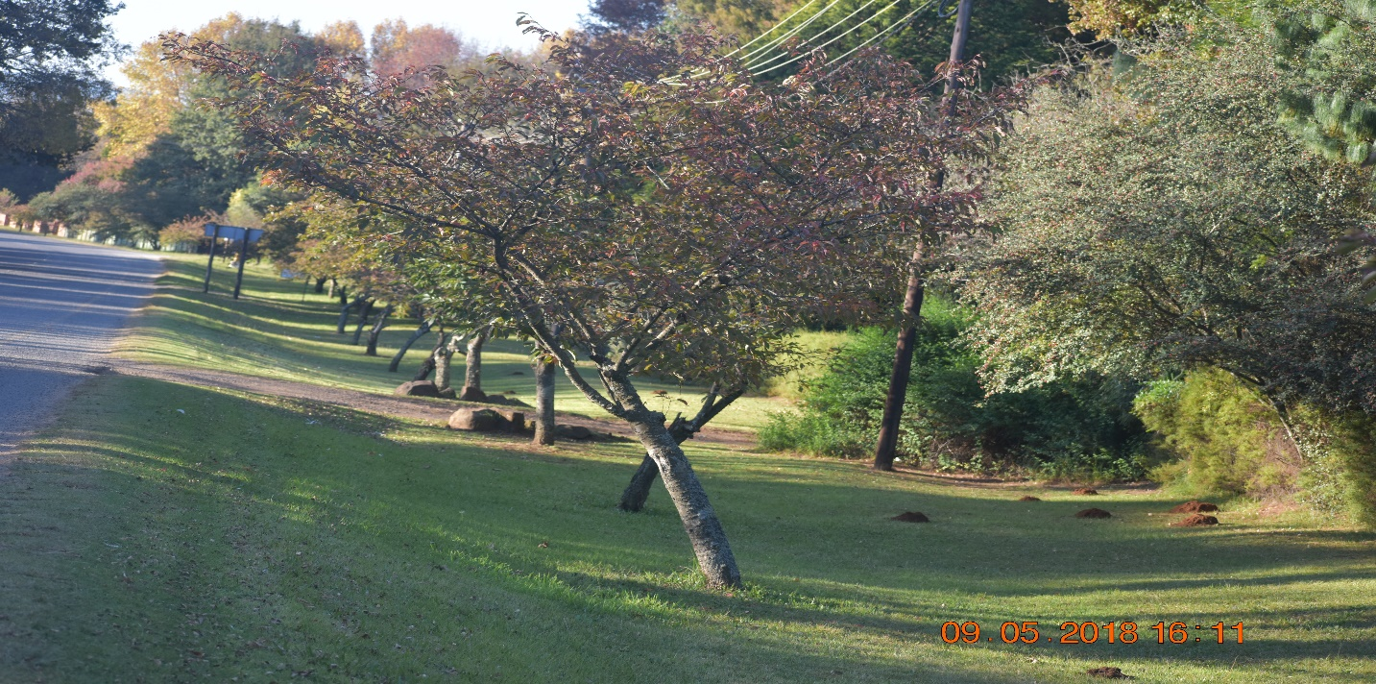

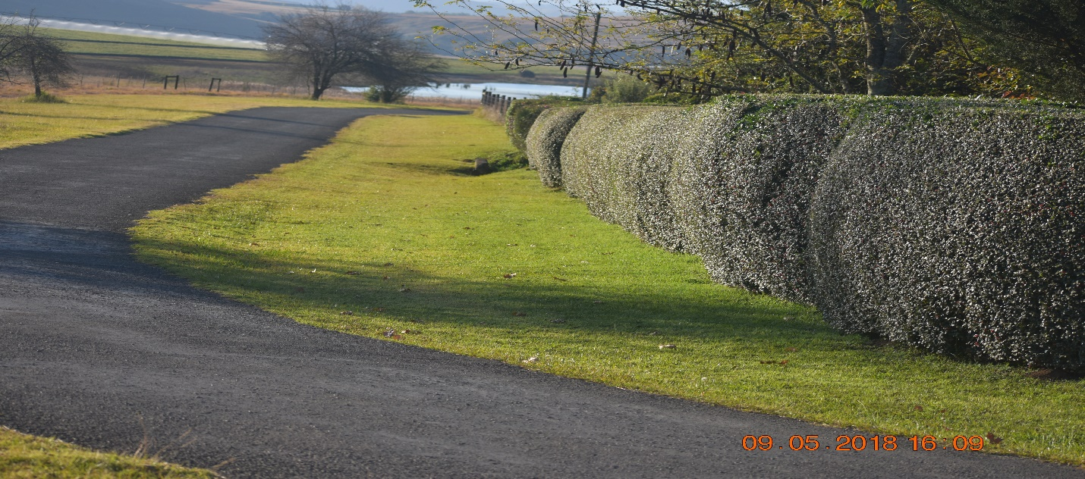
- KEY CHALLENGES
The following challenges identified by the municipality in line with realization of a fully-fledged disaster management and fire services.
- Unavailability of the Dr. NDZ Emergency Management Center (Fire Station), resulting negative impact in terms of coordination of disaster management issues.
- Lack of proper storage to store disaster relief and other related items.
- Limited financial muscle for the municipality to expedite the construction of the emergency centre.
- Unavailability of fire hydrants in some small towns and rural areas within the jurisdiction.

