08
Fall



DR NKOSAZANA DLAMINI ZUMA MUNICIPALITY
HUMAN SETTLEMENT PLAN
June 2018

Contents
1 BACKGROUND AND PURPOSE 1
1.1 Objectives 2
1.2 Outputs 2
2. METHODOLOGY 3
2.1 Situational Analysis 4
2.2 Vision and Strategies 4
2.2.1 Strategies identified 5
2.3 Housing Sector Plan 6
3. POLICY AND LEGISLATIVE FRAMEWORK 7
3.1 National Legislation 7
3.1.1 The Constitution 7
2.1.2 National Housing Act 8
2.1.3 The Municipal Systems Act - MSA 9
2.1.4 National Environmental Management Act - NEMA 10
2.1.5 Spatial Planning and Land Use Management Act - SPLUMA 11
2.2 Provincial Legislation 11
2.2.1 KwaZulu-Natal Housing Act 11
2.2.2 KZN Planning and Development Act - PDA 12
4. POLICY INSTRUMENTS 14
4.1 Provincial Growth and Development Strategy - PGDS 14
4.2 Provincial Spatial Development Framework (SDF) 16
4.3 KZN Dept of Human Settlements Annual Performance Plan 2017/18 - 2019/20 18
4.4 The Densification Strategy 21
4.5 National Directives 22
4.5.1 State of the Nation Address, 2017 22
4.5.2 National Housing White Paper 23
4.5.3 Breaking New Ground (2004) 24
4.5.4 The Housing Code 24
4.5.5 Rural Housing Development 25
4.5.6 National Development Plan 2030 - NDP 26
4.5.7 National outcomes 29
4.5.8 National priorities 30
4.5.9 State of the Province (KZN) Address 30
4.5.10 The Expanded Public Works Programme (EPWP) 31
4.5.11 Operation Sukuma Sakhe 32
5. STATUS QUO ANALYSIS 33
5.1 KZN Provincial Growth and Development Plan 33
5.2 Harry Gwala Integrated Development Plan 2017 - 2022 33
5.3 KZN Department of Human Settlements Annual Performance Plan 34
5.4 Local Situation 34
5.4.1 Spatial context 35
5.4.2 DNDZ nodal classification 35
5.4.3 Densification and urban and settlement edges 36
5.4.4 Restricted development and protection of agricultural land 37
5.4.5 High-level settlement overview 40
5.4.6 Current tenure situation and implications 40
5.4.7 Rural housing 40
5.4.8 Nodes and corridors in relation to municipal sensitive areas 41
5.4.9 Environmental and other restrictions 45
5.5 Dr NDZ Demographics 46
5.6 Economic Context 48
5.7 Social Context 49
5.8 Infrastructural Context 50
5.8.1 Water supply 50
5.8.2 Sanitation 51
5.8.3 Roads and accessibility 53
5.8.4 Electricity 53
5.9 Current Housing Delivery Rate 56
5.10 SWOT Analysis 61
5.11 Housing Demand 63
6. VISION AND STRATEGIES 69
6.1 Proposed Housing Vision 70
6.2 Development Principles 70
6.2.1 Principle of Sustainable Communities 71
6.2.2 Principle of economic potential 71
6.2.3 Principle of Environmental planning 72
6.2.4 Principle of sustainable rural livelihoods 72
6.2.5 Principle of spatial concentration 72
6.2.6 Principle of local self-sufficiency 73
6.2.7 Principle of co-ordinated implementation 73
6.2.8 Principle of accessibility 73
6.2.9 Principle of balanced development 73
6.3 Key Performance dimensions 74
6.3.1 Complexity and choice 74
6.3.2 Equity 74
6.3.3 Multi-functionality 74
6.3.4 Reinforcement and Intensification 74
6.3.5 Clustering of activities 74
6.3.6 Integrating hierarchies 74
6.3.7 Efficiency 75
6.3.8 Exposure 75
6.3.9 Fixed Edge 75
6.3.10 Seams as places for integration 75
6.4 Strategic Objectives 75
6.5 Housing Strategies 77
6.5.1. Strategy 1: Establish Sustainable Communities 77
6.5.2. Strategy 2: Develop the necessary institutional arrangements 82
6.5.3. Strategy 3: Settlement Planning and Services identified 87
6.5.4. Strategy 4: Make provision for HIV/AIDS affected people. 91
6.5.5. Strategy 5: An Integrated Approach Towards Sustainable Human Settlement. 92
7. LOCATION OF FUTURE HUMAN SETTLEMENT PROJECTS 95
7.1 Dr NDZ Settlement Hierarchy 95
7.2 Department of Human Settlement Priorities 96
7.3 Provincial Benchmarking 99
7.3.1 MSP Principles: 99
7.3.2 MSP Objectives: 99
7.4 Proposed Investment Allocation Procedure 99
7.5 Areas Suitable For Housing Development 100
7.6 Dr NDZ Identified Housing Projects: 102
7.7 Future Demand 106
7.8 Housing Typologies 106
7.9 Future Actions 106
8. INSTITUTIONAL ARRANGEMENTS 107
8.1 Current Structure 107
8.2 Housing structure support tools 108
8.2.1 Institutional support 108
8.2.2 Capacity building 109
9. CONCLUSION 111
REFERENCES 113
ANNEXURES 115
Annexure 1: Housing Strategy Tables 116

Figure 1: Dr Nkosazana Dlamini Zuma Municipality locality map 1
Figure 2: Dr Nkosazana Dlamini Zuma Human Settlement Plan methodology 3
Figure 3: Situational Analysis Framework 4
Figure 4: Vision and strategy report methodology 5
Figure 5: Strategic Goals for the Province as indicated in the PGDS 14
Figure 6: KZN Provincial SDF 17
Figure 7: KwaZulu-Natal Human Settlements Master Plan components 19
Figure 8: KwaZulu-Natal Human Settlements Master Plan 20
Figure 9: Nodal Plan – Dr NDZ Municipality as per 2017-2022 IDP 38
Figure 10: Dr NDZ Spatial Development Framework 39
Figure 11: Dr NDZ Municipal Development Areas 44
Figure 12: Number of households per ward 46
Figure 13: Population per ward based on categorisation 47
Figure 14: Percentage of persons per ward who qualify for the use of a DoHS subsidy 48
Figure 15: Dr NDZ Water Infrastructure 52
Figure 16: Dr NDZ Road Infrastructure 54
Figure 17: Dr NDZ Electricity infrastructure 55
Figure 18: Existing Dr NDZ Municipality housing projects 60
Figure 19: SWOT analysis 62
Figure 20: Formal vs Informal housing in DNDZ Municipality 65
Figure 21: Housing project map 68
Figure 22: Dr NDZ Municipal Development Areas 97
Figure 23: Human Settlements Priority Intervention areas 98
Figure 24: Dr NDZ Development Areas based on above criteria 101
Figure 25: Planned housing as per the 2017 IDP 104
Figure 26: Planned housing in relation to development areas as per the restrictions previously identified 105
Figure 27: Dr NDZ Municipality Staff Structure - Housing Officers 108

Table 1: Citizen's Survey: KwaZulu-Natal 15
Table 2: Number of households 46
Table 3: Number of people 46
Table 4: Distribution of annual household income 48
Table 5: Employment status per ward 49
Table 6: Different housing typologies at ward level 49
Table 7: Access to piped water at ward level 50
Table 8: Access to toilet facilities at ward level 51
Table 9: Tertiary corridors 53
Table 10: Housing projects in process 57
Table 11: Completed housing projects 59
Table 12: SWOT analysis findings 63
Table 13: Different housing typologies at ward level 64
Table 14: Housing demand over time 64
Table 15: 2013 backlog in respect of erstwhile Ingwe Municipality 65
Table 16: 2011 backlog in respect of erstwhile KwaSani Municipality 66
Table 17: Proposed housing projects per Ward, based on backlog 66
Table 18: Dr NDZ Municipality nodal classification / spatial hierarchy 95
Table 19: Proposed housing projects 103

ACRONYMS

BNG : Breaking new ground
Dr NDZ : Dr Nkosazana Dlamini Zuma
Dr NDZM : Dr Nkosazana Dlamini Zuma Municipality
CBA : Critical Biodiversity Area
DoHS : Department of Human Settlements
ESA : Ecological Support Area
FLISP : Financial linked individual subsidy programme
HDA : Housing Development Agency
ITB : Ingonyama Trust Board
IDP : Integrated Development Plan
NHRBC : National Home Builders Registration Council
SDF : Spatial Development Framework
SHRC : Social Rental Housing
STATS SA : Statistics South Africa
SWOT : Strengths, Weaknesses, Opportunities and Threats

1 BACKGROUND AND PURPOSE
In terms of Section 9(1) of the National Housing Act, Act No. 107 of 1997, every municipality must, as part of its Integrated Development Planning process, take necessary and reasonable steps to ensure that the inhabitants of the municipality have access to adequate housing. Section 9 further requires that each municipality set delivery goals, undertakes proper planning of human settlements including the provision of services.
The erstwhile Ingwe and KwaSani municipalities adopted their respective housing plans in 2013. This Housing Sector Plan, in respect of the newly created Dr Nkosazana Dlamini Zuma Local Municipality (Figure 1 below) represents a combination of these documents, now aligned to current directives and policies.
Figure 1: Dr Nkosazana Dlamini Zuma Municipality locality map
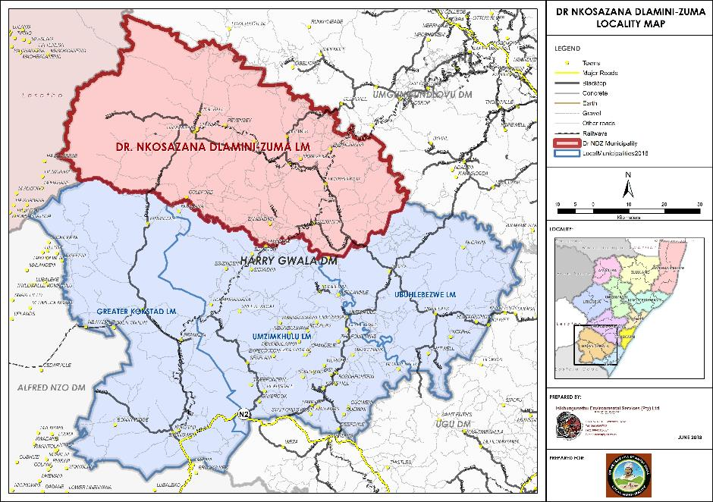
It is a requirement that the plan should set strategies and timeframes for the development of housing in the area and should also be linked to the Municipal Integrated Development Plan (IDP) as well as the Provincial DoHS Master Spatial Plan in order to ensure the alignment of programmes and objectives at all spheres of governance.
Broadly, the Human Settlement Plan sets out to consider the following:

What the current situation is
Status Quo analysis
What DNDZ municipality wants to achieve
Future Planned Human Settlement
How does DNDZ municipality get to the desired state
Housing sector strategies and implementation plan

1.1 Objectives
The Human Settlements Plan (herein after referred to as ‘HSP’) has a number of objectives:
- To ensure that the limited resources available are used most effectively
- To gain consensus on the prioritisation of housing projects
- To ensure more integrated development through co-ordinating development activities of role players including the municipality and the Department of Human Settlements
- To improve linkages between the spatial development framework and the implementation of projects on the ground
- To provide a focus for human settlements within the IDP

1.2 Outputs
In order to achieve these objectives, the HSP needs to provide the following outputs:
- A priority implementation list of the relevant housing projects in the municipal area
- Preliminary assessment of the technical and social feasibility of all projects in the municipal area
- Confirmation of IDP linkages for all prioritised projects
- Co-ordination of MIG and other funding for projects
- Budget and broad project programmes
- Transfer of skills to local municipalities

2. METHODOLOGY
The Dr Nkosazana Dlamini Zuma (DNDZ) Municipality Housing Sector Plan represents the human settlement planning undertaken by the municipality within the context of its Integrated Development Plan (IDP) 2017 to 2022. It is intended that this Housing Sector Plan will form a chapter of the DNDZ IDP within the 2018/19 IDP review cycle, ensuring an integrated approach.
A human settlement plan, in order to be effective, must be aligned to the national and provincial policies, legislation and priorities. The plan must also be guided by the municipal development objectives as contained in the municipal IDP and Spatial Development Framework and relevant sector plans.
Human settlement plans, as mandated by the National Housing Act, No. 107 of 1997, seeks to provide safe and secure housing, focusing on the poor and marginalised communities. Human settlement plans seek to secure more than adequate housing. The KwaZulu-Natal Housing Act No 132 of 1998 requires that municipalities ensure the economic, efficient and effective provision, operation and maintenance of services in respect of water, sanitation, electricity, roads and storm water drainage.
It is therefore the responsibility of the municipality to ensure that access to land for housing is accelerated and that the necessary bulk infrastructure and services are planned for and/or is available for the proposed human settlement development.
Human settlements, in order to be sustainable, must consider the socio-economic situation, existing housing typologies (dwelling condition), spatial planning as well as environmental and other constraints.
Based on the above, the Human settlement plan preparation followed the process illustrated below:
Figure 2: Dr Nkosazana Dlamini Zuma Human Settlement Plan methodology
Phase 1: Situational analysis
Phase 2: Synthesis, Vision and strategies
Phase 3: Human Settlement Sector Plan
Development of Human Settlement Policy in line with findings of the situational analysis, Vision and strategies

2.1 Situational Analysis
This phase considered the legal and policy context of human settlement development cascading from the Constitution, to the National Housing Act, No. 107 of 1997, the Municipal Systems Act, No. 32 of 2000, the National Environmental Management Act, Act No 107 of 1998 and the KwaZulu-Natal Housing Act, Act No. 132 of 1998. Attention was also given to policy instruments such as the Provincial Growth and Development Plan, the associated Provincial Spatial Development Framework and the DoHS Human Settlements Master Spatial Plan.
The focus then shifted to the analysis of the 2017 to 2022 IDP, reflecting on the spatial framework, its nodal focus and strategic directives in respect of human settlement. This was complimented by a review of the situational analysis of the Dr NDZ Municipality socio-economic situation, housing typologies, utility services, land use and land suitability.
This analysis therefore confirmed where the human settlement had been planned strategically and verified that the human settlement planning was aligned to spatial planning including nodes and transportation corridors.
Figure 3: Situational Analysis Framework

Legal framework
Policy framework
IDP: Municipal strategic framework
DNDZ Municipal Situational Analysis
Outcome
- Identification of the strategic human settlement projects aligned to the IDP
- Confirmation of alignment with Municipal Nodes and corridors and densely populated areas
- Identification of challenges: Significant housing backlog and poor communities
- Strategic housing location and land suitable for development correlate
- uKhahlamba World Heritage site not affected

2.2 Vision and Strategies
The situational analysis was followed by the development of a Vision and Strategies.
In terms of this phase, the process was initiated by considering the housing policy framework, with emphasis on principles. This contextual review was followed by a synthesis of the local context considering the spatial context, demographics, the socio-economic situation and constraints. The above was subjected to a SWOT analysis to identify the main strengths, weaknesses, opportunities and treats which was used to inform the strategies and the vision. Attention was also given to the current housing demand and delivery rates.
Figure 4: Vision and strategy report methodology
Step 1
Review of the housing policy framework, including:
- The national housing context
- The KwaZulu-Natal housing context
- The principles for settlement and housing investment
- Principles of housing development
- Housing support grants

Step 2
Assess the local context, giving attention to:
- The municipal spatial context
- Demographics
- Economic context
- Infrastructure
- Social context
- Constraints in respect of the Situational Analysis

Step 3
Undertake a SWOT analysis using the housing policy framework and the local context to identify the main strengths, weaknesses, opportunities and treats which will be used to inform the strategies and the vision

Step 4
Current housing demand
Step 5
Vision and strategies
Step 6
Land identification, aligned to the IDP and planned housing projects aligned to the HSP priorities

2.2.1 Strategies identified
Strategies identified include the following:
- Establishing sustainable communities
- Developing the necessary institutional structures
- Making provision for HIV/AIDS affected people, child-headed households and disabled people
- Sustainable settlement planning and associated services
- An integrated approach towards sustainable human settlements
Each of these main strategies were further defined in projects, discussed later in section 6.5.

2.3 Housing Sector Plan
Phase 3 of the project represents the culmination of all the above information and seeks to address the following:
- The legal and policy framework
- A synthesised local municipal situational analysis, informed by the municipal IDP.
- The strategies developed to facilitate the implementation of the Housing Sector Plan
- Project planning, monitoring and evaluation
- Institutional arrangements

3. POLICY AND LEGISLATIVE FRAMEWORK
This section considers the policy and legislative environment at the national and provincial levels.

3.1 National Legislation

3.1.1 The Constitution
The Constitution of the Republic of South Africa is a legal document which establishes the fundamental rules and principles by which the Republic is governed. It defines the nation’s fundamental political principles and establishes the power and duties of each sphere of government. For the purpose of this study, it is important to understand the principles and the rights of the people in terms of housing provision within the Republic.
Section 26 of the Constitution states that:
- Everyone has the right to have access to adequate housing.
- The State must take reasonable legislative and other measures within its available resources to achieve the progressive realisation of the right.
- No one may be evicted from their home or have their home demolished, without an Order of Court made after considering all the relevant circumstances. No legislation may permit arbitrary evictions.
From the above statements it is clear that the right to adequate housing is for all residents of South Africa. For those who cannot afford to pay for housing it is the responsibility of the State and its implementing agents to unlock the system, to provide access to housing stock as well as the legislative framework to facilitate self-built houses through planning laws and access to finance. Access also implies that it is not only the state that is responsible for the provision of houses but that other agents within society, including individuals themselves, must be enabled by legislative and other measures to provide housing.
The State’s obligation to provide access to adequate housing depends on context and it may differ from province to province, from city to city, from rural to urban areas and from person to person. Some may only need access to land, some may need access to land and building materials, some may need access to finance, and some may need access to services such as water, sewage, electricity and roads. It is thus important for each agent that is implementing housing provision to clearly define the type of access that is required in a particular circumstance.
The core principles stated in Section 26 of the Constitution are:
- The State must respect, protect, promote and fulfil the rights in the Bill of Rights, especially the right to equality, human dignity and access to information.
- There must be legislation, policies and programmes giving effect to section 26 which must, in essence, be reasonable within their social, economic and historical context as well as within the availability of resources
- The needs of the most vulnerable in society require special attention such as devising, funding, implementing and supervising measures to provide relief to those in desperate need. Operation Sukuma Sakhe is a good example of government action on this important mandate.
- The State must examine legal, administrative, operational and financial barriers to accessing socio-economic rights and where possible, take steps to lower them over time so as to ensure the progressive realisation of the right, i.e. so that a larger number and wider range of people can get access to adequate housing over time.
- Responsibilities and tasks must be clearly allocated to different spheres of government and the appropriate financial and human resources must be available.
- There must be proper monitoring of progress in implementing housing projects and programmes.
- Communities must participate in housing policy, process and programmes.

2.1.2 National Housing Act
The Housing Act No. 107 of 1997 hereafter referred to as the Housing Act, sets out the housing development guidelines as well as the roles and responsibilities of all spheres of government for housing. The role of the Local Municipality, as defined in the IDP, is to take necessary steps in line with the National and Provincial housing legislation to:
- ensure that inhabitants of its area of jurisdiction have access to adequate housing on a progressive basis;
- conditions not conducive to the health and safety of the inhabitants of its area of jurisdiction are prevented or removed and
- services in respect of water, sanitation, electricity, roads, storm water, drainage and transportation are provided in the manner which is economically efficient.
Furthermore, the role of Local Government is to set housing delivery goals, identify and designate land for housing development; create and maintain the public environment conducive to housing development; initiate, plan, facilitate, promote and enable appropriate housing development in its area of jurisdiction.
Some of the general principles for housing that are applicable to all spheres of governance include:
- giving priority to the needs of the people with respect to housing;
- ensuring that housing development provides a wide choice of housing and tenure options;
- housing development is in line with the Municipal Integrated Development Plan;
- promote provision of community and recreational facilities in residential areas and
- caters for the housing needs of marginalised women and other groups disadvantaged by unfair discrimination.
Based on the above principles, the role of Local Government should be to ensure that its obligations in terms of housing development are met and that the measures used are in line with the principles of cooperative governance.

2.1.3 The Municipal Systems Act - MSA
The MSA, No.32 of 2000, gives meaning to the term “developmental government”, where “development” means sustainable development; including integrated social, economic, environmental, spatial, infrastructural, institutional, and organisational and human resources revitalisation of a community. It aimed to:
- improve the quality of life of its members with specific reference to the poor and other disadvantaged sections of the community; and,
- ensure that development serves present and future generations.
It is with this understanding that all Municipalities should seek to ensure that the housing needs of its residents are met in order to comply with this developmental approach of the Act. The MSA also provides that a municipality must undertake developmentally oriented planning so as to ensure that it:
- strives to achieve the objects of local government as set out in section 152 of the Constitution;
- gives effect to its developmental duties as required by section 153 of the Constitution; and,
- together with other organs of state contributes to the progressive realisation of (certain) fundamental rights.
With this in mind, Chapter 5 of the MSA gives guidance in the preparation of IDP’s of Municipalities. This is a strategic plan for the municipality which aligns the development goals of the municipality with the financial resources that the municipality has. As part of the IDP the municipality should assess the levels of existing development, formulate strategies for development and align its strategies with the financial plan of the Municipality. The MSA provides that the planning undertaken by a municipality must be aligned with, and complement, the development plans and strategies of other affected municipalities and other organs of state so as to give effect to the principles of co-operative government contained in section 41 of the Constitution.
Municipalities have a key function to undertake integrated development planning and maintain housing areas. Municipal Housing Development Plans must be used to inform the housing component of the IDP. The focus on land and service delivery through provincial housing programmes has implications for municipalities and their integrated development planning.

2.1.4 National Environmental Management Act - NEMA
Section 24 of the Constitution authorises the enactment of the National Environmental Management Act, No. 107 of 1998. NEMA recognises that many inhabitants of South Africa live in an environment that is harmful to their health and well-being; that everyone has the right to an environment that is not harmful to his or her health or well-being and that the State must respect, protect, promote and fulfil the social, economic and environmental rights of everyone and strive to meet the basic needs of previously disadvantaged communities. It indicates that sustainable development requires the integration of social, economic and environmental factors in the planning, implementation and evaluation of decisions to ensure that development serves present and future generations.
Furthermore, everyone has the right to have the environment protected for the benefit of present and future generations, through reasonable legislative and other measures that prevent pollution and ecological degradation; promote conservation; and secure ecologically sustainable development and use of natural resources while promoting justifiable economic and social development. The environment is considered as a functional area of concurrent national and provincial legislative competence, and all spheres of government and all organs of state must co-operate with, consult and support one another. Based on the above, activities that may have a significant effect on the environment and that require authorisation or permission by law, must be considered, investigated and assessed prior to their implementation. This includes environmental impact assessments as well as assessing social impacts and impacts on cultural heritage. Section 24(2) of NEMA indicates that certain activities may not commence without prior authorisation from the Minister or MEC.
For these activities to take place an investigation of the impact on the environment is required. The new EIA regulations have been drawn up in terms of the Act and these should be used in order to assess the impact of intended development on the environment.

2.1.5 Spatial Planning and Land Use Management Act - SPLUMA
The Spatial Planning and Land Use Management Act No. 16 of 2013 (referred to SPLUMA) was gazetted on 5 August 2013, having been accented by President Zuma, on 2 August 2013. The purpose of the Act, inter alia, is to:
- provide a framework for spatial planning and land use management in the whole of South Africa;
- specify the relationship between the spatial planning and the land use management system and other kinds of planning;
- provide for inclusive, developmental, equitable and efficient spatial planning at all different spheres of government;
- ensure that the system of spatial planning and land use management promoted social and economic inclusion;
- provide for the sustainable and efficient use of land;
- address the imbalance of the past and to ensure that there is equity in the application of spatial development planning and land use management systems; and,
- SPLUMA applies to the whole of South Africa, including urban and rural areas and governs informal and traditional land use development processes.
With specific reference to human settlement, SPLUMA further subscribes to the principles of the Constitution, referring to the section 26 of the Constitution, recognising the importance of the right to adequate housing (preamble), section 21(f) of SPLUMA recognising the importance of Municipal SDFs including housing demand across different socio-economic categories, the location and density of future housing developments and section 21(i) reflecting on the importance of inclusionary housing.

2.2 Provincial Legislation

2.2.1 KwaZulu-Natal Housing Act
In terms of a provincial context, the KwaZulu-Natal Housing Act No 132 of 1998 is the most important provincial statute to regulate housing issues in the province and its local municipalities. This Act sets outs the roles, responsibilities, duties and functions of both the Province and Local Municipalities. In terms of this Act, it is the duty and responsibility of the Local Municipality to:
- take all reasonable and necessary steps to ensure that the inhabitants of its municipal area have access to adequate housing;
- set sustainable housing delivery goals in respect of its municipal area;
- identify and designate land for housing purposes;
- ensure the economic, efficient and effective provision, operation and maintenance of services in respect of water, sanitation, electricity, roads and storm water drainage; and,
- regulate health and safety standards relating to housing development.
It is the function of the municipality to ensure that access to land for housing is accelerated and that the necessary bulk infrastructure and services are planned for and/or is available for the proposed housing development. Furthermore, the municipality may:
- initiate, plan and execute projects, provided that in such cases where a project forms part of a housing programme for which the municipality is accredited in terms of section 18, the project shall be referred to the Minister for approval;
- facilitate and co-ordinate housing development in its municipal area; and
- participate in any housing programme by:
  - promoting a housing development project by a developer;
  - entering into a joint venture contract with a developer in respect of a housing development project;
  - establishing a separate business entity to execute a housing development project; or
  - facilitating participation in the housing process.
The above duties and responsibilities calls for necessary measures to be taken by municipalities to ensure that an environment conducive for housing development exists. The strategies and financial plans of the municipality should reflect its obligation to perform such duties for its inhabitants.

2.2.2 KZN Planning and Development Act - PDA
In terms of the Provincial Gazette Notice No. 54 of 22 April 2010, the KwaZulu-Natal Planning and Development Act, Act No. 6 of 2008 substantially came into operation on 1 May 2010. The purpose of the Act is to:
- promote a uniform planning and development system that treats all citizens of the Province equitably;
- provide a fair and equitable standard of planning and development to everyone in the Province while accommodating diversity such as urban and rural needs;
- incorporate and build on good practices and approaches to planning and development which have evolved outside of the formal planning and development system; and
- promote a planning and development system that redresses the historic injustices perpetuated by a fragmented planning and development system.
The Act requires that planning and development decisions must be taken by local government, with appeals being resolved through an independent tribunal appointed by the responsible Provincial Member of the Executive Council.
This Act provides for the adoption, replacement and amendment of a scheme. The purpose of a scheme is to regulate land use and to promote orderly development in accordance with the Municipality’s Integrated Development Plan. The Act requires that a municipality must within five years from the commencement of the Act adopt a scheme or schemes for its whole area of jurisdiction. Once adopted a municipality must review a scheme within six months after it has adopted an Integrated Development Plan for its elected term as contemplated in section 25 of the Municipal Systems Act.
In terms of the transitional arrangements set in the Act, the provisions of a town planning scheme already adopted must be treated as a scheme adopted in terms of the Act. The Act provides for procedures for application for development of land outside of schemes.

4. POLICY INSTRUMENTS

4.1 Provincial Growth and Development Strategy - PGDS
The Cabinet adopted the PGDS Review Framework at the February 2011 Cabinet Lekgotla. The Draft 2030 Vision and PGDS was adopted by Cabinet on 31 August 2011. The strategy was revised in 2016, now considering the 2035 Vision.
The purpose of the PGDS is to:
- focus on a clear vision and development strategy for the Province;
- promote vertical, horizontal and spatial alignment;
- mobilise and synchronise strategic plans and investment priorities in all spheres of government and business and all other social partners in order to achieve the desired growth and development goals, objectives and outcomes and
- build on the strengths and opportunities of the Province, while addressing weaknesses and threats.
The 2016 provincial vision as contained in the PGDS states that:
“By 2035 KwaZulu-Natal will be a prosperous Province with a healthy, secure and skilled population, acting as a gateway to Africa and the World.”
The Strategic Goals for the province as indicated in the PGDS are depicted below:
Figure 5: Strategic Goals for the Province as indicated in the PGDS
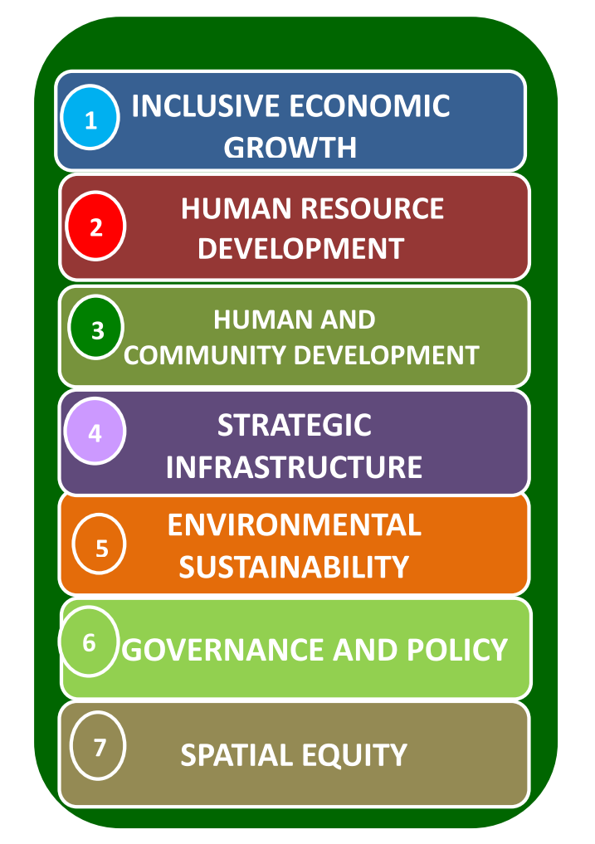
Source: PGDS, 2016: 21.
The implementation of Vision and Strategic Goals aspire to lead to the following:
- position the province as a gateway to South Africa and Africa;
- development of human resources to improve socio-economic standards;
- sustainable use of resources;
- safe, healthy & sustainable living environments;
- healthy educated communities;
- employable people are employed;
- basic services;
- more equitable society;
- world class infrastructure;
- investors’ confidence;
- skilled labour force;
- strong & decisive leadership; and,
- foster social compacts.
The citizens of KwaZulu-Natal in terms of the “Citizen’s Survey” identified, “the provision of housing” as the second most important priority after “Job creation”.
Table 1: Citizen's Survey: KwaZulu-Natal
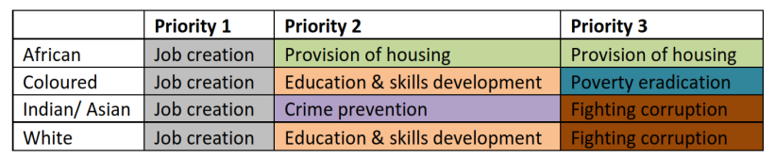
Source: PGDS, 2016:71.
The PDGS (2016, 117) further highlights the importance of putting in place programmes aimed at providing housing for the elderly, with medical care provided as part of the programme.
Strategic objective 3.4 deals directly with sustainable Human settlement.
The provision of housing has in the past dominated the approach to human settlements. The housing programme has evolved into human settlement approach, now requiring liveable human settlements. The approach now includes, “…designing a safe and sustainable living environment, infrastructure that allows and enables economic activity, delivery of services and social facilities as well as ongoing maintenance capacity (PGDS, 2016: 123). Reference is also made to the programme complications associated with land reform difficulties.
The PGDP also recognises the housing programme is affected by land-related constraints relating to tenure. In this regard it is noted that DNDZ municipality has 17,8% of land under the ownership of the Ingonyama Trust Board and 22,4% under protection as part of the uKhahlamba Drakensberg Park World Heritage Site and buffer area.
The need for access to social facilities such as schools, clinics as well as provision of road linkages to markets and other economic activities must inform the way in which human settlements are designed.
The requirements for integrated planning / polycentric planning require co-ordination across various departments, in conjunction with municipalities, and it is imperative for private sector partnerships to be developed. With this being one of the main areas for delivery in the Province, the establishment of a joint provincial forum addressing integrated development planning is important as a strategic means to take forward the issue of housing delivery.

4.2 Provincial Spatial Development Framework (SDF)
The Provincial Spatial Development Plan as per the Provincial Growth and Development Plan (2016), identifies the area along the Drakensburg, i.e., uKhahlamba Drakensburg Park World Heritage Site which needs to be protected (PGDP, 2016, 17).
In terms of the National Environmental Management Act (Act No. 107 of 1998) development, as specified in GNR 327 is restricted outside urban areas and within 10 kilometres from national parks or world heritage sites or 5 kilometres from any terrestrial protected areas.
Large tracts of Dr NDZM is also identified as areas in need of social need (PGDP, 2016, 18).
The Critical Biodiversity Areas (CBA’s) can be divided into two subcategories, namely irreplaceable and optimal. Irreplaceable areas are the only areas for which the conservation targets for the biodiversity features contained within it can be achieved. Development is not recommended for these areas. Dr NDZ municipality has a high proportion of CBAs of irreplaceable value relative to the other municipalities of the District. The high prevalence of CBAs within Dr NDZ municipality may influence and restrict development.
The above has significant implications for the HSP. The uKhahlamba Drakensberg World Heritage Site, and the protective legal and other policies will restrict housing in these areas, whilst the agricultural value will need to be protected through careful planning and urban/ settlement edges.

Figure 6: KZN Provincial SDF
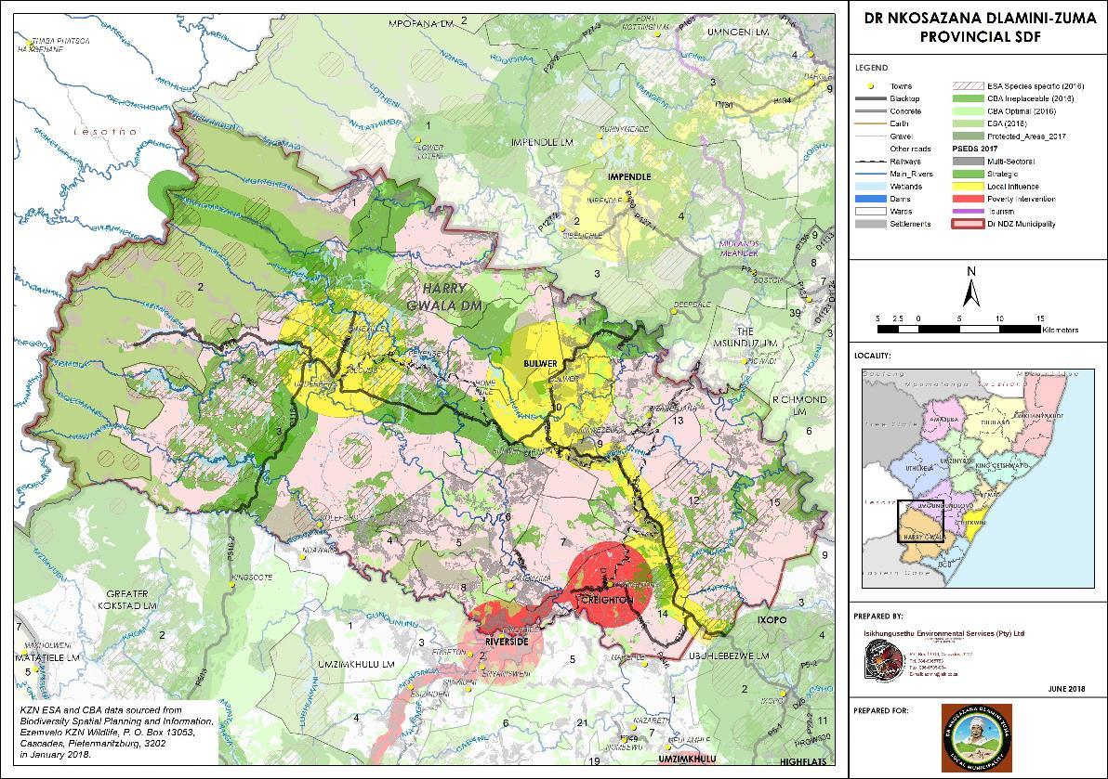

4.3 KZN Dept of Human Settlements Annual Performance Plan 2017/18 - 2019/20
The report, inter-alia, focused on critical service delivery issues, including a strong focus in respect of the upgrading of informal settlements and accelerating national and provincial priorities. It is confirmed that housing delivery has a fundamental role to play in socio-economic transformation.
Reference is made to the five priorities of government for the period 2014/15 -2018/19, which are:
- creation of more jobs, decent work and sustainable livelihoods for inclusive growth;
- rural development, land reform and food security;
- education;
- health; and
- fighting crime and corruption.
These five priorities are supplemented by the recognition of the need to, inter alia, expand access to housing and basic services.
The report further reflects on its commitment to the National Development Plan and Chapter 8 of the Vision 2030. The report explains that chapter 8 of the Plan relates to transforming human settlements and the national space economy to “create the conditions for more humane and environmentally sustainable living and working environments” and achieving a “decent standard of living.” The plan further seeks a holistic approach, including access to employment opportunities, provision of transport to work, housing and basic services.
The guiding role of the Provincial Growth and Development Strategy and the Provincial Growth and Development Plan as key strategic planning tools which inform the development of human settlements.
As part of the planning process, a reflection of the Department’s service delivery performance in relation to the Medium Term Strategic Framework Outcome 8 targets, was discussed to ascertain the Department’s achievements and challenges towards achieving social transformation in addressing inequalities of the past through the creation of sustainable human settlements.
One of the major achievements of provincial Human Settlements planning is the development of a Human Settlements Master Plan following the 2014 directive of the Minister Lindiwe Sisulu directive to embark on a Human Settlements Master Plan, developed through the integration of the following:

Figure 7: KwaZulu-Natal Human Settlements Master Plan components
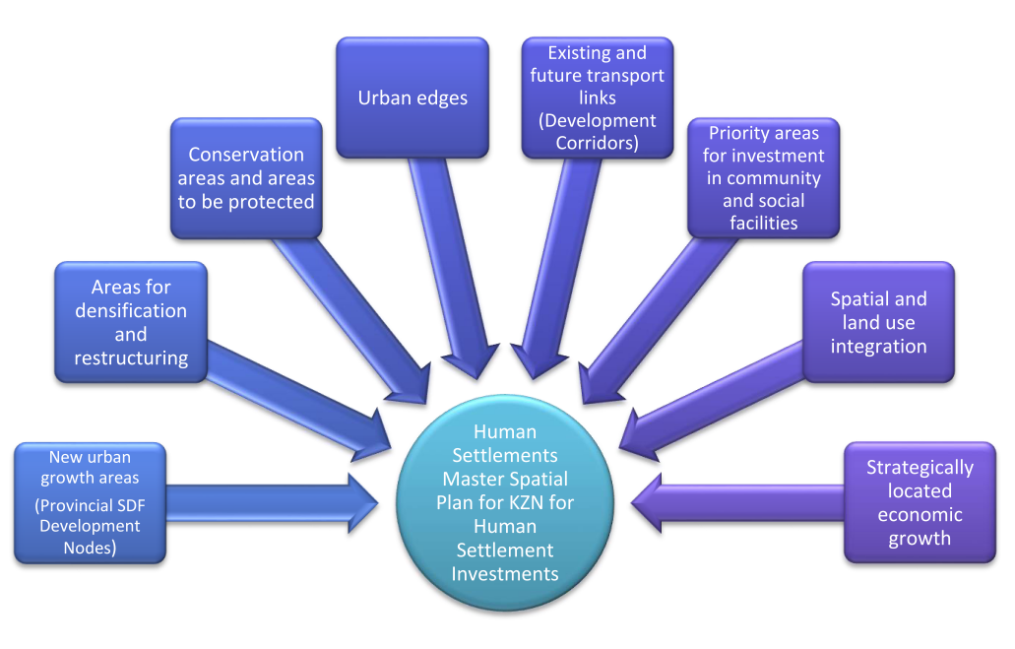
The roll out and implementation of the Master Spatial Plan is already taking place in the bigger municipalities and pilot municipalities and this is therefore a critical implementation tool.
Based on the above and the integration of the National Development Plan (NDP), the Provincial Growth and Development Plan, the Provincial Spatial Economic Development Strategy and Operation Sukuma Sakhe (OSS), the Provincial Master Map below was developed.
The Provincial Human Settlement Master plan identifies a limited number of intervention areas in respect of Dr NDZ municipality.

Figure 8: KwaZulu-Natal Human Settlements Master Plan
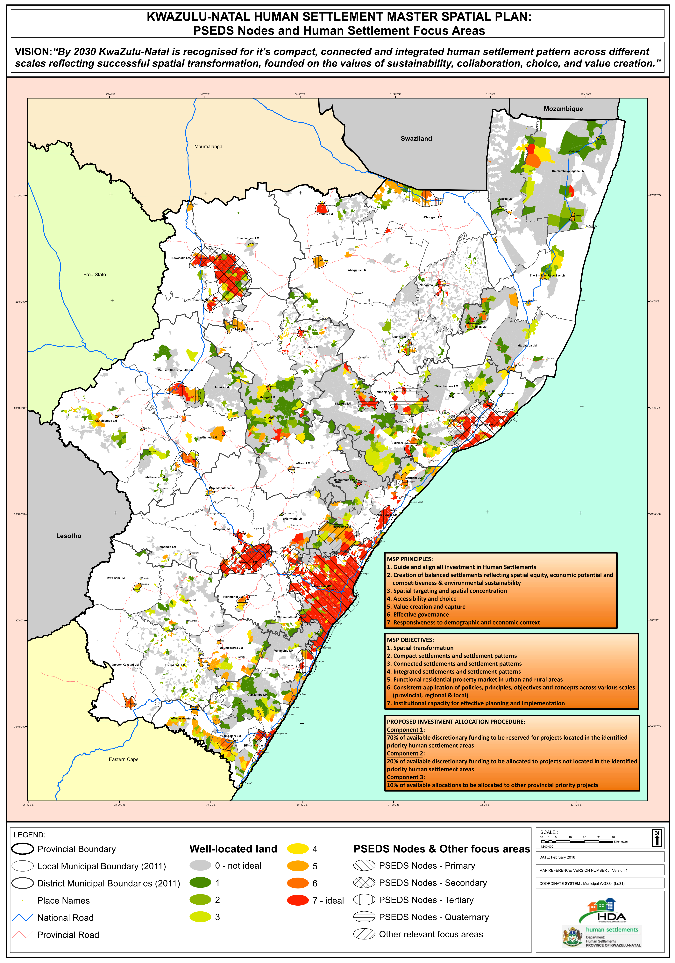

4.4 The Densification Strategy
Densification requires a proper planning framework at all spheres of government. The mandate for these functions vests with municipalities, supported by COGTA. Also, in terms of rural planning, support is required from the ITB as the custodian of traditional land. The Department of Human Settlements will be feeding into these processes. Densification occurs in both an urban and rural context.
Urban – practice of densification is established:
- Vertical in terms of multi-storey (see Msunduzi examples below):
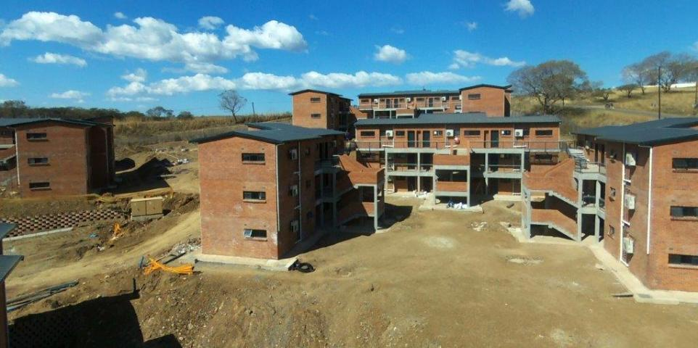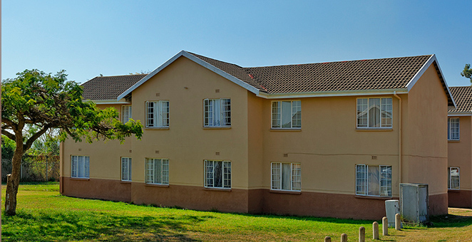
- Horizontal in terms of smaller cities, concentrated development (e.g. 80 sq. in eThekwini, 70 in Cape Town).
- Mix of vertical and horizontal development.
- Examples rental housing types, integrated development settlements such as Cornubia, and Rocky Park and informal settlement upgrade projects, CRU, and Social Housing Projects.
- CSIR Redbook engineering and town planning prescripts apply.
- The process is driven mainly by municipal planning.
- Limitations in terms of the subsidy quantum apply. These relate to higher levels of servicing (e.g. waterborne and tarred road surfaces) and building design interventions.
Rural approach
The rural context had initially been misunderstood. The approach, however, recognises that it is not possible to follow a “one-size-fits all” approach:
- Planning needs to be informed by the local dynamics.
- Some rural areas are already densely settled, thus densification in these areas is a natural phenomenon, especially those abutting existing towns.
- Rural type informal settlements are emerging.
- The suggested approach is not intended to undermine traditional practice, rather to facilitate future planning and land use due to limited resources, and to provide a planning framework for future service delivery and development.
- The rural approach does not imply subdivision of land, but look at settlement plans that should result in a progressive and incremental approach to service delivery.
- This needs more flexible application, based on social and technical dynamics.
Proper settlement planning is crucial; it must be centred on accommodating the existing settlement pattern whilst also providing for future development needs (e.g. infrastructure such as roads) and safe sites for occupation.
The concept of densification should be promoted as a tool to be applied on a case-by-case basis, starting with areas that are already dense in nature and/or where new settlements are planned. The questions to be considered are: “Where do we densify and why?”
Responses would be guided by issues such as alignment with the Provincial Growth and Development Strategy and the relationship with existing dense settlements. Municipal planning criteria and technical conditions (including the need and costs of infrastructural services) needs to be taken into account.

4.5 National Directives

4.5.1 State of the Nation Address, 2017
In the State of the Nation Address (2017) by President Jacob Zuma, the main element of the vision includes the following:
- combating poverty, inequality and unemployment;
- Nine Point Plan to re-ignite growth and associated job creation;
- bulk water-supply various areas with specific reference to increasing access to vulnerable and rural municipalities;
- improved education;
- radical socio-economic transformation;
- more than 4 million houses have been provided by Government since 1994; and,
- the re-opening of land claims.

4.5.2 National Housing White Paper
The Housing White Paper indicates that the national housing vision includes the establishment and maintenance of habitable, stable and sustainable public and private residential environments to ensure viable households and communities in areas allowing convenient access to economic opportunities, and to health, education and social amenities in which all citizens and permanent residents of the Republic will, on a progressive basis, have access to permanent residential structures with secure tenure, ensuring internal and external privacy and providing adequate protection against the elements, as well as potable water, adequate sanitary facilities and domestic energy supply. This vision, the seven key strategies and the principles and points of departure, form the cornerstones of the national housing policy. It resulted in the publication of the National Housing Code.
The National Housing Code sets out the Housing Policy for South Africa and contains the overall vision for Housing in South Africa and the way in which the vision should be implemented. Seven (7) strategies have been identified in the Housing Code. These strategies are integral to the Housing Policy:
- Stabilising the housing environment in order to ensure maximum benefit of State housing expenditure and facilitate the mobilisation of private sector investment.
- Mobilising housing credit and private savings (whether by individuals or collectively) at scale, on a sustainable basis and simultaneously ensuring adequate protection for consumers.
- Providing subsidy assistance to disadvantaged households to assist them to gain access to housing.
- Supporting the peoples housing process entailing a support programme to assist people who wish to build or organise the building of their homes themselves.
- Rationalising institutional capacities in the housing sector within a sustainable long term institutional framework.
- Facilitating speedy release and servicing of land.
- Co-ordinating and integrating public sector investment and intervention on a multi-functional basis.
In line with these strategies; the government has set up various mechanisms that are aimed at ensuring that the housing of the country is implemented.

4.5.3 Breaking New Ground (2004)
The document outlines a plan for achieving sustainable human settlements which needs to be addressed over the next five years. Sustainable human settlements are: “those settlements that provide healthy and secure living environments and where everyone will have access to the services and goods produced by society”.
Priority areas of the plan are to:
- increase access to housing through subsidies catering for people who earn up to R 7000 pm;
- integrate sustainable settlement: enhancing location and design through housing land policy;
- accredit municipalities in order to assign them to perform some of the housing duties that are currently done by provincial departments;
- promote job creation and alleviation of poverty; and,
- provide rural housing including the provision of housing for the farm workers.
One of the key lessons learnt in the review of the outcomes of housing programmes since 1994 is that, owing to a variety of reasons, low income settlements continued to be located on the urban periphery without the provision of social and economic amenities, as in the apartheid era, hence there is a renewed focus on integrated development and area based planning. This needs an assessment of what is needed, by whom, why, to what extent and who is involved in the delivery and this requires a people centred approach.
Government still has extremely limited resources and therefore is not able to assist all the citizens at the same time thus areas are to be prioritised and planned holistically. The Comprehensive Plan shifts the focus to improving the quality of housing and housing environments by integrating communities and settlements. Hence a shift from housing to creating sustainable environments through the integration of services to improve living environments.
It also sets new minimum standards for housing products improving privacy and sustainability by providing for the development of a range of social and economic facilities in housing projects. The Comprehensive Plan also focuses on Informal Settlement Upgrading to meet the Millennium Goals of the United Nations to improve the lives of slum dwellers.

4.5.4 The Housing Code
The National Housing Code of 2009 (update from the 2000 Code) sets the underlying policy principles, guidelines, norms and standards for the various government housing assistance programmes.
The Code contains the national housing policy and the procedural guidelines for the effective implementation of the policy (i.e. it sets out the specifics of the housing assistance programmes). Each provincial government housing department and each municipality should have copies of the Code. The Code is a legal document and is treated as such by the Courts.
The Code comprises several volumes: Volume 1 is a simplified guide to the Code and gives the policy context; Volume 2 comprises the technical guidelines (Ministerial norms and standards, general qualification criteria, environmental guidelines, EPWP programme, variation manual for subsidy amount adjustments and a monitoring and evaluation section). Volumes 3 – 6 comprise the National Housing Programmes grouped into 4 themes: financial interventions; incremental interventions; social and rental interventions; and, rural interventions.

4.5.5 Rural Housing Development
Taking into consideration that rural housing development in the province will take place on tribal land; the KZN Provincial Housing Department drafted a policy that guides housing development on rural land. The policy reiterates the need of alignment of housing projects with the municipal IDPs and that integrated planning should be promoted through ensuring that the different government departments that deal with matters of land development are brought into play to discuss housing development issues in rural areas. The core issue in rural housing is tenure security which should be considered before any housing development takes place. In the case where land rights are vested with the Ingonyama Trust or the Department of Land Affairs; a land availability agreement will have to be concluded with these authorities and this will serve as sufficient proof of development rights on the land.
The granting of common law long term leases will provide sufficient security of tenure to satisfy the requirements of the housing subsidy scheme. In areas where functional security of tenure exists, (i.e. traditional areas where formal tenure is not possible but where beneficiaries are permitted to live on the land in accordance with the traditional arrangements), informal rights to land must be uncontested in order for Rural Subsidy Mechanism to take place.
For freehold tenure and long-term tenure leases tenure options; the institutional subsidy mechanism is the most appropriate to apply. In cases where permission to occupy (PTO) is a common tenure option; the Rural Subsidy Mechanism will be used. This mechanism requires consultation with the Department of Housing and the Department of Land Affairs. In summary, the following roles and responsibilities of municipalities in terms of housing development are reiterated:
- Municipalities must ensure the delivery of sustainable, effective and efficient municipal services. Municipalities must promote social and economic development.
- Municipalities must encourage a safe and healthy environment by working with communities in creating environments and human settlements in which all people can lead uplifted and dignified lives.
- Municipalities must promote sustainable development which includes integrated social, economic, environmental, spatial, infrastructural, institutional, and organisational and human resources revitalising of a community.
- Planning undertaken by a municipality must be aligned with, and complement, the strategies of other affected municipalities and other organs of state so as to give effect to the principles of co-operative government.
- Participation in all processes and programmes must be ensured and promoted.
- Land release procedures must be speeded up.
- Local government is a distinctive sphere of government, interdependent, and interrelated with national and provincial spheres of government and therefore the principle of developmental local government is stressed.
- Municipalities must exercise their executive and legislative authority within the constitutional system of co-operative government. On the other hand, the national and provincial spheres of government must exercise their executive and legislative authority in a manner that does not compromise or impede a municipality’s ability or right to exercise its executive and legislative authority.
- A culture of accountability, openness and transparency in the public administration or in the exercise of a public power or the performance of a public function must be promoted.

4.5.6 National Development Plan 2030 - NDP
The National Development Plan aims to eliminate poverty and reduce inequality by 2030. South Africa can realize these goals through, growing an inclusive economy, building capabilities, enhancing the capacity of the state, and promoting leadership and partnerships throughout society.
The plan focuses on the critical capabilities needed to transform the economy and society. Achieving these capabilities is not automatic, nor will they emerge if the country continues on its present trajectory. Rising levels of frustration and impatience suggest that time is of the essence: failure to act will threaten democratic gains. In particular, South Africa must find ways to urgently reduce alarming levels of youth unemployment and to provide young people with broader opportunities.
Progress over the next two decades means doing things differently. Given the complexity of national development, the plan sets out six interlinked priorities:
- uniting all South Africans around a common programme to achieve prosperity and equity;
- promoting active citizenry to strengthen development, democracy and accountability;
- bringing about faster economic growth, higher investment and greater labour absorption;
- focusing on key capabilities of people and the state;
- building a capable and developmental state; and,
- encouraging strong leadership throughout society to work together to solve problems.
While the achievement of the objectives of the National Development Plan requires progress on a broad front, three priorities stand out:
- raising employment through faster economic growth;
- improving the quality of education, skills development and innovation; and,
- building the capability of the state to play a developmental, transformative role.
A sustainable increase in employment will require a faster-growing economy and the removal of structural impediments, such as poor-quality education or spatial settlement patterns that exclude the majority. These are essential to achieving higher rates of investment and competitiveness and expanding production and exports. Business, labour, communities and government will need to work together to achieve faster economic growth. Social cohesion needs to anchor the strategy. If South Africa registers progress in de-racialising ownership and control of the economy without reducing poverty and inequality, transformation will be superficial. Similarly, if poverty and inequality are reduced without demonstrably changed ownership patterns, the country’s progress will be turbulent and tenuous.
Longer term interventions from the local authority need to take cognizance of the following:
- Promote mixed housing strategies and more compact urban development to help people access public spaces and facilities, state agencies, and work and business opportunities.
- Invest in public transport, which will benefit low-income households by facilitating mobility.
For infrastructure that supports human settlements (housing, water, sanitation, roads, parks and so on) the picture is unnecessarily complicated. The planning function is located at local level, the housing function is at provincial level, and the responsibility for water and electricity provision is split between those responsible for bulk services and reticulation. In practice, these arrangements do not work. In general, human settlements are badly planned, with little coordination between those installing water reticulation infrastructure and those responsible for providing bulk infrastructure. Responsibility for housing should shift to the level at which planning is executed: the municipal level. The plan sets out recommendations for effective urban development. Local government faces several related challenges, including poor capacity, weak administrative systems, undue political interference in technical and administrative decision-making, and uneven fiscal capacity.
The Commission believes that within the framework of the Constitution, there is more room for the asymmetric allocation of powers and functions and for more diversity in how developmental priorities are implemented. To achieve this, longer-term strategies are needed, including addressing capacity constraints, allowing more experimentation in institutional forms and working collaboratively with national and provincial government.
Reshaping South Africa’s cities, towns and rural settlements is a complex, long-term project, requiring major reforms and political will. It is, however, a necessary project given the enormous social, environmental and financial costs imposed by existing spatial divides. The Commission proposes a national focus on spatial transformation across all geographic scales. Policies, plans and instruments are needed to reduce travel distances and costs, especially for poor households. By 2030, a larger proportion of the population should live closer to places of work, and the transport they use to commute should be safe, reliable and energy efficient.
This requires:
- Strong measures to prevent further development of housing in marginal places
- Increased urban densities to support public transport and reduce sprawl
- More reliable and affordable public transport and better coordination between various modes of transport
- Incentives and programmes to shift jobs and investments towards the dense townships on the urban edge
- Focused partnerships with the private sector to bridge the housing gap market.
Rural areas present particular challenges. Policies are required to bring households in these areas into the mainstream economy. There are rural areas, however, where transport links are good and where densification is taking place in the absence of effective land-use management and urban governance. These require urgent interventions.
Noting the key elements of Human Settlements Vision 2030:
- The total eradication of the backlog of plus 2, 1 million housing units which translates into approximately 12.5 million people.
- The outlay of the Human Settlements budget as opposed to that of mere housing in order to create more employment opportunities and thus contribute to increased economic growth and development via the roll out of bulk infrastructure such as sanitation, water etc.
- The creation of integrated community settlements encompassing facilities and amenities such as schools, hospitals, places of worship, sporting facilities and most importantly commercial and industrial areas within reasonable distances from residential areas.
- The utilization of densification and inner-city high-rise strategies to harness economies of scale and thus house more people per square meter.
- The encouragement and facilitation of People’s Housing Process where residents can construct their own houses thereby making them less dependent on government. Ours is a developmental and not a welfare state.
- The total eradication of ghettos including the potentially explosive issue of backyard dwellers many of whom have been in dire straits long before those who are recent land invaders.
- To solicit a greater buy-in by the corporate sector as a partner of government, labour and community stakeholders in campaigns such as the “Each-One-Settle-One” due to be launched later this year.

4.5.7 National outcomes
The 12 National Outcomes that all provincial governments must align to are:
- Quality basic education
- A long and healthy life for all South Africans
- All people in South Africa are and feel safe
- Decent employment through inclusive economic growth
- Skilled and capable workforce to support an inclusive growth path
- An efficient, competitive and responsive infrastructure network
- Vibrant, equitable, sustainable rural communities contributing towards food security for all
- Sustainable human settlements and improved quality of household life
- Responsive, accountable, effective and efficient local government system
- Protect and enhance our environmental assets and natural resources
- Create a better South Africa, a better Africa, and a better world
- An efficient, effective and development oriented public service and an empowered, fair and inclusive citizenship
In terms of government's 12 outcomes, the Department of Human Settlements contributes directly to sustainable human settlements and improved quality of household life (Outcome 8). To accelerate the delivery of basic services and housing opportunities, and improve access to the property market, the Department of Human Settlements, together with provinces and municipalities, will focus on the following outputs over the medium term:
- Upgrading 400 000 units of accommodation within informal settlements
- Improving access to basic services by providing universal access to sanitation
- Facilitating the provision of 80 000 affordable social and rental housing units of accommodation in well-located areas
- Facilitating the provision of improved housing finance opportunities for 600 000 households within the gap market for people earning between R3 500 and R12 800
- Releasing 6 250 ha of public-owned land for housing development.

4.5.8 National priorities
The Five National and Six Provincial Priorities include the following:
- Job creation (Decent work and Economic growth)
- Education
- Health
- Rural development, food security and land reform
- Fighting crime and corruption
- Nation-building and good governance (State of KZN Province Address February 2010)

4.5.9 State of the Province (KZN) Address
The State of the KwaZulu-Natal Province Address was delivered by the Honourable Premier of the province, Mr T.W. Mchunu, on 01 March 2017. In his address the Premier aligns the Province with the strategic direction provided by the State of the Nation Address in meeting the challenges of unemployment, poverty and inequality. The Premier notes that the creation of decent work and building the economy, amid difficult circumstances, have been highlighted as top priority for Government and, consequently, the Province will respond by directing and demonstrating the opportunities available through integrated Government investment, infrastructural development and targeted policy choices. In his address the Premier touches on a number of service delivery, social and economic focus areas that have an impact on the communities in the Province including:
- poverty relief programmes;
- finding opportunities to overcome low levels of economic growth;
- adoption of the 2016 PGDS and the 2016/17 PGDP;
- management of education challenges;
- the need for social cohesion and moral regeneration as imperatives for nation building;
- government’s role in improving the land reform process and overcoming the current slow progress;
- agriculture and food security;
- radical economic transformation including radical agrarian socio-economic transformation (RASET);
- recognising vulnerable groups, promoting the advancement of youth and women;
- improving health;
- agriculture and food security;
- climate change and water provision;
- social development; and,
- fighting crime and corruption.

4.5.10 The Expanded Public Works Programme (EPWP)
The Expanded Public Works Programme (EPWP) has its origins in the Growth and Development Summit (GDS) of 2003. At the Summit, four themes were adopted, one of which was ‘More jobs, better jobs, decent work for all’. The GDS agreed that public works programmes ‘can provide poverty and income relief through temporary work for the unemployed to carry out socially useful activities’.
The Programme is a key government initiative, which contributes to Governments Policy Priorities in terms of decent work & sustainable livelihoods, education, health; rural development; food security & land reform and the fight against crime & corruption. EPWP subscribes to outcome 4 which states “Decent employment through inclusive economic growth.”
In 2004, the EPWP was launched and is currently still being implemented. The EPWP is a nationwide programme covering all spheres of government and state-owned enterprises. The Programme provides an important avenue for labour absorption and income transfers to poor households in the short to medium-term. It is also a deliberate attempt by the public sector bodies to use expenditure on goods and services to create work opportunities for the unemployed. EPWP projects employ workers on a temporary or on-going basis either by government, by contractors, or by other non-governmental organisations under the Ministerial Conditions of Employment for the EPWP employment conditions.
The EPWP creates work opportunities in four sectors, namely, infrastructure, non-state, environment & culture and social, through:
- Increasing the labour intensity of government-funded infrastructure projects under the Infrastructure sector,
- Creating work opportunities through the Non-Profit Organisation Programme (NPO) and Community Work Programme (CWP) under the Non-State sector, and
- Creating work opportunities in public environment and culture programmes under the Environment and Culture sector.
- Creating work opportunities in public social programmes under the Social sector.
The EPWP also provides Training and Enterprise Development support, at a sub-programme level. Part of this plan will involve participation in the national Expanded Public Works Programme (EPWP), which is aimed at addressing the problem of the unemployment, poverty problems and skills development. The EPWP provides an important avenue for labour absorption and income transfers to poor households in the short to medium-term.

4.5.11 Operation Sukuma Sakhe
Operation Sukuma Sakhe has a 'whole of Government approach' as its philosophical basis. It spells out every initiative and how it links to initiatives being implemented by the different sector departments and the spheres of government therefore delivery of services is required through partnership with community, stakeholders and government.
Operation Sukuma Sakhe is a continuous interaction between Government and the community to come together to achieve the 12 National Outcomes. We will encourage social mobilization where communities have a role, as well as delivery of government services in a more integrated way.
Government has structured programs which need to get as deep as to ward level, translating to all 11 districts and all households in all 51 municipalities.

5. STATUS QUO ANALYSIS
The situational analysis commences with a summary of the Provincial Growth and Development Plan, already dealt with in section 3 above. This is followed by a review of the main strategies identified by Harry Gwala District. Before unpacking the local situation, attention will be given to the KwaZulu-Department of Human Settlements Master Plan and its intentions for Dr NDZ municipality.

5.1 KZN Provincial Growth and Development Plan
The Provincial Growth and Development Plan (PGDP), in addition to setting strategic goals in respect of economic growth, human and community development, infrastructure development, environmental sustainability, governance and spatial equity planning, specifically addresses ‘sustainable human settlement’, in strategic objective 3.4.
It is acknowledged that the provision of housing has in the past dominated the approach in respect of human settlements. The housing programme has however evolved into human settlement approach, now requiring liveable human settlements. The approach now includes, “…designing a safe and sustainable living environment, infrastructure that allows and enables economic activity, delivery of services and social facilities as well as ongoing maintenance capacity. (PGDS, 2016: 92). Reference is also made to the programme complications associated with land reform difficulties.
The PGDP also recognises the housing programme is affected by land-related constraints relating to tenure. In this regard it is noted that Dr NDZ municipality has 17,8% of land under the ownership of the Ingonyama Trust Board and 22,4% under protection as part of the uKhahlamba Drakensberg Park World Heritage Site and buffer area.
The need for access to social facilities such as schools, clinics as well as provision of road linkages to markets and other economic activities must inform the way in which human settlements are designed.
The requirements for integrated planning / polycentric planning require co-ordination across various departments, in conjunction with municipalities, and it is imperative for private sector partnerships to be developed.

5.2 Harry Gwala Integrated Development Plan 2017 - 2022
The District Integrated Development Plan (DIDP) identifies a number of key challenges which in turn informs the strategic objectives of the district.

The key issues and strategic objectives are detailed below:
Key challenges | Strategic objectives
- Lack of water and associated bulk infrastructure  - Provision of clean drinking water and decent sanitation  - Linking spatial planning and infrastructure planning  - Attracting investment and growth  - Information and communication technology  - Service infrastructure in urban areas  - Poor waste management practices  - Socio-economic challenges including HIV/AIDS, crime youth unemployment and poverty. | - Finalise implementation of bulk infrastructure projects  - eradication of water and sanitation backlogs by 2030  - innovative and deliberate marketing of the district using tourism as the draw-card  - Development of SMME’s  - Sport development and fighting crime  - Institutional capacitation

In terms of housing, it is pointed that where there is a need for low-income housing, it must be provided in close proximity to areas of opportunity as per the “Breaking New Ground”, policy.
The DIDP recommends the development of a strategy for densification of cities and better located housing and settlements.
A hierarchy of housing provision, linked to the settlement hierarchy, is proposed. Notwithstanding this gradation of housing provision, reference is made to the need for housing opportunities close to agricultural employment opportunities.
In conclusion the DIDP recognises that Dr NDZ municipality is essentially rural in nature and is therefore characterised by relatively large pockets of settlement on Ingonyama Trust and State Land, requiring rural interventions.

5.3 KZN Department of Human Settlements Annual Performance Plan
This is dealt with in paragraph 4.3 above.

5.4 Local Situation
In terms of the local context, consideration will be given to the following: -
- the local spatial context, considering both the Situational Analysis findings integrated with the IDP spatial findings;
- Dr NDZ demographics;
- the economic context;
- infrastructure findings; and,
- social context
The above will become the input for a SWOT analysis, which in turn, together with the current housing projects which are discussed in the next section, will form the basis of the vision and strategies.

5.4.1 Spatial context
The Dr NDZ 2017 to 2022 Integrated Development Plan (2017 IDP) identifies an overall spatial development plan (see Figure 9 below) as well as particular human settlement planning recommendations.
The Dr NDZ IDP identified the following challenges in respect of services and infrastructure (page 29):
- Backlog of infrastructure to service rural communities
- Delay in housing delivery
- Ensuring adequate water and sanitation supply
- Lack of infrastructure that attracts investment
From a social point of view, the following were highlighted:
- High rate of unemployment and low economic growth
- High level of poverty
In respect of spatial and environmental planning (p 30) the following points were mentioned:
- Loss of natural capital
- Unsustainable development practices

5.4.2 DNDZ nodal classification
The Dr NDZ Municipal SDF uses a five-tier nodal classification (p 46), detailed below:
Nodal classification | Nodal description
Municipal Development Node | Economic centre that serves the entire municipal area
Community Development Node | Location of economic activities that serve the surrounding communities
Neighbourhood/ settlement Development Node | Location of economic activities that serve the surrounding settlements (urban/rural).
Rural Service Nodes | Local convenient shops and manufacturing activities
Long Term Future Node | Small local shops and farmstalls
Source: Adapted from Dr NDZ Municipality IDP review, 2017, p46

Based on the above nodal classification, the following nodes, also depicted on the Nodal Map (Figure 9) below refers.
Nodal classification | Nodes identified
Municipal Development Node | Bulwer and Underberg
Community Development Node | Himeville, Creighton and Donnybrook
Neighbourhood/ settlement Development Node | Centecow, Pholela and Richenau
Rural Service Nodes | Hlanganani
Long Term Future Node | KwaSani Pass, Bushmens Nek and Cobham

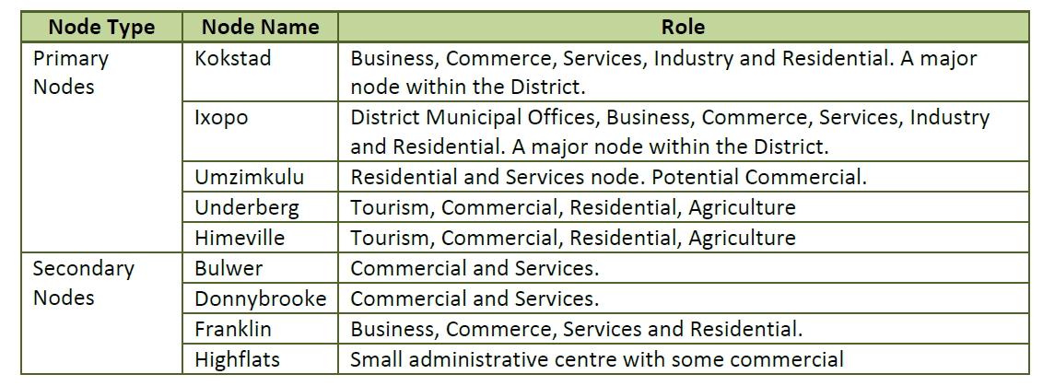
The Harry Gwala District Municipality’s IDP and District Growth and Development Plan identify the following nodal structure for the area:

5.4.3 Densification and urban and settlement edges
One of the tendencies identified in the IDP (2017 – 2022) is that the existing nodes exhibit low levels of densification. Densification is, however, only encouraged where there is sufficient infrastructural capacity to provide services for the densification process. Urban and settlement edges (p 44) were identified in respect of the following settlements.
Urban edges | Bulwer town, Underberg town, Creighton and Himeville
Settlement edges | Donnybrook, Pholela, Centacow, Memela, Masameni, Dazini, Mqatsheni, KwaPitela, Woodford, Pevensy, Enhlanhleni and Reichenau

Further settlement in these areas must therefore heed this strategy.

5.4.4 Restricted development and protection of agricultural land
The IDP discourages increased development within uKhahlamba-Drakensberg Park World Heritage Site (WHS), or the expansion of development towards uKhahlamba-Drakensberg Foothills. Similarly, expansion of the nodes near high potential agricultural land is undesirable.
Figure 9: Nodal Plan – Dr NDZ Municipality as per 2017-2022 IDP
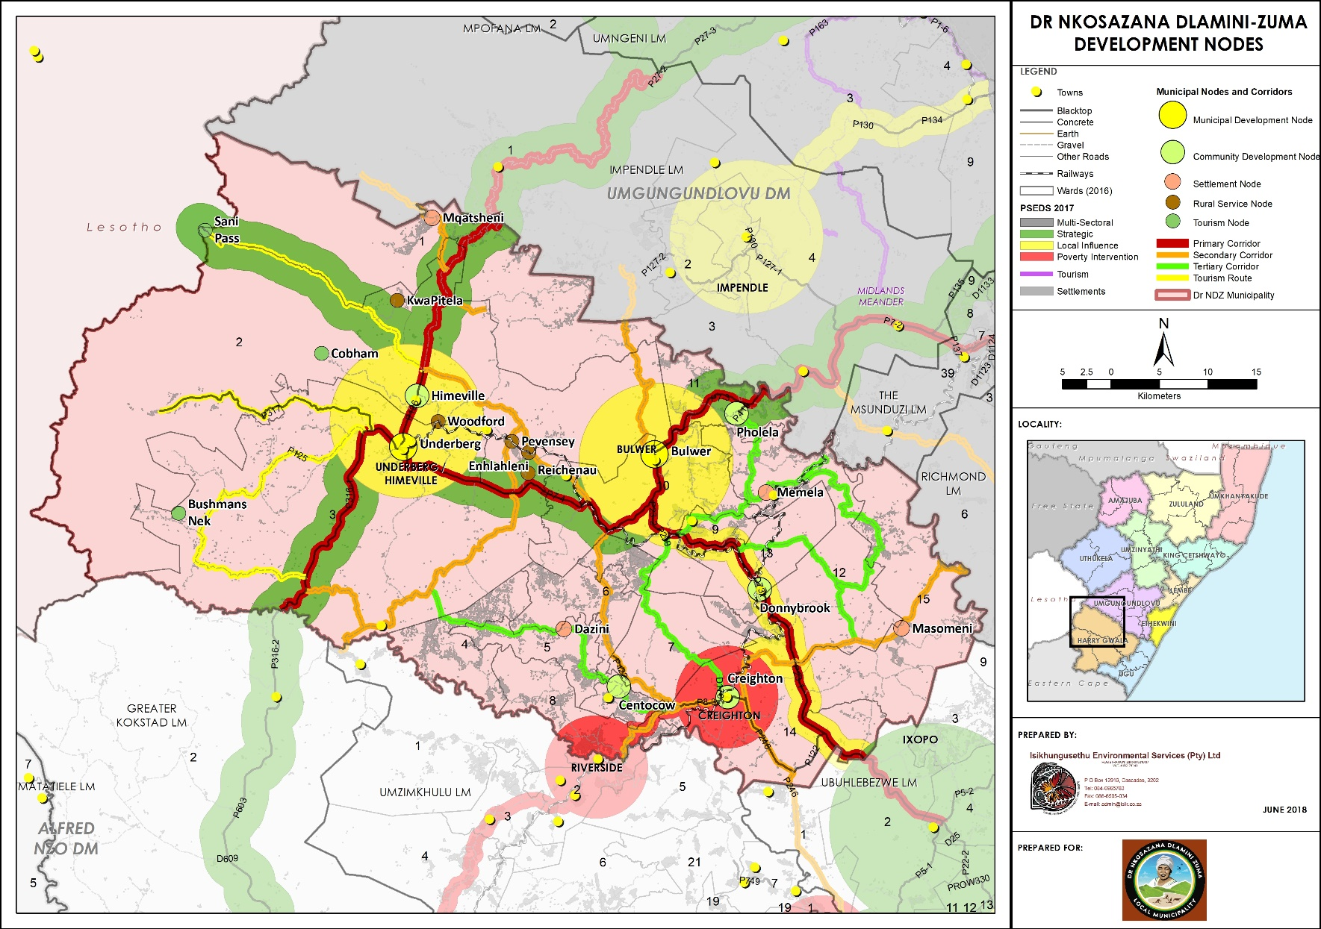
Figure 10: Dr NDZ Spatial Development Framework
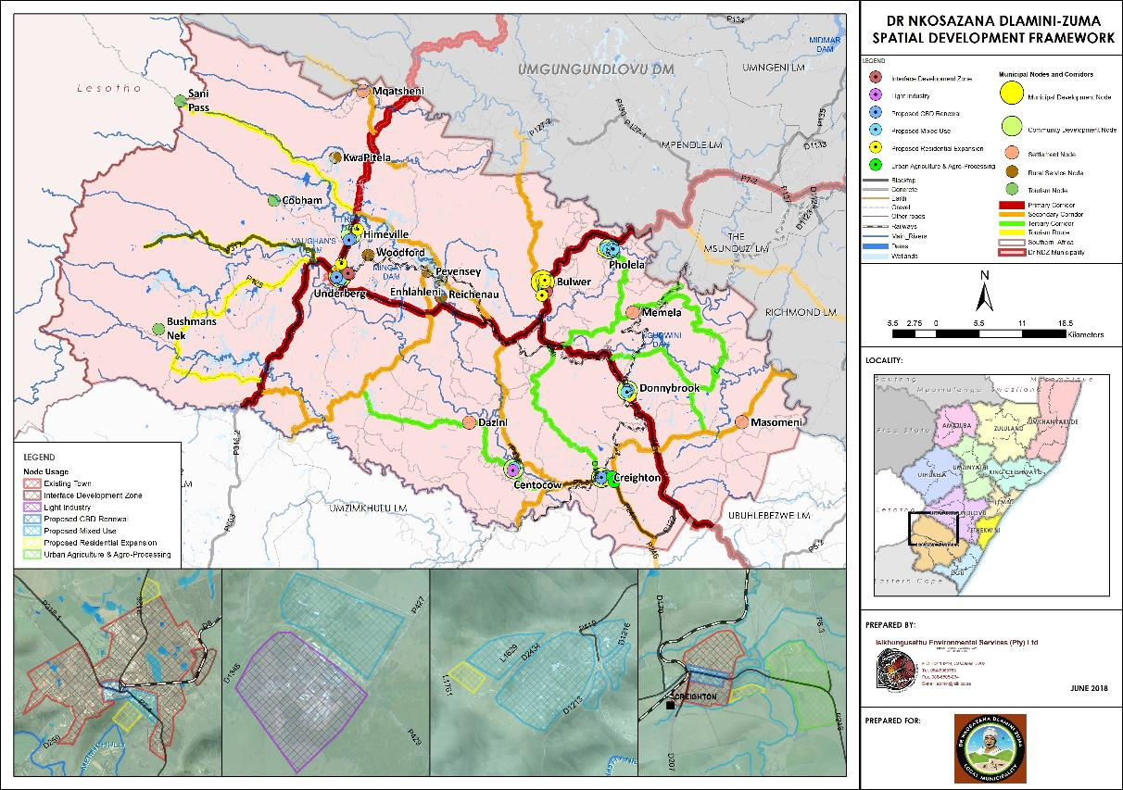

5.4.5 High-level settlement overview
The IDP 2017 (p 51) recommends that low-income housing should be provided in close proximity to areas of opportunity in compliance with the principles of the Breaking New Ground policy.
Dr NDZM is essentially considered to be rural in nature and thus the focus is on sustainable human settlements in the IDP and SDF (p 55). The higher concentration is evident in the south-west of the municipality (see Figure 10). Settlements are mainly situated along main transport routes and in the Traditional Authority areas (p187).

5.4.6 Current tenure situation and implications
The 2017 IDP (p 187) highlights that significant portions of land, previously under Ingwe Municipality, is mostly owned by the Ingonyama Trust Board (ITB) and administered by the traditional authorities. Similar observations were also made in the Harry Gwala District IDP. Reference is made to issues relating to the release of land for housing upgrades, registering of ownership and types of tenure offered, which does have negative implications in respect of project timeframes. This is also the land where the largest need is in respect of housing provision.
There is also a need to develop middle-income housing in the municipality to provide for, inter alia, civil servants who are working in the municipality and are seeking suitable affordable housing, which can be purchased with the assistance of government housing subsidies. Centres such as Bulwer and Donnybrook have been identified for this purpose (p 189).

5.4.7 Rural housing
Rural housing can largely be divided into two categories.

5.4.7.1 Traditional Council areas
A significant number of people are located on land held under communal tenure arrangements. The Ingonyama Trust Board (ITB) is the custodian for this land. There are rural areas where land is under freehold title. However, in some cases, this land is utilised on a collective basis and individuals have access to that land on a communal basis.

5.4.7.2 Commercial farming areas
There a number of farm workers who reside on land owned by private farmers, mostly in the North and North-west area.
Rural housing provision must be dealt with caution. When considering the DoHS provincial Master Plan, it is apparent that the focus of human settlement is aligned to urban or higher density nodes. The identification of potential areas in Dr NDZ municipality corroborates this view.
It is observed that a significant number of the 16 future housing projects are situate in rural, but more dense settlements.

5.4.8 Nodes and corridors in relation to municipal sensitive areas
The following documents identify nodes and corridors where capital investment and growth need to promoted to strengthen the proposed spatial structure of both the Harry Gwala District and Dr NDZ local municipality.
- Harry Gwala IDP
- Harry Gwala District Growth and Development Plan
- Dr NDZ IDP
- Dr NDZ SDF
- KZN PGDP
In order to guide development, it is imperative that areas where development should not be encouraged and supported are identified. Thus, where existing settlements or proposed development corridors fall within the identified areas any further development should be discouraged.
As part of the Situational Analysis, a map was generated (Figure 11) using the criteria below.
It is proposed that the following areas be excluded for green-field housing development sites:
- areas that are further than 30 minutes travel time, by public and other transport, from main roads;
- areas that are further than 30 minutes travel time, by public and other transport, from development nodes;
- areas that are further than 20 minutes travel time, by public and other transport, from social and other facilities;
- areas where the population density is less than 80 people per km²;
- environmentally sensitive areas - exclude all wetlands, reserves, private reserves and conservation areas as well as all areas with an Irreplaceability Index less than 0.8; and
- slope characteristics to exclude all areas with gradient more than 25%.

The report from the Department of Agriculture recommends that the following uses are allowed for the various categories:
- Category A: Irreplaceable - Land use will be restricted to those in support of primary agricultural production only. This may include agricultural infrastructure such as storage sheds, silo's, hay barns, water reservoirs, collection and storage of agricultural waste and on-farm composting facilities.

- Category B: Threatened - Land use will be restricted to those in support of primary agricultural production. Examples include agricultural infrastructure such as storage sheds, silos, hay barns, water reservoirs, collection and storage of agricultural waste and on-farm composting facilities.

Additional consideration may be given to small processing plants e.g. cheese making facilities, value adding food processing facilities, seedling nurseries, and temporary sawmills, small wildlife- / scenery- viewing structures e.g. bird hides and small on-farm farm stalls. These will however only be considered if located on the lower potential areas within the land parcel and will in no way negatively impact the existing farming activities on site, nor on surrounding land parcels, nor should they compromise the “right to farm”.

- Category C: Primary Agricultural Land Use - Land use within this land Category may include those mentioned for categories A and B as well as storage, packing and processing facilities of farm products, limited-footprint Agri-tourist facilities and small education or research structures in support of scientific awareness. These will however only be considered if located on the lower potential areas and will in no way negatively impact on the existing farming activities on site and on surrounding land parcels Preference will be given to land uses which will enhance the viability of the farming enterprise.
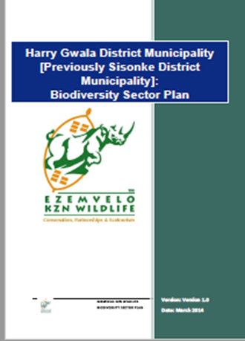
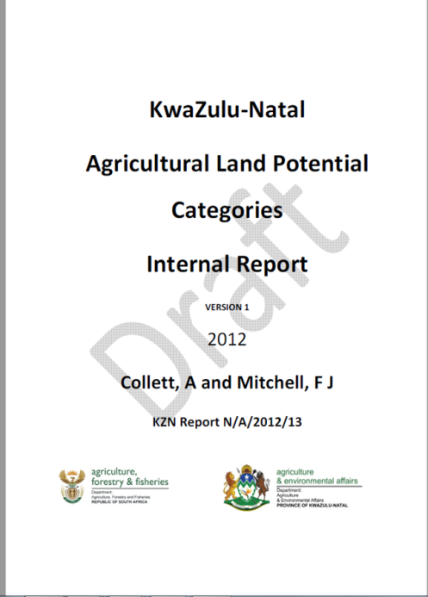

The following Environmental issues need to be taken into consideration as areas that shall not be developed:
- ESA (Ecological Support Area) - Functional, but not necessarily entirely natural, areas that are required to ensure the persistence and maintenance of biodiversity patterns and ecological processes within the Critical Biodiversity Areas.

- CBA Irreplaceable areas - Areas considered critical for meeting biodiversity targets and thresholds, and which are required to ensure the persistence of viable populations of species and the functionality of ecosystems.

- CBA Optimal - Areas that represent an optimised solution to meet the required biodiversity conservation targets while avoiding areas where the risk of biodiversity loss is high Category driven primarily by process but is also informed by expert input.

- Landscape Corridor - A series of bio-geographic corridors created in KZN to facilitate ecological and climate change processes to create a linked landscape for the conservation of species in a fragmented landscape.

- Critical linkage - Areas within Terrestrial Landscape Corridors that, due to the modification of the natural landscape within and surrounding the corridor, represent the only remaining and highly constrained link (i.e. pinch point on corridor) which, if lost, would result in the breakage of the corridor and corridor network. These areas are vital in maintaining the linkage of the corridor and its associated biodiversity related processes

Figure 11: Dr NDZ Municipal Development Areas
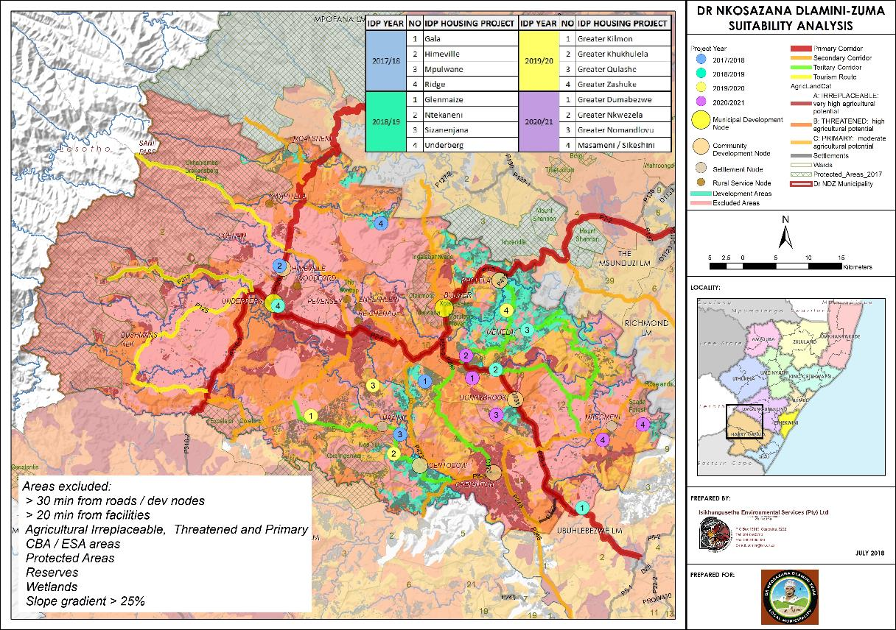

5.4.9 Environmental and other restrictions
The following Environmental issues need to be taken into consideration as areas that shall not be developed:
- The uKhahlamba Drakensberg Park World Heritage Site and buffer areas including Coleford; iGxalingenwa; Indhloveni; Ingelabantwana; Kwa Yili; Marutswa; Marwaqa; Soada Forest; Xotsheyake; Himeville; and The Swamp Nature Reserves.
- ESA (Ecological Support Area) - Functional, but not necessarily entirely natural, areas that are required to ensure the persistence and maintenance of biodiversity patterns and ecological processes within the Critical Biodiversity Areas.
- CBA Irreplaceable areas - Areas considered critical for meeting biodiversity targets and thresholds, and which are required to ensure the persistence of viable populations of species and the functionality of ecosystems.
- CBA Optimal - Areas that represent an optimised solution to meet the required biodiversity conservation targets while avoiding areas where the risk of biodiversity loss is high Category driven primarily by process but is also informed by expert input.
- Landscape Corridor - A series of bio-geographic corridors created in KZN to facilitate ecological and climate change processes to create a linked landscape for the conservation of species in a fragmented landscape.
- Critical linkage - Areas within Terrestrial Landscape Corridors that, due to the modification of the natural landscape within and surrounding the corridor, represent the only remaining and highly constrained link (i.e. pinch point on corridor) which, if lost, would result in the breakage of the corridor and corridor network. These areas are vital in maintaining the linkage of the corridor and its associated biodiversity related processes.
The resultant map (Municipal Development Areas Map, Figure 11 above) excluded the above areas, and indicates the areas where development, such as housing, can take place. Clearly, there are other factors such as high potential agricultural land which falls within the “development areas” depicted in the map, which should not be developed except for agriculture. A finer filter must therefore be employed at project level.

5.5 Dr NDZ Demographics
The information contained hereunder was derived from Stats SA 2016. This section will look at the number of households, the number of people and the average size per household. The 2011 census data adjusted to the 2016 boundaries has been use as this is the only data which is available by ward.
Table 2: Number of households
Source: Stats SA, 2011 Census data adjusted to 2016 boundaries
The total number of households declined slightly from 30 488 in 2011 to 29 591 in 2016. In this process cognisance must be taken of the demarcation changes in 2016, affected by the Demarcation Board. Any changes must therefore bear this in mind.
Table 3: Number of people
Source: Stats SA, 2011 Census data adjusted to 2016 boundaries
The current average household size is calculated per ward (population divided by households).
The largest number of households are situated in Ward 6 (10 240), Ward 4 (9 046) and Ward 14 (8 097), located in the South-east of the municipality, as depicted in Figure 12, the area most densely populated as confirmed by the 2017 IDP review. Also included in Figure 13 is the map of the population per ward, per category.
Figure 12: Number of households per ward

Figure 13: Population per ward based on categorisation
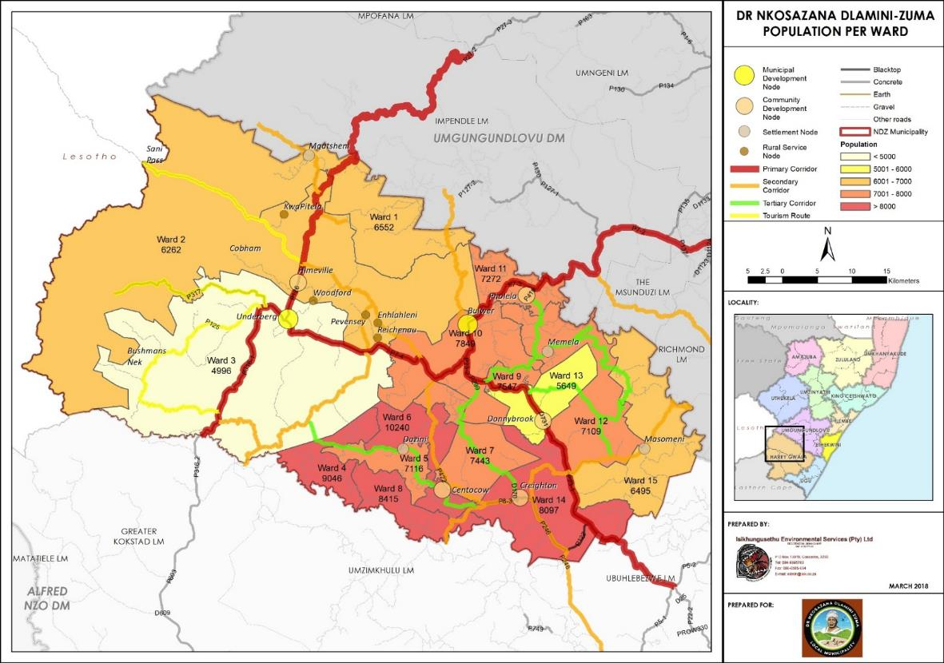

5.6 Economic Context
In respect of economic analysis, consideration has been given to the annual household income per ward.
This is also used to determine the demand for housing based on eligibility for housing subsidies. It should be noted that for households to qualify for a subsidy of some sort, the household needs to have an annual household income of R 153 800 or less calculated at a monthly household income of less than R12 800 per month.
Table 4: Distribution of annual household income
Source: Stats SA, 2011 Census data adjusted to 2016 boundaries

Based on the above assessment, a total of 28 238 or 95.43% households qualify for housing subsidies within the Dr NDZ area as depicted in Figure 14 below.
Figure 14: Percentage of persons per ward who qualify for the use of a DoHS subsidy

Figure 14 above identifies the households earning an income less than R 12 800 per month and therefore qualifying for housing subsidies. A total of 28 238 or 95.43% households qualify for housing subsidies within the Dr NDZ area.
The income levels, linked to economic opportunities, are very low. Ward 10 has the highest number of households 400 (17.7%) that have no form of income, followed by Ward 6 with 373 (16.52%) and Ward 2 with 351 (12.27%).

5.7 Social Context
In terms of the social context, the report will consider employment statistics and the housing typologies. The housing typologies will identify the need replace sub-standard structures with acceptable housing structures.
Employment statistics reveal that only 14.15% people within Dr NDZ municipality are employed, as detailed in Table 5. This represents a very low employment rate.
Table 5: Employment status per ward
Source: Stats SA, 2011 Census data adjusted to 2016 boundaries
Table 6 below reflects the different housing typologies within the Dr NDZ municipality, relating to the determination of housing demand, as per 2011 Census conducted by Stats SA.
Table 6: Different housing typologies at ward level
Source: Stats SA, 2011 Census data adjusted to 2016 boundaries
Table 6 above demonstrates that 7 410 of the 29 591 households live in formal accommodation (brick and mortar) where 22 181 households live in other forms of dwellings; therefore the housing demand can be estimated as a total of 22 181 units.

5.8 Infrastructural Context
This section seeks to assess the level of infrastructure provision in Dr NDZ municipality. It is very crucial to understand the capacity of infrastructure in the Municipality so as to be realistic when setting spatial development goals in relation to housing.

5.8.1 Water supply
The Harry Gwala District Municipality (HGDM) is the Water Services Provider (WSP) and is responsible for the implementation of new capital projects to extend the provision of water services facilities and their maintenance thereof. The District’s Water Services Development Plan (WSDP) indicates that the backlog of water services in DNDZ is still substantial.
The table below reflects the percentage distribution of households by type of water source on ward level, as per the Stats SA 2016 data. A meeting with DoHS on 6 March 2018, it was explained (Engelbrecht, personal communication) that water provision for housing in this municipality is generally not a concern. Water, in some instances, is tanked to community members.
Table 7: Access to piped water at ward level
Source: Stats SA, 2011 Census data adjusted to 2016 boundaries

From the above table, there can be seen that in 2016, 12 578 (or 42.5%) households in the municipality have access to piped water within their yard or dwelling. A total of 10 404 (35.2%) households have no access to piped water. Wards 2, 3, 10 and 14 are the best resourced, whilst Wards 4, 8 and 9 have the largest population without piped water.
In respect of water availability, the water availability map, provided at Figure 15 below, demonstrates the proposed human settlement areas are aligned to the areas supplied with water. The current projects at Bhidla, Manzimnyama, Ngcobo’s Farm, Tar’s Valley as well as two rural projects namely Stepmore and Maguzwane (complete) in the Lotheni area, Underberg and Bulwer are supplied with water. The 436-house extension in Himeville is however delayed due to the lack of services. Water provision is an important consideration, and potentially a restriction, in respect of human settlement development in Dr NDZ municipality.

5.8.2 Sanitation
Table 8 below reflects the percentage distribution of households by type of toilet facilities, as per the 2011 Census conducted by Stats SA.
Table 8: Access to toilet facilities at ward level
Source: Stats SA, 2011 Census data adjusted to 2016 boundaries

In above table can be seen that 927 (3%) of households have no access to toilet facilities and a total of 18 186 (61%) use pit toilets. A small amount of households 3 213 out of the 29 591 have access to flush toilet connected to a sewerage system. Ward 3 has the highest number of households 1 463 who have access to flush toilets connected to a sewerage system. Wards 6 to 8 have the highest amount of households using pit toilets consequently there is a high demand for flush toilets in this area. Ward 5 has the highest demand for toilets, a total of 187 households have no access to toilet facilities.

Figure 15: Dr NDZ Water Infrastructure
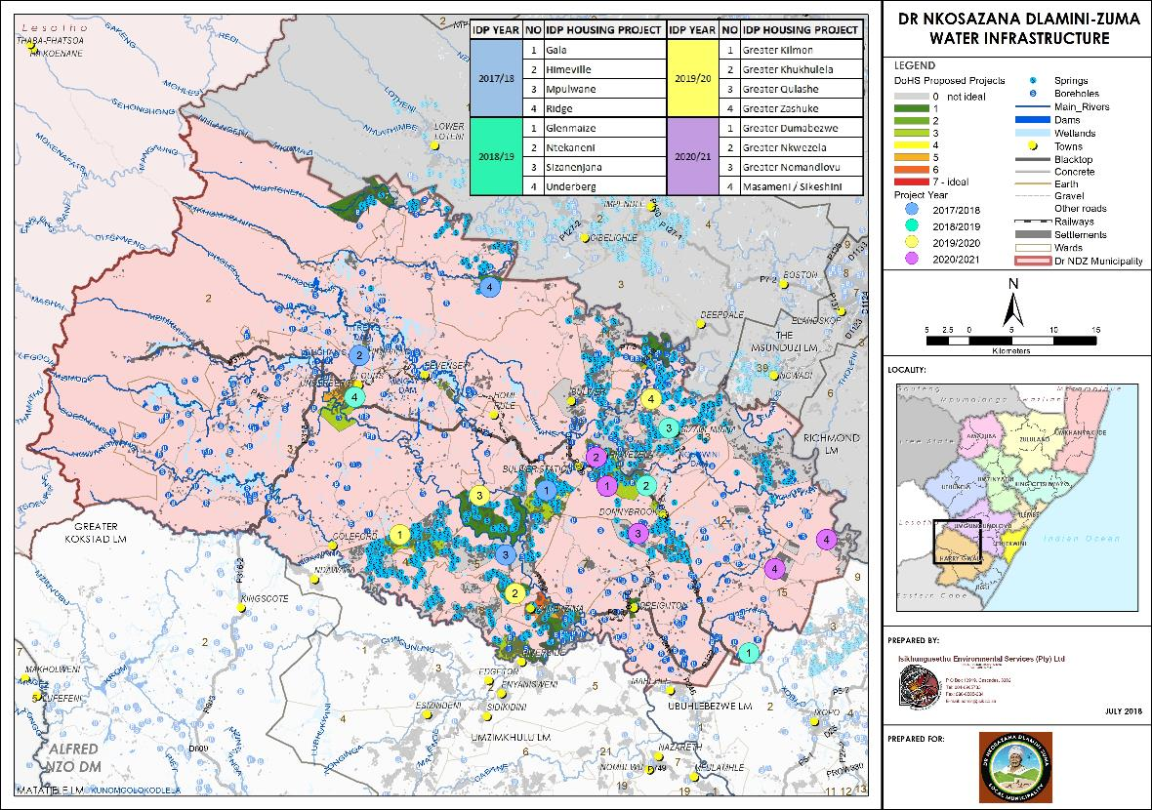

5.8.3 Roads and accessibility
The issue of access roads in the municipality requires attention. The Municipality has a short supply of good all-weather roads. There are some tar roads; however, the majority of roads are gravel and this may restrict the provision of some services such as waste removal, especially during heavy rain seasons.
The 2017 IDP review identifies the upgrade of gravel roads to asphalt surfaces in major towns as well as the construction of gravel access roads in rural areas (Dr NDZ IDP Review, 2017: 30). The 2017 IDP review, in terms of roads have identifies the following tertiary corridors:
Table 9: Tertiary corridors
Road designation | Corridor linkages
P 429 | Links Centocow with other areas in Amakuze and Isibonelo Esihle Traditional Council
P 299 | Branches off from the R612 and links with Creighton in a South-easterly direction
P 419 | Traverses Bhidla Traditional Council and links with the R612 South-west
P 282 | Branches off from the R612 and links with the P8-2
D 818 | Diverts off from the P419 and P282 and traverses traditional council areas such as Vezokuhle and Zashuke
Source: Adapted from IDP Review, 2017: 100.

As shown in Figure 16, the proposed human settlement developments are generally either on, or close to the main public transport routes. This will ensure accessibility as a critical human settlement consideration.

5.8.4 Electricity
The electricity network map indicates that the network covers the most densely populated areas. 83.75% of households in Dr NDZ municipality have access to electricity for lighting from mains. The availability of the network in the most densely populated areas is positive for service delivery as a large number of households can be reached within a relatively short distance and is thus cost effective and efficient.
The proposed future human settlement, as shown Figure 17 below, demonstrates that the proposed settlement is aligned to the Dr NDZ electrification network.

Figure 16: Dr NDZ Road Infrastructure
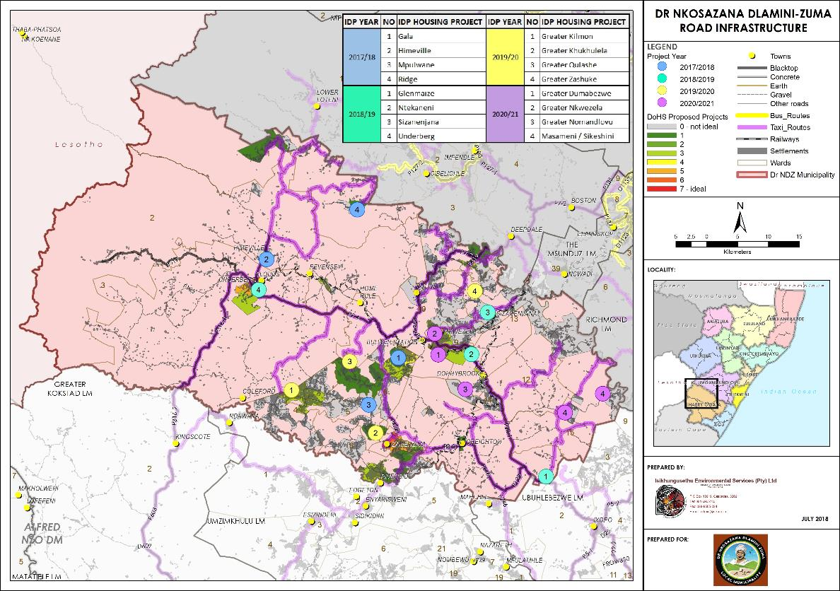
Figure 17: Dr NDZ Electricity infrastructure
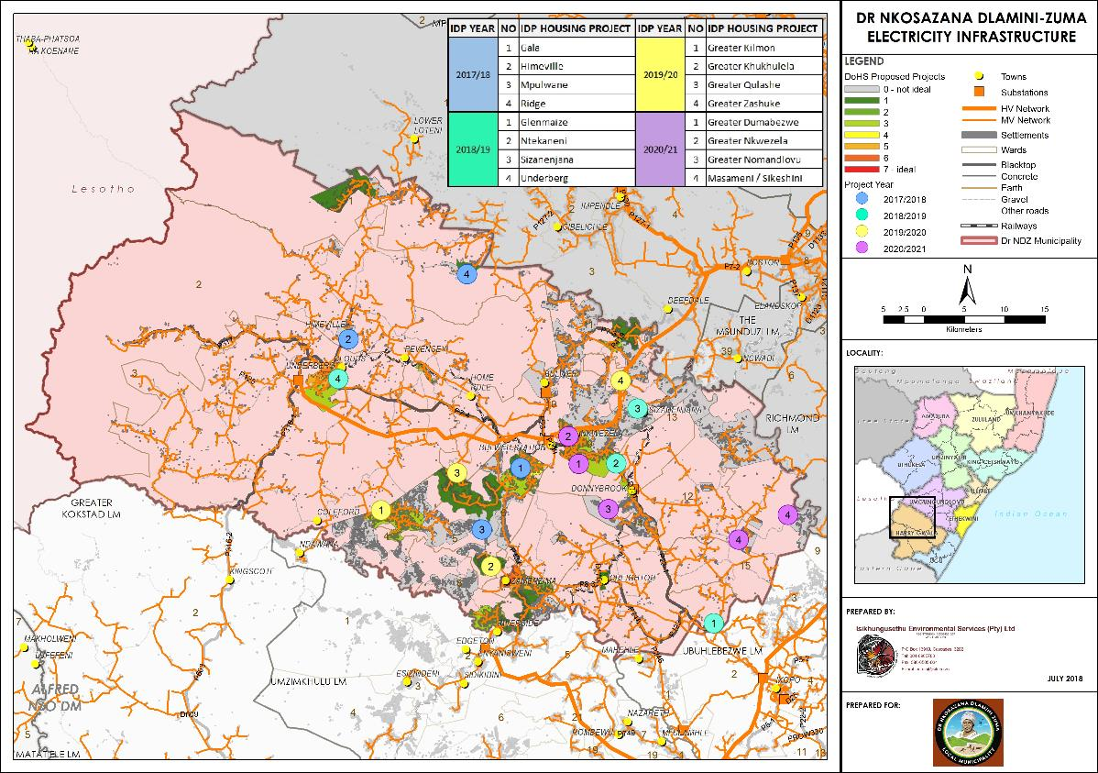

5.9 Current Housing Delivery Rate
Over the past 5 years seven housing projects involving 3 168 structures were commissioned as per Table 10 and Table 11 below. This is a long way from the 1000 houses per project and the initiation of 4 projects a year as is planned in terms of the Dr NDZ 2017 IDP Review.
In addition, funding is a concern. At this stage DoHS has only reserved funding of R300 000 for stage 1 projects meaning that the housing backlog will take an exceedingly long time to address and that the citizens of Dr NDZ must be made aware of this situation to curb any overly optimistic expectations regarding housing provision.
In order for the demand to be realised, the funding support and housing delivery rate will need to be increased significantly.
According to the Project Process document of the KZN Department of Human Settlements attached as Annexure 2 the following is applicable:
The project’s lifespan include the following phases:
- Prefeasibility process
- Feasibility process
- Implementation (Phase2)
- Implementation (Phase 3)
- Close out.
Annexure 3 provide a comprehensive overview of the National Housing Policy and Subsidy Programmes including the requirements to qualify for one of the subsidy programmes.

Table 10: Housing projects in process
Table 10a: Rural Housing and IRDP
Project typology | Rural housing |  |  |  |  |  | IRDP
DoHS Reference no. | K13040008 | K13040008 | K20020040 | K02110001 | K02110002 | K19970089 | K19970089 | K19970067 | Not available yet | K 19990002
Project Name | Bhidla  Ward 11 | Manzimnyama | Ngcobo's Farm | Stepmore | Maguzwane | Tarr'S Valley | Underberg  Ward 3 | Himeville | Himeville Extension | Bulwer
Number of beneficiaries | 500 | 500 | 160 | 400 | 800 | 227 | 217 | 137 | 436 | 315
Nearest centre/ node | 12 km from Bulwer | 12 km from Creighton | On Kwa HelaHela Road | Towards Lutheni | Towards Lutheni |  | Underberg | Himeville | Himeville | Bulwer Town
Project Stage | Stage 1 complete | Busy with Stage 1 Planning | Planning stage | Project complete | Project complete | Partly constructed | Project completed | Project complete | Stage 1 Planning Phase | Project complete
Project status | Planning stage complete: Finalising SCM processes to provide for approval of construction phase | Busy with Stage 1 Planning | Outstanding planning matters being finalised. Top structure application to be implemented | Finalised, at close-out stage | Finalised, at close-out stage | Dept of Human Settlement unblocking project. 85 more houses to be constructed. | Finalised, at close-out stage | Finalised, at close-out stage | Land swop land legal isssues  No bulk services available  Still in Planning stage | Finalised, at close-out stage
Project Value | R40 912 500 | R40 912 500 | R13 092 000 | R32 730 000 | R65 460 000 | R18 574 275 | R36 098 246,50 | R23 31750.00 | TBC | R15 887 552,45

Table 10b: Land Restitution and Sukuma Sakhe
Project typology | Land Restitution | Sukuma Sakhe
DoHS Reference no.
Project Name | Ehubeni Land Reform  Ward 3 | Gqumeni  Ward 7 | Kilmon  Ward 04 | Masamini & Kwa Jani Ward 15 | Masamini  Ward 5 | Bhobhoyi  Ward 8 | Sokela  Ward 13 | Nkwezela  Ward 9 | Bhidla  Ward 11 | Emakholweni  Ward 6
Number of beneficiaries | TBC | 16 | 17 | 47 | 3 | 5 | 4 | 1 | 2 | 1
Nearest centre/ node | TBC | Gqumeni | Kilmon | Masamini & Kwa Jani Ward 15 | Masamini | Bhobhoyi | Sokela | Nkwezela | Bhidla | Emakholweni
Project Stage | Project now under Sukuma Sakhe | Application to DoHs | Completed | Determining process | Application submitted to DoHS | Application submitted to DoHS | Application submitted to DoHS | Application submitted to DoHS | Application submitted to DoHS | Application submitted to DoHS
Project status | Awaiting exemption letter from DEDTEA.  Awaiting letter of commitment from Harry Gwala Municipality regarding bulk services. |  | Completed | Privately Owned Land. Development process being considered | Application submitted to Dept of Human Settlements. Awaiting approval. | Application submitted to Dept of Human Settlements. Awaiting approval. | Application submitted to Dept of Human Settlements. Awaiting approval. | Application submitted to Dept of Human Settlements. Awaiting approval. | Application submitted to Dept of Human Settlements. Awaiting approval. | Application submitted to Dept of Human Settlements. Awaiting approval.
Initial Planning | TBC | R 27 312 | R 29 019 | R 131 349 | R 5 121 | R 8 535 | R 6 828 | R 1 707 | R 3 414 | R 1707
House and variation | TBC | R2 187 536 | R2 324 257 | R6 425 887 | R 410 163 | R683 605 | R546 884 | R 136 721 | R273 442 | R 136 721
Estimated costs | TBC | R2 214 848 | R2 353 276 | R6 557 236 | R415 284 | R692 140 | R553 712 | R138 428 | R276 856 | R138 428
Source: Department of Human Settlements: Meyer,J. (2018/07/03).
At present, the Municipality has the following completed housing projects:
Table 11: Completed housing projects
Project number | Project | Project Type | Ward | Units | Houses built | Implementing agent | Project status | Cost
K02110001 | Stepmore | Rural Housing | 11 | 400 | 400 | Ntokozwene Developers | Completed | R21 643 264.50
K02110002 | Maguzwane | Rural Housing | 1 | 800 | 800 | Ntokozwene Developers | Completed | R52 227 584.38
K19970089 | Underberg | IRDP | 3 | 217 | 217 | NET Projects | Completed | R36 098 000.00
K19990002 | Bulwer | IRDP | 10 | 315 | 315 | Projecon Developers | Completed | R 15 887 552.45
K19970067 | Himeville | IRDP | 2 | 137 | 137 | NET Projects | Completed | R2 331 750.00
K20000000 | Donnybrook | IRDP | 13 | 71 | 71 | NET Projects | Completed | R6 355 060.00
K20000025 | Creighton | IRDP | 14 | 57 | 57 | Bambanane | Completed | R1 048 800.00
K091004 | Zidweni | Rural Housing | 4 | 500 | 500 | Umpheme Development | Completed | R39 412 095.04
K11010001 | Boarder View | Rural Housing | 8 | 500 | 500 | Umpheme Development | Completed | R39 291 101.08
Source: Dr NDZ municipality and Department of Human Settlements, Meyer.J (2018/07/03)

The existing human settlement projects undertaken in the past 7 years are spatially captured in Figure 18 below.

Figure 18: Existing Dr NDZ Municipality housing projects
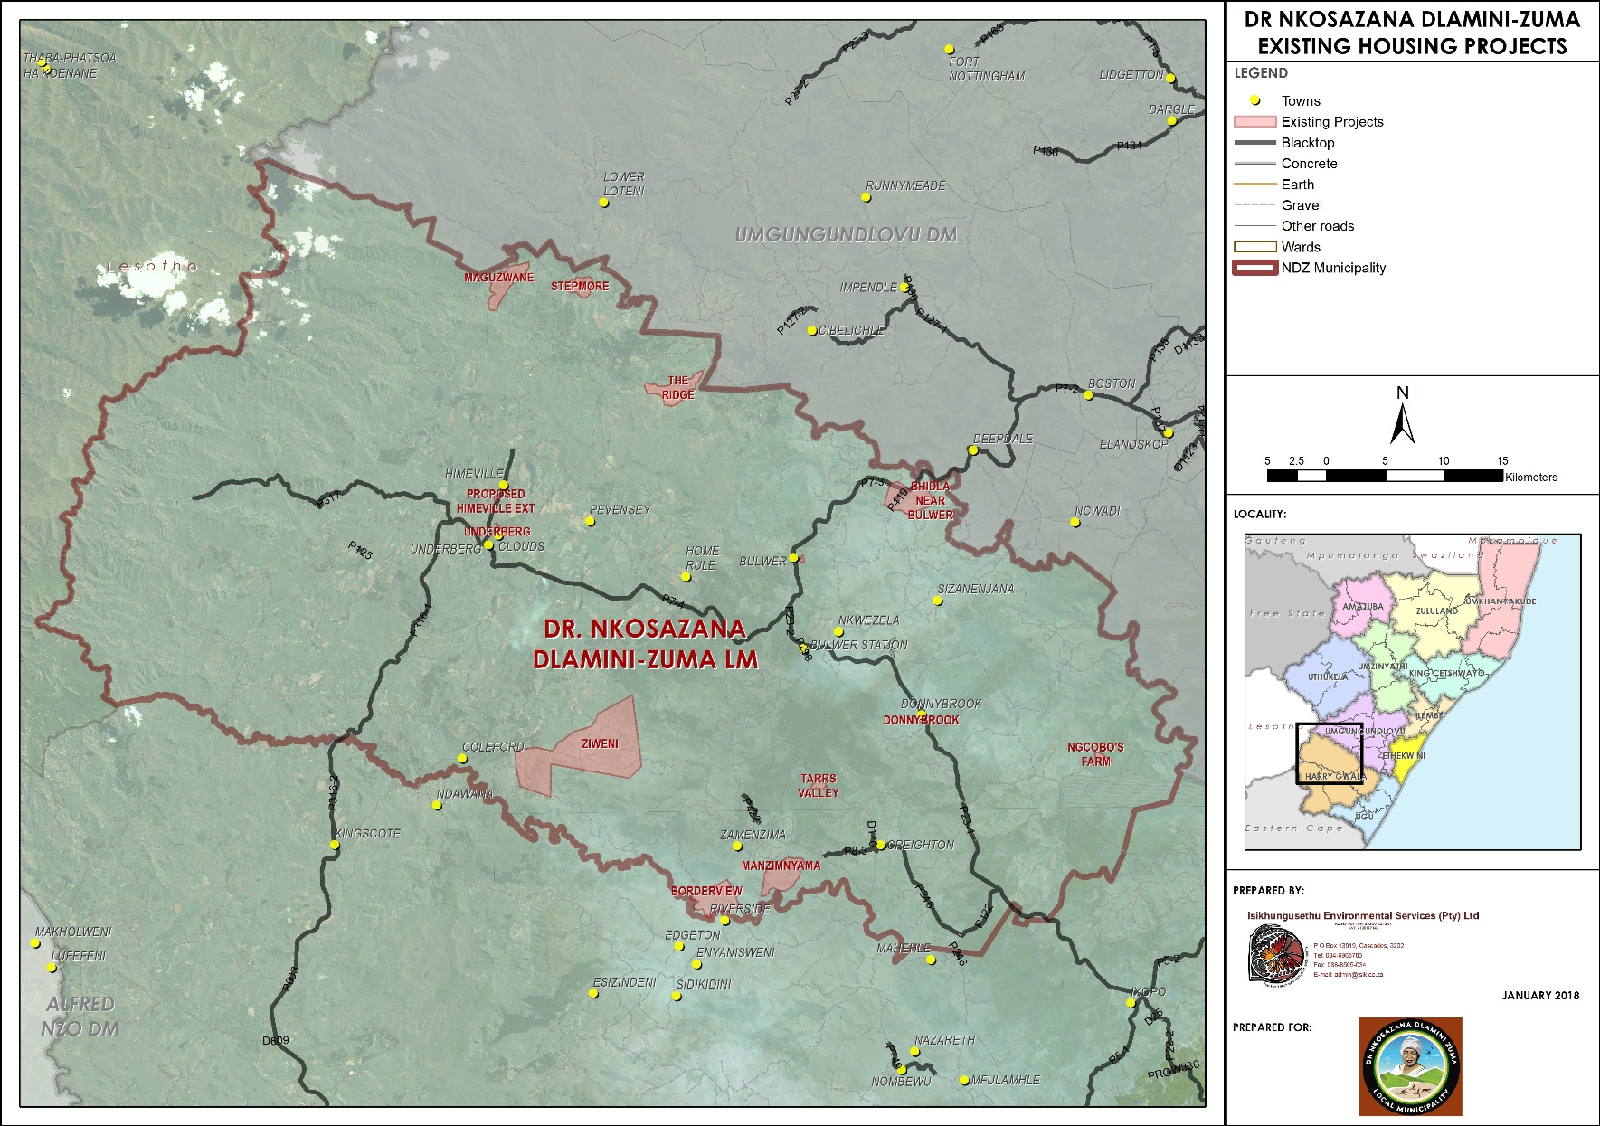

5.10 SWOT Analysis
The SWOT analysis considered the policy provisions, demographics, economics, social requirements, employment, infrastructure and housing development rates over the past few years.
The three most important aspects in respect of Strengths, Weaknesses, Opportunities and Threats were recorded.
These findings in turn were used to identify the three most important aspects which would influence the strategies to inform the Human Settlement Plan in respect of Dr NDZ municipality.
The findings of the SWOT analysis are depicted in Figure 19 below.

Figure 19: SWOT analysis
Strengths
- A large proportion (95,43%) of the population qualify for housing support.
- The majority of the population is situate in the South East away from the environmental sensitive areas.
- The area is blessed with high potential agricultural land and a World heritage site, which needs protection.
- The opportunity exists to align and integrate human settlement provision with social, commercial and services infrastructure.
Weaknesses
Input for Strategy
Input for Strategy
Opportunities
Threats
Input for Strategy
Input for Strategy
- The housing supply rate over the past 5 years has been slow.
- There is a large backlog in respect of housing in Dr NDZ municipality.
- The DNDZ Instructional requirements need to be improved to address the increased demand for housing. Dr NDZ municipality lacks a housing database.
- The current service infrastructure does not allow for the increased rate in housing delivery or for an increase in density.
- DoHS are reducing their backing for rural housing support. As most of the housing projects are in areas considered as rural, this could delay the housing development programme..
- The majority of the population are situate on traditional managed land which often lead to delays in projects due to tenure related matters.
- The provision of services is critical in respect of housing development. It is of critical importance that the service provision programme be accelerated
- The housing programme was generally used to support low-income housing. The IDP has recognised the need for medium income housing and rental stock housing, particularly in respect of the growing number of middle-income Government employees.
- Housing can be planned within the urban and settlement edges developed, ensuring better planned housing.
- The provision of human settlements in the correct position can improve sustainability and employment opportunities.
- Improve Community understanding of the Housing tools available.
1. The majority of the Dr NDZ population qualify for housing support.
2. The World Heritage Site and good agricultural land must be protected.
3. The housing needs correlate with the areas of highest population.
1. There is a need to increase the housing provisioning rate.
2. The Dr NDZ institutional arrangements and project monitoring systems have to improve. This includes the need for a Housing database.
3. The service infrastructure implementation plan needs to improve in order that the housing provision rate can improve.
- Opportunities to diversify the housing stock types, including rental stock housing.
- The opportunity to align future housing with the needs of the Dr NDZ Municipality population needs and the Municipal IDP & SDF.
- Aligning housing development with the Capital Investment framework.
- The improvement of the provision of services is critical to the improved success rate of the housing delivery programme.
- Tenure options must be included in the strategies.
- The housing programme in terms of the IDP will need to be reviewed to ensure that it meets the requirements and criteria being applied by DoHS.
.

The key findings of the SWOT analysis are recorded in Table 12 below.
Table 12: SWOT analysis findings
Strengths | Main strategic requirements
- The majority of the Dr NDZ population qualify for housing support.  - The World Heritage Site and good agricultural land must be protected.  - The housing needs correlate with the areas of highest population. | 1. Large qualifying population.  2. Protection of World heritage and agricultural land
Weaknesses | Main strategic requirements
- There is a need to increase the housing provisioning rate.  - Large number of below standard dwellings.  - The Dr NDZ institutional arrangements and project monitoring systems have to improve. This includes the ned for a Housing database.  - The service infrastructure implementation plan needs to improve in order that the hosing provision rate can improve. | - Increase housing provision rate to address the backlog.  - Need for housing database and monitoring  - Improve service infrastructure.
Opportunities | Main strategic requirements
- Opportunities to diversify the housing stock types, including rental stock housing.  - The opportunity to align future housing with the needs of the Dr NDZ Municipality population needs and the Municipal IDP & SDF.  - Aligning housing development with the Capital Investment framework. | 1. Improve the diversity of Dr NDZ housing stock  2. Alignment with municipal strategic plans  3. Densification  4. Removal of inhabitable dwellings and SLUMS  5. Improve Dr NDZ Housing provision capacity.
Threats | Main strategic requirements
- The improvement of the provision of services is critical to the improved success rate of the housing delivery programme.  - Tenure options must be included in the strategies.  - The housing programme in terms of the IDP will need to be reviewed to ensure that it meets the requirements and criteria being applied by DoHS. | - Lack of bulk infrastructure.  - Tenure challenges in respect of Traditional tenure system

5.11 Housing Demand
The following table indicates the different housing typologies within Dr NDZ municipality boundaries, relating to the determination of housing demand, as per 2016 Community conducted by Stats SA.

Table 13: Different housing typologies at ward level
Source: Stats SA, 2011 Census data adjusted to 2016 boundaries

The above table indicates that 7 410 of the 29 591 households live in formal accommodation (brick and mortar) where 22 181 households live in other forms of dwellings; therefore the housing demand can be estimated to a total of 22 181 units in 2016. As depicted on Figure 20 below, Ward 3, 2 and 10 (1 248, 1 073 and 851 respectively) accommodates the most households living in brick houses, whereas Wards 6, 4 and 2 (2 011, 1 799 and 1 785 respectively) have the households with the least brick houses; consequently these wards have the highest demand and need of brick housing.
The housing backlog in respect of the erstwhile Ingwe municipality, as depicted in Table 15 below was calculated at 15 950. Since then a further 6 518 households have been added as a result of the demarcation changes. A portion of the above increase in households was brought about by the inclusion of the KwaSani Municipal housing findings (3 675 households), depicted in Table 15 below. Adding 6 518 households to the previous 15 950 equals 22 468, very close to the 2016 backlog of 22 181.
According to the StatsSA 2011 census, the municipality had a population of 110 084 people and 118 480 in 2016. This relates to a compounded population growth of 1,34% per annum. By extrapolating the household growth with the 1,34% per annum and using 2016 as the baseline the numbers in the following table indicates the housing demand until 2031.
Table 14: Housing demand over time
Year | 2016 | 2021 | 2026 | 2031
Housing demand | 22 181 | 23 708 | 25 341 | 27 086

The demand indicated in the table is the worst case scenario when no new housing projects are completed during the time. The number of units completed with each project thus needs to be deducted from the demand indicated in the table to reflect the true demand in the municipality.
Figure 20: Formal vs Informal housing in DNDZ Municipality
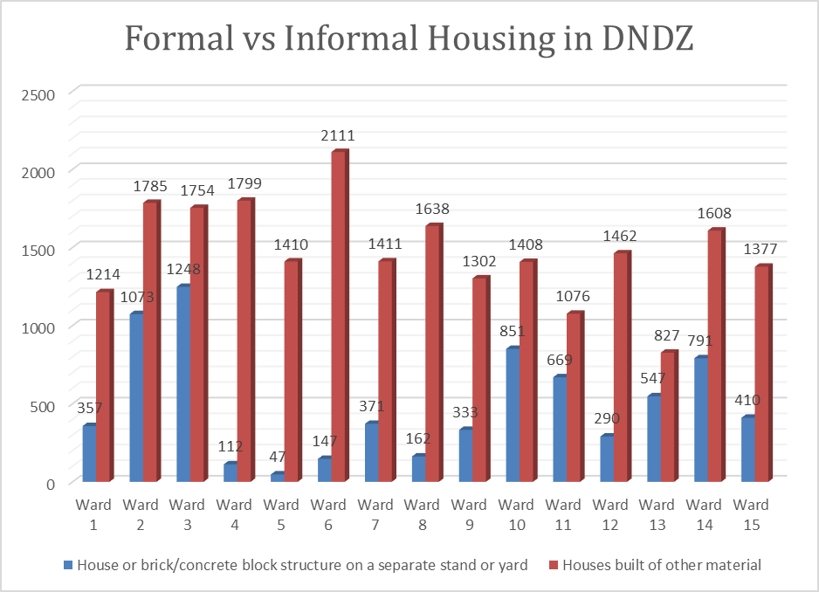

Table 15: 2013 backlog in respect of erstwhile Ingwe Municipality
Wards | Total No. of Households per Ward | Demand by Current Housing Type |  |  | TOTAL
Wards | Total No. of Households per Ward | Traditional Dwelling | Backyard Rooms | Informal Shack
1 | 2108 | 1953 | 0 | 0 | 1953
2 | 1983 | 1811 | 1 | 1 | 1813
3 | 2113 | 1713 | 5 | 7 | 1725
4 | 2024 | 1364 | 1 | 2 | 1367
5 | 1829 | 991 | 5 | 10 | 1006
6 | 2501 | 1521 | 26 | 34 | 1581
7 | 1760 | 1205 | 11 | 0 | 1216
8 | 1885 | 1671 | 2 | 0 | 1673
9 | 2774 | 1267 | 26 | 9 | 1302
10 | 2004 | 1185 | 8 | 1 | 1194
11 | 2091 | 1108 | 11 | 1 | 1120
Total | 23073 | 15789 | 96 | 65 | 15950
Source: Dr NDZ IDP Review, 2017: 190 - 191

Table 16: 2011 backlog in respect of erstwhile KwaSani Municipality
Wards | Total No. of Households per Ward | Demand by housing type |  |  | Total
Wards | Total No. of Households per Ward | Traditional dwelling | Backyard rooms | Informal shacks | Total
1 | 661 | 533 | 1 | 3 | 538
2 | 1131 | 103 | 49 | 151 | 304
3 | 1101 | 42 | 5 | 95 | 141
4 | 780 | 120 | 12 | 16 | 149
Total | 3673 | 798 | 68 | 265 | 1131
Source: Stats SA, 2011 Census data
Dr NDZ municipality, based on the above statistics, requested that the information be translated into projects per ward to address the backlog over the next 5 to 10 years. A detailed analysis was undertaken of the households per ward (based on the Eskom house-hold data) and linked to traditional council areas. Though this process, a detailed list of proposed projects have been developed which will allow Dr NDZ municipality to, in conjunction with the DoHS, and subject to funding schedule human settlement development over the next 5 to 10 years, and in so doing address their housing backlog.
These tables are provided below and are captured in a map, in Figure 20 Shapefiles have been created for each project area to allow Dr NDZ municipality to monitor trends in the future, which could assist with prioritisation.
Table 17: Proposed housing projects per Ward, based on backlog
Wards 2016 | Tribal Area | Greater Area | Housing needs
1 | BATLOAKA | Bucklands | 564
1 | DUMA | Mqatsheni | 515
1 | ISIMINZA | Isiminza | 297
1 | ISIMINZA | The Ridge | 163
2 |  | Himeville | 426
2 |  | KwaPitela | 115
2 |  | Pevensey | 139
3 |  | Underberg | 799
4 | AMAKHUZE | Embantini / Esidangeni | 223
4 | AMAKHUZE | Kilmon | 1435
4 | AMAKHUZE | Ngxalingenwa / Ngxola / Uqaqani | 263
5 | AMAKHUZE | Dazini | 228
5 | AMAKHUZE | Khukhulela | 538
5 | AMAKHUZE | Kilmon | 288
5 | AMAKHUZE | Mpumulwane | 403
6 | AMAKHUZE | Hlabeni / Makhuzeni / Okhetheni | 578
6 | AMAKHUZE | Qulashe | 670
6 | ESIBONELO ESIHLE | KwaShusha / Sibomvini | 62
6 | ESIBONELO ESIHLE | Zamenzima | 295
6 | MACALA GWALA | KwaShusha / Sibomvini | 557
6 | MADZIKANE | KwaShusha / Sibomvini | 185
7 |  | Tarsvaly | 179
7 | AMAKHUZE | Gala | 1031
7 | AMAKHUZE | Qulashe | 291
8 | AMAKHUZE | Ndotine | 236
8 | AMAKHUZE | Ngxalingenwa / Ngxola / Uqaqani | 160
8 | MADZIKANE | Amavondwe / Ingwangwane | 783
8 | MADZIKANE | Bhobhoyi | 197
8 | MADZIKANE | Isibizane | 471
9 | MACALA GWALA | Sokwenzela | 748
9 | MEMELA LOCATION NO. 2 | Sizanenjana | 319
9 | MEMELA LOCATION NO. 2 | Sokwenzela | 267
10 |  | Bulwer | 576
10 | BHIDLA | Chibini / Mqulela | 170
10 | BHIDLA | Mkobeni Kamensia | 216
10 | BHIDLA | Nkelabantwana | 286
10 | MACALA GWALA | Hlafuna | 606
10 | MEMELA LOCATION NO. 2 | Sizanenjana | 227
11 | AMANGWANE | AmaNgwane | 323
11 | BHIDLA | Bhidla | 809
11 | BHIDLA | Nkelabantwana | 663
12 | BHIDLA | Chibini / Mqulela | 133
12 | BHIDLA | Zashuke | 204
12 | MEMELA LOCATION NO. 2 | Sizanenjana | 204
12 | VEZOKUHLE | Emnywaneni | 105
12 | ZASHUKE | Sizanenjana | 86
12 | ZASHUKE | Zashuke | 868
13 |  | Donnybrook | 390
13 | MACALA GWALA | Nkwezela | 73
13 | MEMELA LOCATION NO. 2 | Nkwezela | 222
13 | MEMELA LOCATION NO. 2 | Seaford | 458
13 | MEMELA LOCATION NO. 4 | Luwambeni | 369
14 |  | Creighton | 252
14 |  | Glenmaize | 12
14 | MEMELA LOCATION NO. 4 | KwaNomandlovu / Umjila | 469
14 | MEMELA LOCATION NO. 4 | Luwambeni | 549
15 |  | Masameni / Sikeshini | 629
15 | VEZOKUHLE | KwaNombulula / KwaSandanezwe | 805

It should be noted that based on the accurate counting of the Eskom House-hold data per project area, the number of dwellings increased slightly from 22 181 (please see paragraph 5.11 above) to 23 129. The 22 181 was however based on 2011 data whereas the Eskom data is based on 2013 imagery.

Figure 21: Housing project map
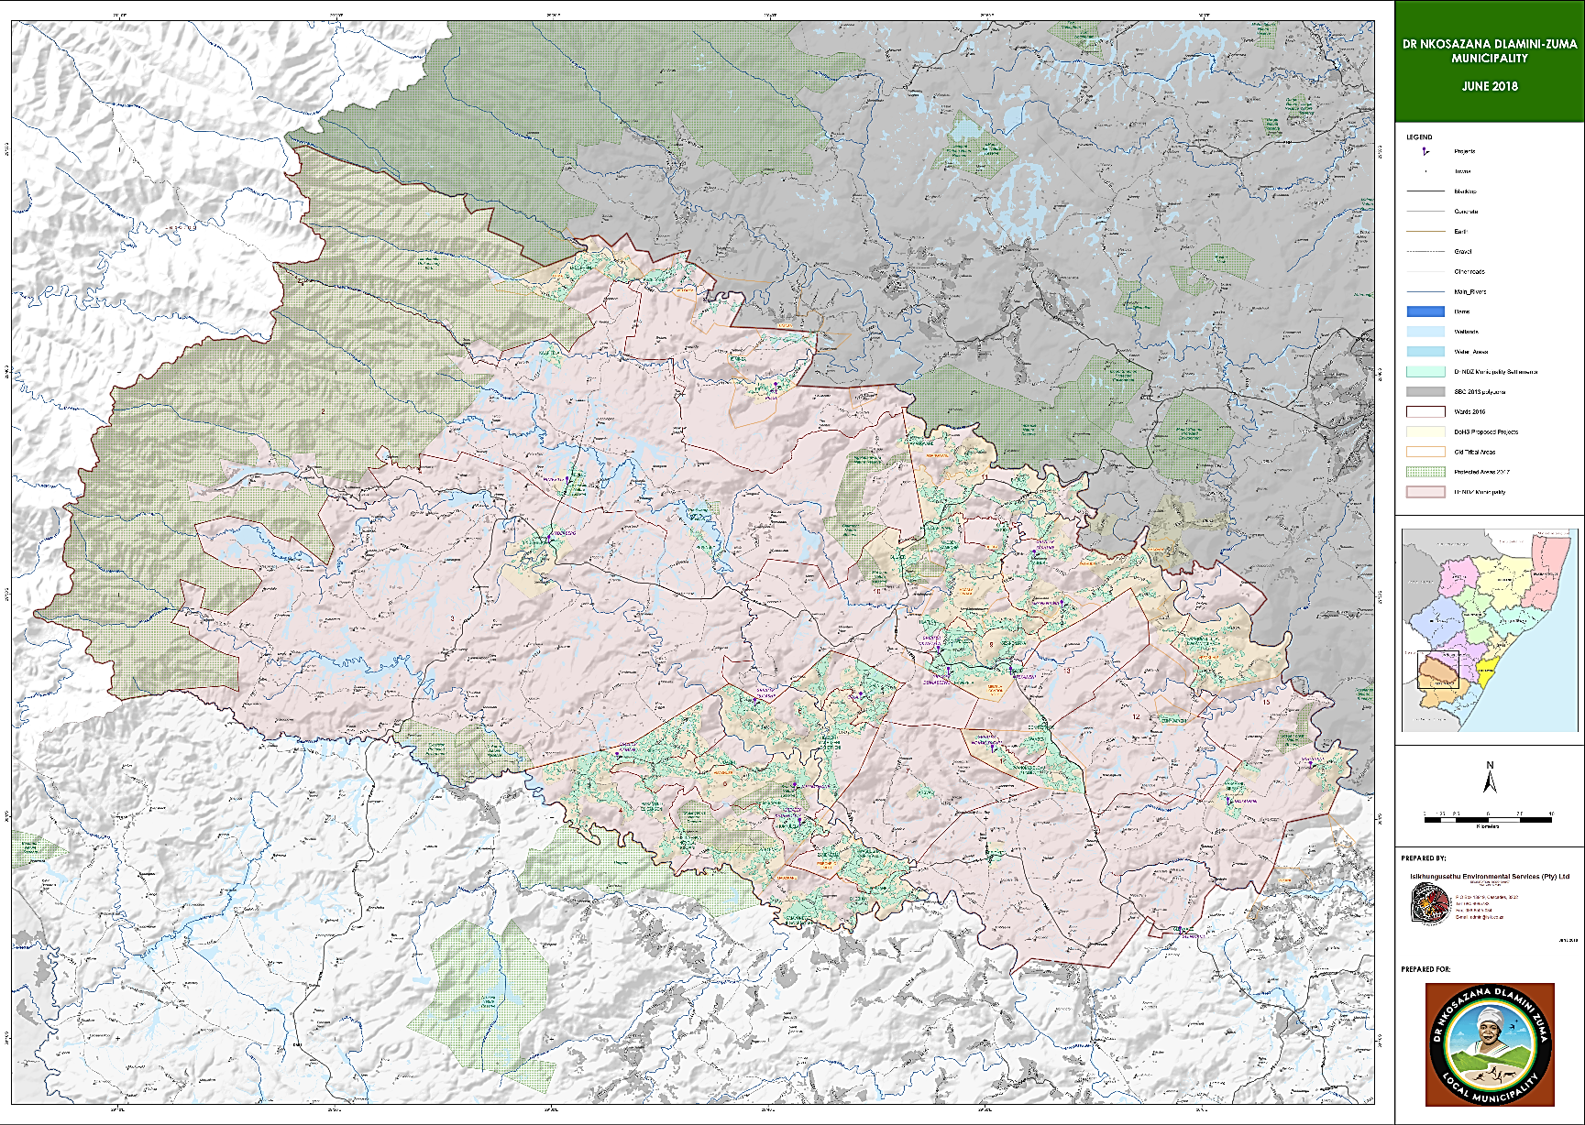

6. VISION AND STRATEGIES
A vision can be defined as insight or speculation into the future. In developing a housing vision, it is essentially an imaginative projection into the future of housing development, in response to local growth trends and unique settlement patterns. Though this vision, the local authority will be able to focus its investment and achieve its strategies in a streamlined manner and to the benefit of the local inhabitants. It will be able to achieve identified national directives.
The Municipality’s Vision in the 2017 – 2022 IDP is as follows:
Well governed quality service provider with a strong focus on Socio-Economic Development while protecting the environment.
The main concepts that come from the above vision are service delivery, local economic development, community development and environmental protection. These concepts are interrelated and should economic development be achieved, community development and service delivery should follow automatically. Economic initiatives and products being produced/sold, no matter where they are situated (in terms of city or province) have to have the optimum locality to provide access to the markets they target. It is therefore necessary to determine what the capabilities within the municipality are with regards to land and resources, and whether the spatial locality of the initiatives provides access to markets or not. If there is a lack of access to markets, and proper marketing is not done, it is not feasible to produce no matter how big the demand is.
One of the objectives of the Housing Plan is to determine the optimum localities for investment and economic initiatives to be located to capitalise on the comparative advantages that are offered by a specific location. Spatial distribution of facilities will be linked to the spatial distribution of spatial needs, but in the sense that it will be provided where a large concentration of similar needs exist to ensure cost effective provision of services.
In the analysis section of the Municipality’s IDP, the need for rural housing in the Ingonyama Trust areas was expressed for rural communities residing in sub-standard housing units. It was also indicated that housing projects, through their construction phases, will contribute towards an increase in skilled and semi-skilled people.
Housing Guiding Principles:
- Facilitate the active involvement of all relevant stakeholders in housing development
- Housing development should be based on integrated development planning
- Promote social, economic and physical integration in urban and rural areas
- Housing development should be provided, where practical, closer to employment opportunities
- Housing should be prioritised to the poorest of the poor
- The role of women in housing should be recognized and promoted
- Housing development should take measures not to harm the environment
- Housing development should be economically, fiscally, social and financially affordable and sustainable
- Housing development should be administered in a transparent, accountable and equitable manner and uphold the practice of good governance
- Promote education in respect of housing development
- Promote the establishment of socially and economically viable communities and safe and healthy conditions to ensure the elimination of slums.

6.1 Proposed Housing Vision
The proposed housing Vision is as follows:-
To house every resident of Dr NDZ in an adequate, sustainable and affordable way, with the necessary services, in progressive communities and an enabling environment to create the best possible standard of living for our people.

6.2 Development Principles
The KwaZulu-Natal Provincial Spatial Development Plan developed nine (9) Principles to guide development in the Province which will enhance the provisions of the SPLUMA. The nine principles of the PGDS are depicted in the diagram below.
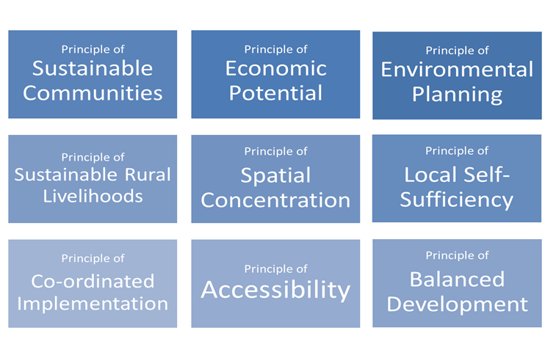
The following nine spatial principles underscores the general spatial intentions of the PGDS and serves as provincial guiding principles which should ideally be pursued within all levels of spatial planning at district and local level in alignment with the provincial spatial development strategy.

6.2.1 Principle of Sustainable Communities
The Principle of Sustainable Communities promotes the building of places where people want to live and work. Again, the sense of quality of life refers to the balance between environmental quality, addressing social needs and promoting economic activities within communities.
Often communities within the rural context of KwaZulu-Natal are not located in the areas with perceived highest economic potential.
Where low economic potential exists, planning and investments should be directed at projects and programmes to address poverty and the provision of basic services in order to address past and current social inequalities towards building sustainable communities.

6.2.2 Principle of economic potential
The Principle of Economic Potential aims to improving productivity and closing the economic performance gap between the various areas of KwaZulu-Natal towards economic excellence of all areas. Rapid economic growth that is sustained and inclusive is seen as a pre-requisite for the achievement of poverty alleviation.
The principles further promote the consideration of spatial needs for Economic Competitiveness (Potential) by proposing an asset based spatial approach based on unique advantages and opportunities within various areas. An essential component of this principle is the engagement of the private sector in the refinement and spatial economic needs of any particular zone / area.

6.2.3 Principle of Environmental planning
The Principle of Environmental Planning (Bioregional Planning) refers to understanding and respecting the environmental character (potential and vulnerability) and distinctiveness of places and landscapes and promoting balanced development in such areas.
The PGDS supports environmental planning as the fundamental methodology on which spatial planning should be based. Thus, rather than being a reactionary barrier to commenced development, the environment is seen as an enabling primary informant to spatial planning and development. Environmental planning can be defined as land-use planning and management that promotes sustainable development. The environmental planning methodology involves the use of broad provincial spatial planning categories to reflect desired land use.

6.2.4 Principle of sustainable rural livelihoods
The Principle of Sustainable Rural Livelihoods considers rural areas in a way which is integrated with other decision making associated with the Sustainable Livelihoods frameworks. This principle requires that spatial planning consider the locality and impact of human, physical, natural, financial and social capitals of an area and spatially structure these in support of each other.
Another aspect of this principle is promoting spatial planning in a continuum where rural areas are not addressed as completely separate entities to urban centres, but rather a gradual change in landscape with the potential progression of rural areas to more closely resemble the service standards and quality of living achieved in some urban contexts.

6.2.5 Principle of spatial concentration
The Principle of Spatial Concentration aims to build on existing concentrations of activities and infrastructure towards improved access of communities to social services and economic activities. In practical terms this promotes concentration along nodes and corridors with multi-sectoral investment i.e. roads, facilities, housing etc. This is envisaged to lead to greater co-ordination of both public and private investment and result in higher accessibility of goods and services to communities while ensuring more economic service delivery.
This principle will further assist in overcoming the spatial distortions of the past. Future settlement and economic development opportunities should be channelled into activity corridors and nodes that are adjacent to or link the main growth centres in order for them to become regional gateways.

6.2.6 Principle of local self-sufficiency
The Principle of Local Self-Sufficiency promotes locating development in a way that reduces the need to travel, especially by car and enables people as far as possible to meet their need locally.
Furthermore, the principle is underpinned by an assessment of each areas unique competency towards its own self-reliance and need to consider the environment, human skills, infrastructure and capital available to a specific area and how it could contribute to increase its self-sufficiency.

6.2.7 Principle of co-ordinated implementation
The Principle of Co-ordinated Implementation actually projects beyond spatial planning and promotes the alignment of role-player mandates and resources with integrated spatial planning across sectors and localities. Essentially the principle suggests that planning-implementation becomes a more continuous process and that government spending on fixed investment should be focused on planned key interventions localities.
The principle ultimately also proposes a move towards more developmental mandate definitions of the various departments away, from single mandates to enable the spatial alignment of growth and development investment.

6.2.8 Principle of accessibility
The Principle of Accessibility simply promotes the highest level of accessibility to resources, services, opportunities and other communities. This is intrinsically linked to transportation planning and should consider localised needs for the transportation of people and goods by various modes of transport as guided by the scale and function of a region. At a provincial level there is a strong correlation between the most deprived areas and poor regional accessibility to those areas. In addressing accessibility at provincial and local level, the need for possible new linkages, the upgrade in the capacity of existing linkages and the suitable mix of modes of transport should be considered.

6.2.9 Principle of balanced development
The Principle of Balanced Development promotes the linking of areas of economic opportunity with areas in greatest need of economic, social and physical restructuring and regeneration at all spatial scales. In practical terms the principles sought to find a balance between the potentially competing land uses by understanding the relationship and integration between major dimensions within the province and promoting a synergetic mixture of land uses in support of each other at various spatial scales.

6.3 Key Performance dimensions
The Provincial Spatial Planning Guideline 1: Public Capital Investment and Settlement Growth identify the following Key Performance Dimensions that should guide the distribution of services and the establishment of the capital investment framework applicable to human settlements.

6.3.1 Complexity and choice
A positive settlement is one which offers greater choice in amenity and opportunity. Complexity, by bringing a range of activities and functions together, enhances choice and opportunity. Compact environment enhances the potential for complexity.

6.3.2 Equity
It is essential that equitable access to a range of functions is achieved in space for as many as possible. The structure and scale of access should facilitate choice and the distribution of activity based on real needs and in serving the interests of many.

6.3.3 Multi-functionality
In order to enhance choice and opportunity, a key performance dimension is ensuring that facilities are multifunctional in nature and integrate various uses over time. This is particularly important in context of scarce resources.

6.3.4 Reinforcement and Intensification
Emphasis needs to be placed on creating a mutually supportive structure or system by bringing together various elements of capital investment to induce greater responses over time.

6.3.5 Clustering of activities
It is important to cluster services to create special places within the system thereby increasing levels of choice available within the system

6.3.6 Integrating hierarchies
Emphasis should be placed on twinning similar scaled facilities across sectors, thereby increasing choice and the generative capacity within key nodes. As example, higher order health facilities should be situated close to higher order public transport facilities.

6.3.7 Efficiency
It is imperative to query space standards with a view to maximise limited space utilisation and in achieving higher levels of overlap and integration. The principle of mixed use should apply as a general approach other than in contexts where specialisation of service is crucial, such as higher order health facilities.

6.3.8 Exposure
The location of facilities must be based on externalisation and ease of access and should never be imbedded within local areas. The logic of location should be reinforced with the dominant public transport mode and circuit.

6.3.9 Fixed Edge
The distribution of services and the direction of growth should be reinforced by a fixed and positively identified edge. It is important to understand the significance of a defined edge within the context of promoting compactness. Defined areas for concentration of facilities should be targeted.

6.3.10 Seams as places for integration
Where elements of the built environment come together, particularly at nodes and streets, it is important to understand these as seams for integration. E.g. streets that are located between a spatially divided settlement should be targeted for investment to enable greater consolidation of development over time.

6.4 Strategic Objectives
The following objectives have been developed.

Objective 1. Integrated Development
Ensure integrated development across all spheres of government regarding development and service delivery. | - Implement Strategic planning tools such as LUMS, SEA and SDF
 | - Establish strong partnerships between the 3 spheres of government, the business community and civil society.
 | - Commitment to 2030 Provincial Vision, especially to the key strategic provincial goal of Human and Community Development
- Plan for changes in the behaviour of the population:
- Take the demographic issues such as age, level of education, gender and income into consideration with future planning
- Determine triggers that can lead to the influx of people to areas of opportunity e.g. jobs, health, services, education. Develop policies to make provision for the settlement of population in such instances. E.g. perusing of opportunities as identified in the LED plan in the Dairy, forestry and tourism sectors.
 | - Flexibility in spatial plans, policies and land use management systems is accommodated to ensure sustainable livelihoods in communities most likely to suffer the impacts of economic and environmental shocks;
Objective 2. Eradicate Urban Sprawl
Promote planned densification of existing and new settlements (where service provision supports same) | - Secure tenure and the incremental upgrading of informal areas;
 | - Provide Information on medium to long term service delivery plans
 | - Determine the urban edge for settlements to contain development to a pre-determined area
- Clustering of social and community facilities:
- Plan for facilities that require public capital investment at more accessible points within rural service centres.
- Fragmented spatial structure causes rural sprawl and should be countered within parameters of rural culture.
- Encourage migration over time to planned areas with services and facilities.

Objective 3. Ensure Capacity at implementation level
Provision of human settlement should be the done by specialised units to ensure best practice in all aspects of human settlement provision. | - Investigate the establishing of a capacitated Section (viz Shared Services Model) with the focus on human settlement.
 | - Ensure institutional capacity for both technocrats and decision makers to guarantee adherence to legislative/strategic plans and policies.
 | - Promote land development that is within the fiscal, institutional and administrative means of the country
 | - Ensuring a fully functional project pipeline that is aligned to the national and provincial priorities inclusive of making significant improvement to the alignment to the priority intervention areas, nodes and corridors of the Provincial Spatial Economic Development Strategy (PSEDS).
Objective 4. Sustainable Development
Land development procedures will include provisions that accommodate access to secure tenure and the incremental upgrading of informal areas. | - Commitment to the Draft Land Reform Green Paper and the Draft Land Tenure Security Bill (LTSB) that refers to sustainable rural human settlements as Agri-villages.
 | - Other forms being considered: SMART Villages (Sustainable, managed assets, resources and technology); Agri-parks
 | - Consider all the current and future costs to all parties for the provision of infrastructure and social services in land developments.
 | - Consider the socio-economic reality of the target population
 | - Promotion of economic activities in closer proximity to the rural unemployed where sustainable.
- Maximum benefit from available resources:
- Use the available resources to determine settlement typology
- Agricultural Potential
- Tourism potential
- Cultural lifestyle
- Availability of infrastructure
- Strategic plans on different levels
Objective 5. Increase quality of life.
Improved neighbourhoods and quality of life | - Eradicate Slums
Improved neighbourhoods and quality of life | - Promote economic activity suitable and sustainable to the settlement population
Improved neighbourhoods and quality of life | - Provide structure to future development of settlements
Improved neighbourhoods and quality of life | - Promote new development and formalisation of existing development in alignment with main bulk utility services along the grid
Improved neighbourhoods and quality of life | - Provide public spaces for interaction and relaxation
Improved neighbourhoods and quality of life | - Spatial Focus of land uses and resources to balance development and protect environmental services which contributes to quality of life
Improved neighbourhoods and quality of life | - Ensure public participation in processes  - Promote participatory and accountable spatial planning and land use management within all areas.  - People need to adopt and buy into the planning and eventual provision of human settlements otherwise the resources spend will be in vain.
Improved neighbourhoods and quality of life | - Plan for a variety of housing types  - The municipality has a wide range of residents that requires provision of human settlement opportunities that covers the total spectrum; urban developments in Underberg, Bulwer, Creighton, Donnybrooks and Himeville to slums clearance projects for poverty stricken people.
Objective 6. Protect the natural and cultural environment
Ensure that development take place in a manner that take cognisance of land and cultural practices that need protection from unbridled and unsustainable use of land. | - Ensure protection of land  - Prime and unique agricultural land,  - Ensure adherence to the KwaZulu-Natal Agricultural Land Potential Categories Internal Report  - Ensure adherence to the Draft Policy Document On The Preservation And Development Of Agricultural Land  - Environmental sensitive areas as indicated in the SEA  - Discourage settlement in the vicinity of water courses and water bodies to protect their integrity and the occurrence of water pollution  - Other protected lands and the safe utilisation of land
 | - Promote land development in locations that are sustainable, and limit urban sprawl as identified in the SDF and SEA.
 | - Investigate innovative, alternative construction methods to ensure settlement with a unique character, sense of place and amenity.

6.5 Housing Strategies
The strategies and projects must lead the municipality to achieve its vision within the framework of its legal obligations, the context of the other role-players, the principles of the development rational and the current reality in which the municipality finds itself. The need for housing strategies is also articulated in the Kwasani HSP (Kwasani Municipality, undated, p 14).

6.5.1. Strategy 1: Establish Sustainable Communities
The housing projects in process and the projects to be undertaken in the future must not only provide a shelter of acceptable standard to the residents of Dr NDZ municipality but it must be used as an opportunity to shape the developmental fabric of the municipal area in such a way that it will enhance the living standard of all the people in the Dr NDZ area.
All of the approximately 22 181 housing units needed by the year 2023 (refer to Section 1) need to be supplied by the public sector as these units would cater for the low-income population groups that rely on housing subsidies and qualify for such subsidies. Furthermore, to ensure that the housing developments are in keeping with the "human settlement" perspective, there is a need to ensure that adequate land is identified to accommodate the supporting functions.
The following actions are necessary to ensure that housing delivery targets are met:

6.5.1.1 Project 1 – Determine the actual housing backlog.
If the municipality does not have a record and benchmark of the actual backlog for housing in its area, it is impossible to ensure the required resource targeting to eradicate the backlog and make provision for future developments. This aspect is also well recorded in the KwaSani HSP (2013 – 2016, p.21)
It would be of crucial importance to the municipality to establish a housing waiting list with registered potential beneficiaries. The benefits of such a database would be the following;
- The real housing backlog in the municipal area would be determined;
- The areas of greatest need can be spatially determined;
- Planning for future housing projects will be on a solid basis and not on the current ad hoc way;
- The financial status of potential beneficiaries will be available and
- It will be possible to apply for the correct kind of subsidy for potential beneficiaries.
It is recommended that the municipality embark upon an intensive beneficiary registration project in order to gather the relevant information. The following methodology is recommended;
- Capacitate officials of the municipality’s housing component to complete the necessary documentation.
- Embark upon an intensive advertising campaign to make residents aware that they should register on the municipality’s housing database.
- Make use of the Council’s Ward Committees to carry the message to their constituents.
- Should the need arise make arrangements for registration points at specific dates in the rural wards where it may be difficult for people to travel to a central point.
- The possibility to use the same venue as for voter registrations can be investigated.
- Once the database has been compiled it should be kept up to date by the municipality.
- The database should be linked to the municipality’s GIS in order to have the various aspects of the housing backlog represented spatially.

It is recommended that the Municipality’s Housing Section embarks on this project before the end of 2018.

Performance Target: Establish actual housing demand in the municipal area before January 2019.

6.5.1.2. Project 2- Land Identification and Evaluation.
In order to utilize the provision of housing as a catalyst to the socio-economic development of the DNDZ municipal area the spatial position of housing projects must be very carefully considered. The development of housing at the correct/best position will enhance the area and lead to the optimization of scarce resources such as developable land, expensive services infrastructure and the natural environment. The Kwasani HSP (2013 to 2016) also reflects on the importance of land availability which links with this (Kwasani Municipality, undated, p 19).
The development informants to be taken into consideration when land for development is identified has been discussed comprehensively in Part One-Section Four of this report. These indicators must be used in tandem with the District and Local municipality’s Land Use Management Systems (LUMS) and Spatial Development Frameworks (SDF) and the principles indicated in Section 2.3 of this report to determine the optimum location for future development initiatives in the Dr NDZ municipal area.
The following actions are recommended within the context of this land identification and evaluation action:
- Undertake a detailed land audit with the focus on land that has been identified as suitable for development in the LUMS; the SDF and the municipality’s Strategic Environmental Plan (SEA). This is to ensure that vacant land and potential infill areas are identified;
- Evaluate potential developable land against the principles indicated in Section 2.3 of this report to ascertain the most advantageous locality.
- Assess all the geological, geotechnical, environmental and physical constraints on the land identified that has development potential;
- Determine legal constraints, land restitution issues, tribal or mining rights as well as any land use right considerations;
- Identify land ownership of land that has been screened through the first three categories, prioritize government owned land as far as possible and then embark on a land acquisition process where required. This acquisition process needs to be budgeted for on a regular basis (annually) so as to ensure that the financial allocations are in line with the identified targeted timelines.

Performance Targets: a) Complete land audit by November 2018.
b) Complete Land Identification by March 2019.
c) Initiate land acquisition by July 2019 at the beginning of the 2019/20
financial year.

6.5.1.3. Project 3 – Establish Security of Tenure.
According to the Spatial Analysis of the 2017 Dr NDZ IDP review, land in the municipality area is occupied under two different systems. The areas that formed part of the former KwaZulu-Natal homeland are largely under tribal ownership, belonging to the Zulu King. These areas are now under the jurisdiction of the Ingonyama Trust Act. The remainder of the land is mostly commercial agricultural land subject to the conventional market in terms of freehold title. According to the Municipality’s IDP about 81% of the population lives in Traditional Authority areas. Whilst they enjoy functional tenure compared to private counterparts who fall outside of Ingonyama land, they do not have conventional Title Deeds.
Land tenure practices in the Ingonyama Trust entails that land is allocated in terms of a "a permission to occupy" (PTO) certificate granted by the relevant tribal authority. This is a formal approval protected in the Constitution as a form of ownership. Each Tribal area is administered through an iNkosi (chief) and his Tribal Council. Each Tribal Area is divided into Isigodi areas, and ruled by Indunas (deputies).
Families are compelled to approach the Induna, who allocates land to the family. This is ratified by the Tribal Authority and Department of Land Affairs in the form of a PTO certificate. The PTO certificate is regarded as a form of ownership and this system of land ownership has a direct impact on land use.
No framework is however available to guide the issuing of PTO's. This raises some concerns regarding the environmental, technical and social suitability of sites for land use.
Security of tenure can be ensured through the various subsidy schemes and programmes of the government. These programmes and subsidies are indicated in Annexure 2 of this report. This leads back to project 1 because the proposed database will provide the relevant information on the correct kind of subsidy to be used to develop a housing project and provide tenure security to the beneficiaries.

Performance Target: Compile a Framework to guide the issuing of PTO’s by February 2019

6.5.1.4. Project 4 - Speedy Release and Servicing of Land.
The focus of this strategy is to facilitate the speedy release and servicing of land. This is achieved primarily through the Spatial Planning and Land Use Management Act (Act 6 of 2013)( SPLUMA). Refer to Section 6.2 of the document.
In addition, a number of other Acts and policies were passed to support this Act. Linked to this strategy is also the issue of ensuring appropriate standards in terms of infrastructure, servicing and housing. All of these issues are explained below.
Other supportive legislation and policies
Other legislation and policies which facilitate the speedy release and servicing of land have emanated primarily from the Department of Rural Development and Land Affairs. Such legislation and policy focuses on land development and land use control, land registration and tenure systems, mechanisms for resolving conflicts in the land delivery process and the alienation of Government owned land. The legislation and policies include the following:
- Provision of Certain Land for Settlement Act, 1993 [Act No. 126 of 1993].
- Land Acquisition Grant Policy.
- Settlement Grant Policy.
- Land Registration and Tenure Systems Policy.
- Extension of Security of Tenure Act, 1997 [Act No. 62 of 1997].
- Communal Property Association Act, 1996 [Act No. 28 of 1996].
- Interim Protection of Land Rights Act, 1996 [Act No. 31 of 1996].
- Land Reform [Labour Tenants] Act, 1996 [Act No. 3 of 1996].
- Upgrading of Land Tenure Rights Act, 1991 [Act No. 112 of 1991].
- The Prevention of Illegal Eviction from and Unlawful Occupation of Land Act, 1998 [Act No. 19 of 1998].

Ensuring appropriate standards
Government’s infrastructure policy and standards apply to the provision of water, sanitation, roads, storm water drainage and domestic energy to housing developments. These standards are governed by departments other than the Department of Human Settlements. Housing standards, are governed by the Department of Housing, through the National Norms and Standards;
Infrastructure: Two types of infrastructural services impact on housing, namely, physical or engineering standards and environmental standards. Infrastructure standards are specified in the following documents;
- Guidelines for Engineering Services and Amenities in Residential Township Development [commonly called the Red Book] which provides information and guidance on the various options available to planners and developers in developing residential towns.
- NHBRC technical requirements published in the NHBRC Home Builders Manual and which outlines design and construction standards for NHBRC registered builders.
- The National Building Regulations, set out in the National Building Regulations and Building Standards Act, 1977 (Act No. 103 of 1977), and which relate to health and safety standards.
Environmental standards: A range of legislation, policy, guidelines and documents set out environmental standards.
Housing: The Minister of Housing in terms of the Housing Act introduced National Norms and Standards for housing. The Norms and Standards include the following rules;
- A maximum up to R7 500 of the basic subsidy provided in terms of the Housing Subsidy Scheme can be spent on services
- The remaining amount of the subsidy must be spent on the top structure that should be a minimum of 30m² in size.
- In addition a minimum level of water, sanitation, roads and storm water drainage is specified. A Provincial Housing Development Board will not approve a housing development project unless the municipality certifies that the necessary bulk and connector services are provided or will be provided to the development.
Variations are allowed in terms of these specifications, depending on the local circumstances of particular projects.
Performance Target: Adopt and implement the Municipality’s Housing Policy before November 2018 to ensure the speedy release and servicing of land for future housing projects.

6.5.2. Strategy 2: Develop the necessary institutional arrangements
The successful implementation of Strategy 1 and its concomitant projects requires that the necessary institutional arrangements are in place at Dr NDZ municipality. The municipality needs a high level official who takes the responsibility for the eradication of the housing backlog and who will be the driver who ensures this housing plan is implemented in the most efficient way possible. This official should be assisted by a capacitated team of people who are dedicated to service delivery in general and housing provision specific.

Every municipality, as part of its process of integrated development planning, must take all reasonable and necessary steps within the framework of national and provincial housing legislation and policy to ensure that the right to have access to adequate housing is realized on a progressive basis.
In order to fulfill its role, every municipality must carry out the following functions:
- Health and Safety: ensure that conditions not conducive to the health and safety of the inhabitants of its area of jurisdiction are prevented or removed.
- Efficient Services: ensure that services in respect of water, sanitation, electricity, roads, storm water drainage and transport are provided in a manner that is economically efficient.
- Housing Delivery Goals: set housing delivery goals in respect of its area of jurisdiction.
- Land for Housing: identify and designate land for housing development.
- Public Environment: create and maintain a public environment conducive to housing development, which is financially and socially viable.
- Conflict Resolution: promote the resolution of conflicts arising in the housing development process.
- Bulk and Revenue Generating Services: provide bulk engineering services, and revenue generating services in so far as specialist utility suppliers do not provide such services.
- Land Use: plan and manage land use and development.
- Housing Development: initiate, plan, co-ordinate, facilitate, promote and enable appropriate housing development in its area of jurisdiction.
The municipality needs to implement the following projects in order to put the necessary institutional arrangements for efficient housing delivery in place:

6.5.2.1 Project 1 – Capacity Building.
This project addresses the following two issues;
- The capacity of the institution, and
- The capacity of individuals within the institution
In order to have the necessary capacity for housing delivery within Dr NDZ municipality it is recommended that the municipality establish a focused Housing Delivery Management Unit (HDMU) under the auspices of the Municipal Manager.
This HDMU should be internally resourced as far as possible but it can outsource some of the specialized functions. It can also have a capacitating and handover programme as the needs require. The HDMU will be required to deal with the entire housing delivery process from land identification through planning, service delivery, development, project management, site handover and long term management.
Further, should the local authority opt for accreditation, the HDMU would form the basis of the long term institutional structure and will be able to initiate the processes and business plan for the accreditation.
The municipal officials of the HDMU should be suitably qualified and capacitated to be able to grasp and the various intricacies and potential long-term impact of the housing delivery process on all the functions of the municipality as indicated above.
Performance Targets: a) Establish a HDMU at the municipality before February 2019 .
b) Capacitate Officials of the municipality to deal with the entire housing
delivery process by July 2019 through training.

6.5.2.2 Project 2 – Traditional Leader capacitation
One of the core intentions of the HSP is to have a master plan in terms of which human settlement development must occur. Dr NDZ municipality, similar to most other municipalities in KwaZulu-Natal, is however faced with the situation that whilst they are responsible for overall land use management, the relevant Traditional Authority, in terms of customary processes and procedures is responsible for land allocation. This dual responsibility in respect of land allocation and land use management requires good co-operation and understanding of all parties. The HSP requires understanding in respect of topography, planning, land use, servicing, environmental protection, agricultural protection as well as municipal and DoHS criteria.
In order that there is common understanding of these matters, it would be important that the Traditional Leaders be capacitated in respect of these matters. They in turn would be a critical source of local and traditional customs.
It is therefore recommended that a strategy be included to capacitate Traditional Leaders in respect of the HSP requirements, to ensure a co-ordinated implementation of the HSP, with the Traditional Leaders and izinduna assisting the municipality with the implementation of the HSP through their on the ground management and facilitation of processes.
Performance targets: (a). Appoint a Service Provider to develop the required course materials.
(b). Undertake the capacitation of the Traditional Leaders in Dr NDZ municipality.

6.5.2.3. Project 3– Decide on the Accreditation Option.
The new human settlements plan envisages the accreditation [and assignment] of municipalities particularly the metropolitan areas. The framework will address various policy, constitutional and legislative aspects in order to enable municipalities to manage the full range of housing instruments within their areas of jurisdiction. In order to be accredited [and ultimately assigned the functions], municipalities will have to demonstrate their capacity to plan, implement, and maintain both projects and programs that are well integrated within IDPs and within the 3 year rolling capital investment programs mandated by the Municipal Finance Management Act (MFMA).
(Breaking New Ground, Part B, Section 5.2 “Expanding the role of local government”)

“By 2050 visible outcomes from effectively co-ordinated spatial planning systems will have transformed human settlements in South Africa into equitable and efficient spaces with citizens living in close proximity to work with access to social facilities and essential infrastructure.
(National Development Plan, 2012)

6.5.2.3(a). Purpose
Accreditation is the recognition by the relevant provincial MEC responsible for housing that whilst a municipality has met certain criteria and standards, the municipality requires additional support and capacity prior to assuming full accountability for the administration of all national housing programmes. Accreditation permits the exercise of functions by a municipality on behalf of the MEC whilst further capacity is being developed.
Assignment involves the formal transfer of the functions related to the administration of national housing programmes from the provincial MEC responsible for housing to a municipality through the existing Constitutional and legal framework for assignment. Assignment involves the shifting of planning, financial and legal accountability from the assigning to the receiving authority.
Accreditation and assignment are regarded as enablers within the housing delivery system that are consistent with the broader public sector reform agenda.
The accreditation of municipalities is intended to integrate the human settlements delivery processes. Section 10(4)(b) of the Housing Act requires provincial accounting officers to transfer funds to municipalities for the performance of the accredited housing function. The Division of Revenue Act regulates grant allocations to the three spheres of government. The intention of the DoRA is to ensure transparent and predictable financial flows. Provinces are required to gazette HSDG allocations to accredited municipalities. The intention is that the HSDG will be directly allocated to assigned municipalities to support integrated planning and budgeting. A Municipal Human Settlement Capacity Grant (MHSCG) was introduced in the 2014/15 financial year targeting metropolitan municipalities accredited to administer national housing programmes. This grant has, however, been discontinued. In its place, up to 3% of the USDG may be used to fund municipal capacity in the built environment.

Level of accreditation:
In summary, two levels of accreditation are available that devolve national housing programme administration functions:
Accreditation Level One: Subsidy Budget Planning, submission of identified Housing Projects and Programmes to the MEC for approval, Beneficiary Management, Housing Subsidy Registration, Subsidy Management, Accreditation Reporting and Document Management.
Accreditation Level Two: Subsidy Budget Planning, submission of identified Housing Projects and Programmes to the MEC for approval, Beneficiary Management, Housing Subsidy Registration, Subsidy Management, Accreditation Reporting and Document Management, Procurement and appointment of Implementing Agents, Project/ Programme management, Contract Administration, Technical Quality Assurance and Budget Management.
Financial administration responsibilities for national housing programmes only shift to municipalities through assignment.
Performance Target: a) Decide on an accreditation option by November 2018.
b) Apply for accreditation by April 2019.

6.5.2.3. Project 4 – Establish Public Participation Structures.
Local government have a legal obligation to community participation in its mandate to service delivery. Through the creation of public participation structures the municipality will make certain that it has the buy-in of the citizens in its area. Public participation will also ensures a transparent process where the community is informed about processes and time frames for housing delivery.
To enhance democratic and responsive public participation practices, Ingwe previously adopted a Community Pparticipation Strategy and Implementation Plan, which will be carried over to Dr NDZ LM. The Community Participation Strategy provides a framework for community participation is built on the inputs from the National Policy Framework for Public Participation. It supports the commitment of the National Government to deepen democracy, which is embedded in the Constitution (RSA) 1996 and above all to provide for participatory engagements at grassroots level.
The purpose of the strategy is to provide paradigm, which Dr NDZM must adapt, to fully involve the community in its affairs and must clarify roles and responsibilities of all relevant stakeholders and affected parties. The strategy provides for the community to participate in the decisions making processes regarding future developments, which is pioneered by the Municipal Council. The most important innovation of public participation at local municipal level lies in the Ward Committee system, chaired by a Ward Councilor.
This will terminate unrealistic expectations regarding the provision of housing and will assist in creating enabled and informed communities which in turn can lead better payment figures for services.
As part of the community participation structure there will have to be a communication plan that sets out various aspects of communication e.g. media, timeframes and processes.
Performance Target: Establish Human Settlement Specific Community participation structures by November 2018.

6.5.2.4. Project 5 – Establish a Housing specific Performance Management System
Set internal performance measures in respect of this Housing Plan and the achievements required to measure and monitor its impact and the effectiveness of the HDMU in achieving its goals in housing delivery and sustainable community development. It is recommended that the municipality include these performance indicators as part of their organisational PMS.
Performance Target; Establish a housing performance management system before the establishment of the HDMU.

6.5.3. Strategy 3: Settlement Planning and Services identified
Housing development must be a catalyst that leads to the following outcomes;

Rural Housing development:
- Much greater access for rural people to government support and information and to commercial services, with a more logical spatial network of towns, services, roads and transport systems serving both market traders and customers;
- Close availability of water, sanitation and fuel sources, giving everyone more time for economic productivity and better health;
- Dignity, safety and security of access for all, especially women, to useful employment, housing, and land, with people able to exercise control over their society, community and personal lives, and to invest in the future.
Urban Housing development:
- Spatially and socio-economically integrated, non-segregated, free of racial and gender discrimination, enabling people to make residential and employment choices to pursue their ideals.
- Centres of economic, environmental and social opportunity where people can live and work in safety and peace.
- Centres of vibrant urban governance managed by democratic, efficient, sustainable and accountable metropolitan and local governments in close co-operation with civil society and geared towards innovative community-led development.
- Environmentally sustainable, marked by a balance between quality built environment and open space; and between consumption needs and renewable and non-renewable resources. Sustainable development meets the needs of the present while not compromising the needs of future generations.
- Planned for in a highly participative fashion that promotes the integration and sustainability of urban environments.
- Marked by housing, infrastructure and effective services for households and business as the basis for an equitable standard of living.
- Integrated industrial, commercial, residential, information and educational centres, which provide easy access to a range of urban resources.
- Financed by government subsidies and by mobilizing additional resources through partnership, more forceful tapping of capital markets, and via off-budget methods.
In order to give effect to this broad developmental role of housing development the following projects must be implemented.

6.5.3.1 Project 1- Hierarchy of nodes
When locating new housing developments, the chosen areas should always be measured against the extent in which it contributes to the establishment of integrated, economically viable and sustainable communities. This involves promoting infill development, instead of allowing urban sprawl to continue unabated.
All housing projects must be done in such a way that the principle of establishing a hierarchy of nodes in the municipal area is adhered to. This includes the strengthening of the primary development nodes, which includes Bulwer and Underberg.
The nodes with urban or settlement edges must actively be promoted for development and similarly development outside of these nodes must actively be discouraged.

Urban edges | Bulwer town, Underberg town, Creighton and Himeville
Settlement edges | Donnybrook, Pholela, Centacow, Memela, Masomeni, Dazini, Mqatsheni, KwaPiteni, Woodford, Pevensy, Enhlanhleni and Reichenau

Performance Target: This is an ongoing principle that all projects must comply to.

6.5.3.2. Project 2 – Protection of Natural Resources.
The municipality’s natural resources as indicated in the Harry Gwala District Municipality’s Biodiversity Sector plan must be protected and declared as “no go” zones for any future development. It is recommended that the municipality embark as a matter of urgency on the compilation of a Strategic Environmental Assessment and Environmental Management Plan in order to protect and manage it’s most valuable asset.

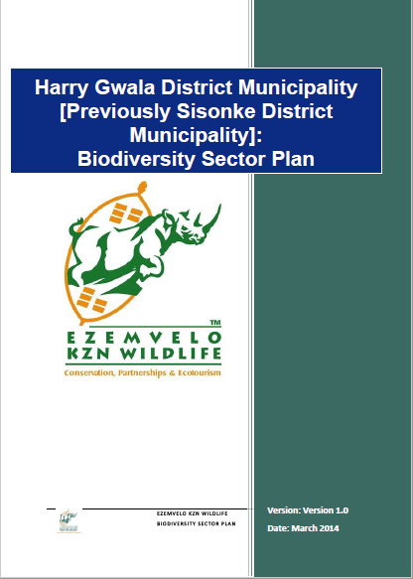
Performance Target: Source funding to compile a Strategic Environmental Assessment and Environmental Management Plan before December 2018.

6.5.3.3 Project 3 – Protection of Agricultural land
The main source of jobs and income in the municipality is the agricultural sector. It is therefore exceedingly important to protect the agricultural land in line with the prescriptions of KZN Department of Agriculture and Rural Development. At present the Municipality does not have an Agricultural Plan and thus need to make use of the Department’s KwaZulu-Natal Agricultural Land Potential Categories Report in conjunction with the Bioresource Programme: A natural resources classification system for KwaZulu-Natal and with the concomitant GIS data to clearly indicate areas that will not be used for any development except agriculturally related.
Performance Target: Source funding to compile an Agricultural Plan before December 2018.

6.5.3.4 Project 4 - Efficient Service Delivery.
Affordable housing projects are reliant on access to bulk municipal services. These include water as the highest priority, followed by sanitation and electricity bulk infrastructure. Usually bulk municipal services are available in or next to existing urban areas, this favours infill development as the primary option for affordable housing development and opposes urban sprawl as a form of urban development.
The municipality’s Service Delivery Plan should take into consideration the principles and strategies as set out in this Housing Plan in order to ensure that services are provided in such a way that it strengthen the development nodes and contribute to a spatially well-ordered settlement pattern. This will ensure that services can be provided to consumers in a sustainable manner with the concomitant benefit of service delivery at an economy of scale basis.
Performance Target: Review the municipality’s Service Delivery Plan before March 2019 with emphasis on the Spatial Development Rationale.

6.5.3.5. Project 5 – Formalization of Existing Informal Settlements.
The formalization of existing settlements should be a priority project of the municipality because it would ensure that the principles and strategies of this housing plan are adhered to. The benefits of formalization are numerous and include the following;
- Security of Tenure
- Accessibility to infrastructure
- Entrance into the property market
- Enhancement of living conditions
- Access to Social and commercial Infrastructure
This project should be of an integrated nature and the HDMU should work closely with the municipality’s Technical and Planning departments to achieve the formalization.
It is recommended that a Development Framework Plan should form the basis for the formalization process.
Performance Target: a) Obtain funding to compile a Development Framework Plan (DFP).
b) Appoint a service provider to compile a DFP for the Municipality.
c) Proceed with formalization of exiting settlements in accordance with the DFP

6.5.3.6 Project 6 - Provide options of housing types
The greatest need for housing will be within the nodal areas. The housing need will largely have to be addressed by the public sector. To promote a greater housing typology mix, a certain amount of affordable, government-subsidized housing would need to be developed in Dr NDZ and a way will have to be found to encourage middle and upper-middle housing private sector development. The municipality needs to access the total range of available subsidies and private sector funding to ensure a variety of housing options over the whole spectrum of requirements.
The project’s specific development proposals are included in Section 3 of this Report.
Performance Target: Adopt the development proposals in Section 3 of this report and ensure adherence to the proposals on an ongoing basis.

6.5.4. Strategy 4: Make provision for HIV/AIDS affected people.
The housing delivery process is faced with problems of having to deal with beneficiaries who are minors after being orphaned by the disease before the project is closed out.
It is recognized that the scourge of HIV/AIDS has been stabilizing and even started to show a decline but there are also citizens with all kinds of other special needs that need to be provided for e.g. people with various degrees of physical disabilities, people with mental illness that can still function in the broader society, the aged, the destitute etc.
There is a need to provide easy access for weakened members of society. In effect homes have to be designed around the needs of wheelchair patients. It also means that municipalities, as developers, have to pay more attention to roads and access to the homes themselves. Planning will have to be integrated so as align housing delivery with other service provision in projects if these special needs are to be addressed. More clinics are going to have to be built and public transport improved to make it easier for special need groups to get medical help. As developers and as a society we have no option but to increase densities in order to bring down the costs of services such as water, sewage and roads and to make public transport viable once again.

6.5.4.1 Project 1- Compile a HIV/AIDS Plan.
It is recommended that the municipality develop a HIV/AIDS plan that must be take into consideration the impact of the disease on service delivery, including housing.

6.5.4.2 Project 2- Compile a Special needs groups plan.
It is recommended that the municipality, in partnership with the relevant government departments, NGO’s and parastatals, compile a plan to address the requirements of the people with special needs of all different categories in our society. It is further recommended that special attention is paid to the housing, transport, access and medical needs of these vulnerable members of our society.
Performance Target: Obtain funding and compile a Special needs and HIV/AIDS plan before November 2018.

6.5.5. Strategy 5: An Integrated Approach Towards Sustainable Human Settlement.
In order to ultimately achieve the vision of Dr NDZ municipality and comply with the strategies of the National Department of Housing it is crucial to have an integrated approach towards sustainable human settlement. It is recommended that this goal be achieved through having settlement progression plans for the different kinds of settlement typologies.

6.5.5.1. Formal Housing Settlement Progression Plan
- Focus on identifying land for infill projects in the urban areas with cost effective settlement as a goal.
- Determine income level housing provision areas/ relating to land potential
- Research and undertake a land audit in identified areas for expansion in the Bulwer and Underberg areas to broaden the tax income base of the Municipality for cross subsidy purposes. Expand development of the tourism industry, to strengthen development potential.
- Research stimulation of the property market by means of development proposals by private and financial institution- backed developers for potential tourism areas.
- Determine a Council policy and partnership agreements and incentives for such tourism expansion plan.
- Communication and capacitating of available finance and housing options, tenure options and housing typologies in the Dr NDZ area.
- Focus on upgrading and maintenance of services to acceptable basic standard levels.
- Access grants (MIG: Municipal Infrastructure Grant) from National Government for identified areas for services.
- Calculate, identify and determine facilities and amenities to achieve sustainable human settlements in the various sectors of the economy.

6.5.5.2. Rural Based Settlements Progression
- Justify settlement in terms of economic perspective in relation to serviced areas.
- Focus in consolidating existing dispersed populations.
- Maintenance of the rural subsistence relationship determine programs for self-reliance, Community garden projects, social programs and recreation areas.
- Creation and strengthening of individualistic energies rather than to compete with urban areas.
- Address farm labour tenure issues in accordance with DLA.
- Provide sufficient and affective and economic access to basic services by determination of viable connection points to services and upgrading programmes.
- Establish funding on a budget basis on Municipal and district level.
- Establish Partnerships for expropriation with the identified farmers and determine support programs and subsidies for sustainability with DLA. And DAEA.
- Formalize a rural development forum and provide support to identify specific community needs.
- Establish Agri-villages according to the prescripts of the Department of Rural Development and Land Reform

6.5.5.3 Tribal Based Settlements Progression;
- Establish a formal working partnership or body between tribal authority and the local authority with executive powers in order to have a forum to determine housing development needs and priority areas.
- Undertake a detailed survey of the tribal land versus dwelling types in the area, human densities and demand statistics.
- Determine existing and potential nodal centers for future housing projects.
- Determine levels of service provision according to a standards list and need areas. Pass information to the established forum.
- Develop a rural housing priority settlement plan for implementation with a set of incentives for support services through the partnership.
- Ensure protection of vulnerable and valuable land

6.5.5.4 Informal Settlement Progression Plan;
- Develop a strategy to curb informal settlements prioritize the accommodation of resettlement programs in terms of the IDP proposals.
- Undertake the identification of research of backyard shacks and through consultation facilitate a change to higher standards.
- Identification of a housing delivery project that can be eligible for donor funding
- Develop a proposal related to HIV/AIDS and human settlements as a climate change mitigation and energy efficient sustainable practice in upgrading and renewal capacitation.
- Determine a training program on the housing subsidy process to community.
- Communication on alternative housing typologies and tenure.
- Develop, refine and monitor a housing waiting list, with the community by a capacitated official of the local authority.

Performance Target: Compile settlement progression plans by March 2019.

7. LOCATION OF FUTURE HUMAN SETTLEMENT PROJECTS

7.1 Dr NDZ Settlement Hierarchy
In the situational analysis section of the Municipality’s IDP for 2017 to 2022, the following issues pertaining to housing provision were identified. Challenges faced by the Dr NDZ municipality in the provision of housing include:
- the planning and provision of bulk infrastructure required for, amongst other things, housing developments, which is presently not aligned to the housing projects and is creating bottlenecks,
- the complex relationship between Amakhosi and the Dr NDZ Municipality over access to land for housing projects,
- unavailability of land for housing development; and
- the dissemination of information to ward committee level.
The SDF states that, “Underberg, Bulwer, Creighton, Donnybrook and Himeville are the urban settlements.” In terms of size, character and performance, these settlements function as small towns which are associated with service provision for the town itself and the surrounding countryside.
Centecow, Pholela and Richenau are the notable peri-urban and densely populated rural settlements within Dr NDZ Municipality. These areas have been identified as the “Settlement Development Nodes.” The Settlement Development Nodes would locate a settlement or cluster of settlements. The services that these provide are limited to the surrounding settlements and include low order public, shopping, and small business enterprise facilities. This would include primary and secondary schools. These areas also generally co-inside with the higher order roads and transportation routes. It would therefore also represent the areas where housing provision would be anticipated and supported.
The above spatial hierarchy is summarised in Table 18 below:
Table 18: Dr NDZ Municipality nodal classification / spatial hierarchy
One of the tendencies identified in the IDP 2017 is that the existing nodes exhibit low levels of densification. Densification is, however, only encouraged where there is sufficient infrastructural capacity to provide services for the densification process. Urban and settlement edges (p 44) were identified in respect of the following settlements.
Urban edges | Bulwer town, Underberg town, Creighton and Himeville
Settlement edges | Donnybrook, Pholela, Centacow, Memela, Masomeni, Dazini, Mqatsheni, KwaPiteni, Woodford, Pevensy, Enhlanhleni and Reichenau

As part of the Status Quo Assessment, a map was developed of the households per Ward. Based on the content of the map, it was clear that the settlement in respect of Dr NDZ municipality is generally located from the centre of the municipality and increasing in density towards the South-East.

7.2 Department of Human Settlement Priorities
The Department of Human Settlements, as part of their mandate has developed a map per municipality, identifying Priority Intervention areas, as depicted in Figure 23.
The Human Settlement Priority intervention plan does generally co-inside with the previous criteria and mapping undertaken.
It is therefore essential that the land identified for housing development aligns with the areas with the greatest population, the areas found suitable for development and the settlements identified for development of housing in terms of the 2017 IDP review.

Figure 22: Dr NDZ Municipal Development Areas

Figure 23: Human Settlements Priority Intervention areas
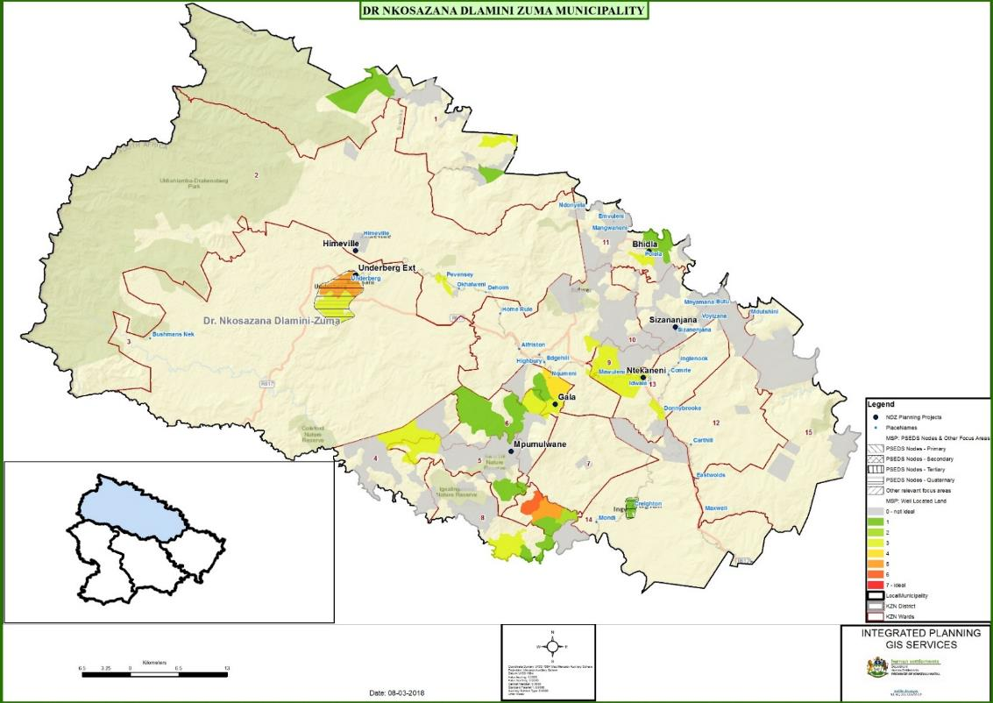

7.3 Provincial Benchmarking
The provincial Department of Human Settlements Master Spatial Plan (MSP) identifies the following as the core benchmarking for measuring projects before funding is approved:

7.3.1 MSP Principles:
- Guide and align all investment in Human Settlements
- Creation of balanced settlements reflecting spatial equity, economic potential and competitiveness & environmental sustainability
- Spatial targeting and spatial concentration
- Accessibility and choice
- Value creation and capture
- Effective governance
- Responsiveness to demographic and economic context

7.3.2 MSP Objectives:
- Spatial transformation
- Compact settlements and settlement patterns
- Connected settlements and settlement patterns
- Integrated settlements and settlement patterns
- Functional residential property market in urban and rural areas
- Consistent application of policies, principles, objectives and concepts across various scales
- (provincial, regional & local)
- Institutional capacity for effective planning and implementation

7.4 Proposed Investment Allocation Procedure
The DoHS have further developed the following criteria for the allocation of resources in respect of housing projects.
Component 1:
70% of available discretionary funding to be reserved for projects located in the identified priority human settlement areas
Component 2:
20% of available discretionary funding to be allocated to projects not located in the identified priority human settlement areas
Component 3:
10% of available allocations to be allocated to other provincial priority projects
It is thus essential that the Municipal priority projects are aligned to the Department of Human settlements project identification and planning.

7.5 Areas Suitable For Housing Development
It is proposed that the following areas be excluded as possible suitable green field housing development sites:
- areas that are further than 30 minutes travel time, by public and other transport, from main roads;
- areas that are further than 30 minutes travel time, by public and other transport, from development nodes;
- areas that are further than 20 minutes travel time, by public and other transport, from facilities and other areas;
- areas where the population density is less than 80 people per km2;
- environmentally sensitive areas - exclude all wetlands, reserves, private reserves and conservation areas as well as all areas with an Irreplaceability Index > 0.8; and
- slope characteristics exclude all areas with gradient >25%.
The map (Figure 24) depicts areas suitable for development.

Figure 24: Dr NDZ Development Areas based on above criteria
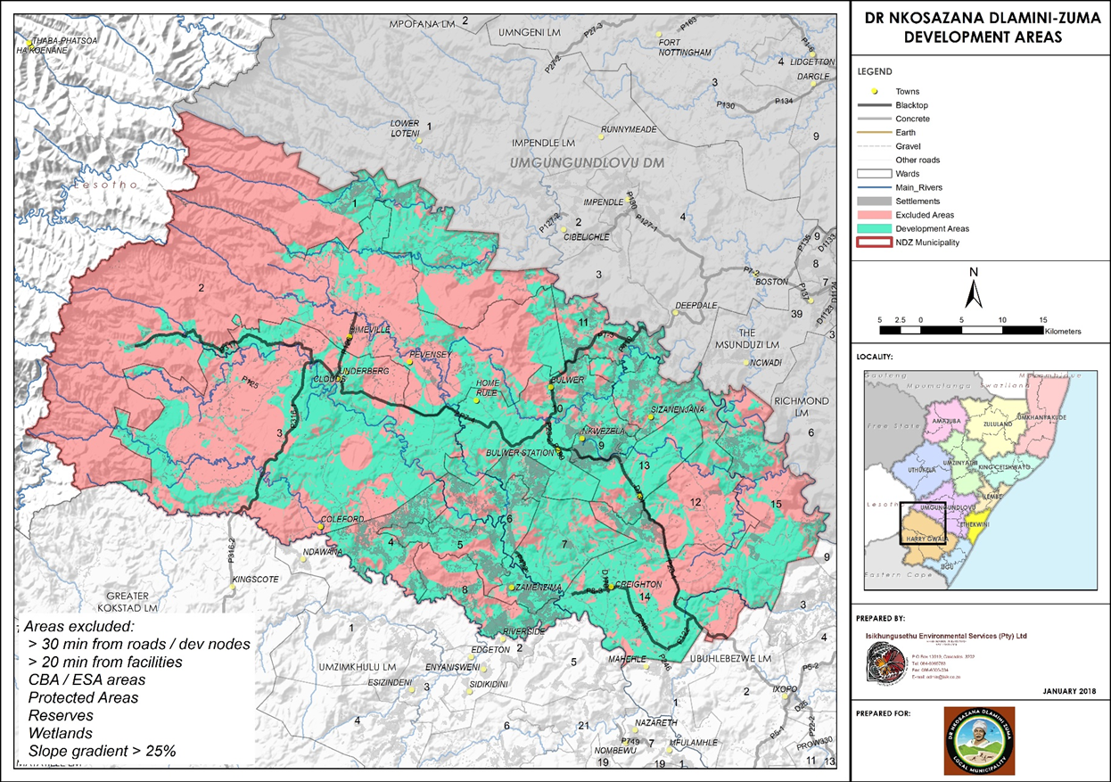

The resultant map excluded the above areas, and indicates the areas considered most suitable for housing development when the existing projects as identified by the Municipality is put as an overlay on the map the result is the map below: Development areas. It can thus be seen the projects as identified by the municipality falls either within the areas suitable for development or at a specific node as identified in the SDF and IDP.

7.6 Dr NDZ Identified Housing Projects:
The following projects have been identified in respect of the period 2017 to 2021, as detailed below. The actual settlement boundaries in respect these projects will only be identified once the detailed beneficiary lists are developed as suggested in terms of Strategy 1 project number 1: Determine the actual housing backlog.

Table 19: Proposed housing projects
These 16 projects (4 per year) are reflected in the maps below.
It should further be observed that the 2017 Dr NDZ IDP recommended a 1000 houses per project. The specific need per project area is however subject to the actual demand per area.

Figure 25: Planned housing as per the 2017 IDP
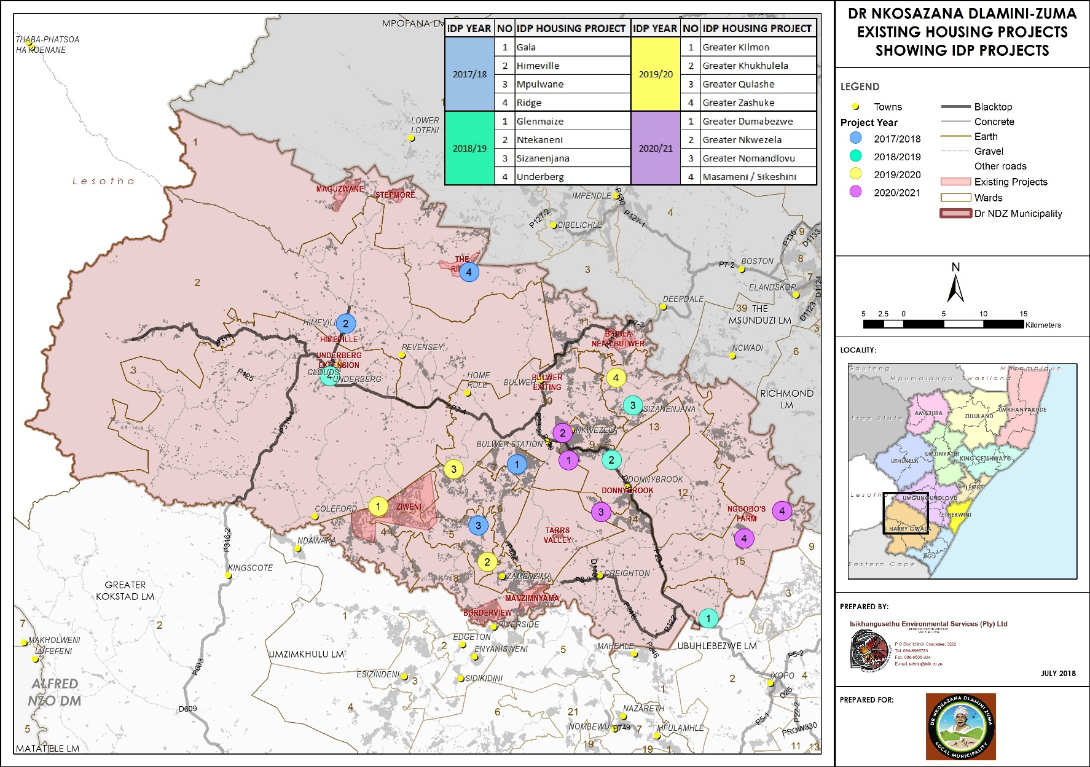

Figure 26: Planned housing in relation to development areas as per the restrictions previously identified
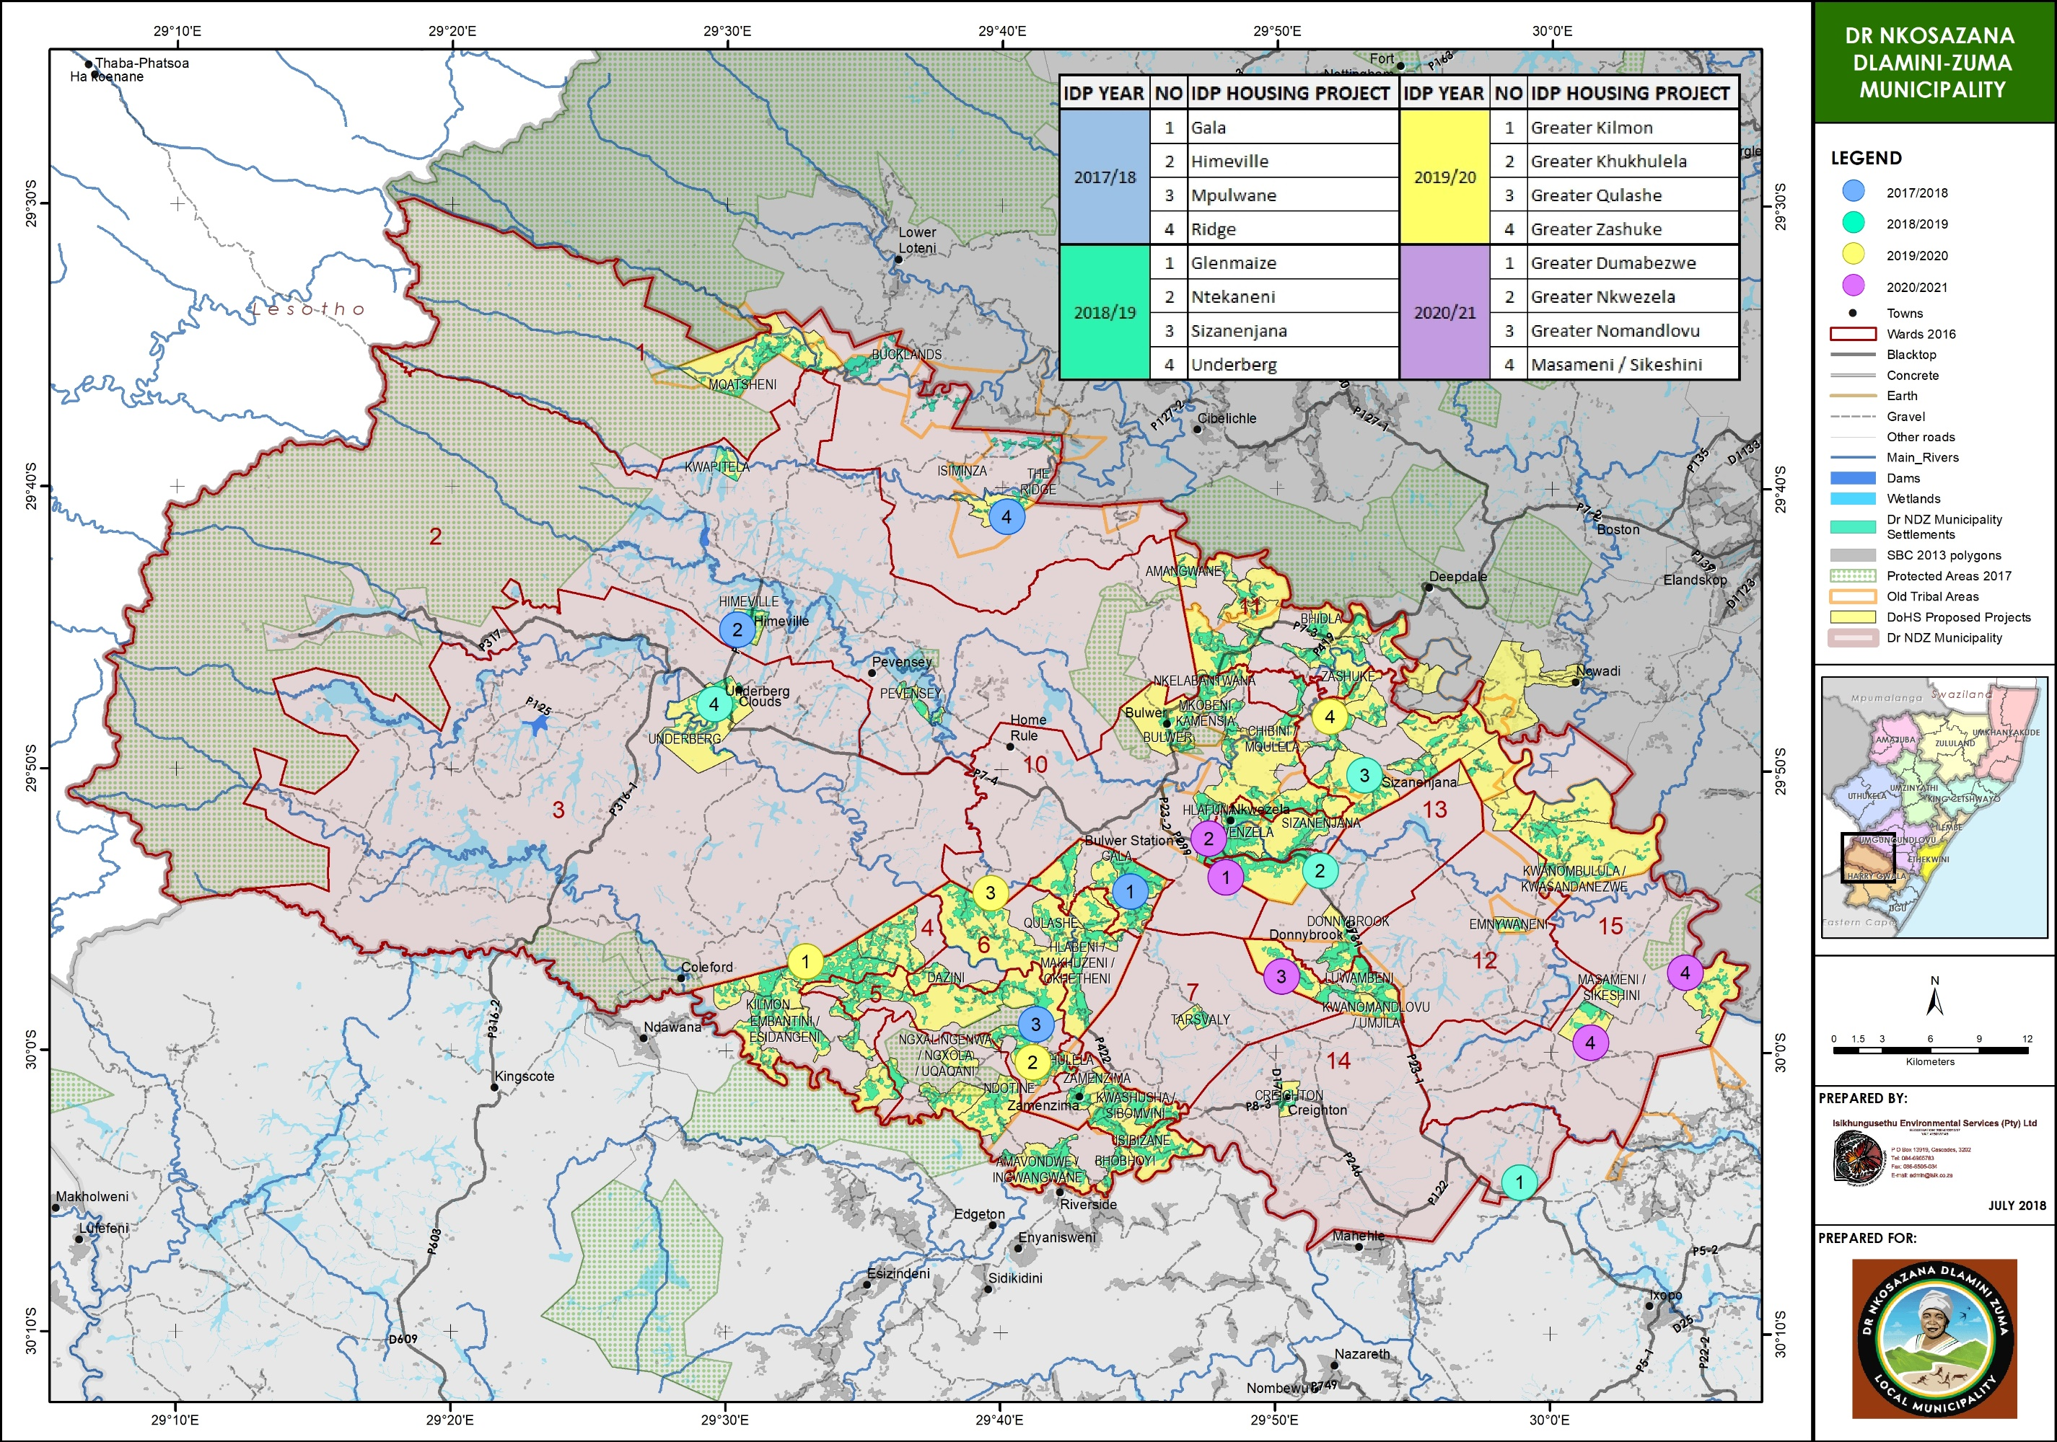

7.7 Future Demand
According to the StatsSA 2011 census, the municipality had a population of 110 084 people and 118 480 in 2016. This relates to a compounded population growth of 1,34% per annum. By extrapolating the household growth with the 1,34% per annum and using 2016 as the baseline the numbers in the following table indicates the housing demand until 2031.
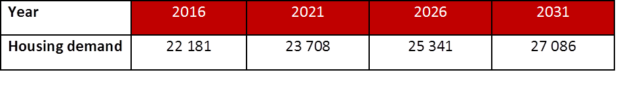

7.8 Housing Typologies
The projects currently identified and indicated on the map are projects requiring the approval of the DoHS. The municipality must make provision at it’s nodal points for the necessary capital investment to ensure that sites are available for middle and higher income residents who can provide their own housing.

7.9 Future Actions
In light of this report read together with the Policy it is imperative that the municipality follow the Strategies, Projects and Performance targets as set out in this document. In order to determine the factual requirements for human settlement provision in Dr NDZ, the municipality need to put in place the required structures and budget to be able to do the necessary intensive study to obtain the correct statistics for the area. This will lead to a situation where the municipality will be able to plan for actual integrated and sustainable human settlements that will add value to the quality of life of it’s residents and enhance service delivery in the municipality in line with the municipality’s mandate.
The current reality is that it is neigh impossible to determine the actual need and backlog at every proposed development node. There is also no clarity regarding the availability of funding from the DoHS over the lifetime of this plan. This in turn leads to a situation where no concrete numbers can be allocated for development at the different identified and suitable areas.

8. INSTITUTIONAL ARRANGEMENTS

8.1 Current Structure
The Dr NDZ Human Settlement Institutional Structure is depicted in Figure 27 hereunder. In terms of the current organisational structure, the Senior Manager: Public Works and Basic Services is responsible for the housing functions within the municipality. This post is currently vacant.
These functions of this section can be summarized as follows:
- To manage, monitor and evaluate the Implementation of the Housing
- Sector Plan Development and implementation;
- To ensure integrated housing development within the municipality;
- To co-ordinate line-function responsibilities and actions pertaining to housing development;
- To maintain a database on all erven and property transfers;
- To provide technical support on housing related matters;
- To ensure compliance with national and provincial legislation and policies relating to housing development;
- Monitor and combat land invasion; and
- To assist communities and other role players with housing related queries.
It is therefore considered imperative that the vacant post for a Housing Officer be budgeted for and filled.
The intention is to construct 8 000 dwellings over the next IDP period. This is an ambitious task with the current structure. It is therefore recommended that the structure be augmented with one, or preferably two more staff members to deal with the administration associated with the development of an average of 2 000 homes annually. To reduce the long term impact on Dr NDZ municipality these additional posts could potentially be contract positions or alternatively a structure similar to Shared Services can be promulgated on a district level. The major advantage of a “Human Settlement Shared Services Unit” will be the economy of scale which will ensure the pooling of resources to enable the participating municipalities to appoint the best possible human resources in the unit.
The current reality is that Local Authorities is constitutionally mandated and obliged to address the virtually unlimited demand for housing with very limited resources. In order to make any progress in real terms the mandated service authority need the best possible human resources to tackle the vast challenge in a meaningful way.
Figure 27: Dr NDZ Municipality Staff Structure - Housing Officers
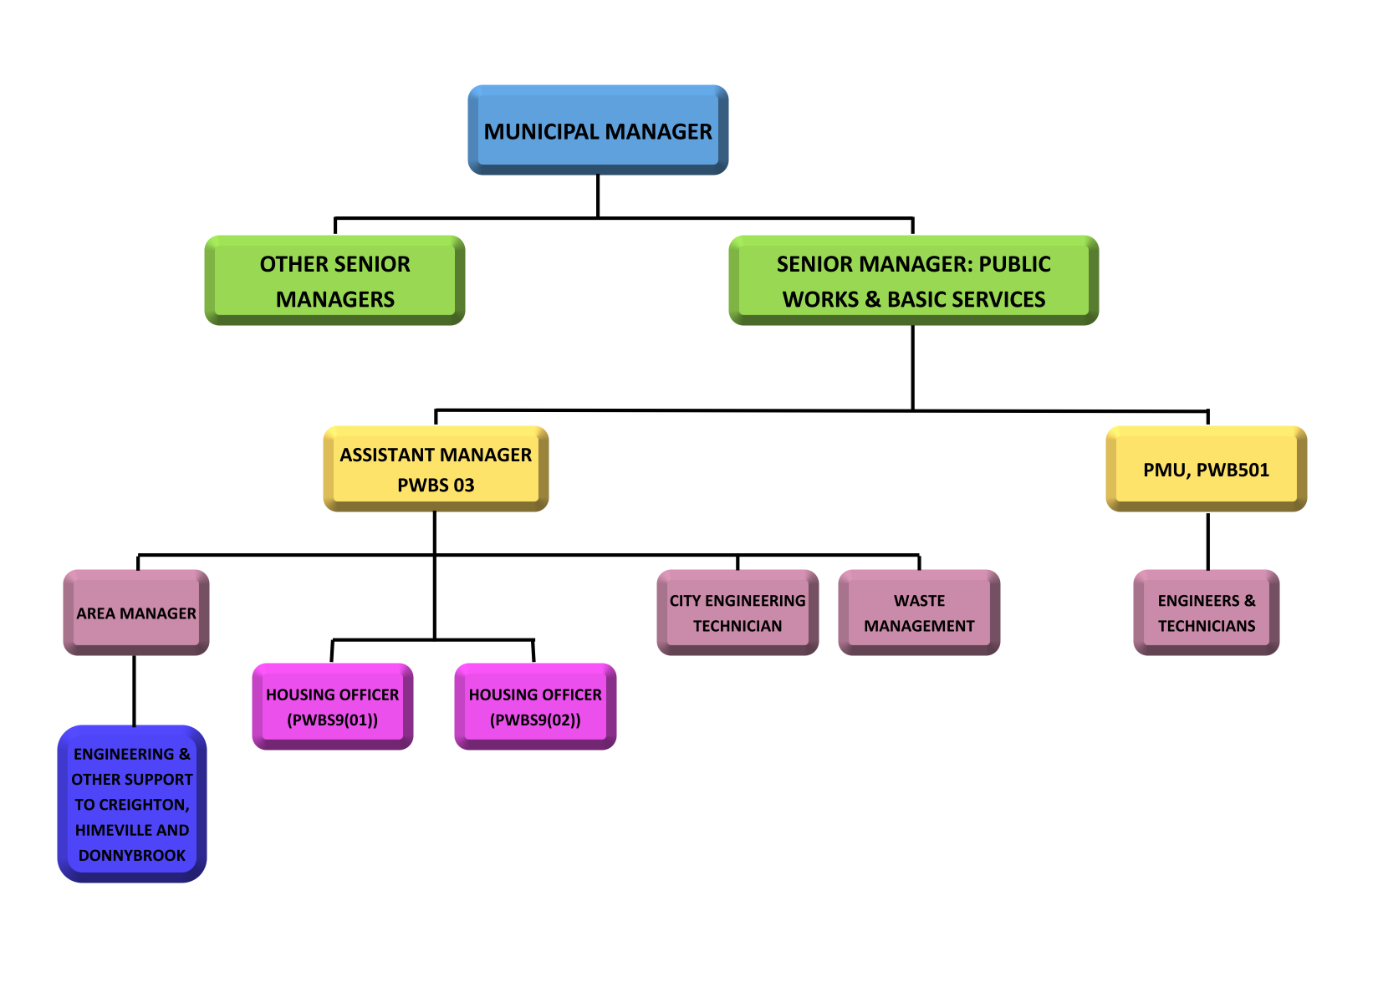

8.2 Housing structure support tools
There are a number of support tools recommended in respect of Dr NDZ municipality. This includes the following.

8.2.1 Institutional support
The implementation of an effective Housing Sector Plan requires effective decision-making structures. The following is suggested.
- The establishment of a Dr NDZ Housing Committee. This committee should ideally report to the Mayor and be constituted of the relevant councillor for human settlement, staff and technical support for the technical departments to ensure the principle of co-ordinated development.
- There should be regular liaison with DoHS as the core funder of projects to ensure alignment and support for municipal priorities.
- As the core decision-making body in respect of human settlement in Dr NDZ Municipality, this structure, based on the compendium policy prepared with the Housing Sector Plan should set the criteria for housing support.
Other functions will include:
- Identification of future land for settlement
- Addressing illegal land occupation
- Funding solutions to informal settlement eradication
In addition, Strategy 6.5.2.1 above recommends the establishment of a Housing Delivery Management Unit. It is recommended that the Housing Development Management Unit deal with the entire housing delivery process from land identification, through to planning and service delivery, development and project management.

8.2.2 Capacity building

Municipal Capacity Building
As already alluded to above, there is a need to augment the current Dr NDZ Housing structure to address the significant backlog.

Traditional Councillor Capacity Building
In addition, as per strategy 6.5.2.2 above, it is recommended that the capacity of the Traditional Leaders be augmented to support and assist with the implementation of the Housing Sector Plan and subsequent land use management. The Spatial Planning and Land Use Management Act, No. 16 of 2013, acknowledges the important role that Traditional Leaders fulfil in land use management, and by empowering Traditional Leaders, this important co-governance of land use can only be enhanced.

Municipal Accreditation
The DoHS, as mentioned in strategy 6.5.2.3 above, has initiated a process in terms of which municipalities, who meet the required criteria, may be assigned administrative powers in support of fulfilling its functions. Local municipalities are required to demonstrate the ability to effectively and responsibly manage the financial and technical aspects associated with the human settlement process and procedures.

Depending on the outcome of the municipal assessment, it could potentially qualify for either Level 1 accreditation, which represents the simplest form of accreditation. Level 2 relates to more complex administrative systems and a larger variety of subsidy mechanisms.
Qualifying for accreditation will allow for better control of the Housing Sector Plan implementation, and should therefore be an important goal for Dr NDZ municipality.

9. CONCLUSION
The intention of this Housing Sector Plan (HSP) is to form part of the Dr NDZ Municipality Integrated Development Plan. In order to achieve this, the HSP must be aligned to the IDP and the municipal Spatial Development Framework. Other requirements include being aligned to national legislation and policies, the provincial Department of Human Settlements Master Plan, recognition of the housing demand, local socio-economic conditions and utility services, as well as linkage to the municipal spatial structure including urban and other centres, movement and other corridors, whilst recognising the need to protect agricultural and environmental resources.
It is submitted that the plan has met the above criteria. The Dr NDZ HSP has demonstrated that it is aligned to the IDP, the SDF, the main legal frameworks and government policies. The planned housing developments are further aligned to the Department of Human Settlements Master Plan, the municipal spatial structure with specific reference to the urban and other centres, movement and other corridors, whilst excluding high value agricultural land and environmental resources
The objectives of the HSP included integrated development, capacity building, sustainable development, improving quality of life and protection of natural and cultural environment.
The strategies proposed in respect of the HSP includes establishing sustainable communities, determining accurate housing backlogs, establishing appropriate structures and capacity, improving the release of land and establishing a housing performance management system. Other strategies includes the protection of environmental sensitive land as well as agricultural land.
The implementation of the plan will give effect to:
- The improvement of living conditions
- Potential job opportunities through construction
- More effective use of utilisation infrastructure
- Reduction in travelling time and costs to access social and economic services
- More integrated development through co-ordinating development activities of role players including the municipality and the Department of Housing
- Improved linkages between the spatial development framework and the implementation of projects on the ground
The provision of progressive, integrated, sustainable human settlements should lead to communities with a sense of opportunity and pride. The implementation of the proposals contained in this document should lead to a better quality of life for the people residing in Dr NDZ municipality and over time to an integrated, holistic, local government that contributes to the provincial and national society in an exemplary manner.

REFERENCES

CSIR, 2002, Sustainability Analysis in Human Settlements in SA, Prepared by CSIR Building and Construction Technology Programme for Sustainable Human Settlement
Dr NDZ Municipality, 2017, Integrated Development Plan 2017 to 2022
Dr NDZ Municipality, 2017, Spatial Development Framework 2017 to 2022
Department of Human Settlements, 2004, Breaking New Ground: A comprehensive plan for the development of sustainable human settlements, August 2004
Department of Human Settlements, 2014, Concept Note: Human Settlements Spatial Planning Framework, Final Draft, October 2014
Englebrecht, J. 2018. Personal communication. 2018.03.06 Department of Human Settlements. KwaZulu-Natal.
Harry Gwala District Municipality, 2016, Water Services Development Plan.
Housing Development Agency, 2014, Spatial Investment briefing to private developers, May 2014
Ingwe Municipality, 2013. Human Settlements Sector Plan
KwaSani Municipality; undated, KwaSani Municipality Housing Sector Plan 2013 – 2016, Prepared by Masakhekulunge Managers
KwaZulu Natal Provincial Planning Commission, 2016. KwaZulu Natal Provincial Growth and Development Plan (Draft)
Republic of South Africa, 2012. National Infrastructure Plan Lexis Nexis
Republic of South Africa, 2010, Guide to the Outcomes Approach, 27 May 2010
uPhongolo Municipality, 2008, uPhongolo Draft Housing Plan, prepared by Vuka Planning Africa
World Commission on Environment and Development, 1987, Our Common Future: The Bruntland Report
Stats SA, 2016, Community Survey: Statistical Release, July 2016
Republic of South Africa, 1998. Municipal Structures Act (117 of 1998) Lexis Nexis
Republic of South Africa, 2000. Municipal Systems Act (32 of 2000) Lexis Nexis
Republic of South Africa, 2013. Spatial Planning and Land Use Management Act (Act 16 of 2013) Lexis Nexis

ANNEXURES
Annexure 1: Housing Strategies

Annexure 1: Housing Strategy Tables
 |  |  |  | Timeline
No. | Strategy | Project | Performance target/s | July/Aug 2018 | Sept/ Oct 2018 | Nov/Dec 2018 | Jan/Feb 2019 | March/ Apr 2019 | May/Jun 2019 | Jul/Aug 2019
1 | Establish Sustainable Communities | Project 1: Determine the actual housing backlog | Establish actual housing demand in the municipal area before January 2019
1 | Establish Sustainable Communities | Project 2: Land Identification and Evaluation | a) Complete land audit by November 2018
1 | Establish Sustainable Communities | Project 2: Land Identification and Evaluation | b) Complete Land Identification by March 2019
1 | Establish Sustainable Communities | Project 2: Land Identification and Evaluation | c) Initiate land acquisition by July 2019 at the beginning of the 2019/20 financial year
1 | Establish Sustainable Communities | Project 3: Establish Security of Tenure | Compile a Framework to guide the issuing of PTO’s by February 2019
1 | Establish Sustainable Communities | Project 4: Speedy Release and Servicing of Land | Adopt and implement the Municipality’s Housing Policy before November 2018 to ensure the speedy release and servicing of land for future housing projects
2 | Develop the necessary institutional arrangements | Project 1: Capacity Building | a) Establish a HDMU at the municipality before February 2019
2 | Develop the necessary institutional arrangements | Project 1: Capacity Building | b) Capacitate Officials of the municipality to deal with the entire housing delivery process by July 2019 through training
2 | Develop the necessary institutional arrangements | Project 2: Traditional Leader capacitation | a) Appoint a Service Provider to develop the required course materials.
2 | Develop the necessary institutional arrangements | Project 2: Traditional Leader capacitation | b) Undertake the capacitation of the Traditional Leaders in DNDZ municipality
2 | Develop the necessary institutional arrangements | Project 2: Decide on the Accreditation Option | a) Decide on an accreditation option by November 2018
2 | Develop the necessary institutional arrangements | Project 2: Decide on the Accreditation Option | b) Apply for accreditation by April 2019
2 | Develop the necessary institutional arrangements | Project 3: Establish Public Participation Structures | Establish Human Settlement Specific Community participation structures by November 2018
2 | Develop the necessary institutional arrangements | Project 4: Establish a Housing specific Performance Management System | Establish a housing performance management system before the establishment of the HDMU | Ongoing
3 | Settlement Planning and Services identified | Project 1: Hierarchy of nodes | This is an ongoing principle that all projects must comply to | Ongoing
3 | Settlement Planning and Services identified | Project 2: Protection of Natural Resources | Source funding to compile a Strategic Environmental Assessment and Environmental Management Plan before December 2018
3 | Settlement Planning and Services identified | Project 3: Protection of Agricultural land | Source funding to compile an Agricultural Plan before December 2018
3 | Settlement Planning and Services identified | Project 4: Efficient Service Delivery | Review the municipality’s Service Delivery Plan before March 2019 with emphasis on the Spatial Development Rationale
3 | Settlement Planning and Services identified | Project 5: Formalization of Existing Informal Settlements | a) Obtain funding to compile a Development Framework Plan (DFP).  (July 2019)
3 | Settlement Planning and Services identified | Project 5: Formalization of Existing Informal Settlements | b) Appoint a service provider to compile a DFP for the Municipality  (Post July 2019)
3 | Settlement Planning and Services identified | Project 5: Formalization of Existing Informal Settlements | c) Proceed with formalization of exiting settlements in accordance with the DFP (On completion of DFP) |  |  |  |  |  |  | Futue
3 | Settlement Planning and Services identified | Project 6: Provide options of housing types | Adopt the development proposals in Section 3 of this report and ensure adherence to the proposals on an ongoing basis (Future) |  |  |  |  |  |  | Futue
4 | Make provision for HIV/AIDS affected people | Project 1: Compile a HIV/AIDS Plan (After July 2019) |  | Secure funding to develop plan
4 |  | Project 2: Compile a Special needs groups plan (After July 2019). | Obtain funding and compile a Special needs and HIV/AIDS plan before November 2018. | Secure funding to develop plan
5 | An Integrated Approach Towards Sustainable Human Settlement |  | Compile settlement progression plans by March 2019

Dr NDZ, 2017, Integrated Development Plan: 2017 - 2022
StatsSA, 2016, Community Survey: Statistical Release P0 301.

