Main Street Creighton, 3263

P.O Box 62

Creighton 3263

Phone: +27 39 833 1038

Fax: +27 39 833 1179 Email: mailbox@ndz.gov.za

A Better Place for ALL www.ndz.gov.za



ADDENDUM FOR A PANEL OF SERVICE PROVIDERS TO SUPPLY AND

DELIVER LAPTOPS DESK TOPS AND OTHER ICT ACCESSORIES FOR A

PERIOD OF 3 YEARS

BID NO: CORP-B051/22/23

Date: 12111/2024

The addendum serves to correct page 43 which had incorrect information and extend the closing date, on page 43 (FORM OF OFFER AND ACCEPTANCE) we had incorrect information.

1. On page 43 we have made changes (see attached correct page)

See below extended date:

|  |  |  |
| --- | --- | --- |
| PROJECT NAME | CONTRACT NO. | EXTENDED DATE AND TIME FOR  CLOSING |
| A PANEL OF SERVICE PROVIDERS TO SUPPLY  AND DELIVER LAPTOPS  DESK TOPS AND OTHER  ICT ACCESSORIES FOR A  PERIOD OF 3 YEARS | CORP-8051/22/23 | 22 November 2024  @12hOO |

IS N. HOLIWE

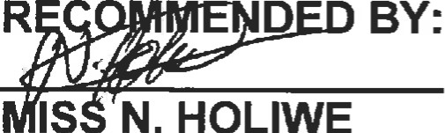

D

BY:

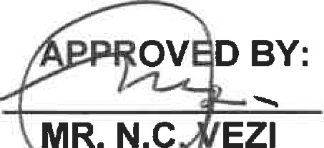

MR.

N.C

SCM MANAGER 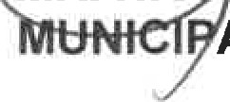AL MANAGER

I acknowledge receipt of this Addendum No.l Name:..

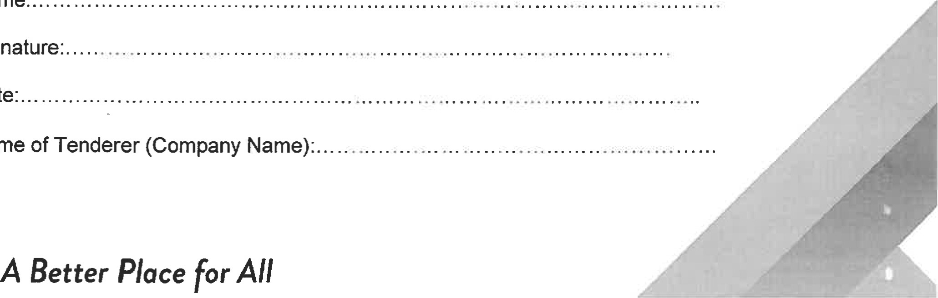

Name

Signature:.

Date:.

1

AGREEMENTS AND CONTRACT DATA

Form of Offer and Acceptance

A: Offer

The Employer, identified in the Acceptance signature block, has solicited offers to enter into a Contract for the procurement of:

BID NO: CORP-B051/22/23 PROPOSAL FOR THE APPOINTMENT OF A PANEL OF SERVICE PROVIDERS TO SUPPLY AND DELIVER LAPTOPS, DESK TOPS AND OTHER ICT ACCESSORIES FOR A PERIOD OF 3YEARS.

The Tenderer, identified in the Offer signature block, has examined the documents listed in the Tender Data and addenda thereto as listed in the returnable schedules, and by submitting this offer has accepted the conditions of tender.

By the representative of the tenderer, deemed to be duly authorized, signing this apart of this form of offer and acceptance, the tenderer offers to perform all of the obligations and liabilities of the contractor under the contract including compliance with all its terms and conditions according to their true intent and meaning for an amount to be determined in accordance with the conditions of contract identified in the contract data.

THE OFFERED TOTAL PRICE INCLUSIVE OF VALUE ADDED TAX (VAT) IS

Rand (in words);

.. (in figures),

This offer may be accepted by the employer by signing the Acceptance part of this Form of Offer and Acceptance and returning one copy of this document to the tenderer before the end of the period of validity stated in the tender data, whereupon the tenderer becomes the party named as the contractor in the conditions of contract identified in the contract data.

Signature:

Name: (in capitals)...-

Capacity of Signatory: .

Name of Tenderer (organisation):

Address:



Fax:

.

Witness:

43