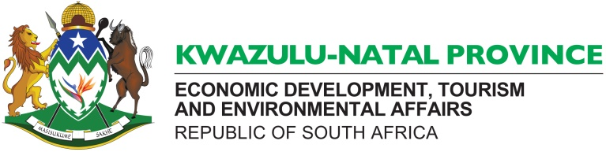

**DIRECTORATE:**

|  |
| --- |
| Private Bag X9152, PIETERMARITZBURG, 3200  **HRM &D**  270 Jabu Ndlovu Street, Pietermaritzburg, 3200  **Tel**: 033 264 2630  **Email Hlengiwe.sishi@kznedtea.gov.za** |

**GRADUATE DEVELOPMENT PROGRAMME FOR 2021-23**

The Department of Economic Development, Tourism & Environmental Affairs is implementing the Graduate Development Programme as part of its contribution to skills development initiatives as expressed in the NSDS III, NGP, PGDS, NDP Vision 2030 objectives by inviting those graduates who have been part of the internship programme of the Department and all other graduates from various institutions in possession of the required qualification to participate in the programme that will provide valuable work experience and increase opportunities towards employment. The programme offered is fully-structured and the Department will pay successful graduates a monthly stipend/allowance.

Applications are invited from interested applicants in possession of a relevant Master’s degree as stipulated below from recognized tertiary institutions/universities to undertake workplace training that shall run for the period of 24 months in the following field/areas:

A PhD qualification will be an added advantage.

|  |  |  |  |
| --- | --- | --- | --- |
| **FIELD/AREA** | **QUALIFICATION** | **NO. OF GRADUATES** | **Ref. Number** |
| Industry Development and Business Regulation | Master’s Degree in Economics/Planning/Public Policy Management/Development Studies | 01 | ID&BR 3MAY/21 1MAY/21 |

**Expected competencies:**

* Excellent writing skills,
* Economic Development understanding
* Research and Policy analysis
* Analytical skills
* Knowledge of using excel and databases
* Strong administrative expertise

**Direction to applicants:**

The application should be submitted in the Z83 form obtainable from any government department and it must be ***signed and dated,***  indicating the **CORRECT** **REFERENCE** **NUMBER** of the field applied for and it must also include ***certified copies (not older than 3 months)*** of the following documents:-

* South African Identity document
* Degree/diploma certificate and matric or senior certificate
* **Full academic record indicating individual modules or courses**

**NB:** **Those who have studied at Private Higher Institutions are also directed to provide Credit**

**Certificate indicating the number of credits the qualification has.**

If any of the documents mentioned above are not attached, the applicant will automatically be disqualified. The department reserves the right to place or not to place applicants based on its needs and requirements.

The closing date for applications is **26 May 2021**.

In addition applicants must be/have:

* Curriculum vitae
* South African citizen
* Reside in KZN
* Unemployed graduates between the age of 18-35
* People with disabilities
* Prepared to enter into a contractual agreement with the Department.

Interested applicants should forward their applications to the following address:

Director: Human Resource Management & Development

The Department of Economic Development, Tourism & Environmental Affairs

P/Bag X 9152

Pietermaritzburg

3200

**For Attention: Ms M Mngoma**

Or hand delivered at the following address at the reception:

The Department of Economic Development, Tourism & Environmental Affairs

270 Jabu Ndlovu Street (former Loop Street)

Pietermaritzburg, 3201

Enquiries should be directed to **Ms M Mngoma 033 264 2684.**