INTEGRATED WASTE MANAGEMENT PLAN (IWMP)

September 2020
Dr Nkosazana Dlamini Zuma Local Municipality

CONTENTS
1. Defining the geographical area 4
2. Situation analysis 5
2.1. Demographics (Population and development profiles) 5
2.1.1. Growth&Demographic Profile 5
2.1.2. Dwelling Types...........................................................................................................................7
2.2. Determining current waste generation and estimating future waste generation rates and quantities 9
2.2.1. Domestric Waste Generation 9
2.3. Waste quantities and types 13
2.3.1. Weighbridge 13
2.3.2. Volume density estimation system 14
2.3.3. Waste stream analysis 15
2.4. Waste recycling, treatment and disposal 16
2.4.1. Status Quo of Waste Disposal Facilities 16
2.4.2. Status Quo of Waste Treatment Facilities 17
2.4.3. Status Quo of Waste Recyclers 18
2.4.4. Status Quo of other types of facilities 19
2.5. Status of waste collection services 20
2.5.1. National Domestic Waste Collection Standandards..................................................................................................20
2.6. Financing of Waste Management 24
2.6.1. Budget/Expenditure: Income and expenditure 24
2.6.2. Revenue sources 26
2.6.4. Organisational and institutional matters 27
3. Desired end state 28
3.1. Setting strategic goals, targets and indicators 28
4. Identify, evaluate and select alternatives 31
4.1. Strategic goals, targets, timeframe, budget 31
5. Communication and Stakeholder Participation 34
5.1. Consultation Process Summary 34
6. Implementation Instruments 35
6.1. Partnerships 35
6.2. Legislative instruments: Development and enforcement of by-laws 36
6.3. Funding mechanisms 37
6.4. Implementation Plan (Summary of an IWMP Planning Process) 38
7. Reporting on Monitoring 40
7.1. Strategic issues 41
7.2. Performance 42
7.3. Public accountability 43
7.4. Communication and public participation plan 44
7.5. Financial plan 45
7.6. Waste management implementation programme 46
Annexure or References (Optional) 47

Defining the geographical area

Dr Nkosazana Dlamini-Zuma Local Municipality (herein referred as “The Municipality”) is a local municipality established after the August 2016 local government elections. It followed a gazetted merger between erstwhile Ingwe and Kwa Sani local municipalities. The Municipality is situated in the southern part of KwaZulu-Natal. It is located within Harry Gwala District Municipality (HGDM), the fourth largest district municipality in Kwa-Zulu Natal.

The Municipality is a predominantly rural municipality with 5 main towns within its boundaries. These include Underberg, Himeville, Creighton, Bulwer, and Donnybrook. It is a category B Municipality and is deemed the second largest municipality in the District in terms of population size.

The Municipality is responsible for the provision of a number of services to the communities within its area of jurisdiction. One of these services is the collection and safe disposal of domestic and commercial waste.

1.1 LAND COVER AND BROAD LAND USES
1.1.1. TOPOGRAPHY

The altitude ranges from 2083 metres above sea level in the north east (aMahwaqa Peak) to a low of approximately 450 metres at the bottom of the Umkhomazi River valley in the south. The Municipality comprises of gently undulating to steeply undulating land. Much of the gently sloped land is restricted to small “plateaus”, which are primarily found in the western highlands areas.

1.1.2. GEOLOGY

The geological nature of an area influences the topography, and alignment of river channels. It also has an influence on the type of soil formations prevalent. The municipal area is underlined by rock derived from dolerite and mudstones. The eastern lower lying areas of the municipality are dominated by shale’s and arsenate. The soils are generally considered to have low fertility. The second very important common characteristic evident in most of the soils within the municipal area is that they are highly erodible. Majority of the municipal area (northwestern portion of the municipality moving towards the central portion) is characterized by mudstone and dispersed with dolerite. The southern and southeastern portion of the municipality is dominated by shale, dispersed with Ecca Group Arenite.

1.1.3. VEGETATION

The Municipality has a wide diversity of vegetation. This includes vegetation that is well represented elsewhere in the province, vegetation that is of particular ecological interest (such as the plant communities that are associated with the dolerite dykes in the area). The variety of vegetation types is widespread throughout the Municipality. Safe to highlight that there are two main vegetation types, which have been identified as being the most significant to the biodiversity in the area.

They are namely: -

- Mist belt grassland- This vegetation type is endemic to KZN and has a high biodiversity value due to the lack of representation of true Mist belt grassland inside and outside the formally protected areas. The Mist belt grassland plays an important role in the provision of a suitable habitat for endangered blue swallow and Oribi.
- Mist belt Forests- This forest is probably the most important forest in the area. This is mainly because it is one of the few forests with a high number of Cape Parrots and it has the Tree Hyrax. Therefore, the conservation of this forest is of great importance.

The vegetation in the Municipality contains several environmentally important and sensitive vegetation types. The area can be divided into seven Bio-resource groups namely,

- Moist Highveld Sourveld (24%),
- Dry Highveld Sourveld (<1%),
- Moist Transitional Tall Grassveld (60%)
- Moist Midlands Mist belt (4%),
- Moist Tall Grassveld (6%),
- Coast Hinterland Thornveld (<1%), and
- Valley Bushveld (5%)

Aside from the indigenous (natural) vegetation, there are extensive areas upon which agricultural activities have affected significant changes to the vegetation. Amongst the most obvious of these are the commercial forestry operations. Dr Nkosazana Dlamini-Zuma Local Municipality has an important role to play in ensuring that both conservation and development are complimentary to one another and ensure that the natural environment is not compromised. It is recommended that development procedures be carried through thoroughly and concisely for all developments taking place within the municipality, more particularly around natural water resources and wetland features.

1.2 AGRICULTURE

1.2.1. METHODS APPLIED IN ASSESSING AGRICULTURAL POTENTIAL

This information is drawn from the Harry Gwala District Rural Plan undertaken in 2015. It highlights that several methods for determining agricultural potential at a high level without having visited an area exist and all these methods rely on Global Information System (GIS) data that have been gathered and interpreted by National Government Departments. Datasets referred to during this study are described briefly as follows:

- Capability – developed by the Agricultural Research Council, land capability GIS data is used to classify land into 8 distinct classes that vary by land-use which can either be arable, grazing and wildlife;

- Bioresource Units (BRUs) –Bioresource Units GIS data is available from the KZN Department of Agriculture and Rural Development (KZNDARD) and uses GIS data to classify units of land where a defined area in which the environmental and physical conditions such as soil types, vegetation, climate and terrain form are sufficiently uniform can be identified and a land management practice recommended; and

- Agricultural Land Categories – the Agricultural Land Categories GIS data compiled by the Natural Resources division of the KZN DARD is by the most recent and comprehensive dataset available and combines various planning datasets to produce a composite layer that can be used for fairly detailed development planning.

- Land

Each of the abovementioned methods and datasets are discussed in greater detail in the following sections.

1.3. ENVIRONMENTAL ANALYSIS
1.3.1. BIODIVERSITY

The effective conservation of the world’s biodiversity results in the long-term survival and well-being of the people. Pressures on biodiversity show no sign of decreasing, yet resources for conservation action are limited. Dr Nkosazana Dlamini- Zuma Local Municipality needs to be strategic and focus efforts where they will have the greatest impact. Mindset is employed as a data analysis function that identifies a “minimum set” of planning units that will assist in meeting conservation targets. Although no detailed sampling of the fauna of the entire Dr Nkosazana Dlamini- Zuma Local Municipality municipal area has been completed, available data indicates that in terms of game animals, species diversity is quite low due to the dominance of Sourveld type grasslands (Dr Nkosazana Dlamini-Zuma Local Municipality IDP 2002). However, there are a number of common, rare and endangered species present.

In terms of high biodiversity value, there are several areas in the municipality identified in terms of priority 1. This is due to the following animals, which are Red Data species found in the Dr Nkosazana Dlamini- Zuma Local Municipalilty. They have high biodiversity value; as such, they need protection from exploitation and habitat loss:

- Oribi: vulnerable but bordering on endangered
- Blue swallow: critically endangered
- Cape parrot: critically endangered
- Wattle crane: critically endangered
- Blue crane: endangered
- Crowned crane: endangered
- Cape vulture: endangered
- Tree hyrax: endangered

The Harry Gwala DM has developed a District Biodiversity Sector Plan. It takes extensive cognizance of the KZN Provincial Biodiversity Plan developed by KZN Wildlife. The District Biodiversity Plan identifies the environmentally sensitive areas, conservation and protected areas as well as the Critical Biodiversity Areas (CBAs). The CBAs are considered as areas critical to meeting biodiversity targets and thresholds. They are crucial to maintain viable population of species as well as the functionality of ecosystems (Escott, et al. 2013).

1.3.2 KEY HYDROLOGICAL FEATURES

The municipal area covers an extremely diverse and unique environment which encompasses vast open grasslands, highly productive arable farmlands, pristine rivers with their huge network of tributaries, numerous wetlands, lakes and dams as well as towering mountains and the foothills leading into them. These physical and scenic resources coupled with a rich diversity of Fauna and Flora as well as cultural and historical resources (e.g. San rock art) have earned the area the reputation of being a most important Inland Tourism Destination. At the same time the high rainfall and abundant water supply in the form of streams and rivers, good natural grazing and some high potential arable soils contribute to the area’s considerable agricultural output.
Emphasis will be placed on:

- Ensuring that productive agricultural areas are not lost to the region by ensuring that proposed new non-agricultural development is carefully controlled and only allowed to take place in the designated development nodes.
- Encouraging sound farming and land use practices especially amongst the subsistence and emerging farmers in the tribal areas.
- Education of the community in the importance and financial benefits of maintaining the environment in a healthy state: The value of maintaining landscape quality cannot be recognized and where necessary reclaiming degraded landscapes due to erosion, overgrazing and other poor land management practices. The need to control or remove alien and invasive plants is of importance here.
- Monitoring and controlling all activities within the Drakensberg Heritage Site Buffer Zone, even where they take place within the designated development nodes. Here again the importance of protecting existing landscape quality is paramount. The importance of preserving and protecting the natural environment is well recognized by the municipality as it will have an enormous influence on the future quality of life and financial well-being of the whole community.

The preservation of the agricultural component, increase in tourism and general attractiveness for people to settle here depend on it.

1.2.3. AIR QUALITY

Due to the rural nature of Dr Nkosazana Dlamini-Zuma Local Municipality, the air quality is considerably good. The dispersed housing and numerous plantations found in and around the area allow for a good oxygen carbon dioxide cycle. Thus, the only air pollution that could endanger the livelihoods of the inhabitants would be the burning of wood, forest waste and fugitive dust emissions generated from unpaved roads.

1.2.4. CLIMATE AND CLIMATE CHANGE

Two bio-climatic regions exist. These are the highland and the moist upland bio-climatic regions. The area can be categorized into two temperature zones:

- The western (higher) portions of Dr Nkosazana Dlamini-Zuma Local Municipality have good climate and are typically cooler. Winter temperatures in the cooler western regions often drop below 00 C.
- The eastern (lower) portions can be described to have high climate. Warmer eastern regions temperatures seldom drop below 50 C.

Summer temperatures range from the low thirties in the west to high thirties in the east. The mean annual rainfall in the area is between 700 and 1200mm per annum with the eastern areas generally being drier than those in the west are.

1.2.5 EXTREME WEATHER RISKS

There is variability in the features that influence the region’s climate. This produces extreme weather conditions in Dr Nkosazana Dlamini-Zuma Local Municipality. Some of the most common climate extremes cause serious impacts. These often record numerous deaths, damage to households (leaving people homeless), create health concerns and require efficient emergency assistance. It also affects negatively on biodiversity.

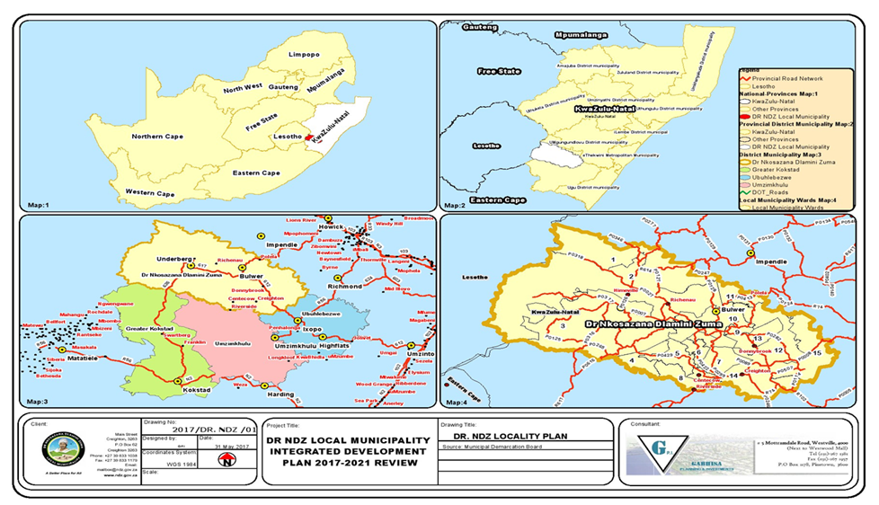
Map 1 Geographic Location of Dr Nkosazana Dlamini Zuma Local Municipality

Situation analysis

Demographics (Population and development profiles)
2.1.1 Growth & Demographic Profile

Dr Nkosazana Dlamini Zuma Local Municipality is composed of a total population of 118480 as indicated in table below (Stats SA, community survey 2016). Dr Nkosazana Dlamini-Zuma Local Municipality is a predominantly rural municipality with five main towns within its boundaries; these include Creighton, Bulwer, Donnybrook, Underberg and Himeville (KwaSani IDP, 2015/16; KZN 436 IDP, 2015/16).

Growth estimates |  | 2011 | 2016
Municipality Population (as per Census 2011): | 100548 |  |  | 118480
Estimated Population Growth (%) as per Census 2011: | -0.67 |  |  | 1.67
Estimated current population as of 2016 (year is a parameter): | 97179.6
Demographic profile
Age:
Youth | 73858 |  |  | 92414
Middle age | 18842 |  |  | 17973
Old age | 7849 |  |  | 8092
Gender:
Male | 46752 |  |  | 56732
Female | 53795 |  |  | 61748
Education:
Primary | 40766
Secondary | 35189
Tertiary | 2088
Employment:
Employed | 10570
Unemployed | 57342

Population distribution graphs:
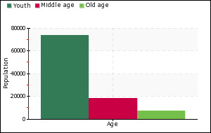 | 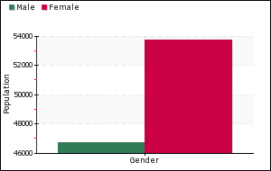
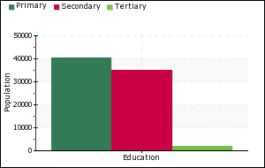 | 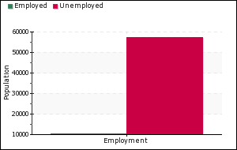

2.1.2 Dwelling Types
House or brick/concrete block structure on a separate stand or yard or on a farm: | 5269
Traditional dwelling/hut/structure made of traditional materials: | 15789
Flat or apartment in a block of flats: | 917
Cluster house in complex: | 97
Townhouse (semi-detached house in a complex): | 66
Semi-detached house: | 15
House/flat/room in backyard: | 533
Informal dwelling (shack in backyard): | 96
Informal dwelling (shack not in backyard e.g. in a informal/squatter settlement or on a farm: | 67
Room/flatlet on a property or larger dwelling/servants quarters/granny flat: | 40
Caravan/tent: | 20
Other: | 143

Dwelling types graphs:

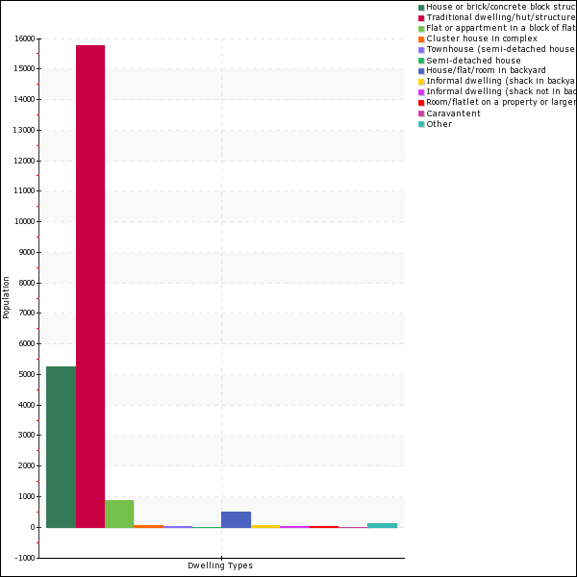

Determining current waste generation and estimating future waste generation rates and quantities

Domestic Waste generation
Current waste generation and estimated future waste generation
Current domestic waste generation rates | 434.68
Future domestic waste generation rates (in 10 years) | 4346.8

Domestic waste generation graph:
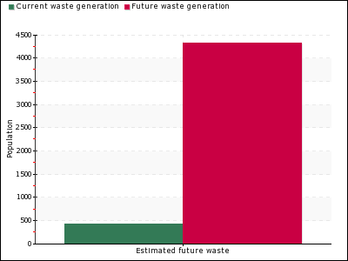

Waste quantities and types

Weighbridge
Dr Nkosazana Dlamini-Zuma Municipality consist of two waste disposal sites which are Creighton and Bulwer waste disposal site and both of them do not have a weighbridge stationed on site. The Himeville Transfer Station that receives large quantities of waste does not have a weighbridge. The waste is quantified based on estimate system. Records of the type of vehicle visiting the site and the type of waste offloaded are recorded.

Volume density estimation system
Creighton Waste Disposal site
Waste type/streams | Waste generated per annum (tons) | Total percentages
Organic waste | 0 | 0 %
Cans | 0 | 0 %
Paper | 0 | 0 %
Glass | 0 | 0 %
Plastic | 0 | 0 %
Construction and demolition waste | 0 | 0 %
Tyres | 0 | 0 %
Other | 0 | 0 %
Total |  | 100 %

Bulwer Waste Disposal Site
Waste type/streams | Waste generated per annum (tons) | Total percentages
Organic waste | 0 | 0 %
Cans | 0 | 0 %
Paper | 0 | 0 %
Glass | 0 | 0 %
Plastic | 0 | 0 %
Construction and demolition waste | 0 | 0 %
Tyres | 0 | 0 %
Other | 0 | 0 %
Total |  | 100 %

Waste stream analysis
The table below shows the estimated results that were obtained during waste characterization exercise that was undertaken by the Dr Nkosazana Dlamini Zuma Municipality at Himeville Transfer Station on the 28 May 2019. The Municipality was assisted by National Department of Environmental Affairs; Umzimkulu Local Municipality and Ubuhlebezwe Local Municipality.

Himeville Transfer Station
Waste type/streams | Waste disposed per annum (tons) | Total percentages
Organic waste | 11 | 17.7419 %
Cans | 8 | 12.9032 %
Paper | 6 | 9.67742 %
Glass | 16 | 25.8065 %
Plastic | 21 | 33.871 %
Construction and demolition waste | 0 | 0 %
Tyres | 0 | 0 %
Other | 0 | 0 %
Total |  | 100 %

The residential waste stream shows that there are various types of waste within Himeville Transfer Station which includes cardbox, clear plastic, glass, paper, textile, PET, polysterene, organic, garden, MCW, metal, nappies, HDPE, ewaste and hazardous waste.

The hotel waste stream is dominated by paper, organic and nappies waste. The availability of other waste types including metal, glass, textile, clear plastic, MCW, garden, polystyrene, cardbox, other plastic, HDPE and textile was also observed.

Soldier Stream

The Soldier camp waste stream categorization shows that there is a lot of waste that comes from this camp. The presence of all waste types was observed.

Waste Stream | Sample in KG
Waste Stream | 1 | 2 | 3 | 4 | 5 | 6 | 7 | 8 | 9 | 10 | 11 | 12 | 13 | 14 | 15 | 16 | 17 | 18 | 19
PET | 1,18 | 1,18 | 1,69 | 3,93 | 1,35 |  |  |  |  |  |  |  |  |  |  |  |  |  |  | 9,31
Clear Plastic |  |  |  |  |  |  |  |  |  |  |  |  |  |  |  |  |  |  |  | 0,00
Paper |  |  |  |  |  |  |  |  |  |  |  |  |  |  |  |  |  |  |  | 0,00
Garden |  |  |  |  |  |  |  |  |  |  |  |  |  |  |  |  |  |  |  | 0,00
organic | 3,89 | 6,83 | 6,01 |  |  |  |  |  |  |  |  |  |  |  |  |  |  |  |  | 16,72
metal | 5,07 | 6,43 | 1,11 | 6,51 | 0,74 | 0,46 |  |  |  |  |  |  |  |  |  |  |  |  |  | 20,31
Hazardous waste | 0,41 |  |  |  |  |  |  |  |  |  |  |  |  |  |  |  |  |  |  | 0,41
Textile |  |  |  |  |  |  |  |  |  |  |  |  |  |  |  |  |  |  |  | 0,00
Cardbox | 1,4 | 1,015 | 1,44 | 1,44 | 1,72 | 1,64 | 1,375 | 1,4 | 2,035 | 1,385 | 2,01 | 1,585 | 1,985 | 1,525 | 2,805 | 2,19 | 2,15 | 2,15 | 2,695 | 33,95
MCW | 2,155 | 6,79 |  |  |  |  |  |  |  |  |  |  |  |  |  |  |  |  |  | 8,95
Nappies |  |  |  |  |  |  |  |  |  |  |  |  |  |  |  |  |  |  |  | 0,00
HDPE | 2,345 | 1,355 |  |  |  |  |  |  |  |  |  |  |  |  |  |  |  |  |  | 3,70
Glass | 13,25 | 13,25 | 6,235 |  |  |  |  |  |  |  |  |  |  |  |  |  |  |  |  | 32,74
Polysterene(foam pack) | 0,895 | 3,005 | 0,89 |  |  |  |  |  |  |  |  |  |  |  |  |  |  |  |  | 4,79
other plastic | 1,535 | 2,265 | 4,37 | 2,07 | 2,125 | 1,305 | 1,56 | 0,26 |  |  |  |  |  |  |  |  |  |  |  | 15,49
ewaste |  |  |  |  |  |  |  |  |  |  |  |  |  |  |  |  |  |  |  | 0,00
TOTAL |  |  |  |  |  |  |  |  |  |  |  |  |  |  |  |  |  |  |  | 146,34

National Domestic Waste Collection Standards (GN21 of 2011)

- All complaints regarding waste must be dealt with promptly, and responded to within 24hours.
- An effective register of complaints must be kept.
- Dr Nkosazana Dlamini Zuma Municipality must create awareness around key waste issues as defined in the standards including illegal dumping, recycling and composting
- Dr Nkosazana Dlamini Zuma Municipality must provide clear guidelines on different domestic waste types, source separation, appropriate containers for domestic waste and disposal methods for waste not collected by kerbside refuse collection service

Waste classification

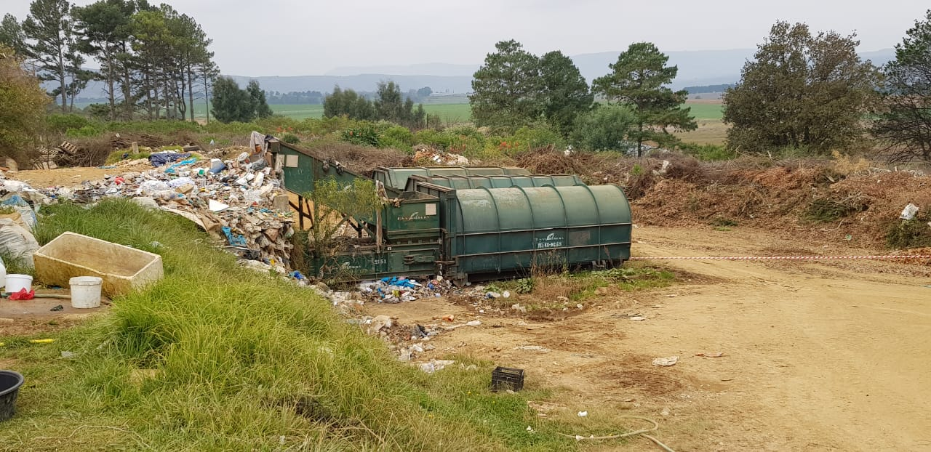

Residual waste ready to be sent to New England Landfill site, Pietermarzburg. Dr NDZ Municipality has a contract with service provider named Enviro serve for collection and transportation of residual waste to licensed landfill site. The packaging waste at Himeville Transfer Station is used by the cooperative for recycling purposes. However, there is a lot of waste such as cans stock piled due to lack of market. Glass is collected by an agency which transport waste to Glass Recycling once the Co-op reaches 35 bags of crushed glass. There is no compost activities that are taking place on site due to lack of chipping machine.

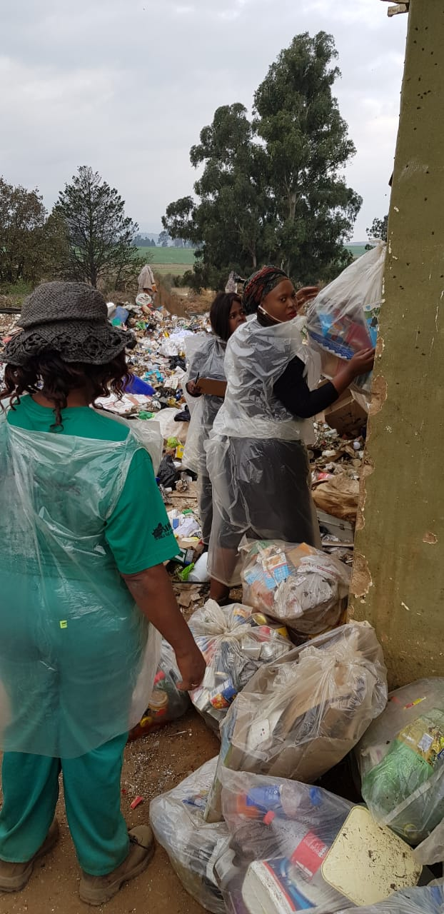
Picture 1: Showing different waste types quantification exercise

Waste recycling, treatment and disposal

Status Quo of Waste Disposal Facilities
Bulwer Waste Disposal Site
Status | Licensed
Total capacity | 6131
Existing capacity | 0
Available airspace | 0

Status Quo of Waste Disposal Facilities

Bulwer Waste Disposal Site

Bulwer waste disposal site is currently operational and is in possession of a valid licence. However, the site does not meet the minimum landfill site standard as per National Environmental Management: Waste Act 59 of 2008. The site has reached it capacity and the Municipality is in a process for applying for Environmental Impact Assessment and Waste Management Licence application for closure of Bulwer Waste disposal site.

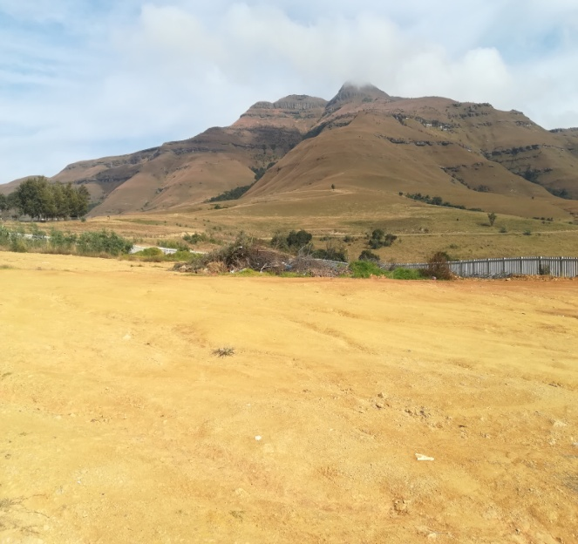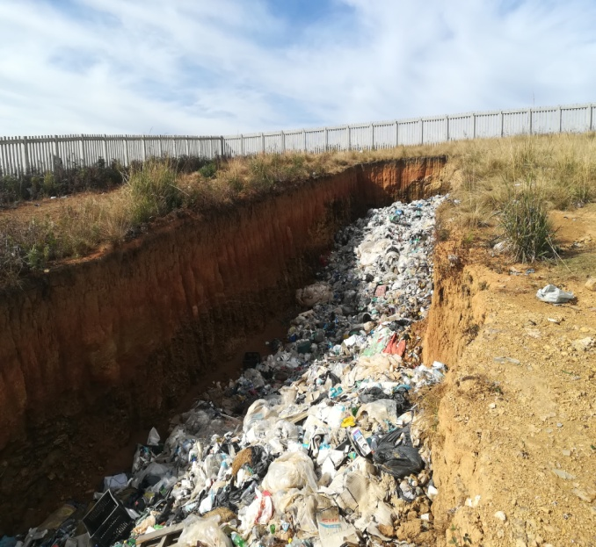
Picture 2: Bulwer Waste Disposal Site

Creighton Waste Disposal Site
The Creighton Waste Disposal Site is also licenced with a license that is valid for a period of 10 years, for continued use after the period of 10 years, a renewal will be submitted at least 6 months prior to the expiry date.

Status Quo of Waste Recyclers
Waste recycling activities are taking place at Himeville Transfer Station. This duty has been outsourced by the municipality and is performed by the SMME (Bazamile). However, there is still a challenge of piled cans within the Himeville transfer station. Although there are waste recyclers within the municipality there is still a need of more SMMEs that can implement recycling within Bulwer and Creighton landfill site.

The Municipality has a database of waste recyclers which are based in Creighton and mainly involved in recycling at the Creighton Waste Disposal Site.

With assistance from the Department of Environmental Affairs, Tourism and Environmental Affairs there has been a number of workshops for the recyclers aimed at building capacity and also contributing to the green economy.

Funding mechanics injected by the National Department, waste recyclers of Dr Nkosazana Dlamini grabs such initiatives.

Status Quo of other types of facilities

Himville Transfer Station
The Himeville Transfer Station is utilized as the waste classification centre where waste is disposed from different sources and classified for recycling activities. The registration of the Himeville Transfer Station was submitted in terms of section 5 of the National Norms and Standards for the Storage of Waste, 2013. The facility is registered under reference KZN/waste/storage/058.

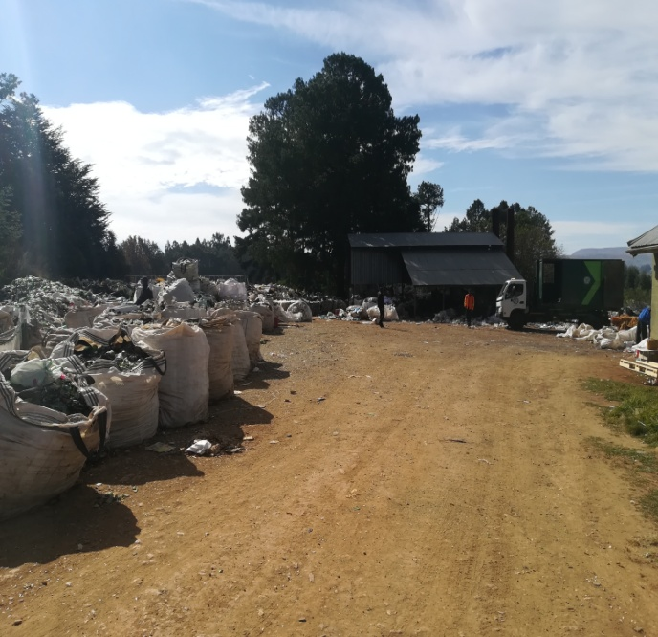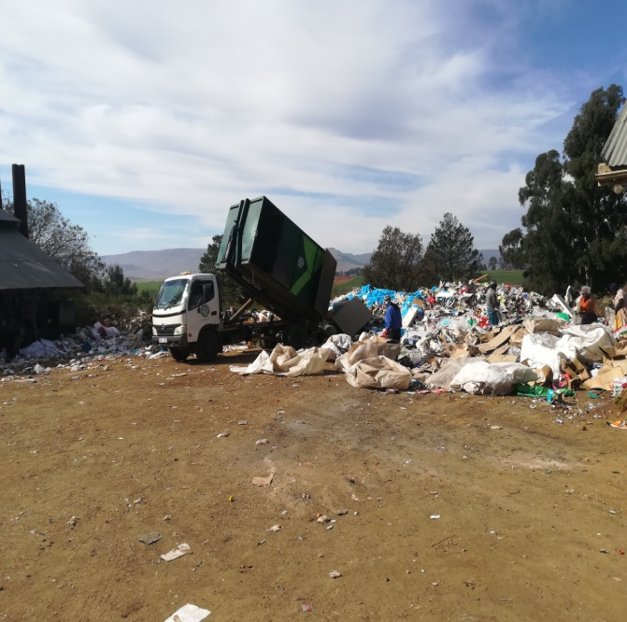
Picture 3: Himeville Transfer Station Municipal fleet disposing waste

collection services

2.5.1National Domestic Waste Collection Standards

Item | Total number
Households | 29619
Serviced households | 4456
Unserviced households | 25163
Indigent households | 151
Unserviced indigent households | 0
Service Level A: On-site appropriate and regularly supervised disposal | 0
Service Level B: Community transfer to central collection point: | 0
Service Level C: Organised transfer to central collection points and/or kerbside collection: | 0
Service Level D: Mixture of Service Level B and Service Level C: | 0
Total Serviced households as per the National Domestic Waste Collection Standards: | 0

National Domestic Waste Collection Standards Graph:

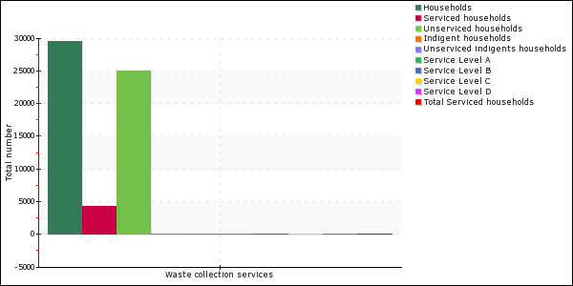

Financing of Waste Management

Budget/Expenditure: Income and expenditure (5 years period)
Item | Amount
Collection
Transportation (refuse removal) | R 5 000 000
Capex-purchase (vehicles) | 0
Maintenance of fleet | R 500 000
Fuel | R 180 000
Receptacles | R 100 000
Subtotal | R 5 780 000
Governance
Staff (remuneration) | R 18 258 100
Education and awareness | R 200 000
IWMP | R 0
Review of by-laws | R 300 000
Subtotal | R 18 758 100
Disposal
Transfer station renovations | R 500 000
Maintenance of Disposal sites | R 2.5 000 000
Acquisition of land for the Municipality landfill site and recycling projects | R 1.8 000 000
Establishment of a new landfill site | R2.5 000 000
Procurement of equipment (shredder and skip loader truck, skip bins, weighbridge) | R4 000 000
Regulatory compliance, EIA’s and licence | R 1.9 000 000
Subtotal | R 13,2 000 000
Total | R 24 538 113,2

Budget/Expenditure graph:

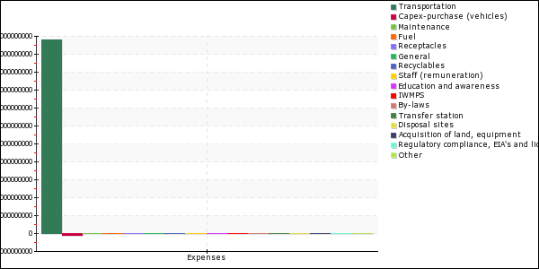

Revenue sources

The Municipality currently does not have any funding mechanisms. However, the Municipality is currently process of applying for MIG Funding for the construction of a landfill for the Municipality.

Source | Amount
MIG Funding | R 0
Equitable share funding | R 0
Revenue from waste disposal fees | R 0
Revenue from enforcement of bylaws | R 0
Revenue from waste collection tariffs
Total | R 0

Organisational and institutional matters
Organogram:

Desired end state

Setting strategic goals, targets and indicators
The desired end state entails identifying priorities and goals that a municipality wishes to attain with regards to waste management. Using the information collected on the historical and present waste management situation, strategic goals for the IWMP should be developed. These should aim to address the gaps and the needs of the community and more importantly should respond to the Waste Act requirements. A program on how these will be attained is developed as an implementation plan. The strategic goals must be set based on the relevant waste legislation, regulations and policies and should be guided by the waste management hierarchy principles. Further, it should also include the setting of targets for waste management services such as collection, recycling, recovery and disposal. The setting of goals, objectives and targets must also take into consideration the municipal response to the goals and targets set in the National Waste Management Strategy.

The National Waste Management Strategy provides a set of goals that municipalities must achieve in the next five years in order to give effect to the Waste Act. It contains an action plan with various targets to be achieved by municipalities in the next five years until 2026. It is important that there should be a target date by which municipal strategic goals and targets are to be attained within the 5 years from the date the IWMP has been approved.

Goal 1: Promote recycling and recovery of waste
Objectives | Targets | Activities | Timeframe
Contribute towards the growth of the green economy | - Encouraging the participation of SMMEs and cooperatives in waste service delivery and recycling | - Provide land for companies to implement viable recycling projects  - Implement a viable green project such as composting and generate revenue  - Support SMMEs and cooperatives in partnership with industries such as PETCO, MONDI, SAPPI, Hotels and Commercial Businesses  - Establish a nursery in Himeville Transfer Station | - 2021-2026  - 2021  - 2021-2026  - 2023-2025
Promote waste minimisation | - Conduct a feasibility of waste minimization municipal wide and develop an action plan to promote their implementation at the local municipality level | - Establish mechanisms for promoting separation at source.  - Conduct a feasibility study to determine whether there is a need to establish buy back centers  - Develop a composting strategy to divert garden waste to the transfer station and waste disposal sites. | - 2021  - 2022  - 2021-2022

Goal 2: Ensure the effective and efficient delivery of waste services
Objectives | Targets | Activities | Timeframe
Ensure/Provide effective and efficient delivery of waste services to the community. | - Rendering of waste removal services to communities (households) | - Provide waste removal services in Bulwer, Donnybrook, Underberg/Himeville, Creighton.  - Provide receptacles for household waste and CBD  - Clear illegal dumping (schedule quarterly clean-up campaigns)  - Adopt open spaces for greening parks and creation.  - Purchase of specialized vehicles to extend waste collection to unserviced areas.  - Purchase adequate drums, skip bins and equipment for the removal of waste from residential areas.  - Develop a feasibility study for rolling out waste collection to rural and unserviced areas. | - Ongoing  - 2021  - Ongoing  - Ongoing  - 2021  - 2021  - 2023-2025  - 2021

Goal 3: Ensure that legislative tools are developed to deliver on the Waste Act and other applicable legislation
Objectives | Targets | Activities | Timeframe
To ensure compliance with municipal by-laws | - Gazetted Municipal by-laws  - System for maintaining electronic records of enforcement actions | - Train staff to enforce by-laws  - Review and promulgate waste management by-laws.  - Installation and maintenance of NO illegal dumping signage. | 2021  2021-2023  ongoing
Development of a waste information system | - Procurement of a weighbridge | - Development Terms of Reference for the procurement and advertise.  - Recording of waste quantities to SAWIS | 2021-2023  2024-2026
Development and implementation of IWMP. | - Complete IWMP | - Implementation and Enforcement of IWMP. | 2021-2026

Goal 4: Sound budgeting and financing of waste management services
Objectives | Targets | Activities | Timeframe
Ensure the availability of budget for waste management services/ resources.  Source external funding  To ensure that residents and businesses are charged in a fair manner, according to the service they receive. | Participate on municipal budget.  External funding.  External funding  Tariff modelling for waste management services. | - Annual allocation of budget for waste management services.  - Apply for funding  - Implement tariffs for waste collection and disposal.  - Implement tariffs for waste disposal by businesses and construction companies.  - Review tariffs in accordance to the costs of rendering waste services | - Ongoing  - 2021  - Ongoing  - ongoing

Goal 5: Ensure the safe and proper disposal of waste
Objectives | Targets | Activities | Timeframe
To provide the public with safe and accessible waste disposal facilities. | - Designs and Commissioning of a Landfill Site for the Municipality  - Establishment of a landfill site for the Municipality  Decommissioning and Rehabilitation of Bulwer Waste disposal site | - Develop a feasibility study for the landfill within Dr Nkosazana Dlamini Zuma Municipality.  - Develop designs for the new landfill site.  - Undertake an environmental impact assessment and waste management licence application for the new proposed landfill site.  - Phase 1 establishment of a landfill site  - Undertake an Environmental Impact Assessment and Waste Management Licence application for closure of Bulwer Waste disposal site.  - Decommissioning and Rehabilitation as stipulated in the rehabilitation plan.  - Undertake an environmental impact assessment and waste management licence application for the new proposed landfill site. | - 2021-2023  - 2021-2023  - 2022-2025  - 2025  - 2023-2025  - 2021-2025  - 2021-2025

Goal 6: Education and awareness
Objectives | Targets | Activities | Timeframe
Initiation and implementation of community education and awareness campaign. | - Annual programme of awareness campaigns.  - Undertake a minimum of 4 clean-ups and awareness campaigns per year | - Strengthen relationship and participation of all stakeholders.  - Schedule clean-up and awareness campaign. | - 2021-2026  - 2021-2026

Goal 7: Compliance and enforcement
Objectives | Targets | Activities | Timeframe
Maintain and provide compliant waste disposal sites according to waste management licence/ norms and standards | - Compliance with permit/ norms and standards requirements for waste facilities | - Auditing of the sites and Implement audit recommendations | Annually

Identify, evaluate and select alternatives

Strategic goals, targets, timeframe, budget

Goal 1: Promote recycling and recovery of waste
Objectives | Targets | Alternatives | Budget
Contribute towards the growth of the green economy | Encouraging the participation of SMMEs and cooperatives in waste service delivery and recycling | Establish a buy back centre for the Municipality.  Public Private Partnership (PPP)  Waste separation at source initiative. | R1000 000
Promote waste minimisation | Establish the feasibility study and implementation plan of waste minimization municipal wide and develop an action plan to promote their implementation at the local municipality level | Continue with Current system, 1 plastic bag | R1 000 000

Goal 2: Ensure the effective and efficient delivery of waste services
Objectives | Targets | Alternatives | Budget
Ensure/Provide effective and efficient delivery of waste services to the community. | Rendering of waste removal services to communities (households) | Pit system by households | R2 000 000
Development and implementation of IWMP. | Complete IWMP |  | Internal capacity

Goal 3: Ensure that legislative tools are developed to deliver on the Waste Act and other applicable legislation
Objectives | Targets | Alternatives | Budget
To ensure compliance with municipal by-laws | - Development and review of waste by-laws  - Develop a system for maintaining electronic records of enforcement actions | Ongoing education and awareness | R1000 000

Goal 4: Sound budgeting and financing of waste management services
Objectives | Targets | Alternatives | Budget
Ensure the availability of budget for waste management services.  Ensure availability of external funding  To ensure that residents and businesses are charged in a fair manner, according to the service they receive.  Ensure effective and efficient budget expenditure | Participate on municipal budget.  External funding  Tariff modelling for waste management services.  Comply with expenditure and supply chain policies | Funding mechanisms for waste management services | N/A
Goal 5: Ensure the safe and proper disposal of waste
Objectives | Targets | Alternatives | Budget
To provide the public with safe and accessible waste disposal facilities. | Designs and Commissioning of a Landfill Site for the Municipality | Continue with current system of waste disposal sites | R2 000 000
 | Decommissioning and Rehabilitation of Bulwer Waste disposal site |  | R2 000 000

Goal 6: Education and awareness
Objectives | Targets | Alternatives | Budget
Initiation and implementation of community education and awareness campaign. | Annual programme of awareness campaign.  Undertake a minimum of 4 clean-ups and awareness campaigns per year | Public private partnership on waste management services.  Installation of electronic branding for raising awareness. | R500 000

Goal 7: Compliance and enforcement
Objectives | Targets | Alternatives | Budget
Maintain and provide compliant waste disposal sites according to waste management licence/ norms and standards | Compliance with permit/ norms and standards requirements for waste facilities | Internally auditing the waste disposal sites. | R1000 000

Communication and Stakeholder Participation

Consultation Process Summary
The Waste Act requires the development of an IWMP to follow a public participation and consultation process (Section 72 and Section 73). Awareness programs should be developed in order to keep stakeholders abreast on issues pertaining to the development and implementation of the IWMP. A municipality can engage its stakeholders in various platforms such as:
- Ward Committee meetings.
- Waste management forum meetings,
- Workshops with interested and affected parties (could include youth environmental groups, taxi associations, religious groups, businesses operating in the area, schools etc.)
- Awareness campaigns i.e.as part of the development of an IWMP a municipality could publish information about the IWMP process and could communicate this in local media such as newspapers, local radio stations, print the information and post it on community notice boards.

The issues raised during the stakeholder participation process should be captured and dealt with under the implementation plan and stakeholders should be informed of progress made with regards to attaining the goals in the five years of implementing the IWMP.

Once the IWMP is approved by the Municipal Council all stakeholders will be informed through the Newspapers and notice board. During IDP consultation process stakeholders will be informed on the implementation of the plan. Performance reports on the implementation of the IWMP will be made available for the public view and will be discussed during community meetings in order that stakeholders.

Stakeholder | Issues raised/ Concerns | Municipality’s response | General comments

Implementation Instruments

Partnerships
The development of partnerships as a mechanism for providing the services and facilities required for Integrated Waste Management should be considered. The categories of partnerships that should be considered include:

- Public-public partnerships: this can be a partnership (between a District municipality and local municipality) for collaborating on waste services such as on the establishment of a regional waste disposal facility or in instances where local municipalities have limited capacity to provide the delivery of waste services,

- Public-private partnerships (PPP): for collaborating on financial assistance for waste services, establishment of waste management facilities, establishment of separation at source and other waste management initiatives i.e. development and management of waste disposal facilities, establishment and management of MRFs, transfer stations, and recycling facilities.

- NGO/Community based organisations (CBO's): partnership with the municipality in order that they may participate or carryout awareness and education campaigns and programs.

The following provides a snapshot of how these partnerships could work, as well as indicates the various aspects that a municipality could partner on with the identified stakeholders.

- Public-private-partnerships: could be formed by calling for proposals from interested parties to indicate how they are going to deliver a certain aspect to waste management. Once the tender has been concluded and the municipality should sign a memorandum of understanding (MOU) in order that the conditions contained in the MOU should be met. The municipality could decide to play an oversight role while the service provider will be responsible for the delivery of the service. Some of the services could include carrying out recycling initiatives through Cooperatives (Co-ops), private company or through a community-based waste collection method etc.

- Leases: in this type of a partnership a municipality would lease land to Co-ops or a private company to establish a buyback centre in order to carry out recycling;

- Privatisation: of a waste collection service i.e. the transportation aspect to the service /transfer of ownership whereby a driver-owner scheme could be in place, this entails the owner of a truck being the actual driver that provides the service on behalf of the municipality;

- Joint ventures: in a wide variety of areas such as in operating a waste disposal site, or in the construction of a waste disposal facility where a private company would be responsible for the project or certain aspects thereof.

Legislative instruments: Development and enforcement of by-laws
As mentioned, South Africa has made significant progress recently with drafting waste legislation and guidelines. A detailed description of these, as well as applicable international legislation, is presented in Appendix A. In order to understand the context of this plan, the key legislation and local policies applicable to this IWMP are introduced briefly below.

6.2.1 National Environmental Management: Waste Act 59 of 2008 (hereafter referred to as the Waste Act)

The Waste Act is South Africa’s core waste legislation, and was promulgated 01 July 2009. The act covers a wide spectrum of issues including requirements for a National Waste Management Strategy, IWMPs, definition of priority wastes, waste minimization, treatment and disposal of waste, Industry Waste Management Plans, licensing of activities, waste information management, as well as addressing contaminated land. A number of regulations have been promulgated under the Waste Act.

6.2.2 National Waste Management Strategy

The first NWMS was published in 1999 by the then DEAT and the then DWAF. It was the first strategy for addressing South Africa’s waste management challenges. The strategy effectively defines South Africa’s vision for waste management highlighting themes such as “cradle to grave” management of waste products and the waste management hierarchy which encourages waste disposal only as a last resort.

The NWMS was revised in 2011 in line with Chapter 2, Part 1, of the Act which requires the establishment of a NWMS within two years of the Act coming into effect. Significant changes include the addition of “remediation” to the waste management hierarchy, and the consolidation of what was previously many different action plans into a single action plan.

6.2.3 Dr Nkosazana Dlamini Zuma Municipality bylaws

The current waste by-laws of Dr Nkosazana Dlamini Zuma Municipality, drafted in 2018, cover the following main topics:

- Development of local waste plans
- Establishment of information systems
- Manner in engaging to waste minimization initiatives
- Provision of commercial services
- Storage of business, industrial and recyclable waste
- Collection and disposal of industrial, business and recyclable waste
- Storage, collection and disposal of garden waste and bulky waste
- Building waste

The current waste bylaw will be reviewed as mentioned in the desired state

Funding mechanisms
A critical precondition for the successful implementation of IWMPs is access to sufficient funding to carry out the plan. Funding will be required for inter-alia:
- Building capacity within the municipality;
- The development and implementation of by-laws;
- Development and implementation of IWMP;
- Development, operation and maintenance costs of waste management facilities;
- and the design and commissioning of new waste management facilities.

Different sources that the Municipality could potentially obtain funding from could include Equitable Share Funding, grant allocation, revenue from rates and tariffs, revenue from fines. For once off projects, funding sources could include the Municipal Infrastructure Grant (MIG) funding for infrastructure related projects, donor funding to fund certain aspects to the delivery of waste services.

Funding sources are not all sustainable, for example donor funding is sometimes only available for a limited period. In order to have sustainable sources of revenue, a full cost accounting of how much it realistically costs to deliver waste management services should be developed.

Once developed, the Municipality will then be able to charge tariffs that are reflective of the cost of rendering waste management services and will generate accurate revenue for the waste services rendered. Municipality will also be able to determine whether there is under-recovery of waste collection revenue from its customers or not.

Implementation Plan (Summary of an IWMP Planning Process)
This section presents a plan by which the Municipality aims to meet the objectives defined in the previous section. The plan consists of a number of projects and initiatives which, if successfully executed, the Municipality will be able to meet its desired state. An implementation programme is presented in the table below. The Municipality faces a number of challenges in the implementation of these projects, to list the few being capacity and financial resources. The Municipality will adjust the implementation programme in accordance to the availability of funds.

To be completed after public participation
Situation Analysis | Desired end state (Goals) | Targets | Action | Y1 (2021) | Y2 (2022) | Y3  (2023) | Y4 (2024) | Y5 (2025) | Selected alternatives | (Implementation mechanisms) Resources
Situation Analysis | Desired end state (Goals) | Targets |  |  |  |  |  |  |  | Human Resource (HR) | Equipment (EQP) | Finance  (HR+EQP)
Lack of waste separation at source | Implementation of separation at source | Urban Households | Provide waste removal services in Bulwer, Donnybrook, Underberg, Creighton | X | X | X | X | X |  | Existing  Staff and additional staff EPWPs, CWPs, | 3 bags system | 500 000
Lack of waste separation at source | Implementation of separation at source | Soldier Camps | Encourage separation at source | X | X | X | X | X |  | Existing  Staff and additional staff EPWPs, CWPs, | 3 bags system
Lack of waste separation at source | Implementation of separation at source | CBD | Encourage separation at source | X | X | X | X | X |  | Existing  Staff and additional staff EPWPs, CWPs, | 2 bags system
Lack of waste separation at source | Implementation of separation at source | Hotels | Encourage separation at source | X | X | X | X | X
Lack of waste separation at source | Implementation of separation at source | Rural & farms | Supervised on-site disposal | X | X | X | X | X |  | Existing  Staff and additional staff EPWPs, CWPs,
Three active waste facilities sites, viz. Underberg, Bulwer & Creighton. All licensed according to NEMWA amended | Improve and develop infrastructure to comply with requirements of the legislation and municipal needs | Ensure that  all the waste sites facilities | Upgrading of transfer station and proper management | X | X | X | X | X |  | Existing  staff and  service  providers | Weighbridge, Weighpads, Proper office with the package, chipping machine | R 9 000 000
 |  | in the  Municipality  are licensed  and comply  with  legislative  requirements. | ansion) of Bulwer Landfill site  Feasibility study for the closure of the Creighton Landfill Site  Closure and Rehabilitation  Construc | X |  |  |  |  |  | Existing  staff and  service  providers |  | R 9 000 000
 |  |  | tion of a Creighton transfer station

Reporting on Monitoring
HELPTEXT FOR THIS SECTION
A framework by which the plan will be monitored should be developed. This should identify the tasks/ targets and roles and responsibilities in order to ensure implementation. This could comprise the following:
- Strategic issues: delivery on the goals and objectives; measuring delivery with regards to attaining the short-medium and long term goals and objectives
- Performance: how the municipality is doing in relation to the implementation of the entire IWMP including financial matters?
- Public accountability: Are the stakeholders kept abreast on the development of the plan? (Has there been awareness on the IWMP, awareness campaigns, information transfer and public participation?).

An institutional and organisational plan should be formulated; this is intended to guide institutional transformation and re-organisation of support structures for carrying out the IWMP and delivering on the waste management strategic objectives. This plan should include the following:
Make provision for human resource development, and the additional staff required.

The communication and public participation plan should detail the communication and public participation process to ensure that the necessary arrangements are in place for stakeholders to be informed about progress and to feedback into the process for the implementation of the IWMP.

The financial plan should reflect the waste management priorities identified in the development of the IWMP. The annual budget should be based on the medium-term financial and institutional plans in order to direct and manage resources in a focused way, to achieve the goals of the planning process. A plan for raising the revenue to support the implementation should be developed.

The waste management implementation programme should detail the activities to be undertaken, delivery targets and delivery milestones. It will also provide information on project management, responsibilities of officials responsible for the implementation of the IWMP and schedules for project implementation.

Click here to read more in the IWMP guideline online.

PLEASE REMOVE THIS BLOCK BEFORE SUBMITTING

Strategic issues

Performance

Public accountability

Communication and public participation plan

Financial plan

Waste management implementation programme

Annexure or References (Optional)

