DR NKOSAZANA DLAMINI-ZUMA LOCAL MUNICIPALITY

SERVICE DELIVERY AND BUDGET IMPLEMENTATION PLAN 2018-2019 FY

Table of contents

Introduction 03

Monthly Revenue Projections 04
- Summary of Revenue and Expenditure 06

Service Delivery Targets per department

Corporate Services Department

Budget and Treasury Office

Community and Social Services Department

Public Works and Basic Services Department

Development and Town Planning

Office of the Municipal Manager

- Introduction
The Municipal Systems Act 32 of 2000 Section 25 and Section 53 (c) of the Municipal Finance Management Act requires that the municipality must develop a Performance Management tool which is commensurate with its resources and circumstance. The Service Delivery and Budget Implementation Plan for 2018-2019 is developed as and implementation tool of the 5 year municipal strategic document – the IDP. The SDBIP has a positive implication on service delivery as it contains plans emanating from the IDP which are to be implemented over one year. It enables monitoring and evaluation to occur as its implementation runs over a period of 1 year.
The Draft IDP and Budget for the period: 2018-2019 has been prepared for presentation to Council on the 29th March 2018. The development of the Draft SDBIP 2018-2019 has commenced taking into account the Objectives, Indicators and Targets as encapsulated in the Draft IDP 2018-2019.
The Draft SDBIP takes into cognisance the following:
- Indication of monthly revenue projections by source
- Quarterly expenditure projections
- Projection of Service Delivery targets by all departments
- Departmental performance indicators

The Draft SDBIP 2018-2019 was presented to Council for noting on the 29th of March 2018 and again on the 31st of May 2018 and was further refined until its final approval by Mayor on the 27th of June 2018 which was still within 28 days of final budget approval in line with the requirements of the MFMA.

- MOTHLY REVENUE PROJECTIONS BY SOURCE
 | July | August | Sept | October | Nov | Dec | January | Feb | March | April | May | June | Total
Local Government Financial Management Grant [Schedule 5 | R 322 500 | R 322 500 | R 322 500 | R 322 500 | R 322 500 | R 322 500 | R 322 500 | R 322 500 | R 322 500 | R 322 500 | R 322 500 | R 322 500 | R 3 870 000
Equitable Share | R 9 263 500 | R 9 263 500 | R 9 263 500 | R 9 263 500 | R 9 263 500 | R 9 263 500 | R 9 263 500 | R 9 263 500 | R 9 263 500 | R 9 263 500 | R 9 263 500 | R 9 263 500 | R 111 162 000
Community Library Services Grant | R 79 167 | R 79 167 | R 79 167 | R 79 167 | R 79 167 | R 79 167 | R 79 167 | R 79 167 | R 79 167 | R 79 167 | R 79 167 | R 79 167 | R 950 000
Provinciliation of Libraries | R 131 500 | R 131 500 | R 131 500 | R 131 500 | R 131 500 | R 131 500 | R 131 500 | R 131 500 | R 131 500 | R 131 500 | R 131 500 | R 131 500 | R 1 578 000
Integrated National Electrification Programme (Mun) | R 1 128 333 | R 1 128 333 | R 1 128 333 | R 1 128 333 | R 1 128 333 | R 1 128 333 | R 1 128 333 | R 1 128 333 | R 1 128 333 | R 1 128 333 | R 1 128 333 | R 1 128 333 | R 13 540 000
Municipal Infrastructure Grant [Schedule 5B] | R 2 222 167 | R 2 222 167 | R 2 222 167 | R 2 222 167 | R 2 222 167 | R 2 222 167 | R 2 222 167 | R 2 222 167 | R 2 222 167 | R 2 222 167 | R 2 222 167 | R 2 222 167 | R 26 666 000
Expanded Public Works Programme Integrated Grant f | R 163 333 | R 163 333 | R 163 333 | R 163 333 | R 163 333 | R 163 333 | R 163 333 | R 163 333 | R 163 333 | R 163 333 | R 163 333 | R 163 333 | R 1 960 000
Property rates | R 3 017 882 | R 3 017 882 | R 3 017 882 | R 3 017 882 | R 3 017 882 | R 3 017 882 | R 3 017 882 | R 3 017 882 | R 3 017 882 | R 3 017 882 | R 3 017 882 | R 3 017 882 | R 36 214 582
Property Rates(Penalty) | R 83 218 | R 83 218 | R 83 218 | R 83 218 | R 83 218 | R 83 218 | R 83 218 | R 83 218 | R 83 218 | R 83 218 | R 83 218 | R 83 218 | R 998 612
Service Charges - Refuse | R 287 905 | R 287 905 | R 287 905 | R 287 905 | R 287 905 | R 287 905 | R 287 905 | R 287 905 | R 287 905 | R 287 905 | R 287 905 | R 287 905 | R 3 454 864
Solid Waste Removal | R 615 | R 615 | R 615 | R 615 | R 615 | R 615 | R 615 | R 615 | R 615 | R 615 | R 615 | R 615 | R 7 380
Interest on Investment Revenue | R 613 226 | R 613 226 | R 613 226 | R 613 226 | R 613 226 | R 613 226 | R 613 226 | R 613 226 | R 613 226 | R 613 226 | R 613 226 | R 613 226 | R 7 358 706
Insurance Refund | R 1 627 | R 1 627 | R 1 627 | R 1 627 | R 1 627 | R 1 627 | R 1 627 | R 1 627 | R 1 627 | R 1 627 | R 1 627 | R 1 627 | R 19 519
Ad-hoc rentals | R 37 760 | R 37 760 | R 37 760 | R 37 760 | R 37 760 | R 37 760 | R 37 760 | R 37 760 | R 37 760 | R 37 760 | R 37 760 | R 37 760 | R 453 116
Community Assets | R 2 693 | R 2 693 | R 2 693 | R 2 693 | R 2 693 | R 2 693 | R 2 693 | R 2 693 | R 2 693 | R 2 693 | R 2 693 | R 2 693 | R 32 316
Straight-lined Operating(Rental) | R 45 487 | R 45 487 | R 45 487 | R 45 487 | R 45 487 | R 45 487 | R 45 487 | R 45 487 | R 45 487 | R 45 487 | R 45 487 | R 45 487 | R 545 839
Cemetery and Burial | R 66 | R 66 | R 66 | R 66 | R 66 | R 66 | R 66 | R 66 | R 66 | R 66 | R 66 | R 66 | R 794
Objections and Appeals | R 6 232 | R 6 232 | R 6 232 | R 6 232 | R 6 232 | R 6 232 | R 6 232 | R 6 232 | R 6 232 | R 6 232 | R 6 232 | R 6 232 | R 74 784
Photocopies and Faxes | R 363 | R 363 | R 363 | R 363 | R 363 | R 363 | R 363 | R 363 | R 363 | R 363 | R 363 | R 363 | R 4 361
Clearance Certificates | R 15 741 | R 15 741 | R 15 741 | R 15 741 | R 15 741 | R 15 741 | R 15 741 | R 15 741 | R 15 741 | R 15 741 | R 15 741 | R 15 741 | R 188 893
Nursery Sale of Plants(Rental sale of hay) | R 9 486 | R 9 486 | R 9 486 | R 9 486 | R 9 486 | R 9 486 | R 9 486 | R 9 486 | R 9 486 | R 9 486 | R 9 486 | R 9 486 | R 113 832
Tender Documents | R 42 502 | R 42 502 | R 42 502 | R 42 502 | R 42 502 | R 42 502 | R 42 502 | R 42 502 | R 42 502 | R 42 502 | R 42 502 | R 42 502 | R 510 021
Waste Paper | R 4 651 | R 4 651 | R 4 651 | R 4 651 | R 4 651 | R 4 651 | R 4 651 | R 4 651 | R 4 651 | R 4 651 | R 4 651 | R 4 651 | R 55 809
Pound Fees | R 4 833 | R 4 833 | R 4 833 | R 4 833 | R 4 833 | R 4 833 | R 4 833 | R 4 833 | R 4 833 | R 4 833 | R 4 833 | R 4 833 | R 57 993
Gains | R 483 350 | R 483 350 | R 483 350 | R 483 350 | R 483 350 | R 483 350 | R 483 350 | R 483 350 | R 483 350 | R 483 350 | R 483 350 | R 483 350 | R 5 800 202
Gains | R 2 171 481 | R 2 171 481 | R 2 171 481 | R 2 171 481 | R 2 171 481 | R 2 171 481 | R 2 171 481 | R 2 171 481 | R 2 171 481 | R 2 171 481 | R 2 171 481 | R 2 171 481 | R 26 057 768
Building Plan Approval | R 20 748 | R 20 748 | R 20 748 | R 20 748 | R 20 748 | R 20 748 | R 20 748 | R 20 748 | R 20 748 | R 20 748 | R 20 748 | R 20 748 | R 248 971
Community Halls and Facilities | R 85 | R 85 | R 85 | R 85 | R 85 | R 85 | R 85 | R 85 | R 85 | R 85 | R 85 | R 85 | R 1 021
Books | R 184 | R 184 | R 184 | R 184 | R 184 | R 184 | R 184 | R 184 | R 184 | R 184 | R 184 | R 184 | R 2 209
Licences and Permits | R 68 243 | R 68 243 | R 68 243 | R 68 243 | R 68 243 | R 68 243 | R 68 243 | R 68 243 | R 68 243 | R 68 243 | R 68 243 | R 68 243 | R 818 917
Fines | R 34 360 | R 34 360 | R 34 360 | R 34 360 | R 34 360 | R 34 360 | R 34 360 | R 34 360 | R 34 360 | R 34 360 | R 34 360 | R 34 360 | R 412 316

- SUMMARY OF REVENUE
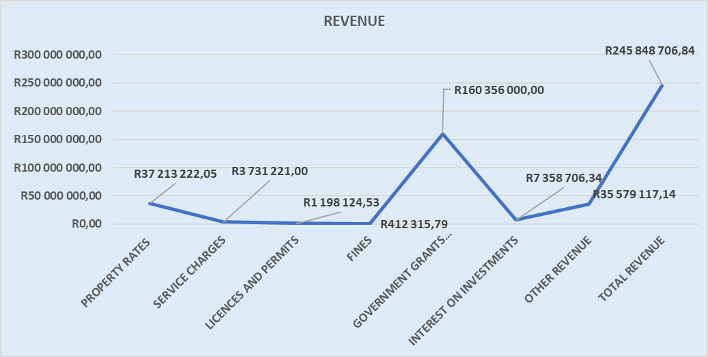

- SUMMARY OF OPERATING EXPENDITURE

- SUMMARY OF CAPITAL EXPENDITURE

